**Test-1**

**Based on C Programming**

**Attempt all 6 questions(passing questions no - 4)**

**Question1 :** Write a C program to find the GCD of two integers.

**Question2:** Write a C program to check if a given number is an Armstrong number between range 1 to 100.

**Question3:** Write a C program to print all prime numbers between range 1 to 100.

**Question4:** Write a C program to convert a binary number to a decimal number.

**Question5:** Pattern program:

# # # # #

# # # #

# # #

# #

#

**Question6:** Pattern program:

1

0 1

1 0 1

0 1 0 1

1 0 1 0 1

**Test-1**

**Based on Python Programming**

**Attempt only 4 questions(passing questions no - 3)**

**Question1 :** Write a python program to print this program.

1

0 1

1 0 1

0 1 0 1

1 0 1 0 1

**Question2:** Write a python program to check if a given number is an Armstrong number between range 1 to 1000.

**Question3:** Write a python program to rotate the image.

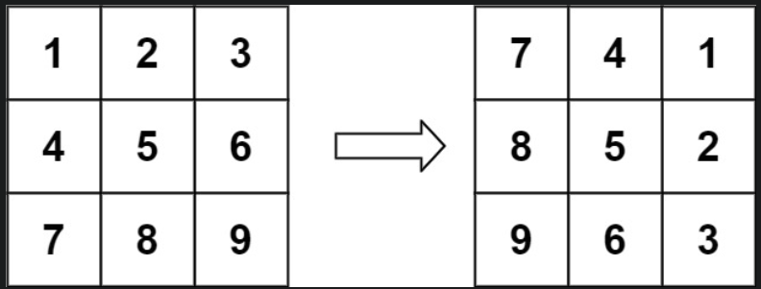

**Input:** matrix = [[1,2,3],[4,5,6],[7,8,9]]

**Output:** [[7,4,1],[8,5,2],[9,6,3]]–

**Question4:** Write a python program to convert a binary number to a decimal number.

**Question5: Two strings are given here and you have to find they are anagram or not.**

**Example 1:**

**Input:** s = "anagram", t = "nagaram"

**Output:** It is anagram

**Example 2:**

**Input:** s = "rat", t = "car"

**Output:** It is not an anagram