HR Employee Attrition Analysis
Business Intelligence Report

1. Business Problem
Employee attrition is one of the most costly and disruptive challenges facing organisations today. Replacing a single employee can cost between 50% and 200% of their annual salary when accounting for recruiting, onboarding, lost productivity, and institutional knowledge. This report analyses IBM's HR dataset of 1,470 employees to identify the scale of attrition, understand its primary drivers, and surface actionable recommendations for HR leadership and business management.

2. Executive Overview
The table below summarises the five core KPIs that frame this analysis. An overall attrition rate of 16.1%, well above the typical industry benchmark of 10–12%, signals a meaningful retention challenge that warrants targeted intervention.
KPI | Value
Overall Attrition Rate | 16.1%
Avg Monthly Income | $6,503
Avg Tenure (Years) | 7.0
Overtime Rate | 28.3%
Avg Job Satisfaction | 2.73 / 4

3. Attrition Trends

3.1 By Department
Sales exhibits the highest attrition rate among all departments, driven by a combination of high-pressure targets, commission variability, and significant overtime demands. Human Resources also sits above the company average, while Research & Development demonstrates the strongest retention performance.
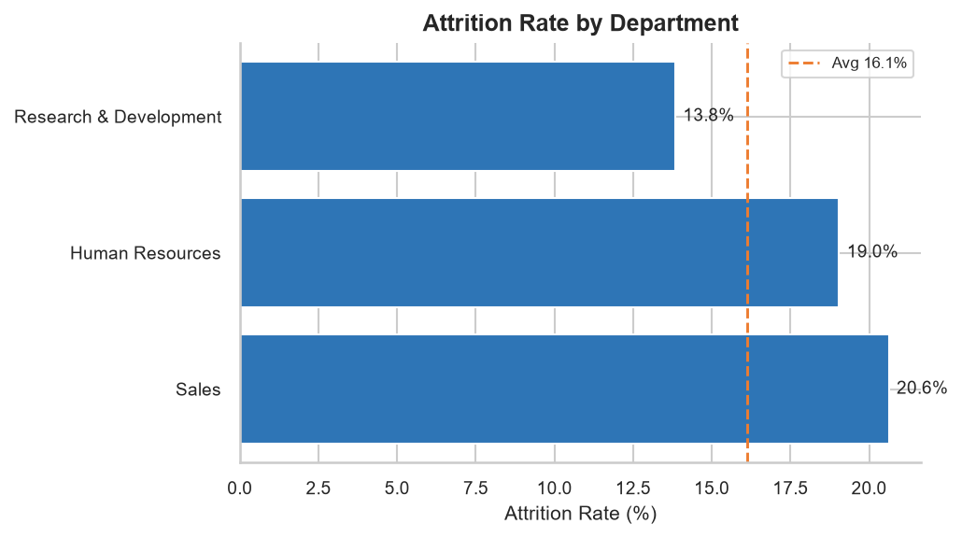

3.2 By Job Role
Sales Representatives record the highest role-level attrition at 39.8%, nearly 2.5x the company average. Laboratory Technicians and Human Resources roles also exceed the average. Managerial and director-level roles consistently show attrition rates below 10%.
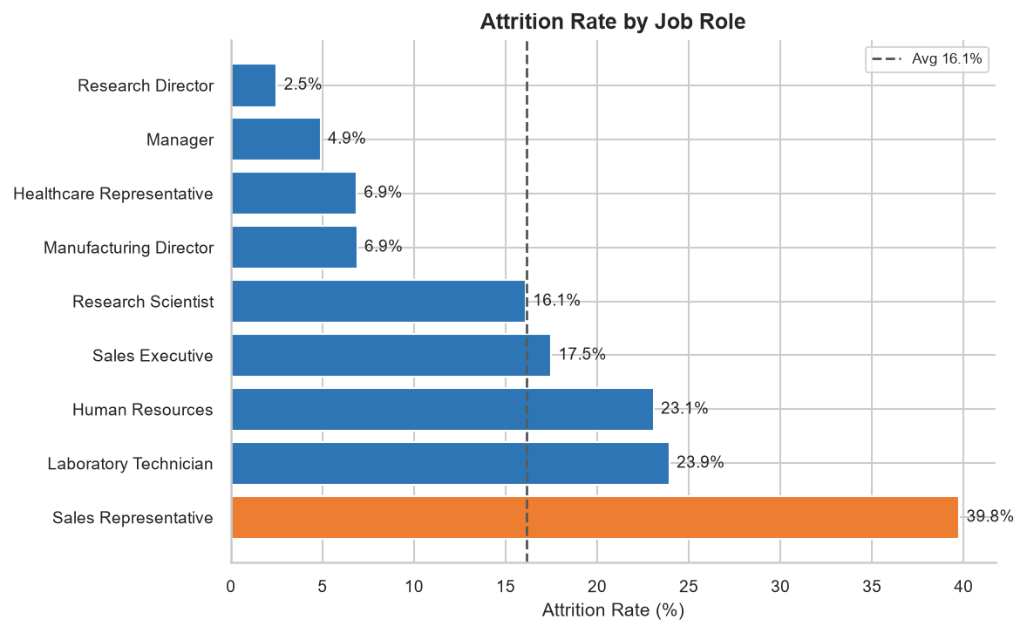

3.3 By Age Group
Younger employees (18–25) leave at more than double the rate of employees aged 36 and above. This pattern is consistent with early-career mobility and suggests that targeted early-tenure engagement programmes could have a significant retention impact.
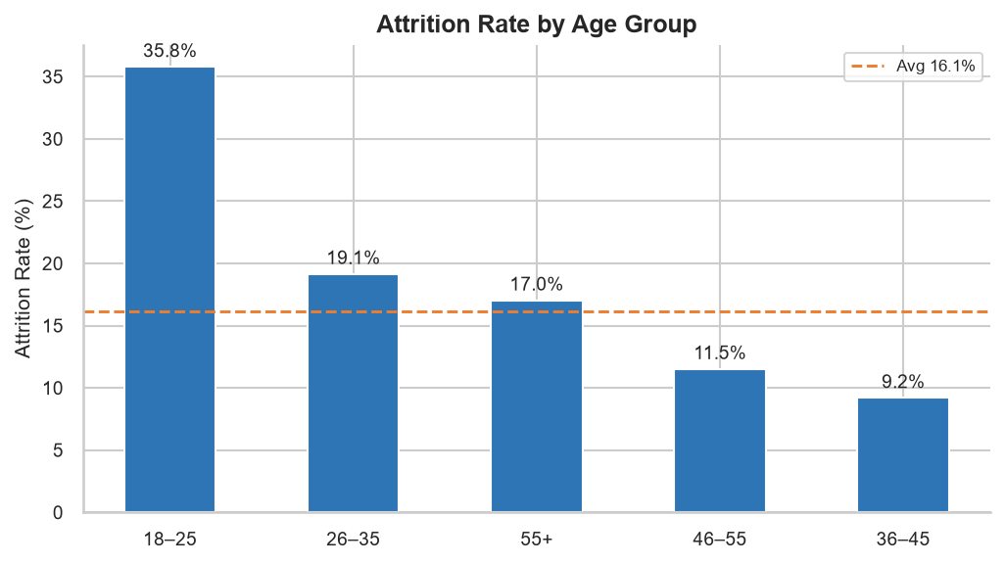

3.4 By Income Band
Attrition is sharply inversely correlated with income. Employees earning below $3,000/month (28.6%) leave at a rate 3.2x higher than those earning above $10,000/month (8.9%). This suggests compensation competitiveness is a material retention lever, particularly for entry-level and junior roles.
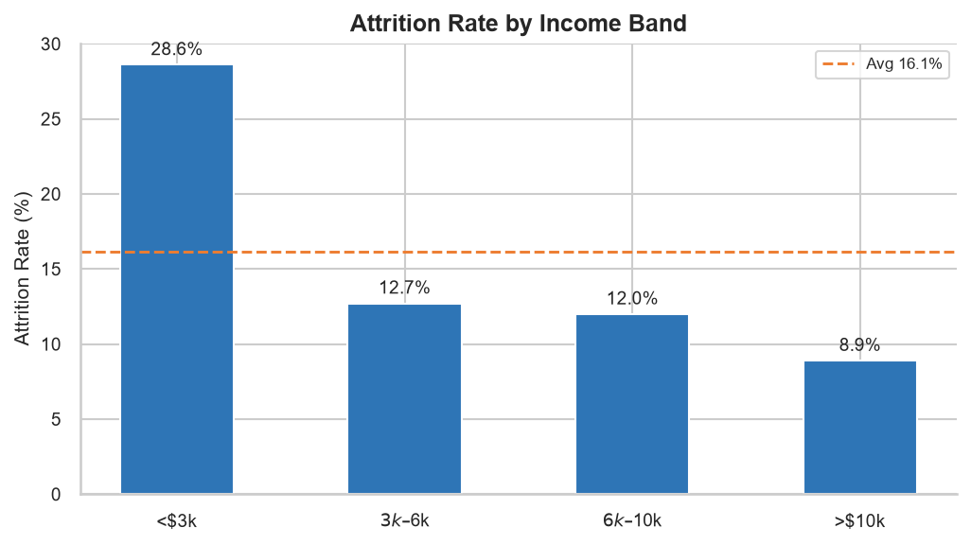

4. Drivers of Attrition

4.1 OverTime
Employees required to work overtime leave at a rate of approximately 30%, more than double the rate of employees who do not work overtime (~10%). This is the single strongest binary driver of attrition in the dataset and represents the clearest lever for HR intervention.
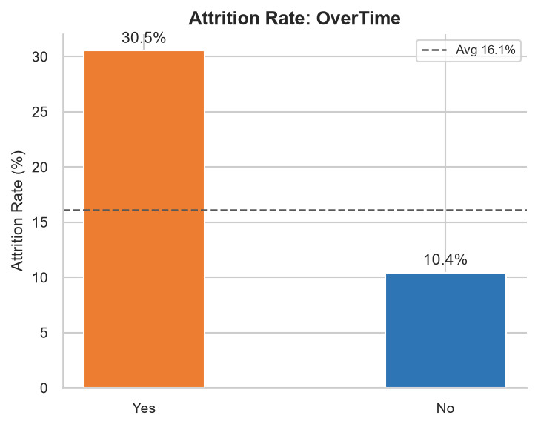

4.2 Job Satisfaction
There is a clear inverse relationship between job satisfaction and attrition. Employees at the lowest satisfaction level (1) leave at nearly 23%, while those at the highest level (4) leave at approximately 11%. Satisfaction surveys and role enrichment initiatives are well-supported by this data.
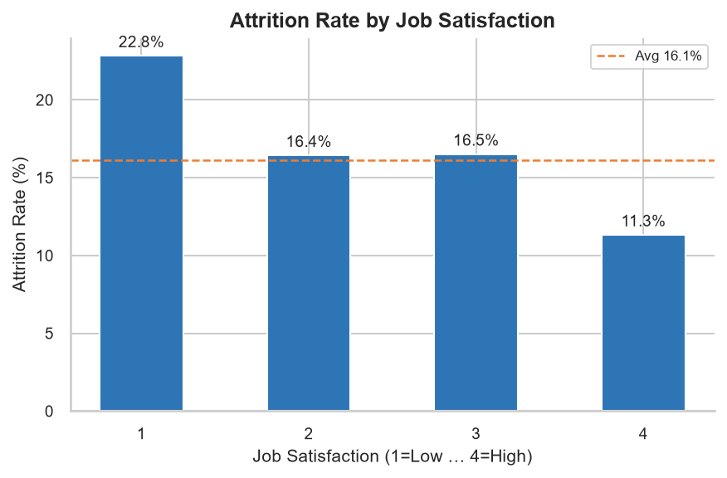

4.3 Work-Life Balance
Poor work-life balance (score 1) is associated with the highest attrition rate. Employees rating their work-life balance as 'Best' (4) still exhibit attrition above the overall average, indicating that balance alone does not fully explain attrition. It interacts with other factors such as compensation and role satisfaction.
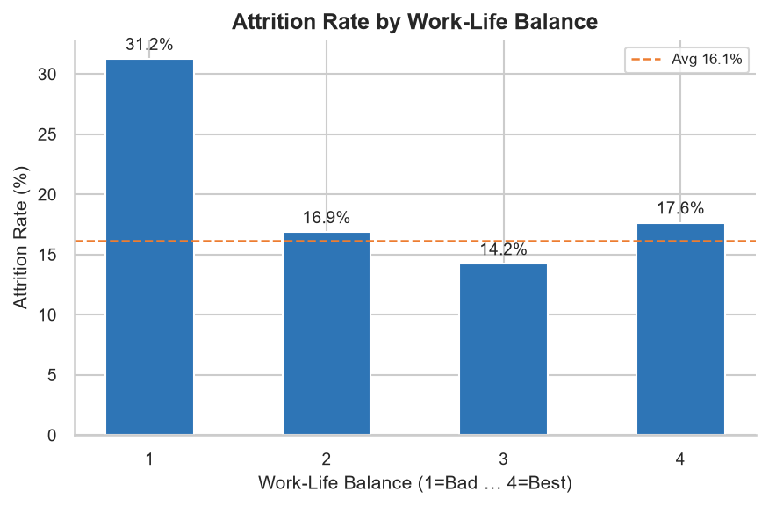

4.4 Time Since Last Promotion
Employees who have not received a promotion in 7 or more years show elevated attrition, suggesting that career stagnation is a contributing factor. However, employees who were promoted very recently (0–1 year) also show higher-than-average attrition, potentially reflecting post-promotion reassessment or unmet expectations following a role change.
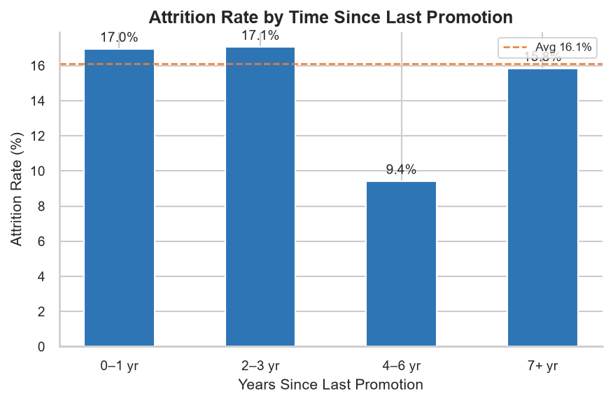

4.5 Distance From Home
Employees who live furthest from the office (16–30 km) show a modestly higher attrition rate than those living nearby. While the effect size is smaller than overtime or satisfaction, it remains statistically relevant and supports the business case for flexible/remote working policies as a retention tool.
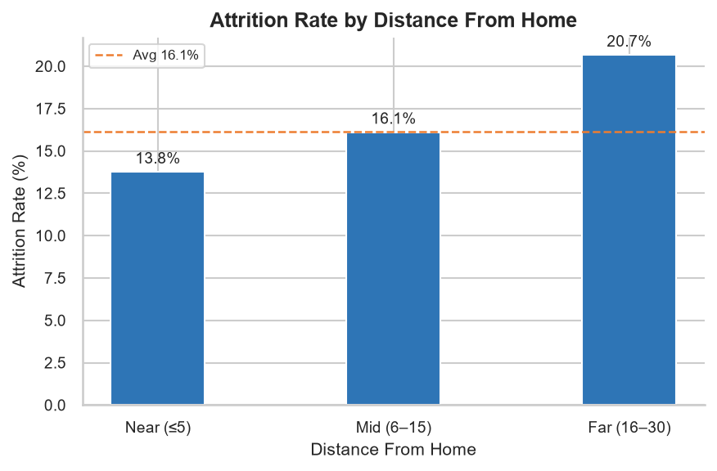

5. Risk, Opportunity & Recommended Action
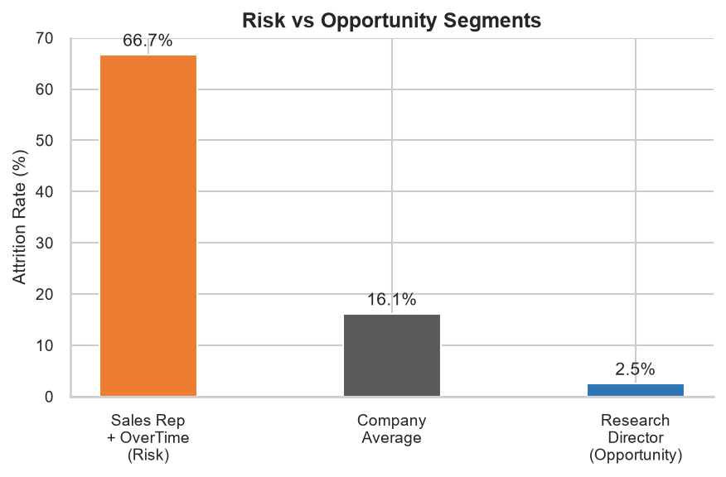

5.1 Risk: Sales Representatives Working Overtime
Sales Representatives who are required to work overtime record an attrition rate of 66.7%, approximately 4.1x the company average. This segment represents a concentrated, high-cost retention risk. The combination of high-pressure targets, variable compensation, and sustained overtime creates a compounding disengagement spiral. Losing experienced sales staff directly impacts revenue pipeline continuity.

5.2 Opportunity: Research Directors
Research Directors exhibit an attrition rate of just 2.5% with an average monthly income of $16,034. This cohort represents the organisation's most stable, high-value talent segment. Investment in their development, including leadership programmes, expanded scope, and mentoring roles, would yield compounding returns by retaining institutional knowledge and building internal succession pipelines.

5.3 Recommended Action
Primary Recommendation: Reduce mandatory overtime for Sales Representatives.
Specifically, the organisation should:
1. Audit current overtime obligations across the Sales department.
2. Introduce a maximum overtime threshold (e.g. no more than 5 hours/week).
3. Pilot flexible scheduling for Sales Representatives in one region.
4. Track attrition monthly for 6 months post-intervention and compare against the current 66.7% baseline.
Target: Bring Sales Representative attrition below the company average of 16.1% within 12 months.

6. Conclusion
This analysis reveals that employee attrition at this organisation is not random: it is concentrated in specific roles, income brackets, and behavioural patterns. The data consistently points to overtime, low job satisfaction, low compensation, and early career stage as the primary drivers. The Sales Representative + OverTime segment is the highest-priority risk requiring immediate action. Addressing this single cohort could meaningfully reduce overall attrition and deliver measurable cost savings within one fiscal year.
All charts and underlying data are reproducible by running KhushiVig_HRAttritionAnalysis.py against the source dataset.

