NumCompute-Stream Programming Task 2
  - Assessment 2

STUDENT ID:
SUBMITTED BY:
UNIVERSITY NAME:

Table of Contents
Introduction and System Overview 3
Design Decisions 3
Testing and Edge Cases 4
Benchmark Results 4
Demo and Visualisation Evidence 5
Reflection and Limitations 6
References 7

Introduction and System Overview
The project built NumCompute-Stream, a modular machine learning framework to support streaming classification tasks using only Python, NumPy and matplotlib. The idea of the system is to mimic online learning, in which data comes in smaller chunks, instead of a single batch. To facilitate this, the framework allows incremental learning via partial_fit methods and streaming metric update via update(), result() and reset APIs. It contains decision-tree classification modules, ensemble learning modules, preprocessing modules, statistical summary modules, modules for metrics, pipeline execution, stream training, as well as visualisation and input/output in CSV format (Gunasekara et al., 2023).
The final implementation is clearly structured in a package. The main source code is in the numcompute_stream/ folder, the unit tests are in the tests/ folder, the Jupyter notebook and sample dataset is in the demo/ folder, and the performance benchmarking script is in the benchmark/ folder. This modular structure makes it easier to test, maintain and extend the framework and enhances reusability. The implementation is done without the use of any external machine learning and data processing libraries, as per the assignment restrictions (scikit-learn and pandas are examples of such libraries).

Design Decisions
The principle design choice was to break each responsibility down into one module. Tree.py is a DecisionTreeClassifier that has a depth limit and is either Gini or entropy based. It has configuration parameters like max_depth, min_samples_split and max_features. Partial_fit() is provided in the classifier for streaming. To simplify (and make it reliable and obvious), the tree keeps chunks and then regenerates a bounded depth-limited tree from the chunks it saves. Compared to a complex fully-online tree, this is an easier to validate method, but it still shows chunk-wise incremental adaptation.
The ensemble.py file contains EnsembleClassifier for handling multiple decision trees. It adopts a bagging/random-forest approach with bootstrap sampling and majority voting. To support partial_fit(), the ensemble is updated by providing sampled data from the current chunk to ea ch tree. The random-forest style configuration also makes use of feature subsets, further diversifying the models. This component was added to meet the ensemble-learning requirement without complicating the design and compromising its testability (Cacciarelli and Kulahci, 2024).
The preprocessing layer was done in “preprocessing.py”. The Imputer imputes missing values based on running column means and the StandardScaler provides streamed mean and variance. There was also a simple OneHotEncoder included that would cater for the incremental addition of categories. Such pre-processing is necessary as streaming data sets can have missing data and/or feature distributions that change over time.
In the module pipeline.py you can find the sequence of preprocessing and modelling. At the time of partial_fit(), the pipeline will update and apply each transformer in turn, and send the output of each to the final estimator. StreamTrainer is part of the stream.py module, where it handles chunk-wise training, prediction, update of metrics, memory estimation and logging. This enables the demo notebook and benchmark script to follow the same procedure.

Testing and Edge Cases
Testing was a big part of the implementation. There are 48-unit tests in the final test suite, which is more than the minimum of 30 required in the assignment. The test command gave the following output: “Ran 48 tests in 1.143s – OK.” This ensures that the key package components run properly.
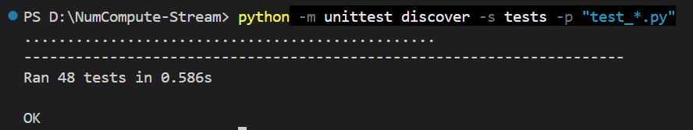
Figure 1: Testing and Edge Cases
These tests test decision tree, ensemble classifier, preprocessing parts, streaming metrics, streaming statistics, pipeline execution and stream training. A couple of edge cases were added. The streaming imputer takes care of missing values, while the scaler takes care of zero variance features to prevent dividing by zero. The implementation also validates empty chunks, mismatching number of features and labels, mismatching feature sizes, and unknown one-hot categories and prediction before fitting the model. Class metrics include accuracy, precision, recall, F1, confusion matrix and AUC. The AUC implementation does not produce false results by returning NaN if only one class is present.
These tests also show that the framework works not only in regular use, but is also resilient against typical issues with streaming data.

Benchmark Results
Benchmarking was done with benchmark/benchmark_stream.py. The script validated the single decision tree with the ensemble classifier using synthetic streaming data of 2000 samples, 8 features, 20 chunks and chunk size 100. The DecisionTreeClassifier's final cumulative accuracy was 0.9225 and the final chunk accuracy was 0.8800. It took 7.8793 seconds to complete and reached a maximum of 0.6528 MB of memory. The EnsembleClassifier got a slightly better cumulative accuracy of 0.9230 and the final chunk accuracy of 0.9000. However, it required 25.6257 seconds and 1.4460 MB of peak memory.
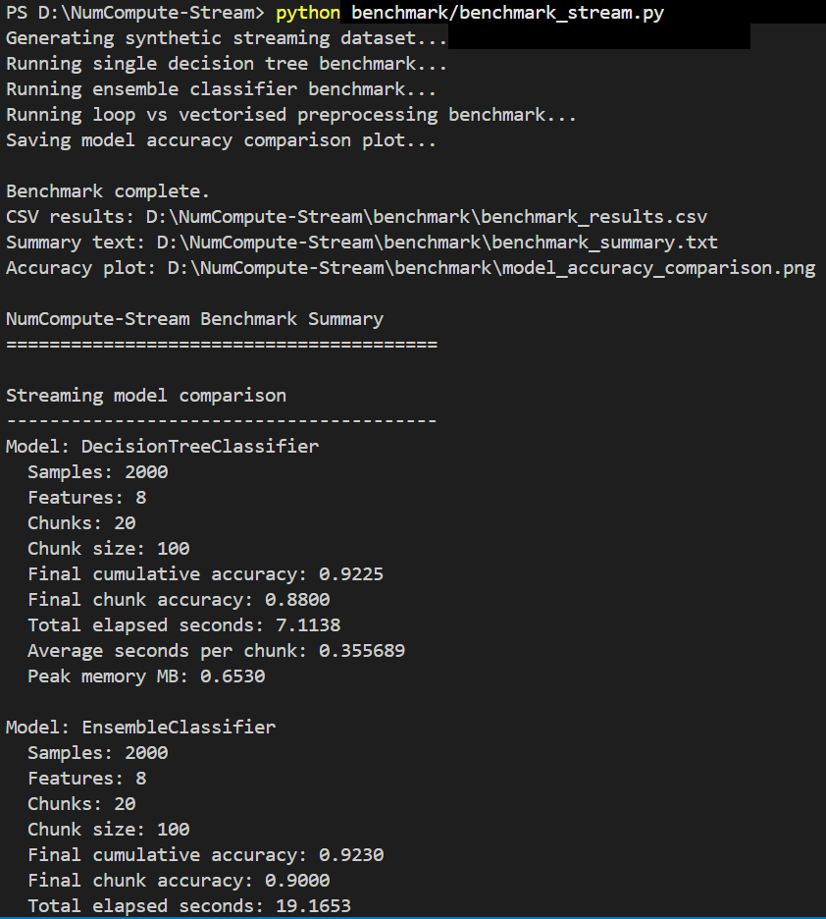
Figure 2: Benchmark Results
These results depict a realistic trade-off between accuracy and cost of computation. The ensemble was slightly more accurate at the end, as it trained multiple decision trees as opposed to just one tree, but was slower and consumed more memory. This is normal in ensemble learning where diverse models may lead to better stability at the expense of computation with majority voting.
There was also a comparison of loop-based preprocessing with NumPy vectorised preprocessing in this benchmark. The average time taken by the loop-based version was 0.118494 seconds, and by the vectorised version was 0.001196 seconds. This resulted in a speedup of about 99.05x, and the largest numerical difference was 0.000000000000. This demonstrates the efficiency of NumPy vectorisation, and it's a requirement in the assignment to use vectorised operations wherever possible.

Demo and Visualisation Evidence
The demo notebook demo/stream_demo.ipynb demonstrates the complete workflow. It loads sample_data.csv using the custom io.py module, splits the dataset into 10 chunks of 30 rows, trains both a single decision tree and an ensemble model using partial_fit(), and logs streaming metrics over time. The dataset contains 300 rows, 6 numeric features, a binary target and missing values to test the imputer.
The notebook generated visualisations for single-tree cumulative accuracy, ensemble cumulative accuracy, tree-versus-ensemble comparison and predictions versus ground truth. These plots demonstrate that the visualisation module works correctly and that the framework can monitor model behaviour across chunks.
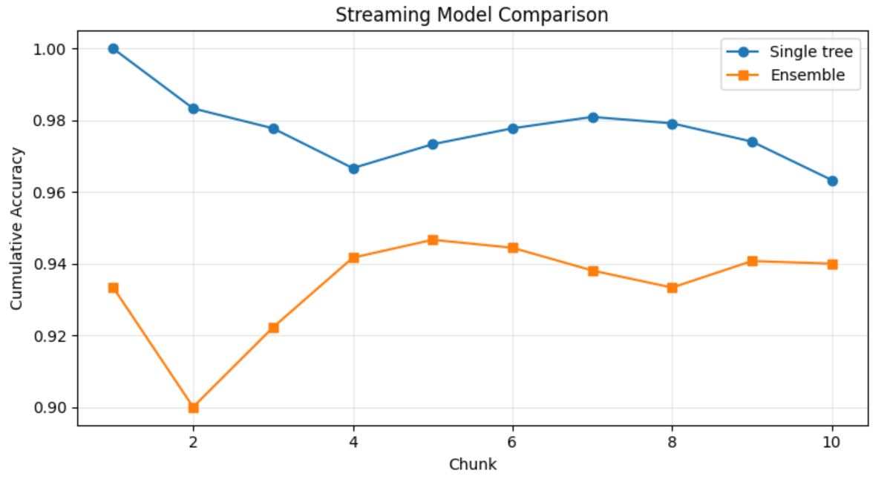
Figure 3: Streaming Model Comparison

Reflection and Limitations
This project provided understanding into streaming machine learning, incremental preprocessing and modular software design. Each component had to retain state between chunks and so partial_fit() was tricky to implement carefully. A further insight of the project was that ensembles are not necessarily the better choice if the data set is small. In the notebook demo, the single tree performed better in terms of the final accuracy, as compared to the ensemble and in the benchmark, the ensemble performed slightly better as compared to the single tree. This shows that the performance of a model will vary based on the size, randomness, and relationships among features, as well as the model configuration, of the dataset.
The drawback is that the decision tree is chunk-wise retraining and not a very advanced online tree algorithm like a Hoeffding tree. The AUC implementation is also very simple and typically used for binary classification. Likewise, retained buffer is used for quantiles instead of fully advanced streaming quantile algorithm. Despite these constraints it does fulfill the primary technical needs: modular design of packages, streaming updates, decision-tree learning, ensemble classification, preprocessing, metrics, statistics, testing, benchmarking and visualisation with only NumPy and matplotlib.

References
Gunasekara, N., Pfahringer, B., Gomes, H.M. and Bifet, A., 2023, August. Survey on Online Streaming Continual Learning. In IJCAI (pp. 6628-6637). https://www.ijcai.org/proceedings/2023/0743.pdf
Cacciarelli, D. and Kulahci, M., 2024. Active learning for data streams: a survey. Machine Learning, 113(1), pp.185-239. https://doi.org/10.1007/s10994-023-06454-2

