MODULE-1

1.What is software?

Ans. Software is a set of instructions, data or programs used to operate computers and execute specific tasks. It is the opposite of hardware, which describes the physical aspects of a computer. Software is a genetic term used to refer to applications, scripts and programs that run on a device.

1(a). What is software engineering?

Ans. Software engineering is the branch of computer science that deals with the design, development, testing and maintenance of software applications.

2. Explain types of software

Ans. Among the various categories of software, the most common types include the following:

* Application software. The most common type of software, application software is a computer software package that performs a specific function for a user, or in some cases, for another application. An application can be self-contained, or it can be group of programs that runs the can be a group of programs that run the application for the user. Examples of modern applications include office suites, graphics software, databases and database management programs, web browsers , web processors, software development tools, image editors and communication platforms.
* System software. These software programs are designed to run a computer’s application programs and hardware. System software coordinates the activities and functions of the hardware and software. In addition, it controls the operations of the computer hardware and provides an environment or platform for all the other types of software to work in. The OS is the best example of system software include the firmware, computer language translators and system utilities.
* Driver software. Also known as device drivers, this software is often considered a type of system software. Device drivers control the devices and peripherals connected to a computer, enabling them to perform their specific tasks. Every device at least one device driver to function. Examples include software that comes with any nonstandard hardware, including special game controllers, as well as the software thar enables standard hardware, such as USB storage devices, keyboards, headphones and printers.
* Middleware. The term middleware describes software that medicates between application and system software or between two different kinds of application software. For example, middleware enables Microsoft Windows to talk to Excel and Word. It is also used to send a remote work request from an application in a computer that has one kind of OS, to an application in a computer with a different OS. It also enables newer applications to work with legacy ones.
* Programming software. Computer programmers use programming software to write code. Programming software and programming tools enable developers to develop, writes=, test and debug other software programs. Examples of programming software include assemblers, compliers, debuggers and interpreters.

3. What is SDLC? Explain each phase of SDLC.

Ans. The software development lifecycle(SDLC) is the cost-effective and time-efficient process that development teams use to design and build high-quality software. The goal of SDLC is to minimize project software meets customer expectations during production and beyond. This methodology outlines a series of steps that divide the software development process into tasks you can assign, complete and measure. Every phase of the SDLC life cycle has its own process and deliverables that feed into the next phase. SDLC stands for Software Development Life Cycle and is also referred to as the Application Development life-cycle.

3.a Phases of SDLC

1. Planning and Analysis

The first phase of the SDLC is the project planning stage where you are gathering busine3ss requirements from your client or stakeholders. This phase is when you evaluate the feasibility of creating the product, revenue potential, the cost of production, the needs of the end-users, etc.

To properly decide what to make, what not to make and what to make first, you can use a **feature prioritization framework**  that takes into cost, the time it takes to build, other factors.

Once it is decided that the software project is in line with business and stakeholder goals, feasible to create, addresses user needs, then you can move on to the next phase.

2. Define Requirements

The phase is critical for converting the information gathered during the planning and analysis phase into clear requirements for the development team. This process guides the development of several important documents: a software requirement specification (SRS), a Use Case document, and a Requirement Traceability Matrix document.

3. Design

The design phase is where you pen to paper-so to speak. The original plan and vision are elaborated into a software design document (SDD) that includes the system design, programming language, templates, platform to use and application security measures. The is also where you can flowchart how the software responds to user actions.

In most cases, the design phase will include the development of a prototype model. Creating a pre-production version of the product can give the team the opportunity to visualize what the product will look like and make changes without having go to through the hassle of rewriting code.

4.Development

The actual development phase is where the development team members divide the project into software modules and turn the software requirement into code that makes the product.

The SDLC phase can take quite a lot of time and specialized development tools. It’s important to have a set timeline and milestones so the software developers understand the expectations and you can keep track of the progress in this stage.

In some cases, the development stage can also

Q4. What is flow chart? Create a flow chart to make addition of two numbers.

Ans. ALGORITHM: An algorithm is a step-by-step procedure to solve a given problem.

Algorithm of addition of two numbers

Start

Declare variables n1,n2.

Read the values for n1 and n2

Sum->n1+n2

Display sum

Stop

FLOWCHART: The flowchart is the most widely used graphical representation of an algorithm and procedural design workflows. It uses various symbols to show the operations and decisions to be followed in a program. It flows in sequential order

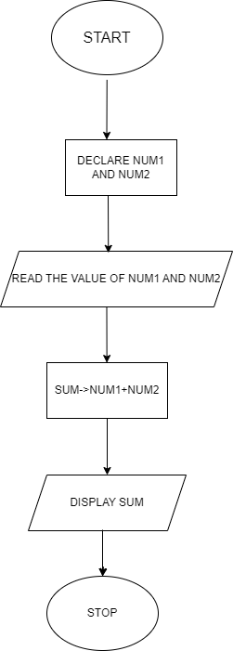

Q5. What is DFD? Create a DFD diagram for flipkart.

Ans. A data flow diagram (DFD) is a graphical or visual representation using a standardized set of symbols and notations to describe a business’s operations through data movement. They are often elements of a formal methodology such as Structured Systems Analysis and Design Method(SSADM).

DFD diagram for flipkart: 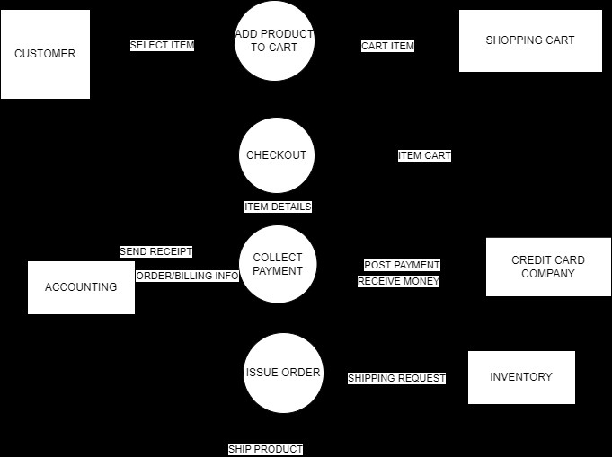

Q6. What is Use-case diagram? Create a use-case on bill payment on paytm.

Ans. Use-case diagram describes the high-level functions and scope of a system

* These diagrams also identify the interactions between the system and its actors.
* The use cases and actors in use-case diagrams describe what the system does and how the actors use it, but not how the system operates internally.
* Use case diagram on bill payment:

