**Machine Learning Unsupervised learning Clustering**

## Introduction

In this in-depth analysis, we explore the intricate dynamics of user behavior within the app ecosystem, aiming to unveil valuable insights to drive retention strategies and bolster user engagement. Through the examination of a dataset encompassing key metrics such as screen time, spending habits, user reviews, and ratings, we embark on a journey to decode the evolution of user interaction within digital applications.

## Data Exploration

### Importing and Summarizing Data

Our exploration begins with the ingestion of the user behavior dataset, a treasure trove of information encapsulating the nuances of user engagement. Post-import, we meticulously scrutinize the dataset's structure, probing for any missing values and obtaining a comprehensive overview of the various attributes encapsulated within.

### Analysis of Screen Time and Spending Habits

Delving into the realm of user behavior, we traverse through the spectrum of screen time and spending habits. By dissecting the distribution of screen time metrics, we uncover patterns of user activity, identifying outliers that may indicate intense engagement or potential disinterest. Simultaneously, our examination of spending habits sheds light on user monetization patterns, revealing variations in user investment across the application ecosystem.

## Relationship Analysis

### Exploration of Spending Capacity vs. Screen Time

Navigating through the intricate interplay between spending capacity and screen time, we seek to unveil the symbiotic relationship between user engagement and financial investment. Through meticulous visualization and analysis, we uncover nuanced correlations between prolonged screen time and increased spending, juxtaposed against instances of minimal spending despite extensive engagement. These insights lay the groundwork for crafting targeted retention strategies and fostering a harmonious relationship between user engagement and financial investment.

### Examination of Ratings vs. Screen Time

Venturing deeper into the realm of user sentiment, we explore user ratings juxtaposed against screen time metrics. By juxtaposing user sentiment with engagement patterns, we unearth the nuanced interplay between user satisfaction and sustained engagement. Through comprehensive visualization and analysis, we discern patterns of heightened user satisfaction correlated with prolonged engagement, providing valuable insights into the factors driving user retention and satisfaction within the application ecosystem.

## User Segmentation with K-means Clustering

### Unsupervised Learning for User Segmentation

Embracing the power of unsupervised learning, we employ the formidable K-means clustering algorithm to delineate distinct cohorts of users based on their behavioral attributes. By partitioning users into homogeneous clusters, we unravel the underlying heterogeneity within the user base, enabling the formulation of targeted retention strategies tailored to the unique preferences and needs of each cohort. Visualization and interpretation of the resultant clusters illuminate nuanced behavioral archetypes prevalent within the user base, paving the way for personalized user engagement strategies and heightened user satisfaction.

## Correlation Analysis

### Unveiling Interdependencies within User Behavior

Delving deeper into the intricate web of user behavior, we embark on an exploration of correlation analysis, aiming to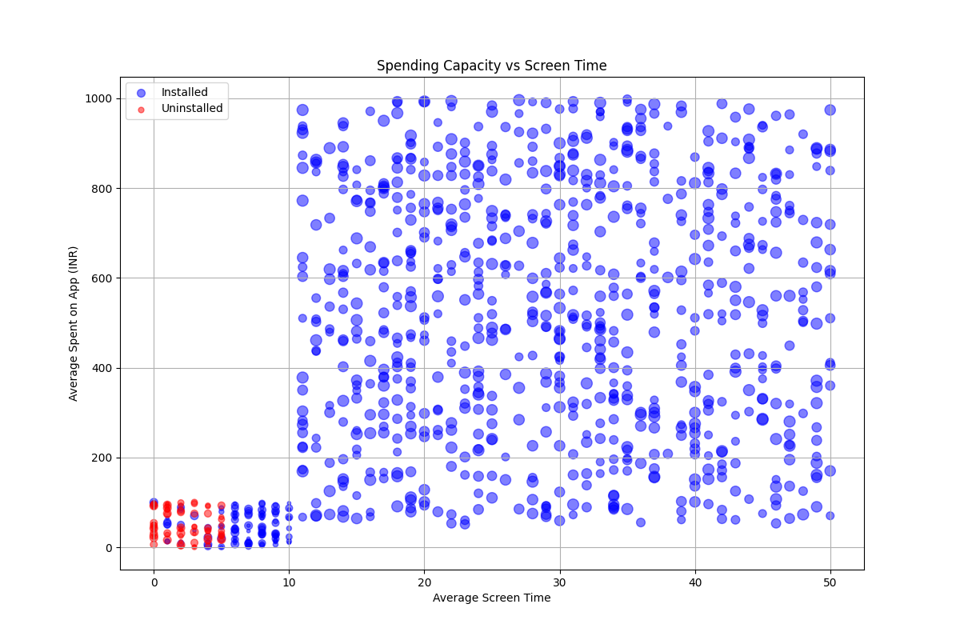 unveil underlying interdependencies between diverse behavioral metrics. Through the construction of a comprehensive correlation matrix, we meticulously dissect relationships between screen time, spending habits, user sentiment, and engagement patterns. By deciphering nuanced interplays between diverse behavioral attributes, we unearth hidden patterns and relationships, providing valuable insights into the drivers of user engagement and retention within the application ecosystem.

## Anomaly Detection

### Safeguarding Application Integrity through Anomaly Detection

Equipped with the powerful Isolation Forest algorithm, we embark on a quest to unearth anomalies lurking within user search queries. Leveraging the prowess of anomaly detection, we meticulously scrutinize user search patterns, flagging outliers indicative of potential anomalies or irregularities. Through comprehensive visualization and interpretation of anomaly detection results, we identify hidden anomalies and irregularities, facilitating proactive mitigation strategies to safeguard the integrity and security of the application ecosystem.

## Conclusion

In conclusion, our comprehensive analysis of app user behavior unveils invaluable insights into the intricate dynamics of user engagement and retention within the application ecosystem. Through meticulous exploration, relationship analysis, user segmentation, correlation analysis, and anomaly detection, we decode the underlying drivers of user behavior, paving the way for targeted retention strategies, heightened user engagement, and sustained growth. Armed with these insights, the application stands poised to navigate the evolving landscape of user engagement, fostering a symbiotic relationship between user satisfaction, engagement, and the application's success.