**TABLES**

1. Students

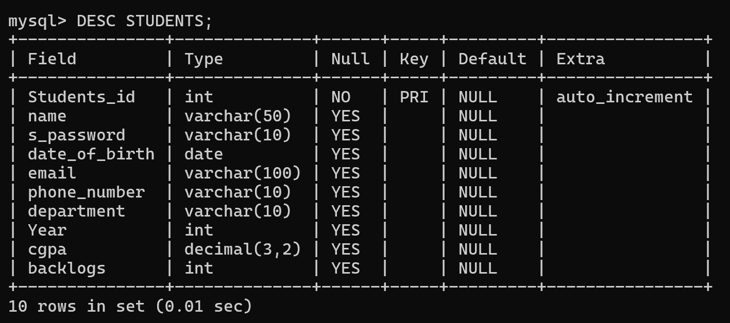

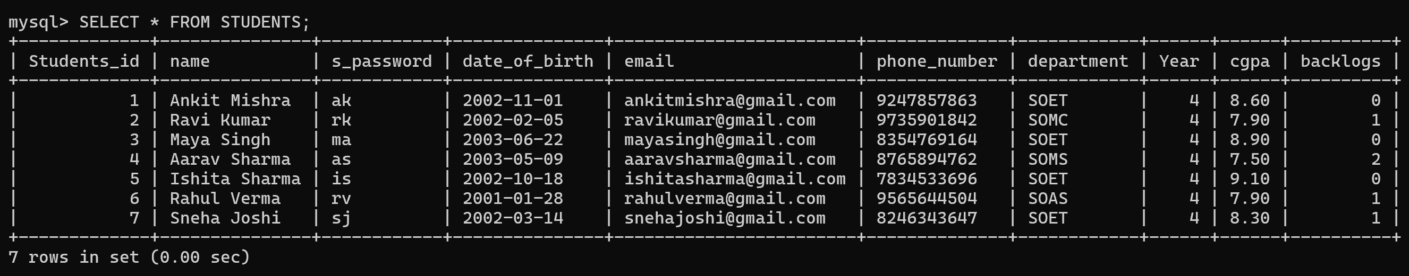

1. **Administrators**

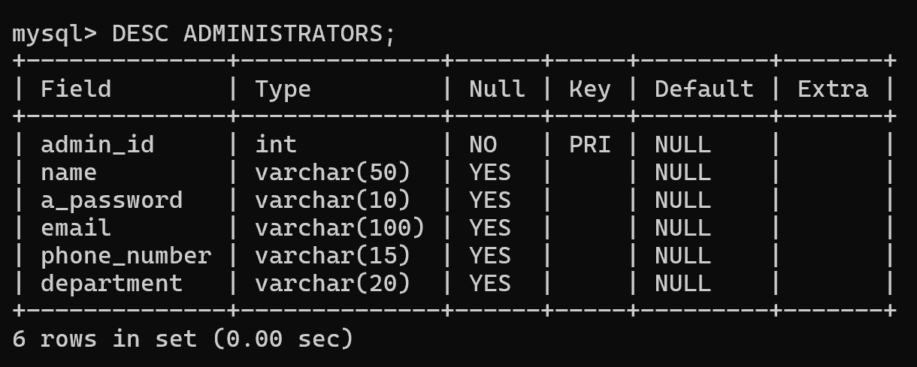

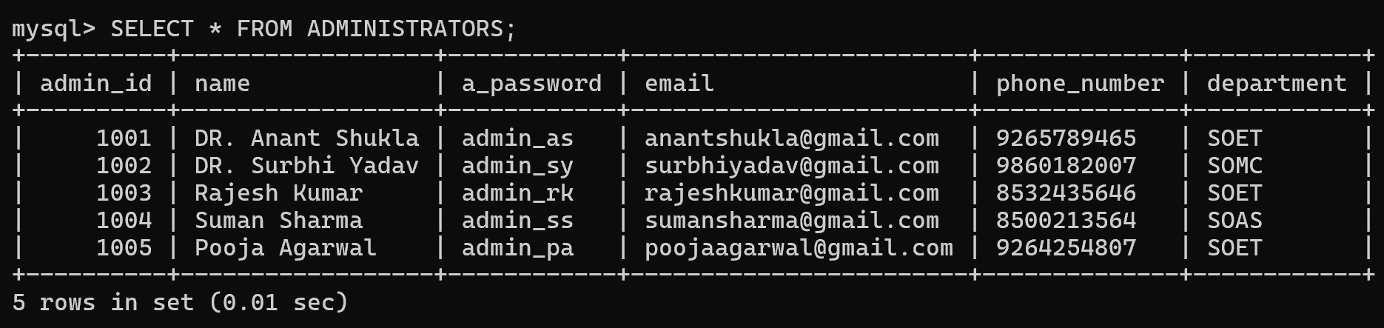

1. **Recruiters**

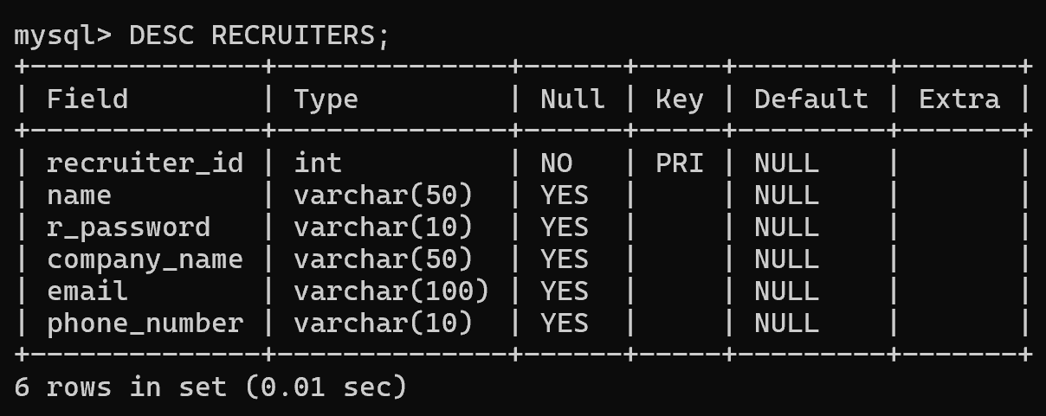

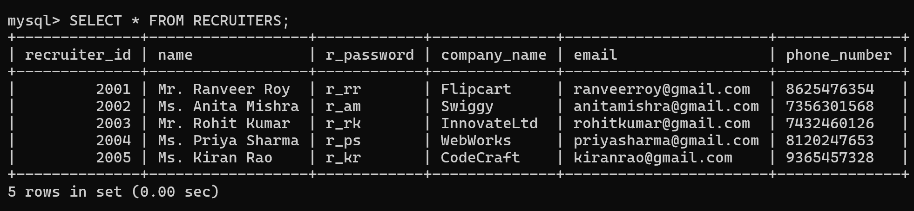

1. **Jobs**

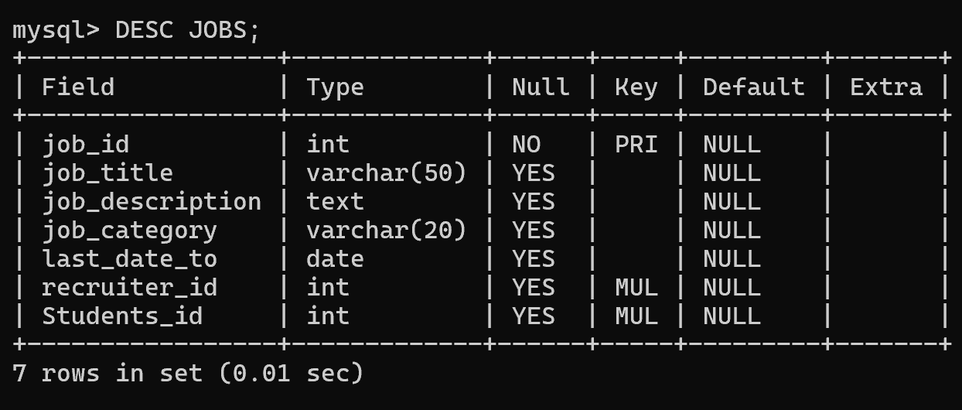

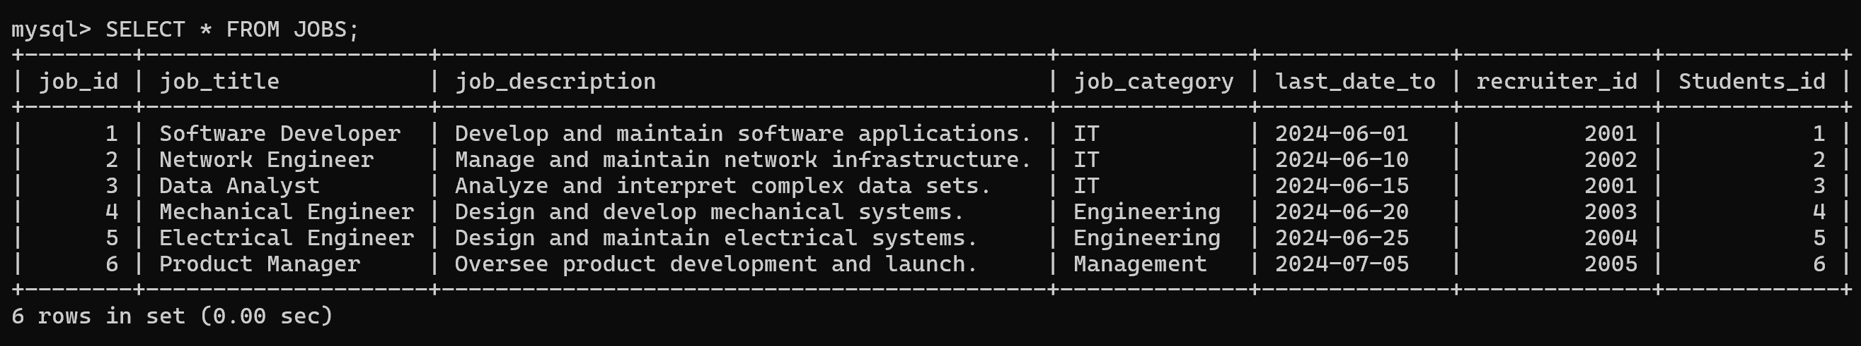

1. **Applications**

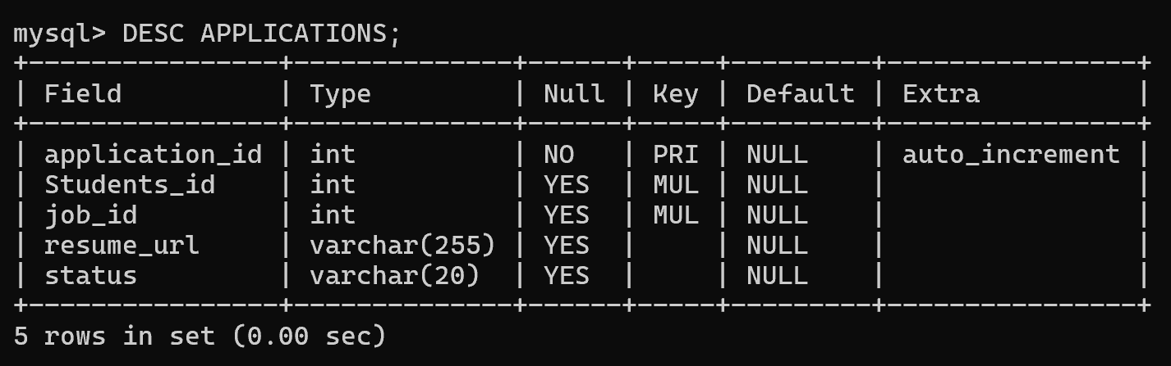

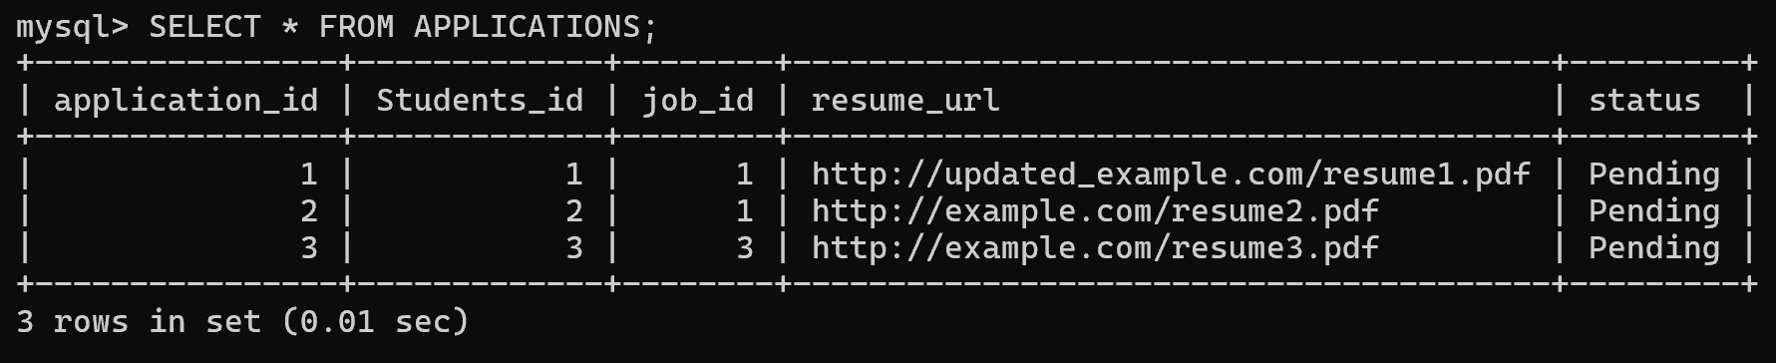

1. **Interviews**

