Data Analysis Report on IPL Batting Performance

1. Introduction
This report presents a data analysis of a cleaned IPL batting dataset. The objective is to analyze batting performance, scoring patterns, and player contributions.

2. Dataset Overview
The dataset contains 22,497 records with 14 attributes including runs, balls faced, boundaries, strike rate, and dismissal details.

3. Graphical Analysis

3.1 Distribution of Runs
The histogram below shows the distribution of runs scored per innings.
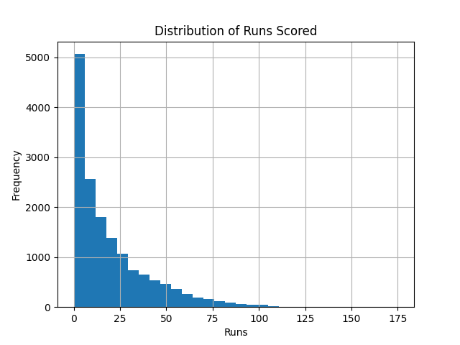

3.2 Dismissal Status
The pie chart below represents the proportion of dismissals and not-out innings.
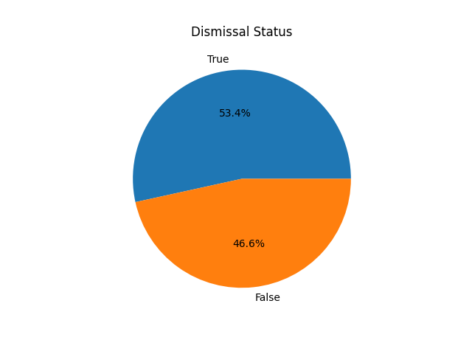

4. Conclusion
The analysis highlights that most innings are low scoring, while a few high-impact performances contribute significantly. Graphical insights make trends easy to understand.

