

MINI PROJECT REPORT
Project Phase – 1 REPORT
on
AI-Driven Intelligent Network for Smart Campus Applications
Submitted by
Khushi Malani [KU2407U464]
Krishna Shah [KU2407U703]
Nirali Kodavala [KU2407U150]
Mansoor Anas [KU2407U696]
in partial fulfilment for the award of the degree of
BACHELOR OF TECHNOLOGY
COMPUTER SCIENCE ENGINEERING
Project Mentor
Ms. Pragya Vats
UNITEDWORLD INSTITUTE OF TECHNOLOGY
KARNAVATI UNIVERSITY
Uvarsad, Gandhinagar, Gujarat – 382422
July – November, 2026
Table of Contents
1. Abstract 3
2. Introduction 4
a) Problem Statement 4
b) Aim and Objectives 4
c) Scope of the Project 5
3. System Requirements and Design 6
a) Hardware Requirements 6
b) Software Requirements 6
c) System Architecture 7
d) Diagrams 9
4. Implementation 11
a) Technologies Used 11
b) Screenshots and Outputs 13
5. Conclusion 16
6. Future Scope 16
References 17

1. Abstract
A modern university campus runs Wi-Fi, e-learning platforms, IoT sensors, CCTV, library systems and administrative servers on one shared network. As the number of devices and users grows, fixed bandwidth rules and manual monitoring find it hard to keep services fast and secure, especially during peak hours.
This project presents an AI-driven intelligent network for smart campus applications. The prototype uses hourly traffic records, builds network features such as active users, bandwidth and their previous values, and applies two machine learning models: a Random Forest that predicts the next hour’s bandwidth demand and an Isolation Forest that flags unusual traffic. The predictions support simple QoS and bandwidth decisions and are shown to the network administrator.
The prototype was tested on a simulated 60-day campus dataset. The Random Forest reached a mean absolute error of 42.0 Mbps against 48.3 Mbps for a Linear Regression baseline, and the Isolation Forest found all 7 injected traffic spikes in the test period. These figures come from simulated data and show how the method works; they are not measurements of a real campus network. The work applies concepts from all five units of the Computer Networks syllabus.
Keywords: smart campus, intelligent network, machine learning, traffic prediction, anomaly detection, QoS, IoT, Wi-Fi

2. Introduction
A smart campus uses connected technology to make teaching, administration and campus life more efficient. Classrooms stream lectures and run online assessments, libraries offer digital resources, hostels depend on Wi-Fi, and sensors and cameras report data all day. All of these services rely on a computer network that carries many kinds of traffic at the same time [1].
Each kind of traffic has different needs. A video lecture needs steady throughput and low delay, an examination portal needs reliability, IoT sensors send small packets often, and CCTV streams need sustained bandwidth. When they compete for the same links, quality drops unless the network is managed with care.
Campus traffic follows patterns: usage rises between lectures, peaks in the afternoon and falls at weekends. Machine learning can learn such patterns from past data, forecast demand, and notice behaviour that does not fit. This is the idea behind an intelligent, self-adapting network, and it is the subject of this project.

a) Problem Statement
The number of devices on campus networks grows every year, and applications such as video conferencing, cloud learning platforms and IoT monitoring generate heavy and unpredictable traffic. Administrators usually react after users complain about slow Wi-Fi or an outage, and unusual or harmful traffic can go unnoticed among normal flows.
There is a need for an intelligent network that studies traffic features, predicts demand before congestion occurs, flags abnormal behaviour and helps adjust resources. This project builds a learning prototype of such a system, using simulated or authorised data, with the final decision left to a human administrator.

b) Aim and Objectives
Aim: To design and build an AI-driven intelligent network prototype that improves the performance and security of smart campus applications.
Objectives:
- To study the structure of a smart campus network and the traffic its applications generate.
- To collect or simulate campus traffic data and identify useful network features.
- To train a machine learning model that predicts bandwidth demand for the coming hour.
- To detect abnormal traffic patterns that may indicate faults, misuse or attacks.
- To use the predictions to suggest QoS or bandwidth-allocation decisions.
- To evaluate the models with suitable metrics and present the results clearly.

c) Scope of the Project
Within scope:
- Hourly traffic data for a campus network, either simulated or taken from authorised logs.
- Traffic prediction with Random Forest and comparison with simple baseline models.
- Anomaly detection with Isolation Forest.
- Rule-based QoS suggestions that an administrator can review.
- Evaluation with standard error and classification metrics.
Outside scope:
- Deployment on a live production network or automatic changes to real devices.
- Deep-learning models, packet-level payload inspection and attack classification.
- Collection of personal data about individual users.
The prototype is meant for learning and demonstration. Its alerts need human review, and any real data must be anonymised and used only with permission, in line with the institution’s privacy policy.

3. System Requirements and Design

a) Hardware Requirements
The prototype works on tabular data and light models, so an ordinary laptop is enough. Optional network equipment is useful only for live testing.
Table 3.1: Hardware requirements
Component | Minimum | Recommended
Processor | Intel Core i5 or AMD Ryzen 5 (4 cores) | Intel Core i7 or AMD Ryzen 7
Memory (RAM) | 8 GB | 16 GB
Storage | 20 GB free space | 50 GB SSD for datasets and captures
Network interface | Wi-Fi or Ethernet adapter | Gigabit Ethernet adapter
Display | 1366 x 768 | 1920 x 1080
Optional equipment | Not required | Managed switch with port mirroring, Wi-Fi access point, Raspberry Pi as an IoT node

b) Software Requirements
Table 3.2: Software requirements
Software | Requirement | Purpose
Operating system | Windows 10/11 or Ubuntu 22.04 | Platform for development and testing
Programming language | Python 3.10 or later | Data handling and model training
Libraries | Pandas, NumPy, Scikit-learn, Matplotlib | Data preparation, models, metrics and charts
Interface | Streamlit or Jupyter Notebook | Dashboard and report of results
Network simulation | Cisco Packet Tracer or ns-3 | Building and testing the campus topology
Packet analysis | Wireshark | Inspecting authorised sample traffic
Editor and browser | VS Code or Jupyter, any modern browser | Coding and viewing the dashboard

c) System Architecture

Layered architecture
The system has four layers. Data moves upward from the campus devices to the AI engine and the dashboard, and control decisions move downward to the network.
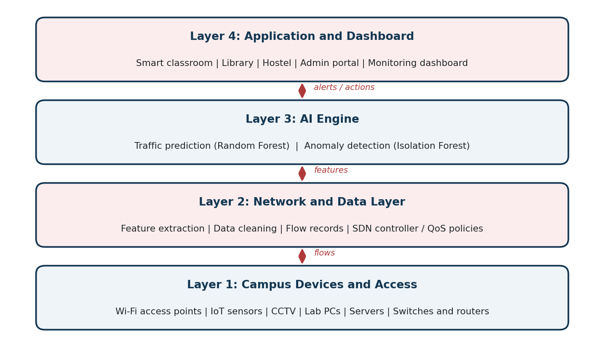
Figure 3.1: Layered architecture of the AI-driven smart campus network
Table 3.3: Role of each layer
Layer | Role
1. Campus devices and access | Wi-Fi access points, IoT sensors, CCTV, lab computers, servers, switches and routers that create and carry traffic.
2. Network and data layer | Collects flow records, cleans them, extracts features and applies QoS or SDN policies.
3. AI engine | Runs the traffic prediction and anomaly detection models.
4. Application and dashboard | Serves smart classrooms, library, hostel and administration, and shows forecasts and alerts to administrators.

Main modules
- Data collection and preparation: gathers or simulates hourly records of users, bandwidth, packets and latency, then cleans them and builds features.
- Traffic prediction: estimates the bandwidth of the next hour from time of day, day of week and recent usage.
- Anomaly detection: marks records that differ strongly from normal behaviour, such as a sudden bandwidth spike.
- QoS and decision support: turns forecasts and alerts into suggestions, for example giving priority to lecture streaming.
- Dashboard: shows forecasts, alerts and performance scores in one place.

Computer Networks concepts used
The project applies ideas from all five units of the Computer Networks syllabus; Table 3.4 maps each unit to its use in the prototype.
Table 3.4: Mapping of the project to the syllabus
Unit | Concepts | Use in this project
Unit I | Application protocols and network services | DNS, HTTP and e-learning portals produce much of the campus traffic that is measured.
Unit II | TCP/UDP, ports, congestion control, throughput, latency | Throughput, delay and packet counts are used as features and evaluation measures.
Unit III | IP addressing, routing, subnetting, VLANs | Campus segments such as classrooms, hostels and labs are separated and monitored by subnet or VLAN.
Unit IV | Wi-Fi (802.11) [6], Ethernet, switching | Access-point load and link-layer access influence how congestion is predicted.
Unit V | Network security, monitoring, anomaly detection | Unusual traffic is detected and reported; authorised data use and privacy are followed.

d) Diagrams

Campus network topology
Figure 3.2 shows the campus network on which the system is meant to run. The core router connects to the internet through a firewall and to the distribution switches of each campus block. The AI server receives mirrored traffic or flow records from the core, and its decisions reach the network through an SDN controller or QoS policy.
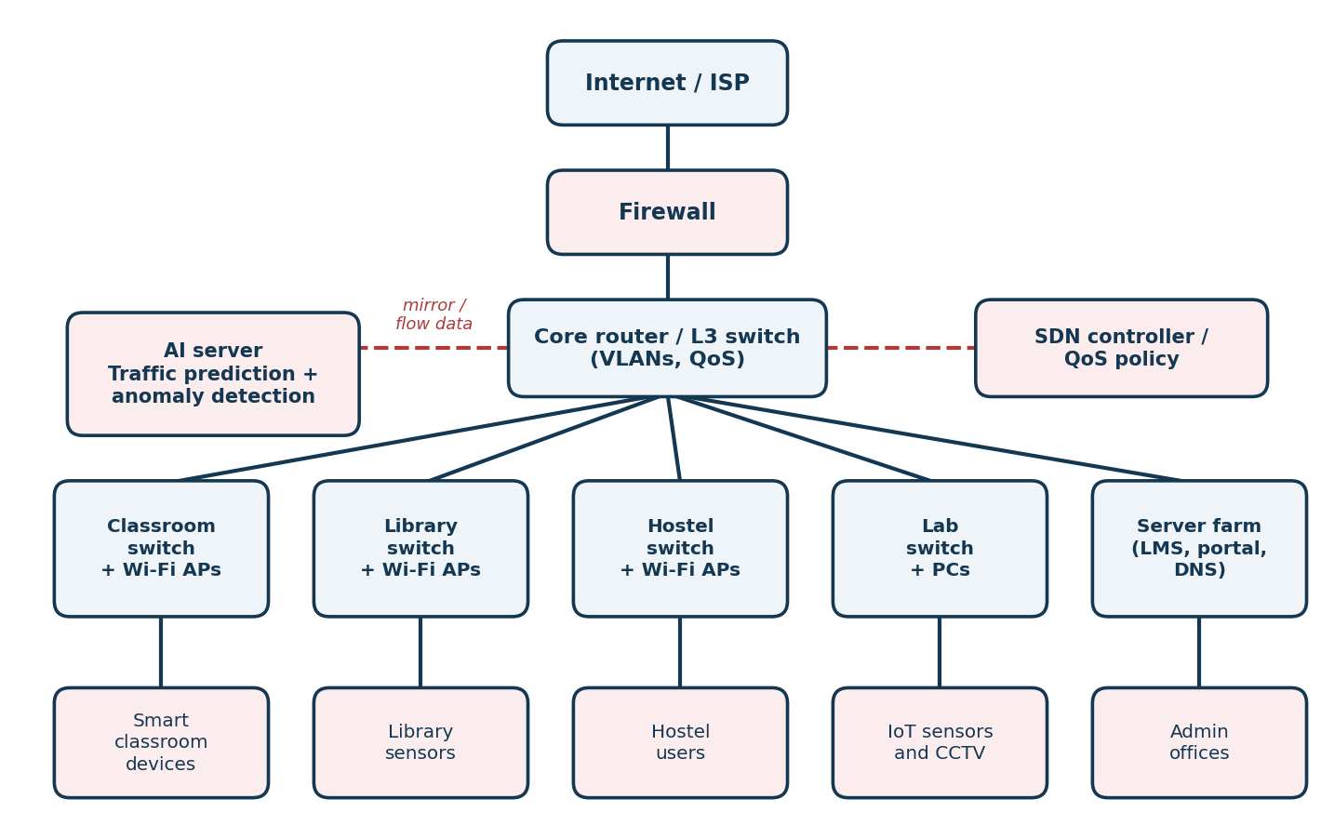
Figure 3.2: Campus network topology with the AI server

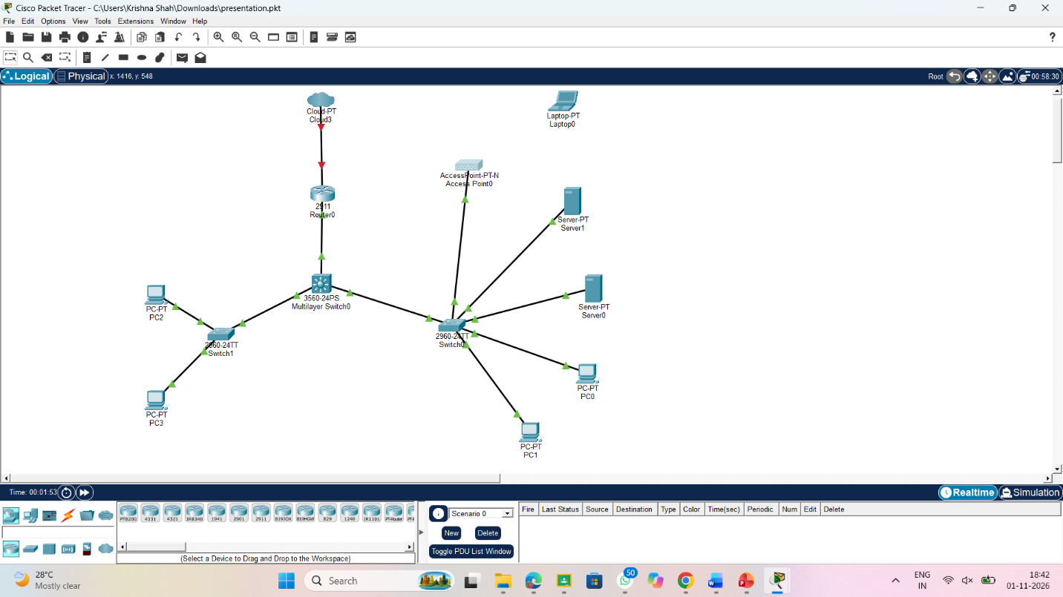

Workflow of the system
Figure 3.3 shows the processing steps. Data is collected, cleaned and converted into features, then split by time so that the test period always comes after the training period. The trained models predict load and flag anomalies, and the results lead to decision suggestions and the dashboard.
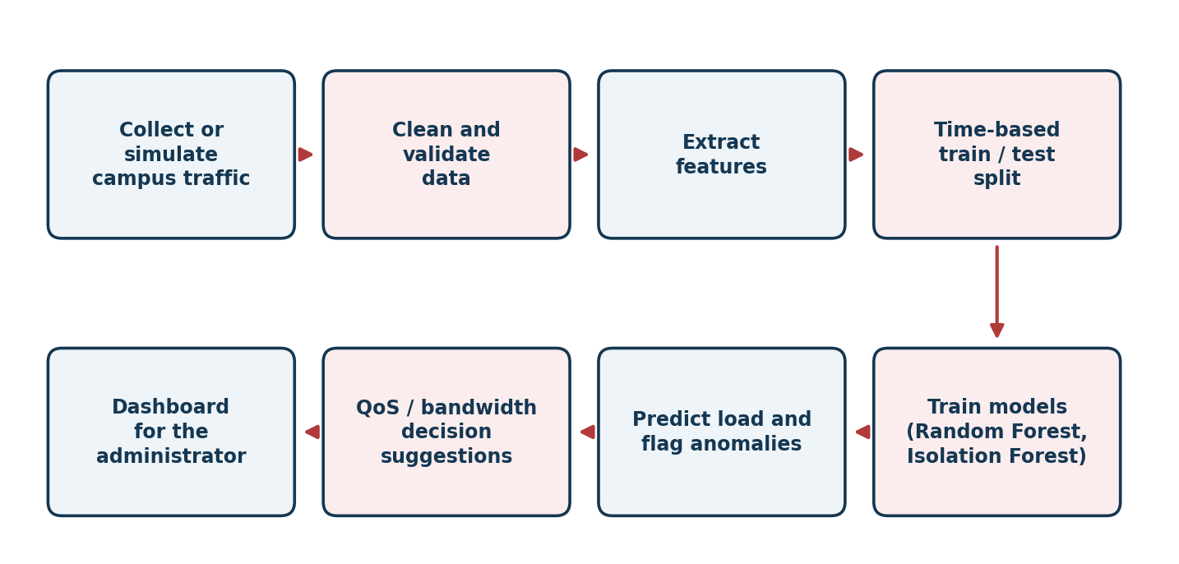
Figure 3.3: Workflow of the AI-driven intelligent network

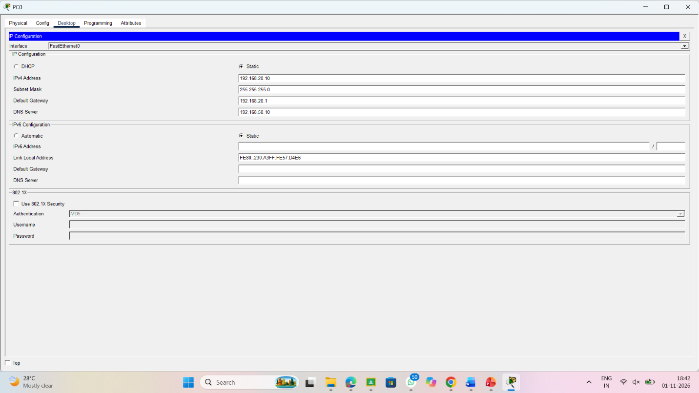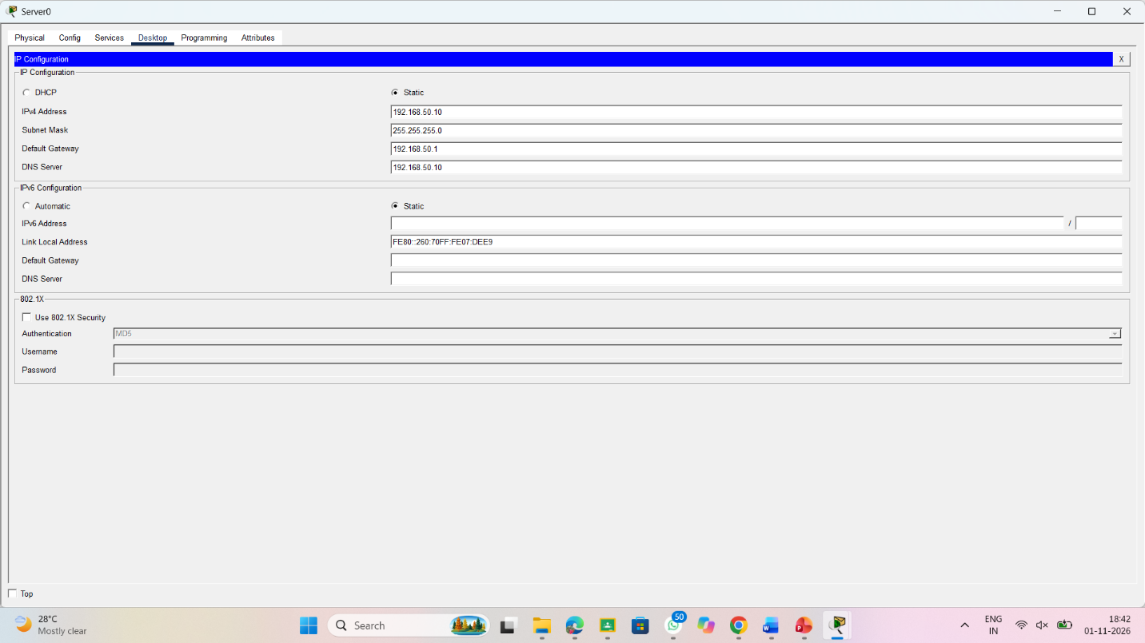

4. Implementation

a) Technologies Used
The prototype is written in Python. Pandas and NumPy handle the data, Scikit-learn [2], [8] provides the models and metrics, and Matplotlib draws the charts. A Streamlit dashboard or a Jupyter Notebook can present the results, while Packet Tracer or ns-3 can be used to build the campus topology and Wireshark [7] to inspect authorised sample traffic.

Dataset and features
The prototype uses a simulated dataset of 60 days of hourly records. The simulation reproduces the usual campus pattern: activity rises in the morning, peaks around 2 pm and is about half as high at weekends. Random noise is added, and 24 abnormal bandwidth spikes (1.8 to 2.6 times the normal value) are inserted so that the anomaly detector can be tested. After the lagged features are created, 1,416 records remain, of which 1,062 are used for training and 354 for testing.
Table 4.1: Features used by the models
Feature | Description | Used for
Hour of day, day of week | Captures daily and weekly usage patterns | Prediction
Active users | Number of devices connected in that hour | Prediction (previous hour), anomaly detection
Bandwidth (Mbps) | Traffic volume in that hour; the value to be predicted | Target, anomaly detection
Bandwidth 1 h and 24 h ago | Recent and same-time-yesterday traffic | Prediction
Anomaly label | 1 for an inserted spike, 0 otherwise | Evaluation only
The data is split by time, with the first 75% of the records used for training and the last 25% for testing. This avoids leakage, where information from the future would unfairly help the model. For real data, user identifiers such as names, MAC addresses and IP addresses should be removed or anonymised first.

Algorithms
Random Forest combines many decision trees and averages their outputs, which makes it stable and well suited to tabular data [3]. It predicts the bandwidth of the next hour.
Isolation Forest isolates unusual points with random splits; points that are isolated quickly are treated as anomalies [4]. It needs no labelled attack data, which suits a campus where examples of attacks are rare.
Baselines. A Linear Regression model and a naive rule that repeats the value from the same hour on the previous day are used for comparison, so that the benefit of the Random Forest can be judged honestly.

Implementation steps and core code
- Simulate or collect campus traffic and check for missing or invalid values.
- Prepare the features and labels, including the lagged values.
- Split the data into training and testing sets by time.
- Train the Random Forest and baseline models, and the Isolation Forest.
- Predict on the test period, flag anomalies, and compute the metrics.
- Show the predictions, alerts and scores, and suggest QoS actions.
The core of the prototype is shown below. It runs as a single script and prints the main metrics.
import numpy as np, pandas as pd
from sklearn.ensemble import RandomForestRegressor, IsolationForest
from sklearn.linear_model import LinearRegression
from sklearn.metrics import mean_absolute_error, precision_score, recall_score

# 1. Simulate 60 days of hourly campus traffic
rng = np.random.default_rng(42)
t = np.arange(24 * 60)
hour, dow = t % 24, (t // 24) % 7
users = 200 + 150 * np.exp(-((hour - 14) ** 2) / 18)
users = users * np.where(dow >= 5, 0.5, 1.0) + rng.normal(0, 15, t.size)
users = np.clip(users, 5, None)
bw = 1.8 * users + rng.normal(0, 20, t.size) # bandwidth in Mbps
anom = np.zeros(t.size, dtype=int)
for i in rng.choice(t.size, 24, replace=False): # abnormal spikes
bw[i] *= rng.uniform(1.8, 2.6)
anom[i] = 1

# 2. Build features (lagged values) and split by time
df = pd.DataFrame({"hour": hour, "dow": dow, "users": users,
"bw": bw, "anom": anom})
df["bw_lag1"] = df.bw.shift(1)
df["bw_lag24"] = df.bw.shift(24)
df["users_lag1"] = df.users.shift(1)
df = df.dropna().reset_index(drop=True)
cut = int(len(df) * 0.75)
train, test = df.iloc[:cut], df.iloc[cut:]
X = ["hour", "dow", "bw_lag1", "bw_lag24", "users_lag1"]

# 3. Traffic prediction: Random Forest vs Linear Regression baseline
rf = RandomForestRegressor(n_estimators=100, random_state=42)
rf.fit(train[X], train.bw)
lr = LinearRegression().fit(train[X], train.bw)
print("RF MAE :", mean_absolute_error(test.bw, rf.predict(test[X])))
print("LR MAE :", mean_absolute_error(test.bw, lr.predict(test[X])))

# 4. Anomaly detection: Isolation Forest on users and bandwidth
iso = IsolationForest(contamination=0.03, random_state=42)
iso.fit(train[["users", "bw"]])
flag = (iso.predict(test[["users", "bw"]]) == -1).astype(int)
print("Precision:", precision_score(test.anom, flag))
print("Recall :", recall_score(test.anom, flag))

b) Screenshots and Outputs
The outputs in this section were produced by the code above on the simulated dataset, so they demonstrate how the system behaves and are not measurements of a real campus network.

Traffic prediction
Table 4.2: Prediction error on the test period (lower error is better)
Model | MAE (Mbps) | RMSE (Mbps) | R-squared
Naive (same hour yesterday) | 101.6 | 155.1 | -0.12
Linear Regression | 48.3 | 80.9 | 0.69
Random Forest | 42.0 | 76.9 | 0.72
The Random Forest gave the lowest error, with a mean absolute error of 42.0 Mbps compared with an average test-period bandwidth of about 394 Mbps. Linear Regression was close behind at 48.3 Mbps, which shows that much of the pattern in simulated data is simple, while the naive rule was much worse at 101.6 Mbps because weekends and spikes break the day-to-day repeat. An R-squared of 0.72 means the model explains most, but not all, of the variation; the inserted spikes and random noise cannot be predicted from past values.
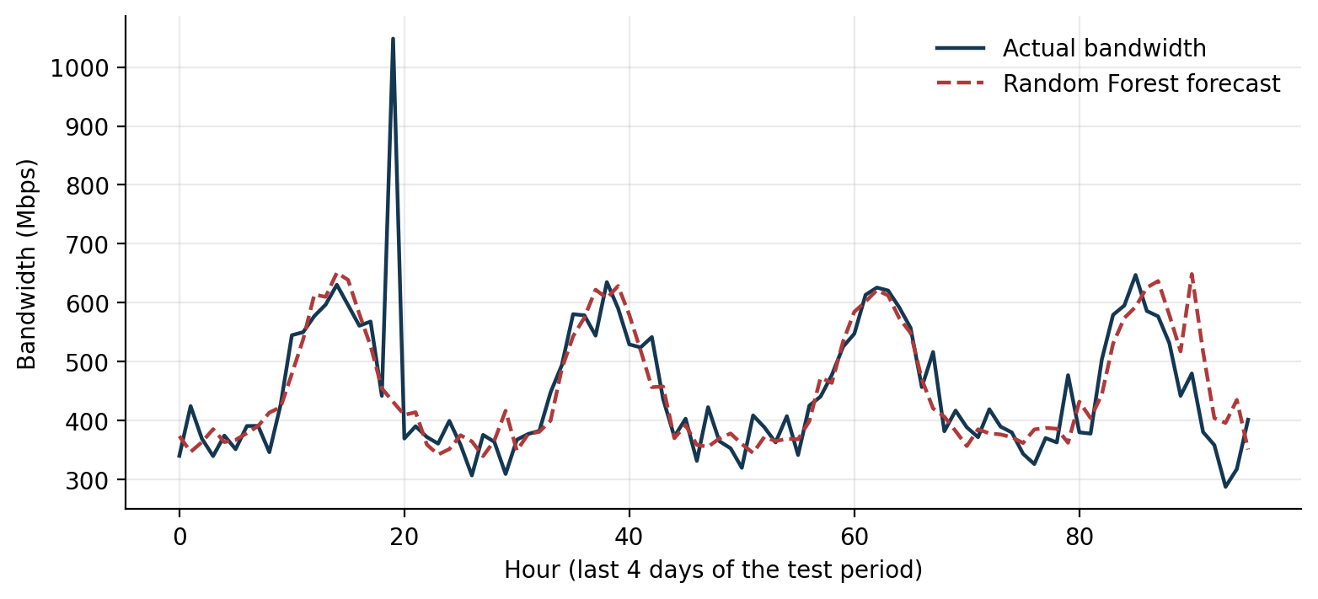
Figure 4.1: Actual bandwidth and Random Forest forecast for four days of the test period
Figure 4.1 shows that the forecast follows the daily rise and fall closely. The one sharp spike is an inserted anomaly, which a forecasting model cannot foresee; it is the anomaly detector’s job to catch it.
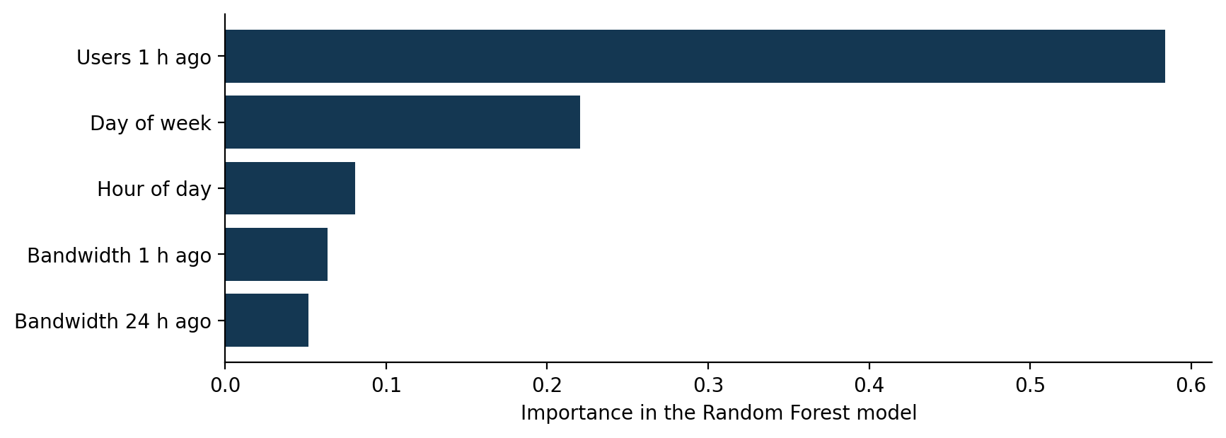
Figure 4.2: Importance of each feature in the Random Forest model
Figure 4.2 shows that the number of users in the previous hour and the day of the week matter most, which matches the weekday and weekend pattern built into the data.

Anomaly detection
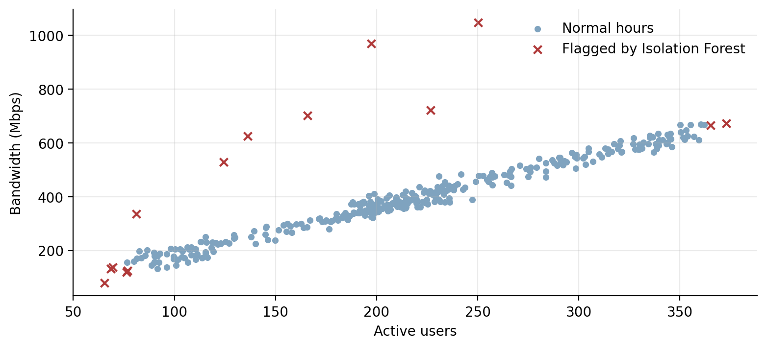
Figure 4.3: Hours flagged by the Isolation Forest (red crosses) in the test period
In Figure 4.3 normal hours lie along a line, because bandwidth grows with the number of users, and the flagged hours stand out well above it. The Isolation Forest flagged 14 hours in the test period, which contained 7 inserted spikes. It found all 7 of them (recall 1.00), but only 50% of its alerts were real spikes (precision 0.50); the other flags were mostly normal hours at the very low or very high end of usage. In practice this means the alerts are useful for an administrator to review, but some false alarms should be expected.

Decision suggestions
The predictions and alerts are converted into suggestions by simple rules. In the prototype the actions are only suggested to the administrator; a real deployment would link them to an SDN controller or switch policy after careful testing.
Table 4.3: Example decision rules
Condition | Suggested action
Predicted load of a segment is high | Give priority to lecture streaming and examination traffic; limit background downloads.
Predicted load is low | Allow normal best-effort use; consider reducing the number of active access points.
Anomaly flagged on a segment | Show the segment and time on the dashboard; the administrator checks the cause.
Repeated anomalies from one segment | Escalate to the administrator for a detailed packet inspection with Wireshark.

5. Conclusion
This project designed and built a prototype of an AI-driven intelligent network for smart campus applications. By learning from traffic patterns, the system forecasts bandwidth demand, flags unusual traffic and supports QoS decisions, while using the main concepts of Computer Networks such as application services, TCP/UDP behaviour, IP addressing and VLANs, Wi-Fi and Ethernet, and network monitoring and security.
On the simulated dataset the Random Forest predicted hourly bandwidth with a mean absolute error of 42.0 Mbps, better than both baselines, and the Isolation Forest detected every inserted spike, at the cost of some false alarms. The main benefits of the approach are early warning of congestion, better use of bandwidth, less manual monitoring and repeatable experiments. It can be applied to smart classrooms, hostels, libraries, laboratories, campus security and administration.
The work also has limits. The results come from simulated data, which is simpler than real traffic, so the numbers should not be expected to carry over unchanged. Predictions can be wrong, anomaly alerts include false alarms, and unusual but legitimate events such as examinations or university events can look abnormal. The system should therefore support network administrators and not replace them, and any real data must be anonymised and used with permission.

6. Future Scope
The prototype can be extended in the following directions:
- Train and test the models on authorised live campus data instead of simulated data.
- Connect the decisions to an SDN controller so that QoS changes are applied automatically after testing.
- Compare more models, including LSTM networks for longer time-series patterns [5].
- Add explainable AI so that administrators can see why a prediction or alert was produced.
- Use Wi-Fi 6 links and edge computing for faster, real-time decisions.
- Extend the system to other smart campus services such as energy use, attendance and safety.

References
[1] J. F. Kurose and K. W. Ross, Computer Networking: A Top-Down Approach, 8th ed. Pearson, 2021.
[2] F. Pedregosa et al., “Scikit-learn: Machine Learning in Python,” Journal of Machine Learning Research, vol. 12, pp. 2825–2830, 2011.
[3] L. Breiman, “Random Forests,” Machine Learning, vol. 45, no. 1, pp. 5–32, 2001.
[4] F. T. Liu, K. M. Ting and Z.-H. Zhou, “Isolation Forest,” in Proc. IEEE International Conference on Data Mining (ICDM), 2008, pp. 413–422.
[5] S. Hochreiter and J. Schmidhuber, “Long Short-Term Memory,” Neural Computation, vol. 9, no. 8, pp. 1735–1780, 1997.
[6] IEEE Standard for Information Technology – Telecommunications and Information Exchange between Systems – Local and Metropolitan Area Networks – Specific Requirements – Part 11: Wireless LAN Medium Access Control (MAC) and Physical Layer (PHY) Specifications, IEEE Std 802.11.
[7] Wireshark User’s Guide, Wireshark Foundation, wireshark.org/docs.
[8] Scikit-learn User Guide: Random Forest, Isolation Forest and model evaluation, scikit-learn.org.

