WEDOLiT® CS 6206

Water Soluble, High Performance Lubricant

WEDOLiT CS 6206 is suitable for grinding of steel, cast iron, aluminium, non-ferrous metals, glass and especially carbides.

cutting grinding water miscible

Physical Properties Typical Data

Concentrate

Colour | Mineral oil content | Viscosity at 20°C: ASTM D 7042 | Density at 20°C: ASTM D 7042 | Copper corrosion: DIN 51759-1
Yellowish, clear | Free | 30.0 mm²/s | 1.13 | Not determined*
5% Solution

Colour | pH-value (tap water) | Corrosion protection DIN 51360-2 | Refractometer factor (brix) | Conductivity (Deionised water)
Clear | 9.1 | 4 % grade 0 | 1.7 | 8090 μS/cm

Mineral oil | EP-additives | Chlorine | Boron | Amines | FAD
- | + | - | - | - | -
*Discolourations of non-ferrous metals should be examined in preliminary tests

Application Guidelines
The preparation of the solution is carried out by slowly adding the concentrate into water (drinking water quality) under thorough stirring. A more homogenous product is achieved by the use of automatic mixing systems.

Storage must be frost-free between 5 - 40°C.
The minimum durability is 12 months in an original sealed package.

Additional Information
The information herein is given in good faith and believed current as of the date of publication and should apply to the current formula version. Because conditions of use are beyond our control, no guarantee, representation or warranty expressed or implied is made. Consult Master Fluid Solutions for further information. For the most recent version of this document, please go to this URL: https://2trim.us/diw/?plr=CS-6206*en*eu

WEDOLiT® CS 6206
©2017-2026 Master Fluid Solutions™ | 2026-05-22

Choose WEDOLiT CS 6206:
Offers high cooling- and flushing properties with a very good wetting behaviour
Contributes to a high tool life Very good application stability Almost free of foam
Offers a good skin compatibility

Recommended mixing ratio
Grinding: from 4% General cutting: from 6%

Health and Safety
For further information, see the most recent SDS which is available directly from Master Fluid Solutions.

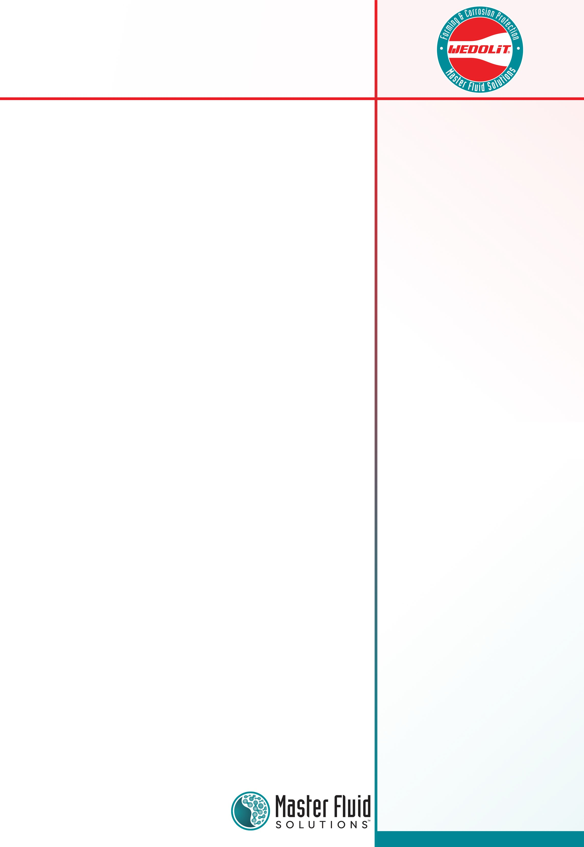



Hasselsstraße 6-14
Düsseldorf, 40597 Germany
+49 211 41 72 82 00

info-eu@masterfluids.com masterfluids.com/eu/en/

