PLC-Based Predictive Maintenance System for Water Pumping Industry Using IoT
Aniruddha Nemade, Khushi Sawalkar, Ruchi Parekar, Vinayak More, Prof. Nestor Philips
Department of Electronics and Telecommunication Engineering
JSPM's Rajarshi Shahu College of Engineering, Tathawade, Pune, India
Email: parekarruchi@gmail.com
Abstract— Water pumps are central to the continuous operation of manufacturing plants and water treatment facilities, and when one fails without warning the disruption is rarely limited to the pump itself. Most facilities still rely on corrective maintenance, repairing a pump only after it fails, or preventive maintenance, servicing it at fixed intervals regardless of its actual condition. Neither approach reliably catches the slow, quiet degradation that often precedes a failure. This paper presents a PLC-based predictive maintenance system that continuously monitors industrial water pumps using current, temperature, vibration, and speed sensors to build a more complete picture of pump health. Sensor readings are collected by an ESP32 module, which compares them against threshold values in real time and uploads the data to a cloud dashboard. The dashboard stores historical data and performs trend analysis to identify gradual degradation and support predictive maintenance decisions. While readings remain within normal limits the system continues monitoring; when a critical condition is detected, the ESP32 sends a command to a Programmable Logic Controller (PLC), which stops the pump and triggers an alert, fault indication, and data logging before the condition can develop into a failure, giving maintenance staff time to respond. During testing, the system detected developing faults early enough to be actionable, which simplified maintenance planning, reduced downtime, and extended pump service life. The design is affordable and straightforward to scale, making it well suited to a wide range of water-pumping applications and illustrating how Industry 4.0 tools can improve everyday factory operations.
Keywords— Predictive Maintenance, PLC, ESP32, IoT, Industrial Automation, Water Pump, Vibration Monitoring, Current Sensor, Temperature Monitoring, Cloud Computing.

I. Introduction
Water pumping systems underpin industrial plants, municipal water supply, farm irrigation, and wastewater treatment. They are expected to operate continuously, since any interruption affects the processes and communities that depend on them. In practice, however, wear, motor faults, and a range of other issues cause pumps to fail, often suddenly and with little warning.
Pumps are conventionally maintained in one of two ways. Corrective maintenance addresses a fault only after it occurs. Preventive maintenance schedules repairs at fixed intervals irrespective of the pump's actual condition. The latter reduces the likelihood of unexpected breakdowns but also results in unnecessary servicing of equipment that may still be functioning normally. This trade-off is driving a shift toward predictive maintenance, an approach that tracks a pump's actual condition and identifies problems while they are still minor.
This shift has been made possible by recent advances in the Internet of Things (IoT), cloud computing, and industrial controllers, which together support the development of intelligent maintenance systems. Once sensors are integrated with controllers and cloud platforms, continuous tracking of parameters such as current draw, vibration, and temperature becomes practical, enabling earlier fault detection and remote diagnosis.
This work addresses that need. Sensors connected to a controller acquire real-time operating data, which is then relayed to a monitoring platform for visualization and analysis. The resulting system is more reliable, less prone to unplanned downtime, less costly to maintain, and better aligned with the predictive maintenance strategies increasingly adopted in the water pumping industry under Industry 4.0.
II. Research Gap and Motivation
A. Research Gap
A number of predictive maintenance systems already exist for industrial equipment, but most rely on a single parameter, such as motor current, vibration, or temperature, as the primary indicator of health. This is a limitation, since equipment failures are rarely caused by one factor in isolation; they typically arise from several operating conditions interacting simultaneously, so a single-parameter view captures only part of the picture. Many existing systems also depend on periodic inspection rather than continuous monitoring, so faults are often identified later than necessary, sometimes only after the equipment has already failed.
A comparable gap exists on the software side. IoT-based monitoring platforms are effective at collecting sensor data but generally provide limited decision-support capability. PLC-based systems present the opposite trade-off: they offer reliable industrial automation but rarely include cloud connectivity, remote diagnostics, or predictive analytics. Without multi-sensor monitoring combined with some form of intelligent analysis, maintenance remains largely reactive and more costly than necessary.
What is missing is a system that integrates industrial-grade PLC control, IoT-based remote monitoring, multi-parameter condition monitoring, and a degree of intelligent fault analysis into a single framework capable of improving equipment reliability and reducing downtime.
B. Motivation
As industries move toward uninterrupted operation, predictive maintenance has become a core component of Industry 4.0 rather than an optional addition. An unexpected pump failure does not merely halt production; it also tends to increase repair costs and energy consumption.
This work is motivated by the need for a predictive maintenance system that is both technically capable and affordable to deploy, while providing continuous, real-time visibility into the pump parameters that matter most. Combining a PLC with an ESP32 IoT gateway and cloud services enables early fault detection, remote monitoring, and maintenance alerts issued while there is still time to act. In practice, this translates into improved equipment reliability, longer service life, lower maintenance costs, and maintenance planning driven by data rather than fixed schedules.
III. Literature Review
TABLE I. LITERATURE SURVEY
Ref. | Existing Work | Limitation | Proposed Improvement
[1] | Lee et al. (2019) — IoT-based motor monitoring | Only current monitoring | Multi-sensor health monitoring
[2] | Wang et al. (2020) — Vibration-based fault detection | Cannot detect electrical faults | Combines vibration and electrical parameters
[3] | Patel et al. (2021) — PLC automation for pump control | No cloud connectivity | PLC with IoT integration
[4] | Sharma et al. (2022) — Temperature monitoring | No predictive analytics | Intelligent fault prediction
[5] | Kumar et al. (2023) — Remote monitoring dashboard | Limited industrial automation | Industrial PLC + IoT architecture

A review of the literature shows that most predictive maintenance systems monitor only one or two machine parameters, which limits the accuracy of the resulting health assessment. Current-based methods are effective at detecting overload conditions but cannot identify mechanical faults such as bearing wear or shaft misalignment. Vibration analysis has the opposite limitation: it captures mechanical degradation well but provides no information about electrical abnormalities.
IoT-based monitoring systems generally provide good remote visibility into machine data but often fall short of industrial-grade reliability and real-time control. PLC-based automation systems sit on the other side of this trade-off, offering strong, dependable machine control but rarely any cloud connectivity or predictive analytics.
These findings indicate that the greatest gains in predictive maintenance performance are likely to come from combining PLCs, IoT communication, cloud monitoring, and multi-sensor condition monitoring within a single architecture. The system proposed in this paper adopts this approach, integrating current, vibration, temperature, and speed monitoring into one architecture capable of real-time fault detection and remote monitoring.
Taken together, this suggests that combining PLCs, IoT communication, cloud monitoring, and multi-sensor condition monitoring is where the real gains in predictive maintenance performance are likely to come from. The system proposed here takes that lesson seriously, bringing current, vibration, temperature, and speed monitoring together into one architecture capable of real-time fault detection and remote monitoring.
IV. Novel Contributions of the Proposed System
The major contributions of the proposed work are as follows:
• Development of a PLC-based predictive maintenance system for industrial water pumps.
• Integration of multiple sensors, including current, vibration, temperature, and speed sensors, for comprehensive equipment health monitoring.
• Real-time protective pump shutdown via PLC command, triggered by ESP32-based fault detection.
• IoT-enabled remote monitoring through an ESP32 gateway and cloud platform.
• Early fault detection and predictive maintenance alerts based on continuously monitored sensor data.
• A scalable and cost-effective architecture suitable for Industry 4.0 industrial applications.
• Reduction in equipment downtime, maintenance costs, and unexpected pump failures through intelligent condition monitoring.
V. Proposed System
The proposed system is designed to continuously monitor the operating condition of industrial water pumps and detect potential failures before they occur. It combines industrial automation and IoT by integrating a Programmable Logic Controller (PLC), a set of condition-monitoring sensors, an ESP32 communication module, and a cloud-based monitoring platform.
The condition-monitoring sensors send their readings to the ESP32 module, which reads the sensor data continuously, compares it against predefined threshold values, and uploads the data to a cloud dashboard. The dashboard stores this data and performs trend analysis to identify gradual degradation and support predictive maintenance. While readings remain within normal limits, the ESP32 continues monitoring. When it detects a critical condition, the ESP32 sends a stop command to the PLC, which shuts down the pump and triggers an alert, a fault indication, and a data-logging event.
Whereas conventional monitoring systems typically rely on a single parameter, this system evaluates motor current, bearing temperature, vibration level, and shaft speed simultaneously. This combination improves fault-detection accuracy and allows maintenance to remain predictive rather than reactive.
The proposed system offers the following functionalities:
• Continuous monitoring of pump operating parameters.
• Real-time PLC-based industrial control.
• IoT-enabled remote monitoring through cloud connectivity.
• Early fault detection using threshold-based condition analysis.
• Alarm generation and maintenance notification.
• Historical data storage for future analysis and maintenance planning.
• Improved equipment reliability with reduced downtime and maintenance costs.
VI. System Architecture
The proposed system is organized into four major layers:
1. Data Acquisition Layer
This layer is responsible for collecting real-time operating data from the pump. A set of sensors is installed on the pump and motor to monitor their condition, covering:
• Current Consumption (Current Transformer Sensor)
• Motor Temperature (MAX6675 with K-Type Thermocouple)
• Motor Vibration (MPU6050 Accelerometer)
• Motor Speed (Speed Sensor)
Together, these sensors provide a continuous stream of machine health data to the ESP32.
2. Control Layer
The PLC acts on commands from the ESP32 to protect the pump. Its responsibilities include:
• Receiving stop commands from the ESP32
• Stopping the water pump motor
• Executing industrial control logic
• Controlling alarms and protection relays
PLCs are designed for this operating environment, offering high reliability, fast response times, and the ability to run continuously.
3. IoT Communication Layer
The ESP32 functions as the system's central intelligence, reading sensor data, analyzing it, and managing the cloud connection. It is responsible for:
• Reading data from the sensors
• Comparing readings against threshold values
• Sending a stop command to the PLC when a critical condition is detected
• Formatting sensor data
• Uploading data to the cloud server
• Enabling remote monitoring through Wi-Fi
• Sending maintenance alerts to operators
This layer allows maintenance engineers to check pump health remotely from any location with an internet connection.
4. Cloud Monitoring Layer
The cloud platform receives data from the ESP32, stores it, and presents it in a usable form, offering:
• Real-time dashboard
• Historical trend analysis
• Equipment health monitoring
• Alarm history
• Maintenance reports
• Remote access through web or mobile devices
Storing this data in the cloud also enables long-term performance analysis, which is essential to a genuinely predictive maintenance strategy.
VII. Working Principle
In operation, the system follows this sequence:
• 1. The industrial water pump is switched ON.
• 2. Current, vibration, temperature, and speed sensors continuously monitor machine health.
• 3. Sensor signals are transmitted to the ESP32, which reads the sensor data.
• 4. The ESP32 compares each parameter against predefined threshold values and uploads the sensor data to the cloud dashboard, which stores it and performs trend analysis.
• 5. If all parameters remain within acceptable limits, the ESP32 continues monitoring.
• 6. If a critical condition is detected, the ESP32 sends a stop command to the PLC.
• 7. The PLC stops the water pump.
• 8. The system generates an alert and fault indication, and logs the event.
• 9. The ESP32 simultaneously uploads sensor readings to the cloud platform.
• 10. Maintenance personnel can remotely monitor equipment status using a web dashboard.
• 11. Historical sensor data are stored for trend analysis and predictive maintenance planning.
VIII. System Component Architecture
To illustrate the system's physical and logical layout, a component diagram was developed, shown in Fig. 1.
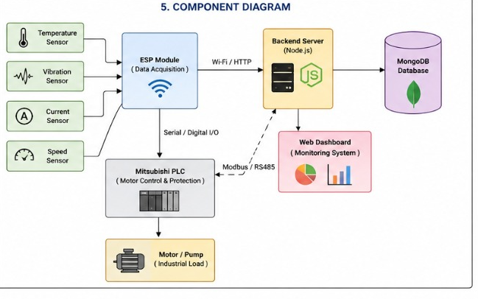
Fig. 1. Component Diagram of the Proposed System
As shown in the diagram, the temperature, vibration, current, and speed sensors feed into the ESP32 module, which reads the sensor data and performs threshold comparison locally. The ESP32 communicates wirelessly (Wi-Fi/HTTP) with a Node.js-based backend server for continuous data logging and dashboard visualization, where historical data is stored and trend analysis is performed to identify gradual degradation. Separately, over serial/digital I/O, the ESP32 sends a stop command to the PLC whenever a critical condition is detected. The PLC then stops the pump and triggers the alarm and fault-indication signals and updates the backend server over Modbus/RS-485. The backend server writes data to a MongoDB database and drives the web-based monitoring dashboard. Together, this provides a clear structural view of the system, from sensor-level data acquisition to the communication between individual hardware components.the way down to how the individual hardware components talk to one another.
IX. Hardware and Software Requirements
A. Hardware Requirements
The system is built from industrial-grade hardware selected to withstand harsh industrial environments. The hardware configuration includes sensors for condition monitoring, an ESP32 module for data acquisition, threshold analysis, and IoT communication, a PLC that executes pump shutdown on command, and a cloud dashboard for historical storage, trend analysis, and remote monitoring.
TABLE II. HARDWARE SPECIFICATIONS
Component | Specification | Purpose
PLC | Mitsubishi FX Series PLC | Pump shutdown execution and protection
ESP32 | Dual-Core Wi-Fi Microcontroller | IoT communication
Current Sensor | Current Transformer (CT) Sensor | Motor current monitoring
Temperature Sensor | MAX6675 with K-Type Thermocouple | Motor temperature monitoring
Vibration Sensor | MPU6050 | Bearing and shaft vibration analysis
Speed Sensor | Hall Effect / IR Speed Sensor | Shaft RPM measurement
Relay Module | 24 V Industrial Relay | Pump protection
Water Pump | Single Phase / Three Phase Motor | Experimental setup
Power Supply | 24 V DC | System power
Wi-Fi Router | IEEE 802.11 b/g/n | Internet connectivity

The software configuration draws on industrial automation software, embedded programming tools, cloud services, and data visualization platforms.
On the software side, the setup draws on industrial automation software, embedded programming tools, cloud services, and data visualization platforms.
TABLE III. SOFTWARE SPECIFICATIONS
Software | Purpose
GX Works3 / GT Designer3 | PLC and HMI Programming
Arduino IDE | ESP32 Programming
Node.js / MongoDB | Backend Server and Cloud Database
MQTT Protocol | IoT Communication
Python | Data Processing (Optional)
Microsoft Excel | Data Analysis
Windows 10/11 | Development Environment

A laboratory-scale water pumping system was built for testing, integrating a PLC, an ESP32, and the full sensor suite. The ESP32 continuously reads the current, temperature, vibration, and speed sensors mounted on the pump motor, compares the readings against programmed threshold values, and transmits the data to the cloud dashboard over Wi-Fi, where it is stored and analyzed for trends.
Testing covered several operating conditions, including normal operation, overload, excessive vibration, and motor overheating, with threshold values programmed into the ESP32 to recognize abnormal readings. Whenever a monitored parameter exceeded its safe limit, the ESP32 sent a stop command to the PLC, which shut down the pump and activated the protective relay to prevent equipment damage, while the ESP32 continued uploading live sensor readings and the resulting alert and fault indication to the cloud dashboard, making the abnormal condition visible for remote monitoring and maintenance planning.
Overall, the system performed reliably, demonstrating continuous monitoring, real-time fault detection, and remote visualization of the pump's health parameters.
Overall, the setup held up well, demonstrating continuous monitoring, real-time fault detection, and remote visualization of the pump's health parameters.
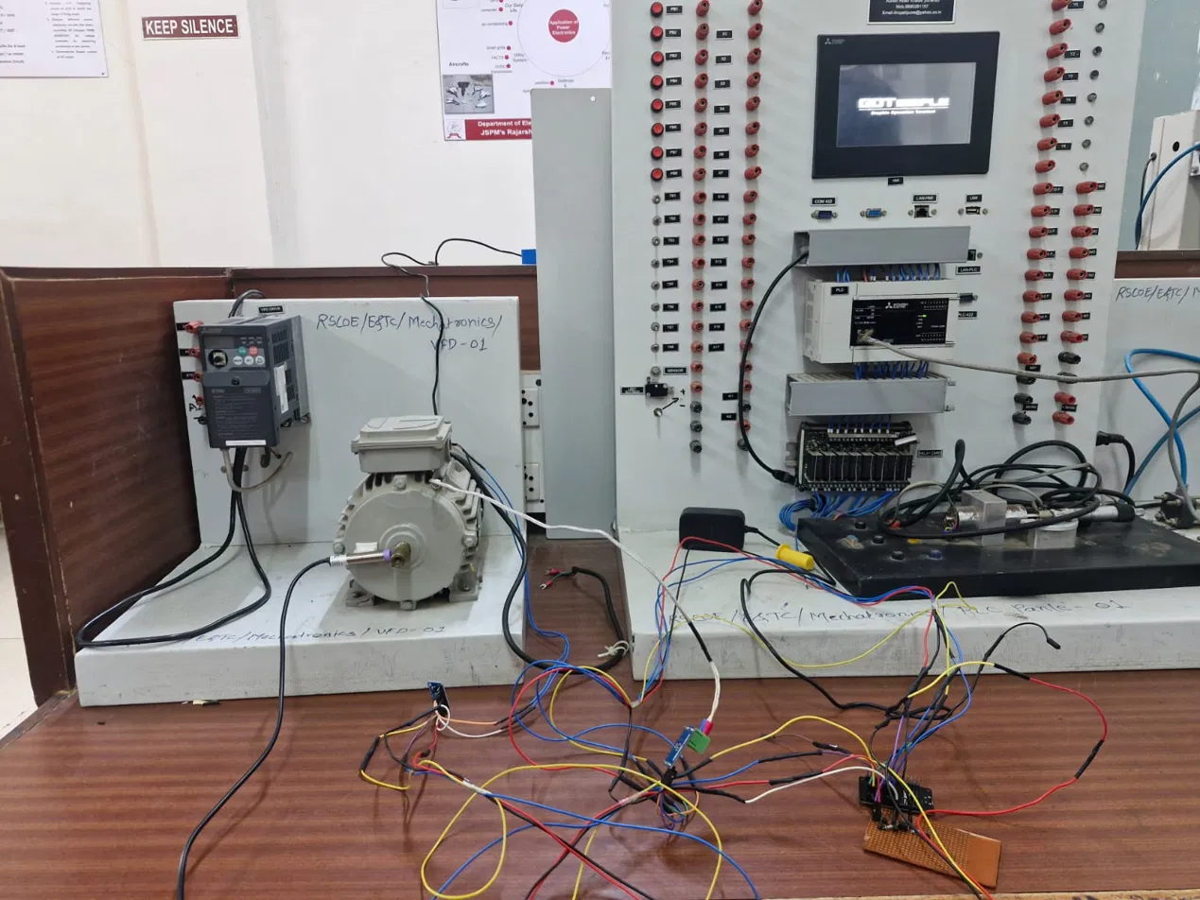
Fig. 2. Laboratory-Scale Experimental Test Setup — PLC Panel, VFD, and Motor Under Test
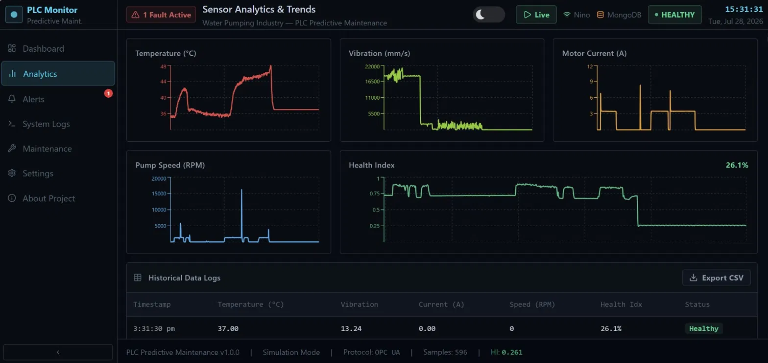
Fig. 3. Sensor Analytics and Trends Dashboard Showing Temperature, Vibration, Current, Speed, and Health Index
The system was evaluated across a range of operating conditions while sensor data was collected continuously, in order to assess its monitoring and fault-detection performance. Throughout testing, the ESP32 consistently identified abnormal conditions by comparing live measurements against the configured threshold values and reliably commanded the PLC to stop the pump when required.
The use of multiple sensors improved fault-detection accuracy compared with a single-parameter approach. Cloud-based monitoring allowed maintenance staff to check equipment status remotely, and the PLC consistently executed the pump shutdown commands issued by the ESP32 to protect the equipment.
Pulling in multiple sensors clearly paid off in fault-detection accuracy compared to a single-parameter system. Meanwhile, cloud-based monitoring meant maintenance staff could check equipment status without being on site, and the PLC reliably executed the pump shutdown commands issued by the ESP32 to protect the equipment.
TABLE IV. PERFORMANCE ANALYSIS UNDER DIFFERENT OPERATING CONDITIONS
Operating Condition | Current | Temp. | Vibration | Speed | Status
Normal Operation | Normal | Normal | Normal | Normal | Healthy
Overload | High | Normal | Normal | Reduced | Warning
Bearing Fault | Normal | Slightly High | High | Normal | Maint. Req.
Motor Overheating | High | High | Normal | Reduced | Critical
Combined Fault | High | High | High | Low | Shutdown

TABLE V. PERFORMANCE SUMMARY
Parameter | Result
Real-Time Monitoring | Yes
PLC Response Time | < 100 ms
Cloud Update Interval | 1–2 s
Fault Detection | Real-Time
Remote Monitoring | Supported
Predictive Maintenance | Enabled

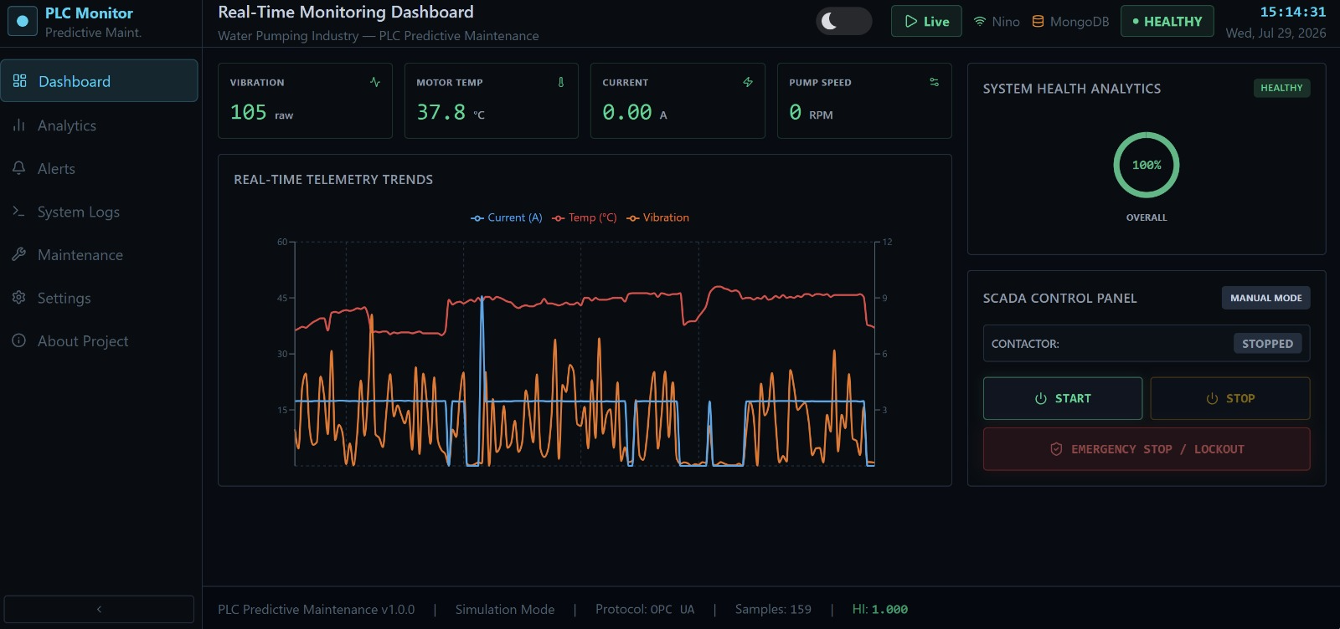
Fig. 4. Real-Time Monitoring and SCADA Control Dashboard During Testing
XII. Advantages of the Proposed System
• Continuous monitoring of critical pump parameters.
• Early detection of mechanical and electrical faults.
• Reduction in unplanned equipment downtime.
• Lower maintenance and operational costs.
• Remote monitoring through IoT technology.
• Improved equipment reliability and service life.
• Industrial-grade PLC-based control for high reliability.
• Scalable architecture suitable for Industry 4.0 applications.
XIII. Applications
• Water Treatment Plants
• Municipal Water Distribution Systems
• Industrial Pumping Stations
• Chemical Processing Industries
• Oil and Gas Industries
• Agricultural Irrigation Systems
• Power Plants
• Manufacturing Industries
• Smart Factories
• Industrial Automation Systems
This paper presented a PLC-based predictive maintenance system for the water pumping industry that combines industrial automation, multi-parameter condition monitoring, and cloud-based remote monitoring within a single framework. Dedicated sensors connected to an ESP32 module continuously monitor motor current, temperature, vibration, and rotational speed. The ESP32 compares these readings against threshold values and streams the data to a cloud dashboard, which stores it and performs trend analysis. When the ESP32 detects a critical condition, it sends a stop command to a PLC, which shuts down the pump and raises an alert, allowing maintenance personnel to review equipment status and long-term trends remotely.
Testing confirmed that the system reliably detected abnormal operating conditions before they developed into failures, reducing downtime and maintenance costs while improving overall pump reliability. Its modular architecture, industrial-grade control, and IoT connectivity make it well suited to modern Industry 4.0 environments and smart manufacturing systems more broadly.
Testing backed this up: the system reliably caught abnormal operating conditions before they turned into failures, which is exactly what brings down downtime and maintenance costs while making the pump more reliable overall. Between the modular architecture, industrial-grade control, and IoT connectivity, the design is a natural fit for modern Industry 4.0 environments and smart manufacturing systems more broadly.
The system can be extended in several directions, including:
There is also plenty of room to build on this system further, particularly by incorporating:
• Machine Learning models for fault prediction.
• Artificial Intelligence-based Remaining Useful Life (RUL) estimation.
• Digital Twin technology for real-time equipment simulation.
• Edge AI implementation for local predictive analytics.
• MQTT and OPC UA protocols for industrial communication.
• SCADA integration for centralized monitoring and control.
• Mobile application with instant fault notifications.
• Cloud-based analytics dashboards for multiple pumping stations.
• Energy consumption optimization using AI algorithms.
• Integration with Computerized Maintenance Management Systems (CMMS).
References
[1] Lee, J. et al., "IoT-based motor monitoring for industrial equipment," 2019.
[2] Wang, Y. et al., "Vibration-based fault detection in rotating machinery," 2020.
[3] Patel, R. et al., "PLC automation for pump control systems," 2021.
[4] Sharma, A. et al., "Temperature-based condition monitoring of industrial motors," 2022.
[5] Kumar, S. et al., "Remote monitoring dashboard for industrial equipment," 2023.

