PLC-Based Predictive Maintenance System for Water Pumping Industry Using IoT
Aniruddha Nemade, Khushi Sawalkar, Ruchi Parekar, Vinayak More, Nestor Philips
Department of Electronics and Telecommunication Engineering
JSPM's Rajarshi Shahu College of Engineering, Tathawade, Pune, India
Email: parekarruchi@gmail.com
Abstract: Water pumps play an essential role in the basic operation of a manufacturing plant, even if we rarely realise this until it fails, and occasionally without warning; their immediate impact is non-existent. Most places use corrective maintenance, fixing a pump only after it breaks, or preventative maintenance by servicing it at set times for no reason. Neither method reliably catches the slow, gradual degradation that so often precedes a failure. In this paper, we introduce PLC-based predictive maintenance for monitoring the health status of industrial water pumps, using current, temperature, vibration, and speed sensors to obtain a fuller picture of pump health. An ESP32 module collects readings from sensors, compares them with threshold values in real time, and sends them to a cloud dashboard. Metrics stored in the dashboard maintain historical data and help detect trends indicating slow degradation, assisting with predictive maintenance decisions. The system continues to monitor whilst readings are still within limits, but when a critical condition is detected the ESP32 sends a command to a Programmable Logic Controller (PLC) which stops the pump and records an alert, fault indication and data logging ahead of the dangerous condition manifesting itself as failure, providing time for maintenance staff to respond. The system identified developing faults knowledgably before it was unavoidable in time, leading to an improvement in maintenance planning, reduced downtime and extended pump service life. The design is low-cost and easy to scale, making it ideal for several water-pumping tasks- and shows how Industry 4.0 tools can assist with simple factory operations.
Keywords— Predictive Maintenance, PLC, ESP32, IoT, Industrial Automation, Water Pump, Vibration Monitoring, Current Sensor, Temperature Monitoring, Cloud Computing.

I. Introduction
Water pumping systems form the backbone of many essential operations. Industrial plants, municipal water supply networks, farm irrigation and wastewater treatment facilities all depend on them. These systems are expected to run continuously because any interruption disrupts the processes and communities that rely on them. In practice pumps do not always behave as expected. Wear on mechanical parts, motor faults and a range of other issues push a pump toward failure gradually or suddenly. Warning signs are often minimal and there is little time to react once a fault begins.
Pumps have traditionally been kept running in one of two ways. Corrective maintenance addresses a fault only after it happens. The pump runs until something breaks and repairs follow in response. Preventive maintenance takes a more proactive stance and schedules repairs at fixed time intervals regardless of the pump's actual condition. This lowers the chance of sudden breakdowns but brings its own drawback. Equipment that is still working normally often gets serviced anyway simply because the schedule calls for it. The result is wasted resources and downtime that could have been avoided. This trade-off has pushed the industry toward predictive maintenance instead. Predictive maintenance tracks a pump's actual condition over time and catches developing problems before they turn into major failures.
This shift has become possible largely because of recent progress in the Internet of Things (IoT), cloud computing and industrial controllers. Together these technologies support intelligent maintenance systems that can watch over equipment around the clock. Once sensors are connected with controllers and cloud platforms continuous tracking of key parameters such as current draw, vibration and temperature becomes practical and affordable. This makes earlier fault detection possible and allows remote diagnosis so engineers no longer need to be at the site in person.
This work addresses that need directly. Sensors connected to a controller collect real-time operating data as the pump runs. This data is then sent to a monitoring platform where it can be viewed and analyzed giving operators a clear picture of the pump's condition at any moment. The resulting system is more reliable, less prone to unplanned downtime, cheaper to maintain and better aligned with the predictive maintenance strategies now spreading across the water pumping industry under Industry 4.0.
II. Research Gap and Motivation
A. Research Gap
Some predictive maintenance systems already exist for industrial equipment but most rely on a single parameter such as motor current, vibration or temperature as the primary indicator of health. This is a limitation. Equipment failures are rarely caused by one factor in isolation. They typically arise from several operating conditions interacting at the same time so a single-parameter view only captures part of the picture. Many existing systems also depend on periodic inspection rather than continuous monitoring so faults are often caught later than necessary sometimes only after the equipment has already failed.
A similar gap exists on the software side. IoT-based monitoring platforms are good at collecting sensor data but generally offer limited decision-support capability. PLC-based systems present the opposite trade-off. They offer reliable industrial automation but rarely include cloud connectivity, remote diagnostics or predictive analytics. Without multi-sensor monitoring combined with some form of intelligent analysis maintenance stays largely reactive and ends up costing more than it should.
What is missing is a system that brings together industrial-grade PLC control, IoT-based remote monitoring, multi-parameter condition monitoring and a degree of intelligent fault analysis into a single framework capable of improving equipment reliability and reducing downtime.
B. Motivation
As industries move toward uninterrupted operation predictive maintenance has become a core part of Industry 4.0 rather than an optional addition. An unexpected pump failure does not just halt production. It also tends to drive up repair costs and energy use.
This work is motivated by the need for a predictive maintenance system that is technically capable and affordable to deploy while giving continuous real-time visibility into the pump parameters that matter most. Combining a PLC with an ESP32 IoT gateway and cloud services enables early fault detection, remote monitoring and maintenance alerts issued while there is still time to act. In practice this means better equipment reliability, longer service life, lower maintenance costs and maintenance planning driven by data rather than fixed schedules.
III. Literature Review
TABLE I. LITERATURE SURVEY
Ref. | Existing Work | Limitation | Proposed Improvement
[1] | Lee et al. (2019) — IoT-based motor monitoring | Only current monitoring | Multi-sensor health monitoring
[2] | Wang et al. (2020) — Vibration-based fault detection | Cannot detect electrical faults | Combines vibration and electrical parameters
[3] | Patel et al. (2021) — PLC automation for pump control | No cloud connectivity | PLC with IoT integration
[4] | Sharma et al. (2022) — Temperature monitoring | No predictive analytics | Intelligent fault prediction
[5] | Kumar et al. (2023) — Remote monitoring dashboard | Limited industrial automation | Industrial PLC + IoT architecture

A review of the literature shows most predictive maintenance systems monitor only one or two machine parameters. This limits how accurate the overall health assessment can be. Current-based methods detect overload conditions well but cannot pick up mechanical faults such as bearing wear or shaft misalignment. Vibration analysis suits mechanical fault detection instead but gives no information about electrical problems.
IoT-based monitoring systems offer remote access to machine data and make continuous monitoring easier. They often lack the reliability and real-time control industrial applications need though. PLC-based automation systems provide dependable machine control and real-time operation but usually come with limited cloud connectivity and few predictive maintenance features.
These observations point to one conclusion. Better predictive maintenance comes from combining PLCs, IoT communication, cloud monitoring and multi-sensor condition monitoring within a single system. The approach proposed in this paper follows that idea and brings current, vibration, temperature and speed monitoring together into one architecture. This allows real-time fault detection while also supporting remote monitoring.

IV. Novel Contributions of the Proposed System
The main contributions of this work are summarized below:
- Development of a PLC-based predictive maintenance system for industrial water pumps.
- Integration of current, vibration, temperature and speed sensors to monitor the overall health of the equipment.
- Real-time pump protection through PLC-controlled shutdown triggered by fault detection using the ESP32.
- IoT-based remote monitoring using an ESP32 gateway and a cloud platform.
- Early fault detection and predictive maintenance alerts based on continuously monitored sensor data.
- A scalable and cost-effective system built for Industry 4.0 industrial applications.
- Reduced equipment downtime, maintenance costs and unexpected pump failures through continuous condition monitoring.

V. Proposed System
The proposed system continuously monitors the operating condition of industrial water pumps and catches possible faults before they lead to failure. It combines industrial automation with IoT using a Programmable Logic Controller (PLC), condition-monitoring sensors, an ESP32 communication module and a cloud-based monitoring platform.
The sensors send their readings to the ESP32 module. The ESP32 continuously reads the sensor data and compares the values against predefined thresholds. It also uploads the readings to a cloud dashboard. The dashboard stores the collected data and analyzes trends over time to spot gradual changes in pump condition and support predictive maintenance. As long as the readings stay within normal limits monitoring continues without interruption. If a critical condition is detected the ESP32 sends a stop command to the PLC. The PLC then shuts down the pump while the system generates an alert, records the fault and logs the related data.
Unlike conventional monitoring systems that usually depend on a single parameter the proposed system monitors motor current, bearing temperature, vibration level and shaft speed at the same time. Using these parameters together gives a more complete picture of the pump's condition and helps catch faults at an early stage. This lets maintenance decisions be based on the pump's actual condition rather than waiting for a failure to happen.
The proposed system provides the following functions:
- Continuous monitoring of the operating parameters of the water pump.
- Real-time industrial control using a PLC.
- Remote monitoring through IoT-based cloud connectivity.
- Early fault detection using threshold-based condition monitoring.
- Automatic alarm generation and maintenance notifications when faults are detected.
- Storage of historical operating data for trend analysis and maintenance planning.
- Improved equipment reliability with lower downtime and reduced maintenance costs.
VI. System Architecture
The proposed system is divided into four main layers.
1. Data Acquisition Layer
The data acquisition layer collects real-time operating data from the water pump. A set of sensors is installed on the pump and motor to continuously monitor their operating condition. The monitored parameters include:
- Current consumption (Current Transformer Sensor)
- Motor temperature (MAX6675 with K-Type Thermocouple)
- Motor vibration (MPU6050 Accelerometer)
- Motor speed (Speed Sensor)
These sensors continuously send machine condition data to the ESP32, giving the system the information it needs for monitoring and fault detection.
2. Control Layer
The PLC receives commands from the ESP32 to protect the water pump during operation. Its main responsibilities include:
- Receiving stop commands from the ESP32.
- Stopping the water pump motor when a fault is detected.
- Executing the required industrial control logic.
- Operating alarms and protection relays.
PLCs are built for industrial applications and offer reliable operation, quick response and steady performance under demanding operating conditions.
3. IoT Communication Layer
The ESP32 acts as the central processing unit of the proposed system. It reads sensor data, analyzes the operating conditions and manages communication with the cloud platform. Its main functions include:
- Reading data from the sensors.
- Comparing sensor readings with predefined threshold values.
- Sending a stop command to the PLC when a critical condition is detected.
- Formatting sensor data for transmission.
- Uploading data to the cloud server.
- Providing remote monitoring through Wi-Fi.
- Sending maintenance alerts to operators.
This layer lets maintenance engineers monitor the condition of the water pump remotely from any location with an internet connection.
4. Cloud Monitoring Layer
The cloud platform receives data from the ESP32, stores it and displays it in a user-friendly format. It provides the following features:
- Real-time dashboard for monitoring system performance.
- Historical trend analysis of sensor data.
- Equipment health monitoring.
- Alarm history for recorded fault events.
- Maintenance reports.
- Remote access through web and mobile devices.
The cloud platform also stores historical operating data, making it possible to study long-term performance trends. This information supports predictive maintenance by helping spot changes in equipment condition over time.
VII. Working Principle
During operation, the system follows the sequence below:
- The industrial water pump is switched ON.
- The current, vibration, temperature, and speed sensors continuously monitor the operating condition of the pump.
- Sensor data are transmitted to the ESP32 for processing.
- The ESP32 compares each parameter with predefined threshold values and uploads the sensor data to the cloud dashboard for storage and trend analysis.
- If all parameters remain within the acceptable limits, the ESP32 continues monitoring the system.
- If a critical condition is detected, the ESP32 sends a stop command to the PLC.
- The PLC stops the water pump.
- The system generates an alert, records the fault, and logs the event.
- At the same time, the ESP32 uploads the sensor readings to the cloud platform.
- Maintenance personnel can remotely monitor the equipment status through a web dashboard.
- Historical sensor data are stored for trend analysis and predictive maintenance planning.
VIII. System Component Architecture
To illustrate the system's physical and logical layout, a component diagram was developed, shown in Figure 1.
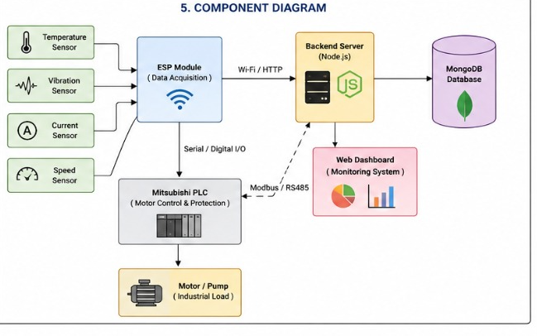
Fig. 1. Component Diagram of the Proposed System
As shown in the diagram the temperature, vibration, current and speed sensors feed into the ESP32 module which reads the sensor data and performs threshold comparison locally. The ESP32 communicates wirelessly (Wi-Fi/HTTP) with a Node.js-based backend server for continuous data logging and dashboard visualization where historical data is stored and trend analysis is performed to spot gradual degradation. Separately over serial/digital I/O the ESP32 sends a stop command to the PLC whenever a critical condition is detected. The PLC then stops the pump, triggers the alarm and fault-indication signals and updates the backend server over Modbus/RS-485. The backend server writes data to a MongoDB database and drives the web-based monitoring dashboard. Together this gives a clear structural view of the system, from sensor-level data acquisition down to how the individual hardware components talk to one another.
IX. Hardware and Software Requirements
A. Hardware Requirements
The system is built from industrial-grade hardware chosen to withstand harsh industrial environments. The hardware configuration includes sensors for condition monitoring, an ESP32 module for data acquisition, threshold analysis and IoT communication, a PLC that carries out pump shutdown on command and a cloud dashboard for historical storage, trend analysis and remote monitoring.
TABLE II. HARDWARE SPECIFICATIONS
Component | Specification | Purpose
PLC | Mitsubishi FX Series PLC | Pump shutdown execution and protection
ESP32 | Dual-Core Wi-Fi Microcontroller | IoT communication
Current Sensor | Current Transformer (CT) Sensor | Motor current monitoring
Temperature Sensor | MAX6675 with K-Type Thermocouple | Motor temperature monitoring
Vibration Sensor | MPU6050 | Bearing and shaft vibration analysis
Speed Sensor | Hall Effect / IR Speed Sensor | Shaft RPM measurement
Relay Module | 24 V Industrial Relay | Pump protection
Water Pump | Single Phase / Three Phase Motor | Experimental setup
Power Supply | 24 V DC | System power
Wi-Fi Router | IEEE 802.11 b/g/n | Internet connectivity

The software configuration draws on industrial automation software, embedded programming tools, cloud services and data visualization platforms.
TABLE III. SOFTWARE SPECIFICATIONS
Software | Purpose
GX Works3 / GT Designer3 | PLC and HMI Programming
Arduino IDE | ESP32 Programming
Node.js / MongoDB | Backend Server and Cloud Database
MQTT Protocol | IoT Communication
Python | Data Processing (Optional)
Microsoft Excel | Data Analysis
Windows 10/11 | Development Environment

A laboratory-scale water pumping system was built for testing. It integrates a PLC, an ESP32 and the full sensor suite. The ESP32 continuously reads the current, temperature, vibration and speed sensors mounted on the pump motor, compares the readings against programmed threshold values and sends the data to the cloud dashboard over Wi-Fi, where it is stored and analyzed for trends.
Testing covered several operating conditions including normal operation, overload, excessive vibration and motor overheating, while sensor data was collected continuously to assess the system's monitoring and fault-detection performance. Threshold values were programmed into the ESP32 to recognize abnormal readings. Whenever a monitored parameter went past its safe limit the ESP32 sent a stop command to the PLC, which shut down the pump and activated the protective relay to prevent equipment damage. The ESP32 kept uploading live sensor readings along with the resulting alert and fault indication to the cloud dashboard, making the abnormal condition visible for remote monitoring and maintenance planning. Throughout testing the ESP32 consistently identified abnormal conditions by comparing live measurements against the configured threshold values and reliably commanded the PLC to stop the pump when required.
Overall the setup held up well, showing continuous monitoring, real-time fault detection and remote visualization of the pump's health parameters. Pulling in multiple sensors clearly paid off in fault-detection accuracy compared to a single-parameter system. Cloud-based monitoring meant maintenance staff could check equipment status without being on site, and the PLC reliably executed the pump shutdown commands issued by the ESP32 to protect the equipment.
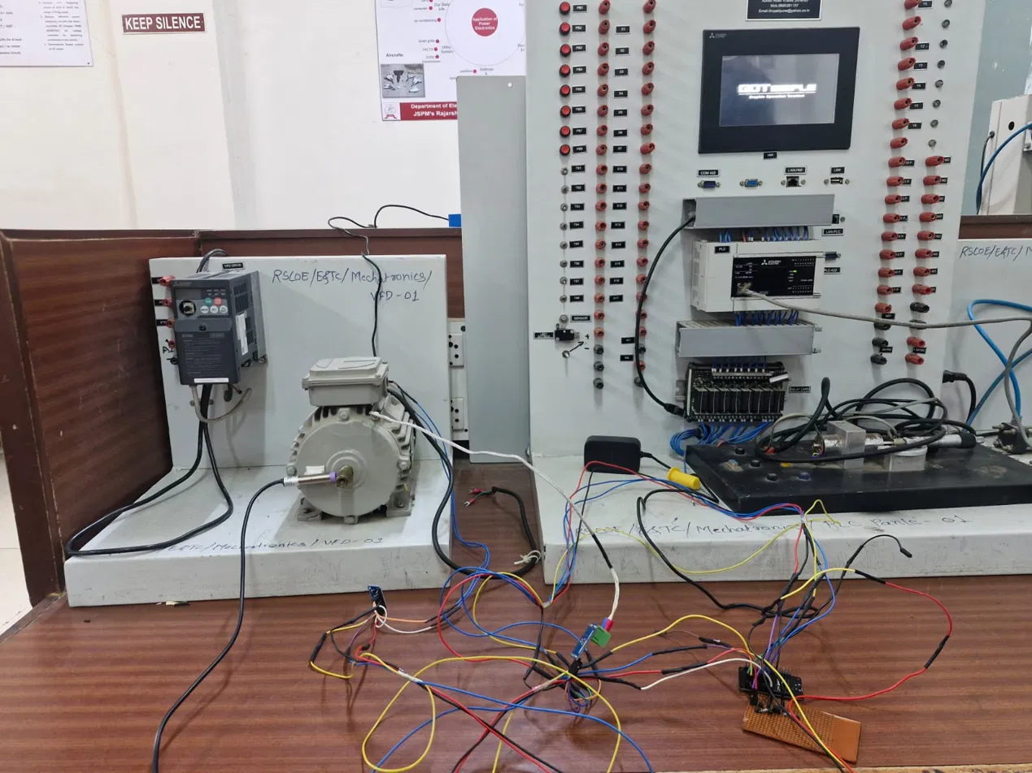
Fig. 2. Laboratory-Scale Experimental Test Setup — PLC Panel, VFD and Motor Under Test
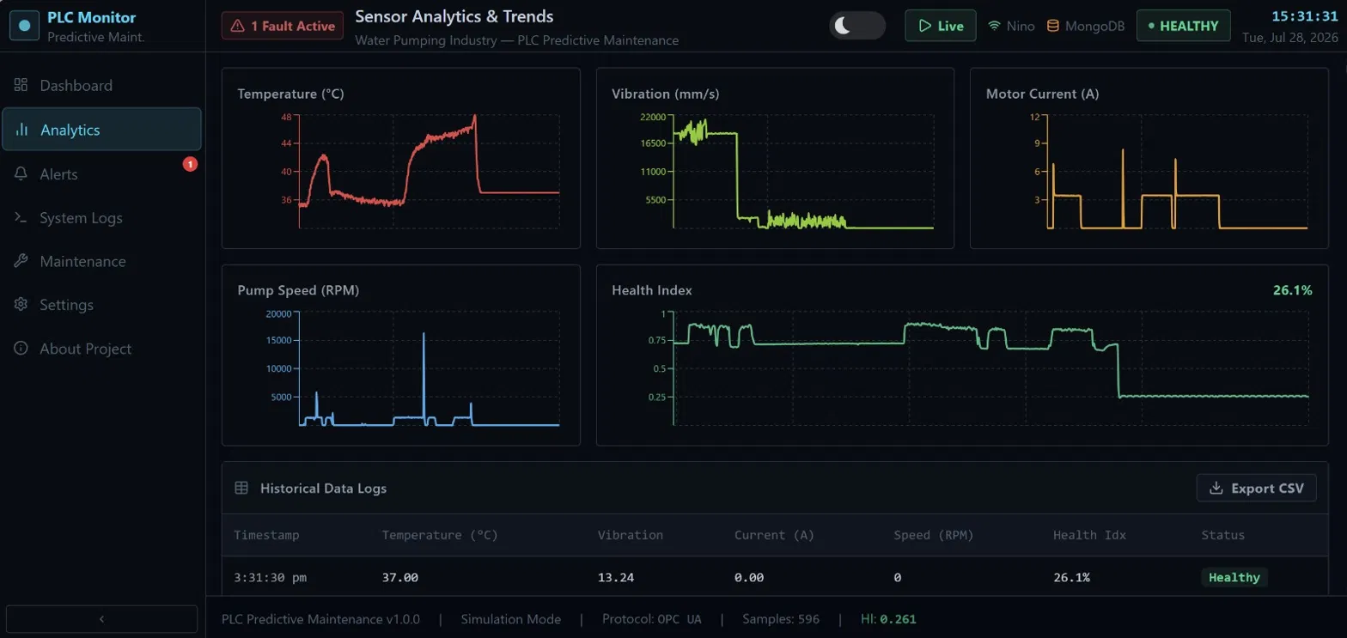
Fig. 3. Sensor Analytics and Trends Dashboard Showing Temperature, Vibration, Current, Speed and Health Index

TABLE IV. PERFORMANCE ANALYSIS UNDER DIFFERENT OPERATING CONDITIONS
Operating Condition | Current | Temp. | Vibration | Speed | Status
Normal Operation | Normal | Normal | Normal | Normal | Healthy
Overload | High | Normal | Normal | Reduced | Warning
Bearing Fault | Normal | Slightly High | High | Normal | Maint. Req.
Motor Overheating | High | High | Normal | Reduced | Critical
Combined Fault | High | High | High | Low | Shutdown

TABLE V. PERFORMANCE SUMMARY
Parameter | Result
Real-Time Monitoring | Yes
PLC Response Time | < 100 ms
Cloud Update Interval | 1–2 s
Fault Detection | Real-Time
Remote Monitoring | Supported
Predictive Maintenance | Enabled

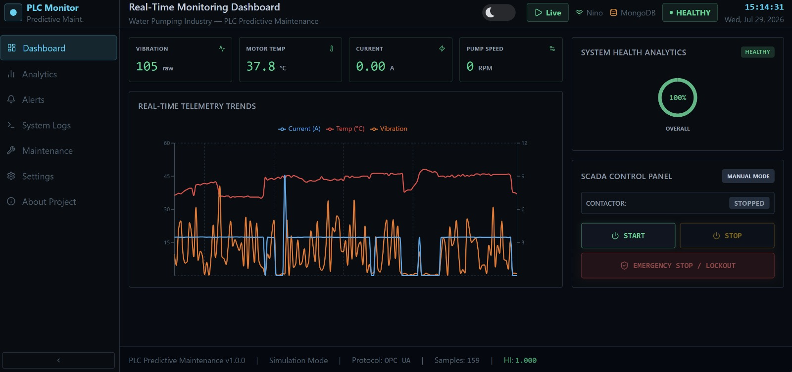
Fig. 4. Real-Time Monitoring and SCADA Control Dashboard During Testing
XII. Advantages of the Proposed System
• Ongoing tracking of key pump parameters.
• Early detection of mechanical and electrical faults.
• Fewer unplanned equipment shutdowns.
• Lower maintenance and running costs.
• Remote monitoring made possible through IOT.
• Better equipment reliability and longer service life.
• Industrial-grade PLC-based control for dependable operation.
• A scalable design suited to Industry 4.0 applications.
XIII. Applications
• Water Treatment Plants
• Municipal Water Distribution Systems
• Industrial Pumping Stations
• Chemical Processing Industries
• Oil and Gas Industries
• Agricultural Irrigation Systems
• Power Plants
• Manufacturing Industries
• Smart Factories
• Industrial Automation Systems
This paper presented a PLC-based predictive
maintenance system for the water pumping industry
that combines industrial automation, multi-parameter
condition monitoring and cloud-based remote monitoring
within a single framework. Dedicated sensors connected
to an ESP32 module continuously monitor motor current,
temperature, vibration and rotational speed. The ESP32
compares these readings against threshold values and
streams the data to a cloud dashboard, which stores it and
performs trend analysis. When the ESP32 detects a critical
condition it sends a stop command to a PLC, which shuts
down the pump and raises an alert, letting maintenance
personnel review equipment status and long-term trends
remotely. Testing backed this up. The system reliably
caught abnormal operating conditions before they turned
into failures, which is exactly what brings down downtime
and maintenance costs while making the pump more
reliable overall. Between the modular architecture,
industrial-grade control and IoT connectivity, the design is
a natural fit for modern Industry 4.0 environments and
smart manufacturing systems more broadly.
The system can be extended in several directions, including:
There is also room to extend this system further, especially by bringing in:
• Machine Learning models for predicting faults.
• AI-based estimation of Remaining Useful Life (RUL).
• Digital Twin technology for simulating equipment behavior in real time.
• Edge AI for running predictive analytics locally.
• MQTT and OPC UA protocols for industrial-grade communication.
• SCADA integration for centralized monitoring and control.
• A mobile app for instant fault alerts.
• Cloud-based analytics dashboards covering multiple pumping stations.
• AI-driven optimization of energy consumption.
• Integration with Computerized Maintenance Management Systems (CMMS).
References
[1] Lee, J. et al., "IoT-based motor monitoring for industrial equipment," 2019.
[2] Wang, Y. et al., "Vibration-based fault detection in rotating machinery," 2020.
[3] Patel, R. et al., "PLC automation for pump control systems," 2021.
[4] Sharma, A. et al., "Temperature-based condition monitoring of industrial motors," 2022.
[5] Kumar, S. et al., "Remote monitoring dashboard for industrial equipment," 2023.

