**Task Master – UI Overview**

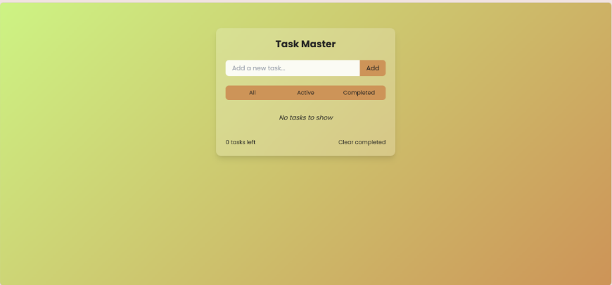This image displays the **Task Master** UI, a task management application designed for efficient task organization. The layout maintains a clean and modern aesthetic, complemented by a gradient background transitioning from green to orange.

**Interface Components:**

* **Title:** "Task Master" prominently displayed at the top.
* 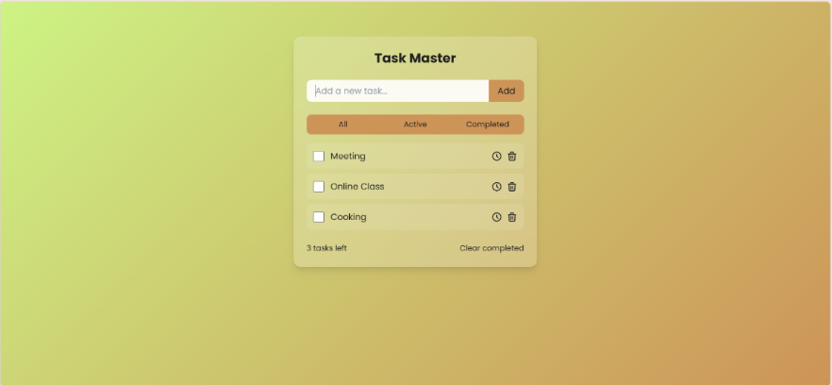**Task Input Field:** A text box labelled *"Add a new task..."* accompanied by an **"Add"** button.
* **Task Filters:** Three filter buttons -**"All," "Active," and "Completed"** - allow users to sort and view tasks based on their progress.
* **Task List:** Displays tasks with key interactive elements:
  + **Checkboxes:** Used to mark tasks as completed.
  + **Clock Icons:** Indicating scheduling functionality for task alarms.
  + **Trash Icons:** Allow users to remove tasks quickly.
* **Displayed Tasks:**
  + **"Meeting"** (marked as completed).
  + **"Online Class"** (currently active).
  + **"Cooking"** (marked as completed).
* **Footer Section:**
  + Indicates **"1 task left,"** reflecting the remaining workload.
  + The **"Clear Completed"** button is available for bulk removal of completed tasks.

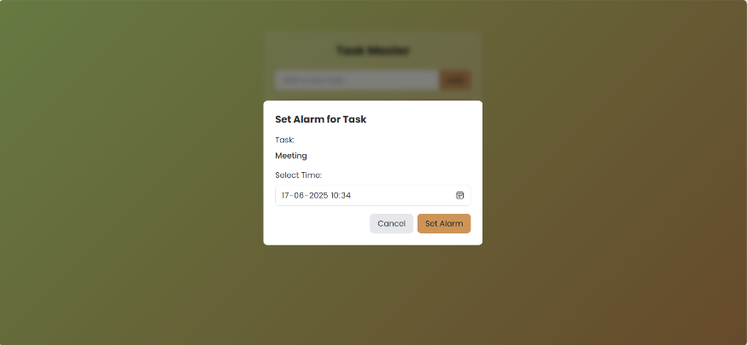**Alarm Feature Integration:**

* Users can **set alarms** for specific tasks using the integrated clock icon.
* The **alarm setup dialog** allows:
  + **Task Selection:** Assign an alarm to a task.
  + **Time Input:** Choose a date and time.
  + **Action Buttons:**
    - **"Cancel"** to discard the alarm setup.
    - 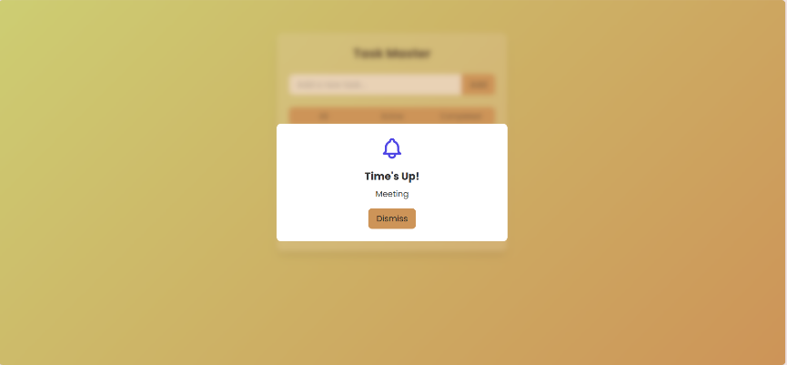**"Set Alarm"** to confirm and schedule the alarm.
* Once the scheduled time is reached, the **alarm triggers** with a notification.

### Task Master – Expanded Workflow Explanation

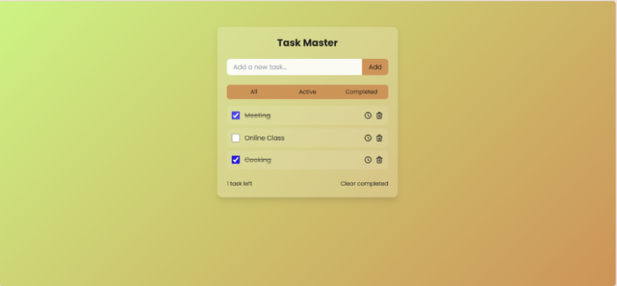The **Task Master** application streamlines task management, allowing users to add, track, and organize their tasks efficiently. Below is a detailed breakdown of its workflow:

**1. Adding a Task**

* Users enter a task description into the input field labeled **“Add a new task...”**
* Clicking the **"Add"** button saves the task, and it appears in the active task list.

**2. Marking Task Completion**

* Each task features a **checkbox** beside it.
* Once a task is completed, the user can click the checkbox, marking it as **finished**.
* 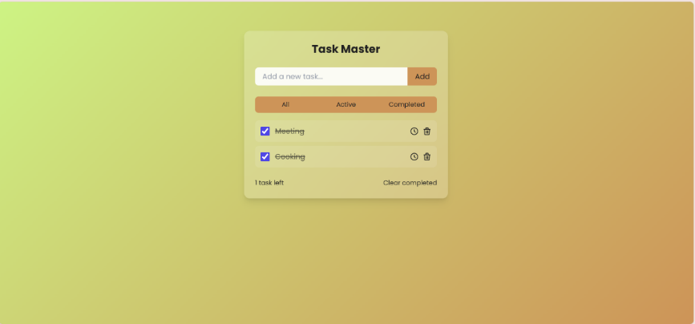Completed tasks will automatically move into the “Completed” filter view.

**3. Viewing Active Tasks**

* The **"Active"** filter shows tasks that have not yet been marked as completed.
* Users can freely switch between **"All," "Active," and "Completed"** filters to manage their tasks effectively.

**4. Clearing Completed Tasks**

* Users can remove finished tasks from the list by clicking the **“Clear completed”** button.
* 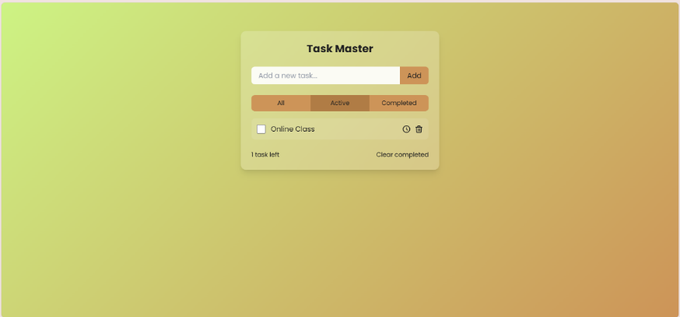This ensures only active tasks remain visible, keeping the workspace clean and uncluttered.

**5. Checking Completed Tasks**

* Clicking the **"Completed"** filter displays all tasks that have been checked off.
* This allows users to review their past tasks and track their progress.

**6. Alarm Functionality (If Enabled)**

* Users can set alarms for specific tasks using the **clock icon**.
* Selecting a date and time ensures the system will trigger a notification when the task is due.
* The alarm **alerts the user** at the scheduled time, serving as a reminder.