LOGISTICS KPI PERFORMANCE REVIEW
On-Time Delivery • Cost per Shipment • Hub Dwell Time
A fictional Kolkata-based cold-chain distributor • 12 hubs • Calendar year 2025
⚠ SYNTHETIC DATA — ALL DATA IN THIS REPORT IS SYNTHETIC (SEED 42). IT IS NOT REAL COMPANY DATA.

Author: Khushi Tomar
Final-year B.Tech, Computer Science & Engineering (AI & ML)
Yuva Intern — Logistics Data Analytics Specialist Internship
November 2026
Headline results (2025, synthetic data)
KPI | Result | Status
On-time delivery (OTD) | 76.48% (268,330 eligible; 63,118 late) | AMBER
Cost per shipment | ₹4,102.68 (293,485 valid-cost shipments) | AMBER
Average destination dwell | 15.49 hours | AMBER
Average origin dwell | 2.5 hours | —
Shipments analysed (clean) | 300,000 (from 304,500 raw) | —
Validation | 38/38 checks passed, 0% variance | GREEN

Scope note: the dataset covers 2025 only, so there is no true year-over-year comparison. H1 vs H2 2025 is used as the prior-period comparison and is labelled as such wherever it appears.
How this report was produced: Python (pandas) pipeline in src/ — generate → profile → clean → transform (star schema) → KPI calculation → validation → visualisation. Reconciliation tolerance 0.5%; all 38 validation checks passed with 0% variance. Power BI .pbix cannot be generated programmatically; the project instead provides cleaned datasets plus DAX measures and a build guide (see §10 and the Appendix).

Contents
1 Cover Page
2 Executive Summary
3 Introduction
4 Business Problem
5 Project Objectives
6 Dataset Description
7 Data Profiling
8 Data Quality Issues
9 Data Cleaning Methodology
10 Data Architecture and Modelling
11 KPI Definitions and Calculations
12 Exploratory Data Analysis
13 Hub and Route Performance Analysis
14 Top and Bottom Decile Analysis
15 Contribution and Root Cause Analysis
16 Business Impact Assessment
17 KPI Scorecard
18 Key Findings
19 Three Business Recommendations
20 Limitations
21 Conclusion
22 Appendix
Note: figures and tables are numbered in the text (Figure 1–8, Table 1–…); every number is traceable to a file listed in the Appendix.

2. Executive Summary
All data in this report is SYNTHETIC — generated with seed 42 for a fictional company. It is not real company data and no finding here describes a real business.
This review assesses the logistics performance of a fictional Kolkata-based cold-chain distributor across 12 hubs in 2025, using 300,000 clean shipments and 1,194,000 clean scan events. Three KPIs were tracked: on-time delivery (OTD), cost per shipment, and hub dwell time.
Overall OTD was 76.48% (268,330 eligible shipments, 63,118 late) — below the 85% GREEN threshold, so AMBER. Cost per shipment was ₹4,102.68 on 293,485 valid-cost shipments (total valid cost ₹1,204,074,833.69), also AMBER against a ₹4,000 GREEN threshold. Average destination dwell was 15.49 hours (origin 2.5 h; combined 8.9 h), AMBER against a 12-hour GREEN threshold. Performance was flat across the year: monthly OTD stayed between 75.72% (2025-04) and 77.04% (2025-05), and H1 vs H2 2025 differed by only 0.02 percentage points — this is a structural, not a seasonal, problem.
The gap is concentrated, not diffuse. Three destination hubs — Guwahati (GAU, 53.95%), Malda (MLD, 61.89%) and Ranchi (RNC, 69.04%) — account for 41.76% of all late deliveries, while the best hubs reach ~84%. Frozen is the weakest category (72.06% OTD, 33.1% of late deliveries) and the most expensive per shipment among the high-volume categories. The worst route, RT-006, delivered on time only 57.11% of the time.
Modelled business impact (bottom-quartile segments converging to the network median, on synthetic data — not a forecast of real savings): the realistic scenario avoids 9,706 late deliveries, saves ₹31,13,832.63 and recovers 4,296 excess dwell hours. The conservative (50% of the gap closed) scenario avoids 4,853 late deliveries and saves ₹15,56,916.31; the optimistic scenario saves ₹34,25,215.89.
Three recommendations follow in §19: (1) corridor recovery for Guwahati / Malda / Ranchi; (2) destination-hub dwell reduction at bottom-quartile warehouses; (3) Frozen-category cold-chain reliability and cost control on bottom-quartile routes. Data quality is a strength of this project, not a caveat: 200,528 changed records were logged (100% coverage) and 38/38 independent validation checks passed with 0% variance against a 0.5% reconciliation tolerance.

3. Introduction
Cold-chain distribution lives or dies on three promises: the goods arrive on time, at a controlled cost, and without spending unnecessary hours sitting in a warehouse. This project reviews all three for a fictional Kolkata-based cold-chain distributor operating 12 hubs across East India (West Bengal, Assam, Bihar, Jharkhand and Odisha), 60 routes, 180 vehicles and 24 warehouses in calendar year 2025.
All data in this report is SYNTHETIC — generated with seed 42 for a fictional company. It is not real company data and no finding here describes a real business. The company, its hubs and its shipments were generated by src/generate_data.py with seed 42, with defects deliberately injected (duplicates, orphan scans, negative costs, messy hub identifiers, out-of-order scans) so that the profiling, cleaning and validation stages of the project could be demonstrated on realistic dirty data. Because the data is synthetic, the findings describe the simulated network only; the value of the project is the reproducible method — profiling, cleaning, modelling, KPI calculation, validation and visualisation — that can be re-run on real data.
The report is organised as a full analytics delivery: business problem and objectives (§4–5), dataset and profiling (§6–7), data-quality issues and cleaning (§8–9), architecture and KPI definitions (§10–11), exploratory and segment analysis (§12–15), quantified business impact (§16), a RAG scorecard (§17), findings (§18), three owned recommendations (§19), limitations (§20) and conclusion (§21), with source traceability in the Appendix (§22).

4. Business Problem
The distributor did not know, in measurable terms, where its service was failing or what fixing it would be worth. Anecdotes pointed at late deliveries and long warehouse waits, but there was no single trusted set of numbers: shipment records contained duplicates and inconsistent hub spellings, scan events arrived out of order, some costs were negative or zero, and timestamps were missing or unparseable. Any KPI computed on the raw files would have been wrong in ways that were hard to see.
- Undefined KPIs. No agreed definition of on-time delivery, cost per shipment or dwell time, and no agreed denominator for any of them.
- No segment view. No view of which hubs, routes, warehouses or product categories drive lateness, cost or dwell.
- No business case. No quantified value of improvement, so operations, warehouse and fleet actions could not be prioritised or costed.
- No trust in the numbers. No reconciliation or validation, so nobody could say whether the numbers could be trusted to within an agreed tolerance (0.5% in this project).
This project answers those four gaps on the 2025 synthetic dataset and leaves a repeatable pipeline and a Power BI build (datasets + DAX + guide, §10) for ongoing reporting.

5. Project Objectives
- 1. Profile the raw shipment and scan-event data and document every data-quality issue with counts.
- 2. Clean the data with fully logged, rule-based transformations and preserve a complete audit trail (cleaning log).
- 3. Build a star-schema trusted analysis table (one row per clean shipment) with conformed dimensions.
- 4. Define and compute three KPIs — on-time delivery %, cost per shipment (INR), hub dwell time (hours) — with explicit denominators and exclusions.
- 5. Analyse performance by month, half-year, hub (origin and destination), route, warehouse, product category and vehicle type, including top/bottom deciles and contribution (Pareto) analysis.
- 6. Quantify the business impact of bringing bottom-quartile routes and warehouses up to the network median, under conservative, realistic and optimistic scenarios.
- 7. Validate every headline figure independently (38 checks, 0.5% tolerance) and visualise the results in eight charts.
- 8. Deliver three prioritised, owned business recommendations with a monitoring metric for each, and a Power BI reporting pack (cleaned datasets + DAX measures + build guide; a .pbix file cannot be generated programmatically).

6. Dataset Description
All data in this report is SYNTHETIC — generated with seed 42 for a fictional company. It is not real company data and no finding here describes a real business.
The source data was generated by src/generate_data.py (seed 42) for 1 January–31 December 2025. Raw files: shipments_raw.parquet (304,500 rows) and scan_events_raw.parquet (1,200,000 rows) — 1,504,500 raw records in total. After cleaning: 300,000 shipments and 1,194,000 scan events — 1,494,000 clean records. Generation manifest: data/raw/generation_manifest.json.
Entity | Count | Notes
Shipments (raw → clean) | 304,500 → 300,000 | 4,500 duplicate rows removed
Scan events (raw → clean) | 1,200,000 → 1,194,000 | 6,000 orphan scans removed
Total records (raw → clean) | 1,504,500 → 1,494,000 | 10,500 records removed in total
Hubs | 12 | KOL Kolkata (origin-heavy), HWH, SIL, DGP, ASN, MLD, GAU, PAT, RNC, JSR, BBS, CTC
Routes | 60 (+ UNKNOWN) | RT-001–RT-060; 1,521 shipments on UNKNOWN route after cleaning
Vehicles | 180 | 5 vehicle types; 1,429 shipments with missing vehicle_id → 'Unknown'
Warehouses | 24 | 2 per hub (e.g. WH-KOL-1, WH-KOL-2)
Product categories | 5 (+ Unknown) | Ambient, Chilled, Dairy, Frozen, Pharma; 857 shipments 'Unknown'
Date range | 2025-01-01 – 2025-12-31 | 365 days; no data outside 2025 — hence no true year-over-year

Source files
- Shipments. data/raw/shipments_raw.parquet — one row per shipment record (including duplicates). Columns: shipment_id, shipment_date, origin_hub, destination_hub, route_id, vehicle_id, vehicle_type, warehouse_id, category, promised_delivery_ts, actual_delivery_ts, shipment_cost_inr, status.
- Scan events. data/raw/scan_events_raw.parquet — one row per scan event (Loading / Departure / Arrival and one further scan type; 4 distinct scan types). Columns: scan_event_id, shipment_id, hub_id, warehouse_id, scan_type, scan_ts.
- Dimensions. data/reference/dim_hub.csv, dim_route.csv, dim_vehicle.csv, dim_warehouse.csv, dim_category.csv, dim_date.csv, hub_crosswalk.csv — conformed dimensions and the messy-variant → canonical hub crosswalk used in cleaning.
- Cleaned outputs. data/processed/shipments_clean.parquet, scan_events_clean.parquet, trusted_analysis_table.parquet (one row per clean shipment) and trusted_analysis_table_sample.csv.
Injected defects (generation manifest): 4,500 duplicate shipment rows; 6,000 orphan scans; negative dwell in 1.0% of shipments; out-of-order scans in 5.0% of shipments; messy hub identifiers in 30.0% of rows; invalid route references in 0.5% and invalid vehicle references in 0.5% of rows. These were injected deliberately so the cleaning stage has something real to do; they are not findings about a real company.

7. Data Profiling
Profiling (src/data_profiling.py) was run on the raw files before any cleaning. Full per-column profiles are in outputs/kpi_reports/column_profile_shipments.csv and column_profile_scans.csv; the headline profile is summarised below.

Shipments — raw profile (304,500 rows)
Column | Missing | Missing % | Unique | Observation
shipment_id | 0 | 0.00 | 300,000 | 4,500 duplicate values — the injected duplicates
shipment_date | 0 | 0.00 | 365 | Full calendar year 2025
origin_hub / destination_hub | 0 | 0.00 | 72 each | 72 raw variants mapping to 12 canonical hubs
route_id | 0 | 0.00 | 61 | 60 routes + invalid references
vehicle_id | 1,455 | 0.48 | 181 | Missing vehicle references
vehicle_type | 0 | 0.00 | 5 | 5 vehicle types
warehouse_id | 0 | 0.00 | 24 | 24 warehouses
category | 873 | 0.29 | 5 | Missing category
promised_delivery_ts | 2,407 | 0.79 | 26,371 | Missing + unparseable timestamps (see §8)
actual_delivery_ts | 3,601 | 1.18 | 293,017 | Missing + unparseable timestamps (see §8)
shipment_cost_inr | 2,954 | 0.97 | 234,574 | Missing, negative and zero costs (see §8)
status | 0 | 0.00 | 5 | Delivered, Delayed, Returned and two further statuses

Scan events — raw profile (1,200,000 rows)
Column | Missing | Unique | Observation
scan_event_id | 0 | 1,200,000 | No duplicates
shipment_id | 0 | 301,643 | Includes 6,000 orphan references; 898,357 duplicate values (4 scans per shipment)
hub_id | 0 | 72 | Same 72 messy variants as shipments
warehouse_id | 0 | 24 | 24 warehouses
scan_type | 0 | 4 | Loading, Departure, Arrival + 1 further type
scan_ts | 0 | 921,432 | No invalid scan timestamps in the raw profile

Two profiling facts shape everything downstream. First, hub identifiers appear in 72 variants for 12 real hubs (§8) — no hub analysis is possible before standardisation. Second, the OTD denominator is not 300,000: only shipments with a valid promised and actual timestamp and a Delivered/Delayed status are eligible (268,330), and the cost denominator is only shipments with a valid (positive, non-zero) cost (293,485). Reporting a KPI without its denominator would overstate coverage.

8. Data Quality Issues
The raw-file data-quality audit (outputs/kpi_reports/data_quality_report.md and data_quality_checks.json) found the following. Counts are raw-file counts, before deduplication; the cleaning-log counts in §9 are post-deduplication action counts, so the two tables differ slightly for the same issue — both are reproduced exactly as recorded in their source files, and the validation in §22 reconciles the headline totals rather than every intermediate count.
Issue (raw file) | Count
duplicate shipment id rows | 9,000
duplicate shipment ids distinct | 4,500
duplicate scan event id rows | 0
negative cost rows | 2,474
zero cost rows | 1,172
invalid cost rows | 0
invalid promised ts rows | 3,081
invalid actual ts rows | 2,980
missing promised ts rows | 2,407
missing actual ts rows | 3,601
unrecognised origin hub rows | 0
messy variant origin hub rows | 91,486
unrecognised destination hub rows | 0
messy variant destination hub rows | 92,027
invalid route ref rows | 1,548
invalid vehicle ref rows | 1,557
missing vehicle rows | 1,455
missing category rows | 873
invalid scan ts rows | 0
orphan scan rows | 6,000
out of order scan shipments | 20,914
out of order scan events | 29,287
negative dwell origin hub shipments | 39
negative dwell dest hub shipments | 2,905

Reading the audit:
- Duplicates. Duplicates are the largest structural issue: 9,000 duplicate shipment-id rows (4,500 distinct ids duplicated), i.e. 4,500 extra rows to remove. Scan events have no duplicate ids.
- Cost. Negative costs (2,474) and zero costs (1,172) together with missing costs (2,954 in the column profile) remove 6,515 shipments from the cost denominator; invalid/non-numeric costs are 0.
- Timestamps / OTD eligibility. Invalid promised timestamps (3,081) and invalid actual timestamps (2,980), plus missing promised (2,407) and missing actual (3,601), remove 31,670 shipments from the OTD denominator (300,000 − 268,330).
- Hub identifiers. 91,486 origin-hub and 92,027 destination-hub rows use messy variants (spellings/ids) of the 12 canonical hubs; no hub value is wholly unrecognised (0 rows), so the crosswalk resolves all of them.
- References. 1,548 invalid route references and 1,557 invalid vehicle references, plus 1,455 missing vehicle ids and 873 missing categories.
- Scans. 6,000 orphan scans reference shipments that do not exist; 29,287 scan events in 20,914 shipments are out of order and must be re-sequenced; no scan timestamp is invalid (0).
- Dwell. Negative dwell pairs — 39 shipments at origin, 2,905 at destination — are physically impossible (departure before arrival) and are excluded from the dwell KPI.

9. Data Cleaning Methodology
Cleaning (src/data_cleaning.py) is rule-based, deterministic and fully logged. Every rule below is one row (or, for re-sequencing, one described action) in outputs/cleaning_logs/cleaning_log.csv — 19 issue rows, 200,528 changed records logged in total, i.e. 100% changed-record coverage: every record the cleaner touched is traceable in the log.
Issue | Records affected | Cleaning action | Validation after cleaning
Invalid promised_delivery_ts (unparseable string) | 2323 | Timestamp set to NaT; shipment excluded from OTD denominator | Re-parsed after cleaning: 0 unparseable values remain (all NaT)
Invalid actual_delivery_ts (unparseable string) | 2219 | Timestamp set to NaT; shipment excluded from OTD denominator | Re-parsed after cleaning: 0 unparseable values remain (all NaT)
Hub identifier standardised (origin_hub) | 91486 | Mapped raw variant to canonical hub id via hub_crosswalk.csv | After mapping, all values are in Dim_Hub (12 hubs)
Hub identifier standardised (destination_hub) | 92027 | Mapped raw variant to canonical hub id via hub_crosswalk.csv | After mapping, all values are in Dim_Hub (12 hubs)
Duplicate shipment_id (extra copies) | 4500 | Removed extra copies; kept the most complete record (fewest nulls, first occurrence) | shipment_id unique after cleaning
Negative shipment cost | 2439 | Flagged cost_valid=False; excluded from cost-per-shipment denominator | No negative costs in valid-cost set
Zero shipment cost | 1156 | Flagged cost_valid=False; excluded from cost-per-shipment denominator | No zero costs in valid-cost set
Missing shipment cost | 2920 | Flagged cost_valid=False; excluded from cost KPI | Valid-cost set contains no nulls
Missing category | 857 | Kept as 'Unknown' dimension member for segment reporting | No nulls remain in the column
Missing vehicle_id | 1429 | Kept as 'Unknown' dimension member for segment reporting | No nulls remain in the column
Missing promised_ts_utc | 5405 | Kept as NaT; shipment excluded from OTD denominator | OTD denominator contains only valid timestamps
Missing actual_ts_utc | 6479 | Kept as NaT; shipment excluded from OTD denominator | OTD denominator contains only valid timestamps
Invalid route reference | 1521 | Set to UNKNOWN route; kept in shipment table, excluded from route segments | 0 invalid route refs remain
Invalid vehicle reference | 1543 | Set to UNKNOWN vehicle; kept in shipment table, excluded from vehicle segments | 0 invalid vehicle refs remain
Invalid scan timestamp | 0 | Timestamp set to NaT; event excluded from dwell/sequencing | 0 unparseable scan timestamps remain
Orphan scan events (no matching shipment) | 6000 | Removed; cannot be joined to any shipment | 0 orphan scans remain; referential integrity holds
Out-of-order scan events | see profiling (re-sequenced) | Sorted by UTC timestamp within each shipment; scan_sequence assigned | Within each shipment, scan_ts_utc is non-decreasing
Negative dwell (dwell_origin_h) | 18 | Flagged dwell_valid=False; excluded from dwell KPI | Dwell KPI contains no negative durations
Negative dwell (dwell_dest_h) | 2885 | Flagged dwell_valid=False; excluded from dwell KPI | Dwell KPI contains no negative durations

Rules and principles applied:
- Deduplication. Keep the most complete copy (fewest nulls, then first occurrence) and drop the other copies. 4,500 rows removed; shipment_id is unique afterwards.
- Hub standardisation. Map every raw hub variant to its canonical hub id via data/reference/hub_crosswalk.csv (91,486 origin + 92,027 destination rows). After mapping, all hub values are in Dim_Hub (12 hubs).
- Invalid timestamps. Unparseable promised/actual timestamps → NaT; the shipment is excluded from the OTD denominator (never imputed — an invented delivery time would fabricate the headline KPI).
- Cost flags. Negative (2,439 in the cleaning log) and zero (1,156) costs and missing costs (2,920) → cost_valid=False, excluded from the cost denominator. Zero is treated as a failed charge capture, not a free shipment.
- Missing category / vehicle — no imputation. Missing category (857) and missing vehicle_id (1,429) are kept as an 'Unknown' dimension member for segment reporting. Imputing a category or vehicle would invent information.
- Invalid references. Invalid route (1,521) → UNKNOWN route, kept in the shipment table but excluded from route segments; invalid vehicle (1,543) → UNKNOWN vehicle.
- Orphan scans and re-sequencing. Orphan scans (6,000) removed — they cannot be joined to any shipment. Remaining scans are sorted by UTC timestamp within each shipment and scan_sequence is assigned; after cleaning, 0 shipments have out-of-order scans and scan_ts is non-decreasing within every shipment.
- Negative dwell. Negative dwell pairs (origin 18, destination 2,885 in the cleaning log) → dwell_valid=False, excluded from the dwell KPI.
What was deliberately NOT done: no missing values were imputed, no labels were changed, no difficult observations were deleted beyond the documented duplicate/orphan removals, and no test/train-style leakage applies (this is a descriptive KPI review, not a predictive model). The cleaned tables are data/processed/shipments_clean.parquet and scan_events_clean.parquet; the cleaning summary is data/processed/cleaning_summary.json.
Note on counts: the cleaning log records 2,439 negative and 1,156 zero costs, 2,323 invalid promised and 2,219 invalid actual timestamps, and 18 / 2,885 negative dwell pairs, while the raw-file audit in §8 records 2,474 / 1,172, 3,081 / 2,980 and 39 / 2,905 for the same issues. The difference is the stage at which each file counts (raw file including duplicates vs. actions on the deduplicated set). Both figures are reproduced exactly as recorded; the headline reconciliation (300,000 clean shipments, 1,194,000 clean scans, all KPI totals) is validated independently in §22.

10. Data Architecture and Modelling
The pipeline (src/) runs in five stages: generate_data.py → data_profiling.py → data_cleaning.py → data_transformation.py → kpi_calculations.py, followed by validation.py and visualizations.py. Transformation builds a star schema around one trusted analysis table:
Table | Grain / role | Key columns
trusted_analysis_table (fact) | One row per clean shipment (300,000 rows) | shipment_id, shipment_date, origin_hub, destination_hub, route_id, vehicle_id, vehicle_type, warehouse_id, category, promised/actual timestamps (UTC), shipment_cost_inr, status, otd flag, cost_valid, dwell_valid, dwell hours
Dim_Hub | One row per hub (12) | hub_id, hub_name, state, region, is_cold_chain
Dim_Route | One row per route (60 + UNKNOWN) | route_id, origin_hub, destination_hub, distance_km, planned_transit_hours
Dim_Vehicle | One row per vehicle (180 + UNKNOWN) | vehicle_id, vehicle_type, capacity_kg, home_hub
Dim_Warehouse | One row per warehouse (24) | warehouse_id, hub_id, warehouse_name, capacity_pallets
Dim_Category | One row per category (5) | category, base_cost_inr
Dim_Date | One row per date (365) | date, month, half-year (H1/H2 2025)

Design choices:
- One trusted table. The fact table carries pre-computed flags (OTD-eligible, cost-valid, dwell-valid) so every KPI denominator is explicit and reproducible, and every downstream cut (month, hub, route, warehouse, category, vehicle) sums back to the 300,000-shipment total — verified by the validation checks in §22.
- Unknown members, not dropped rows. Unknown members ('Unknown' category/vehicle, UNKNOWN route) preserve referential integrity instead of dropping rows: a shipment with a missing category still counts in the network total.
- UTC + re-sequenced scans. All timestamps are normalised to UTC before any comparison; dwell is computed from re-sequenced scan events (arrival → departure at the same hub), never from source file order.

Power BI reporting pack
A Power BI .pbix file cannot be generated programmatically — there is no code path that writes a .pbix. The project therefore provides the next best thing, and the report is explicit about the substitution so that nobody mistakes this document for a finished dashboard:
- 1. Datasets. Cleaned datasets: data/processed/shipments_clean.parquet, scan_events_clean.parquet and trusted_analysis_table.parquet (plus trusted_analysis_table_sample.csv for a quick import test).
- 2. DAX measures. DAX measures (definitions in §11; full text in the Appendix): OTD %, Cost per Shipment, Avg Destination Dwell (h), Avg Origin Dwell (h), Late Deliveries, Total Valid Cost.
- 3. Build guide. Build guide (Appendix): import the trusted table, create the Dim_Hub / Dim_Route / Dim_Vehicle / Dim_Warehouse / Dim_Category / Dim_Date relationships on the hub/route/vehicle/warehouse/category/date keys, paste the DAX measures, and build the eight chart views that correspond to Figures 1–8.
At the time this report was built, the powerbi/ folder in the project repository was empty — the DAX measures and build steps are therefore documented in full in the Appendix (§22) so they can be placed there without re-deriving them. No .pbix file is claimed to exist.

11. KPI Definitions and Calculations
Each KPI states its numerator, its denominator, its exclusions and its unit. A KPI without a denominator is not reported anywhere in this document.
KPI | Definition | Denominator / exclusions | 2025 result
On-time delivery (OTD) % | Eligible shipments delivered on or before the promised timestamp ÷ eligible shipments × 100. On time = actual_delivery_ts ≤ promised_delivery_ts. | Eligible = status Delivered/Delayed with valid promised AND actual timestamps: 268,330 of 300,000. Excluded: 31,670 shipments (missing/invalid timestamps or other statuses). | 76.48%
Cost per shipment (INR) | Total valid shipment cost ÷ valid-cost shipments. | Valid cost = cost present, > 0. 293,485 shipments; total ₹1,204,074,833.69. Excluded: 6,515 shipments (missing, zero or negative cost). | ₹4,102.68
Avg destination dwell (h) | Mean hours between arrival and departure scans at the destination hub, over dwell-valid shipments. | Dwell-valid only; negative dwell pairs excluded (2,905 destination pairs in the raw audit). | 15.49 h
Avg origin dwell (h) | Mean hours between arrival and departure scans at the origin hub, over dwell-valid shipments. | Dwell-valid only; negative dwell pairs excluded (39 origin pairs in the raw audit). | 2.5 h
Avg combined dwell (h) | Mean of origin + destination dwell per shipment (dwell-valid). | As above. | 8.9 h
Late deliveries (count) | Eligible shipments with actual_delivery_ts > promised_delivery_ts. | Subset of the 268,330 eligible shipments. | 63,118

Worked check (OTD): 268,330 eligible − 63,118 late = 205,212 on time; 205,212 ÷ 268,330 × 100 = 76.48%. Worked check (cost): ₹1,204,074,833.69 ÷ 293,485 = ₹4,102.68. Both were recomputed independently from the trusted table in validation (0% variance).
Deciles and quartiles used later in the report: shipment deciles rank eligible shipments by lateness (actual − promised, hours); route deciles rank the 60 routes (+ UNKNOWN) by OTD; warehouse deciles rank the 24 warehouses by average destination dwell; quartiles split the same ranked lists into four. The business-impact model in §16 uses quartiles, not deciles.

12. Exploratory Data Analysis

Monthly trend — flat all year
Monthly OTD ranged only from 75.72% (2025-04, 5,352 late) to 77.04% (2025-05). Monthly cost per shipment stayed between ₹4,076.98 and ₹4,127.07, and destination dwell between 15.42 h and 15.59 h. There is no seasonal story to tell: the largest month-on-month OTD move in the file is +1.32 pp (April→May 2025) and the largest fall is −1.04 pp (March→April 2025). The network's problem is structural and geographic, not calendar-driven.
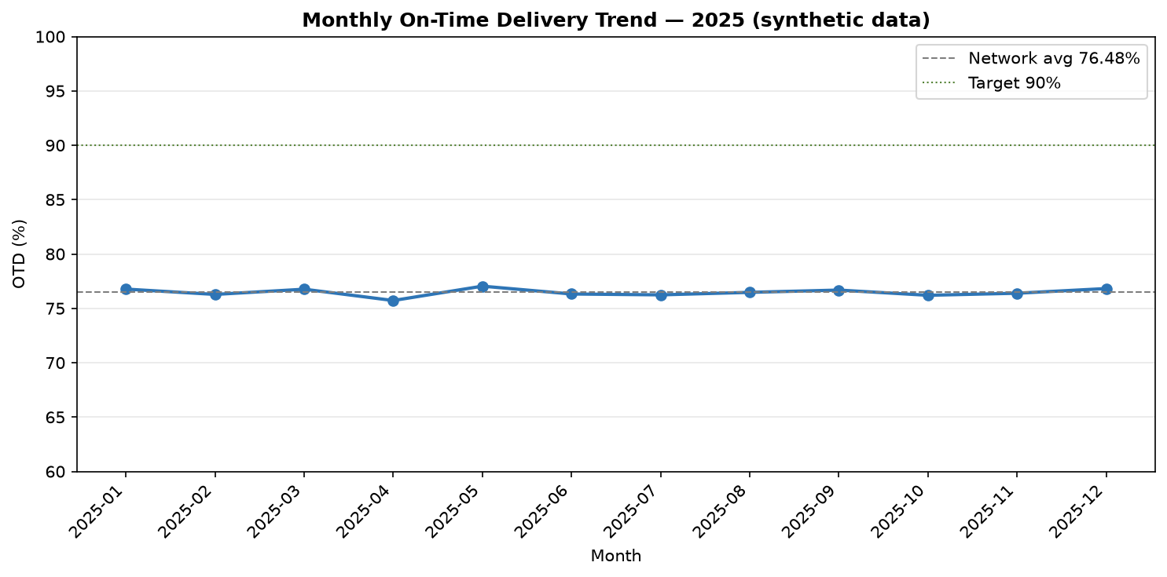
Figure 1 — Monthly OTD % and cost per shipment, January–December 2025 (synthetic data). OTD is flat in a 75.7–77.0% band all year.
Month | Shipments | OTD % | MoM (pp) | Late | Cost / shipment | Dest. dwell (h)
2025-01 | 25,395 | 76.77 | — | 5,281 | ₹4,101.63 | 15.46
2025-02 | 22,951 | 76.28 | -0.49 | 4,864 | ₹4,088.56 | 15.47
2025-03 | 25,526 | 76.76 | 0.48 | 5,305 | ₹4,076.98 | 15.59
2025-04 | 24,667 | 75.72 | -1.04 | 5,352 | ₹4,103.40 | 15.52
2025-05 | 25,521 | 77.04 | 1.32 | 5,249 | ₹4,127.07 | 15.44
2025-06 | 24,639 | 76.32 | -0.72 | 5,207 | ₹4,115.88 | 15.44
2025-07 | 25,474 | 76.24 | -0.08 | 5,392 | ₹4,111.50 | 15.44
2025-08 | 25,619 | 76.47 | 0.23 | 5,400 | ₹4,110.39 | 15.53
2025-09 | 24,815 | 76.68 | 0.21 | 5,187 | ₹4,109.78 | 15.42
2025-10 | 25,378 | 76.2 | -0.48 | 5,410 | ₹4,100.98 | 15.53
2025-11 | 24,448 | 76.39 | 0.19 | 5,166 | ₹4,088.70 | 15.57
2025-12 | 25,567 | 76.82 | 0.43 | 5,305 | ₹4,095.92 | 15.48

Half-year comparison (the prior-period comparison — not year-over-year)
The data covers 2025 only, so no true year-over-year comparison exists. H1 vs H2 2025 is the prior-period comparison and is labelled as such.
Period | Shipments | OTD % | Late | Cost / shipment | Dest. dwell (h) | Origin dwell (h)
H1 2025 | 148,699 | 76.49 | 31,258 | ₹4,102.40 | 15.49 | 2.5
H2 2025 | 151,301 | 76.47 | 31,860 | ₹4,102.95 | 15.5 | 2.5

H1 2025 OTD was 76.49% and H2 2025 was 76.47% — a difference of 0.02 percentage points on 148,699 vs 151,301 shipments. Cost per shipment moved by ₹0.55 (4102.4 → 4102.95) and destination dwell by 0.01 h. In other words, nothing changed between halves: whatever is wrong in H1 is still wrong in H2.

Volume and mix
Kolkata (KOL) dominates as an origin hub (105,172 shipments originated there, about 35% of the network), while destination volumes are spread evenly across the 12 hubs (17,745–26,851 shipments each). By category, Frozen is the largest volume (83,741 shipments), followed by Chilled (77,715); Pharma is the smallest named category (35,768). Vehicle types are evenly split (59,843–60,101 shipments each) and, as §13 shows, perform almost identically — vehicle type is not a driver of lateness in this data.
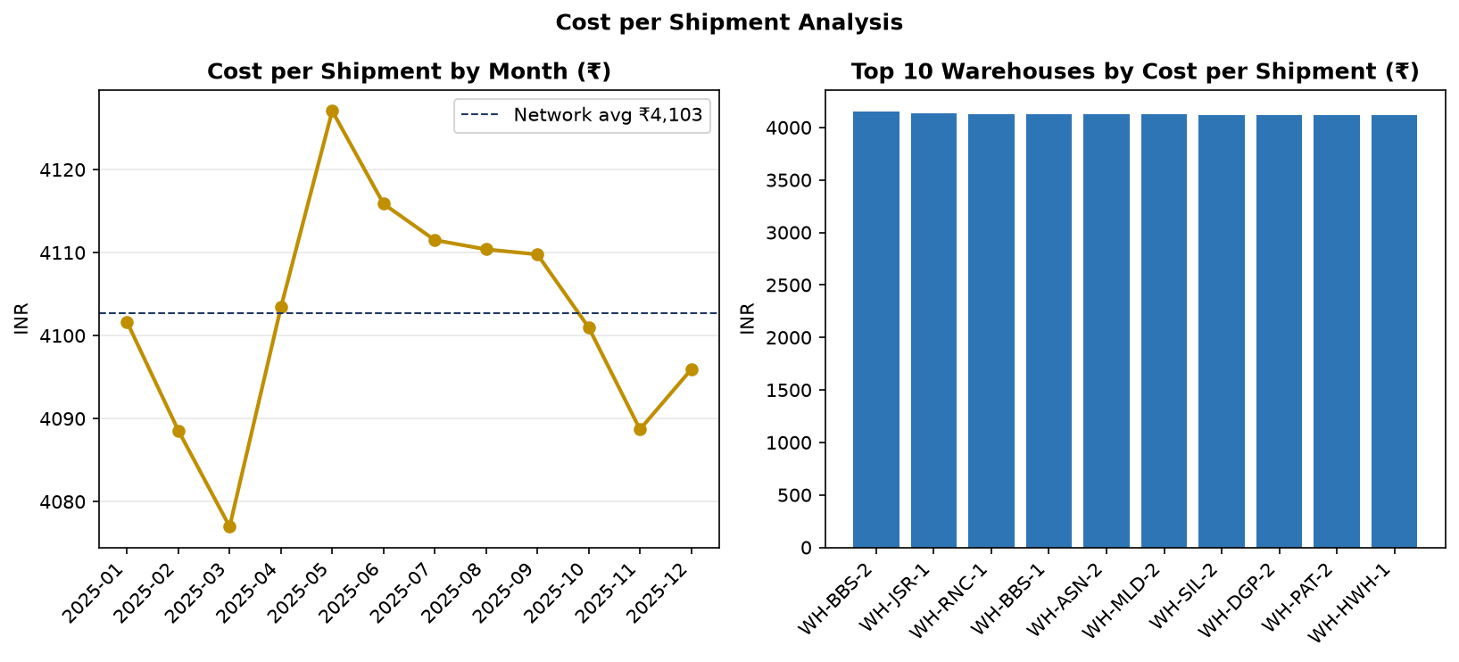
Figure 2 — Cost per shipment by segment. Category, not vehicle type or hub, drives the cost spread (see §13).

13. Hub and Route Performance Analysis

Destination hubs — the single biggest split in the network
Destination-hub OTD falls into two distinct groups: nine hubs at 74–84% and three hubs far below. Origin-hub OTD, by contrast, is tightly bunched (75.26–78.80%) — where a shipment starts barely matters; where it ends matters enormously. That asymmetry points at destination-side handling (unloading, hub capacity, onward dispatch) rather than line-haul departure performance.
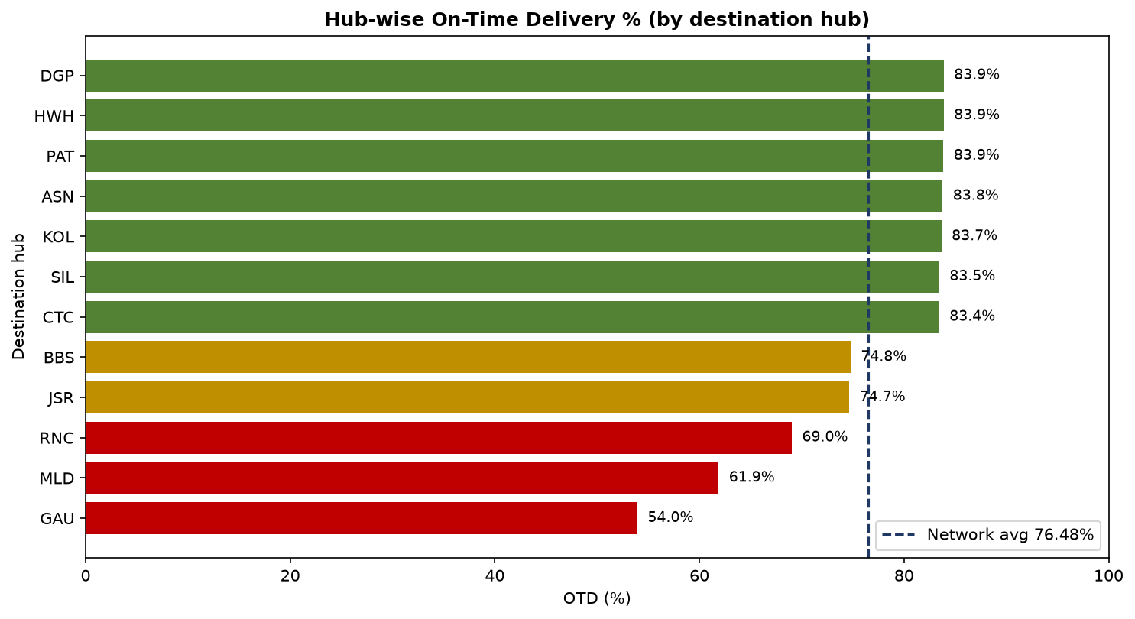
Figure 3 — OTD % by destination hub, 2025 (synthetic data). Guwahati, Malda and Ranchi sit 15–30 pp below the best hubs.
Destination hub | Hub name | Shipments | OTD % | Late | Cost / shipment | Dest. dwell (h)
GAU | Guwahati | 25,254 | 53.95 | 10,364 | ₹4,103.15 | 15.54
MLD | Malda | 26,027 | 61.89 | 8,851 | ₹4,119.11 | 15.4
RNC | Ranchi | 25,776 | 69.04 | 7,143 | ₹4,103.30 | 15.48
JSR | Jamshedpur | 26,097 | 74.66 | 5,953 | ₹4,100.03 | 15.52
BBS | Bhubaneswar | 26,691 | 74.78 | 6,014 | ₹4,111.41 | 15.41
CTC | Cuttack | 26,851 | 83.44 | 3,977 | ₹4,103.70 | 15.57
SIL | Siliguri | 24,838 | 83.45 | 3,667 | ₹4,076.73 | 15.55
KOL | Kolkata | 17,745 | 83.66 | 2,596 | ₹4,098.48 | 15.49
ASN | Asansol | 25,695 | 83.78 | 3,724 | ₹4,079.22 | 15.5
PAT | Patna | 25,444 | 83.86 | 3,667 | ₹4,119.90 | 15.47
HWH | Howrah | 24,211 | 83.88 | 3,504 | ₹4,120.85 | 15.48
DGP | Durgapur | 25,371 | 83.89 | 3,658 | ₹4,094.74 | 15.5

The three weakest destination hubs — Guwahati 53.95%, Malda 61.89%, Ranchi 69.04% — together contribute 41.76% of all late deliveries (see §15). The best destination hubs are Durgapur (83.89%), Howrah (83.88%) and Patna (83.86%). Destination dwell, however, is nearly identical across hubs (15.40–15.57 h): dwell time alone does not explain the OTD gap — the gap must also involve transit and destination handling that dwell as measured here does not capture (see §20).

Origin hubs
Origin hub | Shipments | OTD % | Late | Cost / shipment
ASN | 17,950 | 75.26 | 3,952 | ₹4,091.93
DGP | 20,874 | 75.38 | 4,612 | ₹4,114.33
HWH | 36,182 | 75.66 | 7,878 | ₹4,104.13
PAT | 20,998 | 76.2 | 4,467 | ₹4,103.32
BBS | 6,015 | 76.22 | 1,281 | ₹4,138.09
SIL | 24,045 | 76.33 | 5,088 | ₹4,094.30
KOL | 105,172 | 76.34 | 22,258 | ₹4,101.76
JSR | 11,899 | 76.58 | 2,488 | ₹4,095.96
CTC | 3,026 | 77.16 | 623 | ₹4,096.03
RNC | 14,911 | 77.54 | 2,989 | ₹4,118.22
MLD | 14,864 | 78.11 | 2,913 | ₹4,102.45
GAU | 24,064 | 78.8 | 4,569 | ₹4,096.03

Origin OTD spans only 3.54 pp (CTC 77.16% at the top on 3,026 shipments; ASN 75.26% at the bottom). No origin hub is an outlier, and Kolkata's dominance in origin volume (105,172 shipments) does not make it a performance outlier either (76.34%).

Routes — 60 routes, one clear tail
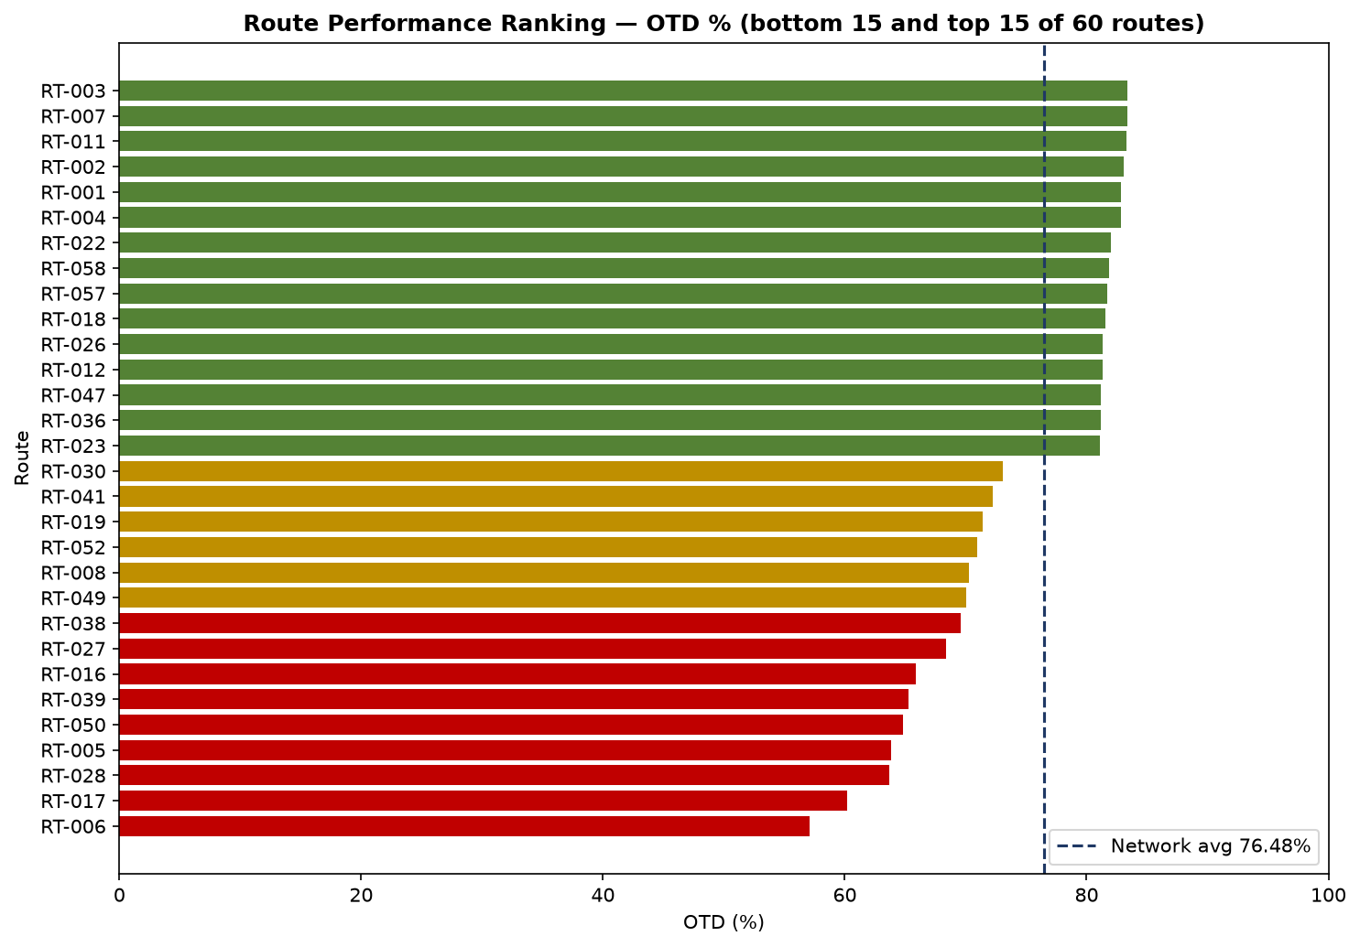
Figure 4 — Route OTD ranking, 2025 (synthetic data). The bottom six routes (57–65% OTD) sit far below the top six (83–84%).
Route | Origin → Destination | Shipments | OTD % | Late | Cost / shipment
RT-006 | KOL → GAU | 10,938 | 57.11 | 4,182 | ₹4,117.13
RT-017 | HWH → GAU | 4,784 | 60.2 | 1,706 | ₹4,121.62
RT-028 | SIL → GAU | 3,658 | 63.67 | 1,187 | ₹4,114.29
RT-005 | KOL → MLD | 10,869 | 63.81 | 3,525 | ₹4,139.69
RT-050 | ASN → GAU | 3,063 | 64.84 | 962 | ₹4,052.36
RT-039 | DGP → GAU | 3,359 | 65.25 | 1,048 | ₹4,123.85
RT-004 | KOL → ASN | 10,839 | 82.83 | 1,663 | ₹4,054.00
RT-001 | KOL → HWH | 11,124 | 82.84 | 1,714 | ₹4,099.23
RT-002 | KOL → SIL | 11,069 | 83.04 | 1,671 | ₹4,078.14
RT-011 | KOL → CTC | 10,953 | 83.31 | 1,631 | ₹4,088.83
RT-007 | KOL → PAT | 10,922 | 83.34 | 1,624 | ₹4,134.20
RT-003 | KOL → DGP | 10,934 | 83.41 | 1,620 | ₹4,095.39

The six worst routes (RT-006 57.11%, RT-017 60.20%, RT-028 63.67%, RT-005 63.81%, RT-050 64.84%, RT-039 65.25%) are all 57–65% OTD; the six best (RT-004 82.83% through RT-003 83.41%) cluster at 83–84%. Route cost per shipment varies little (₹4,024–₹4,196 across the 60 named routes; the UNKNOWN route is ₹4,176.21 on 1,521 shipments), so the worst routes are not obviously the most expensive — they are the least reliable. The most expensive named route in the file is RT-014 (₹4,195.83) and the cheapest is RT-047 (₹4,024.04); neither is in the OTD top or bottom six, which underlines that cost and reliability do not move together here.

Warehouses and dwell
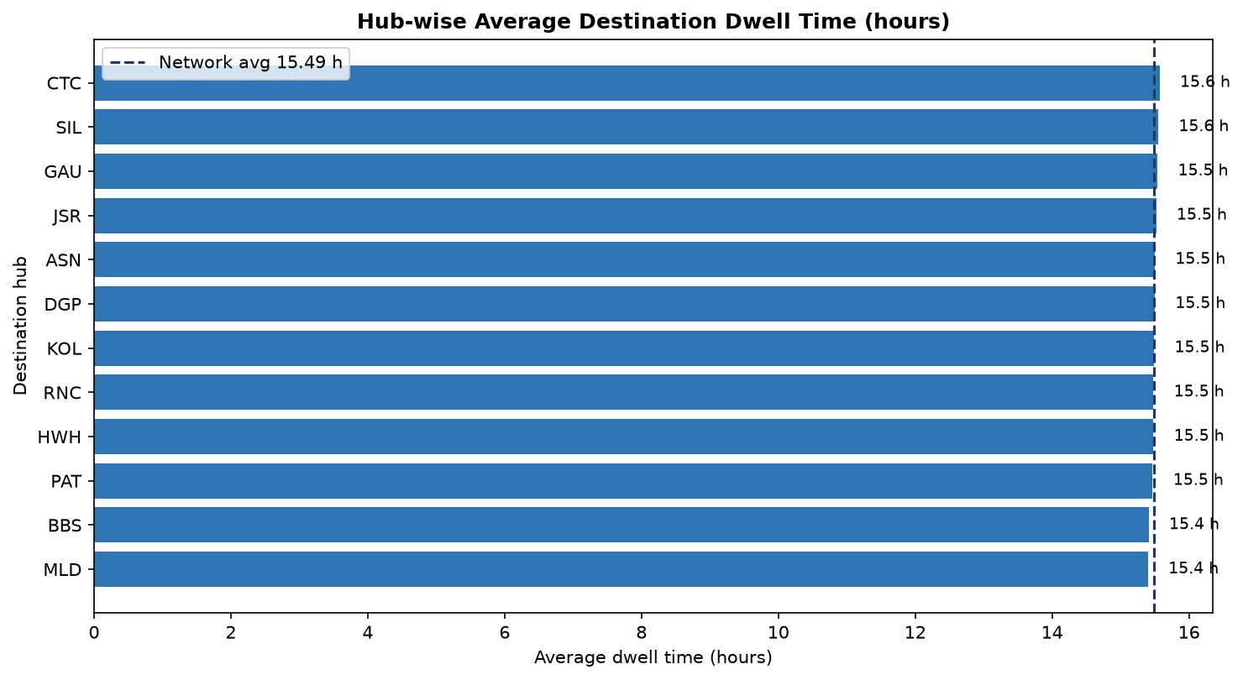
Figure 5 — Average dwell time by hub (origin vs destination), 2025 (synthetic data). Destination dwell (~15.5 h) is roughly six times origin dwell (2.5 h) at every hub.
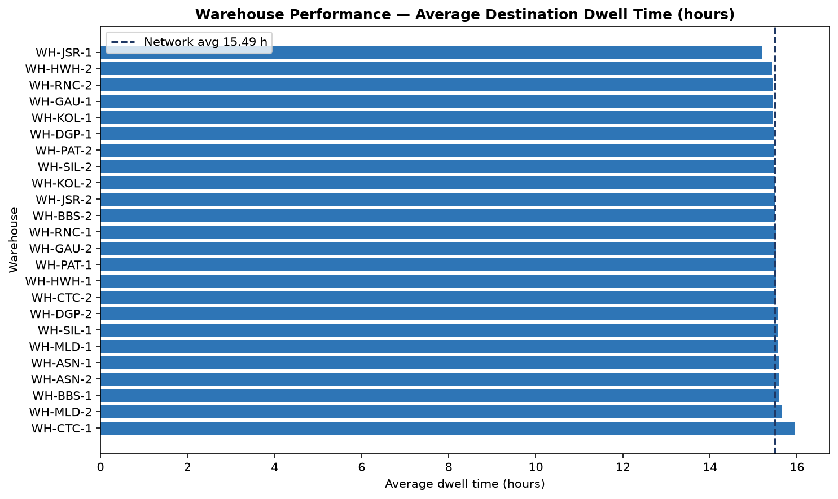
Figure 6 — Warehouse performance: average destination dwell and OTD by warehouse (24 warehouses). Dwell varies little; OTD varies more.
Warehouse (highest dest. dwell) | Shipments | Dest. dwell (h) | OTD %
WH-CTC-1 | 1,513 | 15.95 | 77.84
WH-MLD-2 | 7,496 | 15.64 | 78.14
WH-BBS-1 | 2,984 | 15.59 | 76.74
WH-ASN-1 | 8,938 | 15.58 | 75.34
WH-ASN-2 | 9,012 | 15.58 | 75.19

Average destination dwell across warehouses spans only 15.21 h (WH-JSR-1, the lowest) to 15.95 h (WH-CTC-1, the highest) — a 0.74 h spread on a 15.5 h base. The two Kolkata warehouses alone handle 105,172 shipments (35% of the network) at 15.45–15.49 h destination dwell. Dwell is a network-wide condition (every warehouse sits near 15.5 h), not a single bad warehouse; the bottom-quartile warehouses in §16 are therefore only marginally worse than the median, and the recoverable dwell hours there are correspondingly modest (4,295.8 h in the realistic scenario).

Category and vehicle type
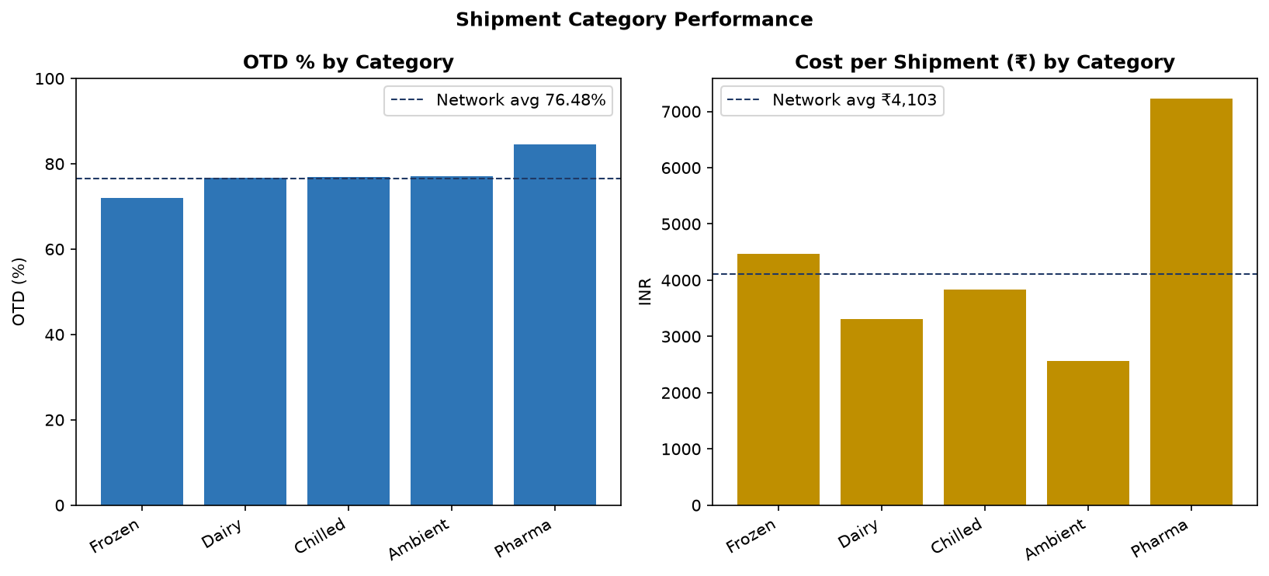
Figure 7 — OTD % and cost per shipment by product category, 2025 (synthetic data). Pharma is best on time and most expensive; Frozen is worst on time.
Category | Shipments | OTD % | Late | Cost / shipment | Total valid cost
Frozen | 83,741 | 72.06 | 20,895 | ₹4,466.98 | ₹365,787,225
Dairy | 48,103 | 76.66 | 10,042 | ₹3,304.45 | ₹155,454,756
Unknown | 857 | 76.66 | 179 | ₹4,137.87 | ₹3,479,949
Chilled | 77,715 | 76.9 | 16,065 | ₹3,832.47 | ₹291,471,086
Ambient | 53,816 | 77.16 | 11,001 | ₹2,560.95 | ₹134,805,994
Pharma | 35,768 | 84.59 | 4,936 | ₹7,226.40 | ₹253,075,824

Pharma is the best-performing category (84.59% OTD) and also the most expensive (₹7,226.40 per shipment — consistent with its higher base cost in Dim_Category, ₹6,800). Frozen is the worst (72.06% OTD, 20,895 late deliveries) and the second most expensive (₹4,466.98). Ambient is the cheapest (₹2,560.95). The category OTD ranking is stable in every month of the cohort tables (Frozen lowest, Pharma highest, in all 12 months) — again, a structural pattern, not a one-off. Vehicle type shows no meaningful difference: OTD 76.24–76.64% and cost ₹4,095.95–₹4,107.20 across all five types, so fleet mix is not a lever in this data.
Vehicle type | Shipments | OTD % | Late | Cost / shipment
Cold Storage Van | 60,101 | 76.24 | 12,791 | ₹4,107.20
Insulated Truck | 59,843 | 76.64 | 12,516 | ₹4,106.70
Reefer Truck | 59,905 | 76.58 | 12,539 | ₹4,095.95
Reefer Van | 60,071 | 76.61 | 12,565 | ₹4,102.26
Refrigerated Container | 60,080 | 76.33 | 12,707 | ₹4,101.30

14. Top and Bottom Decile Analysis

Shipments by lateness (bottom 10% vs top 10%)
The bottom decile — the 26,833 eligible shipments that were latest (10% of 268,330 eligible) — arrived on average 12.88 hours late. The top decile — the 26,833 earliest shipments — arrived on average 12.09 hours early. The spread between the two tails is therefore about 24.97 hours. Notably, the latest shipments are slightly cheaper on average (₹3,983.53 vs ₹4,374.46 for the earliest), so lateness is not being bought off with higher spend — if anything the reverse. Full shipment-level decile files: outputs/kpi_reports/bottom10pc_shipments.csv and top10pc_shipments.csv.
Shipment decile | Shipments | Mean lateness (h) | Mean cost
Bottom 10% (latest) | 26,833 | +12.88 | ₹3,983.53
Top 10% (earliest) | 26,833 | -12.09 | ₹4,374.46

Routes by OTD (bottom 10% vs top 10%)
Route decile | Route | Shipments | OTD % | Cost / shipment
Bottom 10% | RT-006 | 10,938 | 57.11% | ₹4,117.13
Bottom 10% | RT-017 | 4,784 | 60.2% | ₹4,121.62
Bottom 10% | RT-028 | 3,658 | 63.67% | ₹4,114.29
Bottom 10% | RT-005 | 10,869 | 63.81% | ₹4,139.69
Bottom 10% | RT-050 | 3,063 | 64.84% | ₹4,052.36
Bottom 10% | RT-039 | 3,359 | 65.25% | ₹4,123.85
Top 10% | RT-004 | 10,839 | 82.83% | ₹4,054.00
Top 10% | RT-001 | 11,124 | 82.84% | ₹4,099.23
Top 10% | RT-002 | 11,069 | 83.04% | ₹4,078.14
Top 10% | RT-011 | 10,953 | 83.31% | ₹4,088.83
Top 10% | RT-007 | 10,922 | 83.34% | ₹4,134.20
Top 10% | RT-003 | 10,934 | 83.41% | ₹4,095.39

The bottom-decile routes (57.11–65.25% OTD) trail the top-decile routes (82.83–83.41%) by roughly 18–26 percentage points on similar shipment volumes (~3,000–11,000 per route). Their cost per shipment is not systematically higher (₹4,052–₹4,140 vs ₹4,054–₹4,134), so the decile gap is a reliability gap, not a spending gap.

Warehouses by destination dwell (bottom 10% vs top 10%)
Warehouse decile | Warehouse | Shipments | Dest. dwell (h) | OTD %
Bottom 10% (longest dwell) | WH-CTC-1 | 1,513 | 15.95 | 77.84%
Bottom 10% (longest dwell) | WH-MLD-2 | 7,496 | 15.64 | 78.14%
Top 10% (shortest dwell) | WH-HWH-2 | 18,007 | 15.42 | 75.31%
Top 10% (shortest dwell) | WH-JSR-1 | 5,935 | 15.21 | 76.06%

The warehouse decile spread is strikingly narrow: the longest-dwell warehouses average 15.64–15.95 h and the shortest-dwell 15.21–15.42 h — a gap of under 0.75 h. Dwell deciles therefore identify only marginal differences, and §16's dwell recovery (4,295.8 h) is small in absolute terms. This is itself a finding: if dwell is to be a management lever, it needs to be measured at a finer grain (e.g. by hour of arrival or by unloading bay) than the hub-level averages in this dataset allow.

15. Contribution and Root Cause Analysis
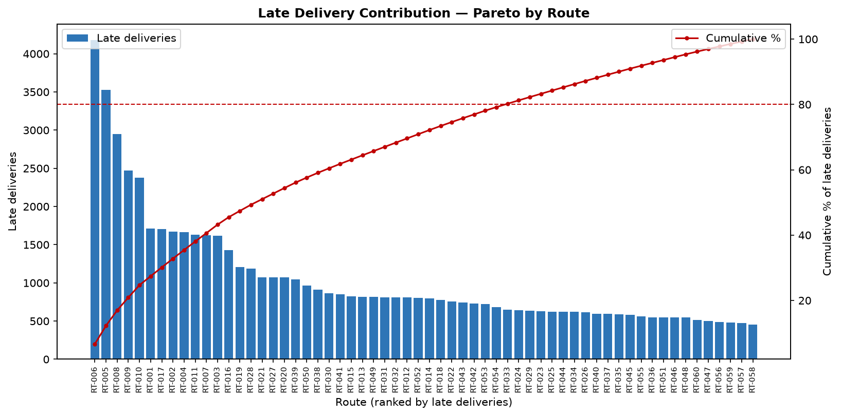
Figure 8 — Pareto of late deliveries by route, 2025 (synthetic data). 39 of 61 routes account for 80% of late deliveries.

Where the late deliveries come from
Late deliveries total 63,118. Their concentration is moderate: 39 of 61 routes account for 80% of them — a Pareto pattern, but not an extreme one (an 80/20 split would need only ~12 routes). Fixing a handful of routes will not fix the network; the improvement programme in §19 therefore targets segments (corridors, warehouses, a category), not single routes.
Top 5 routes by share of late deliveries | Share of all late deliveries
RT-006 | 6.63%
RT-005 | 5.58%
RT-008 | 4.67%
RT-009 | 3.92%
RT-010 | 3.76%

RT-006 alone contributes 6.63% of all late deliveries (4,182 late on 10,938 shipments) and RT-005 a further 5.58% (3,525 late). Together the top five routes contribute 24.56% of late deliveries.
Destination hub | Share of all late deliveries
GAU | 16.42%
MLD | 14.02%
RNC | 11.32%
BBS | 9.53%
JSR | 9.43%
CTC | 6.3%
ASN | 5.9%
PAT | 5.81%
SIL | 5.81%
DGP | 5.8%
HWH | 5.55%
KOL | 4.11%

By destination hub the concentration is sharper: Guwahati 16.42%, Malda 14.02% and Ranchi 11.32% — 41.76% of all late deliveries end at just three of the twelve hubs. Bhubaneswar (9.53%) and Jamshedpur (9.43%) are the next largest contributors; Kolkata, the largest hub by volume, contributes only 4.11% of late deliveries because its OTD is high (83.66%).
Category | Share of all late deliveries
Frozen | 33.1%
Chilled | 25.45%
Ambient | 17.43%
Dairy | 15.91%
Pharma | 7.82%
Unknown | 0.28%

By category, Frozen alone is 33.10% of late deliveries (20,895 late) and Chilled a further 25.45%; Pharma, despite being the most expensive category, is only 7.82%. By vehicle type the shares are almost identical (19.83–20.27% each) — vehicle type contributes nothing to the explanation of lateness, which rules it out as a root cause in this data.

Root-cause reading (what the data supports — and what it does not)
- 1. Destination, not origin. Destination-side performance dominates: destination-hub OTD spans 30 pp while origin-hub OTD spans 3.5 pp, and the three worst destination hubs contribute 41.76% of late deliveries. The cause sits at or after arrival at Guwahati / Malda / Ranchi, not at departure.
- 2. Frozen cold-chain reliability. Frozen is the weakest category in every month and contributes a third of all late deliveries while being the second most expensive category — a cold-chain reliability problem (reefer performance, handling, or route planning for frozen loads), not a price problem.
- 3. Reliability ≠ cost. The worst routes are unreliable, not expensive: bottom-decile route costs overlap top-decile route costs. Cost control and reliability improvement are separate workstreams on these routes.
- 4. Dwell does not explain the OTD gap. Destination dwell is uniformly ~15.5 h everywhere, so it cannot explain a 30 pp OTD gap between hubs. Either the dwell measure (arrival→departure at the hub) misses the delay (e.g. time from departure to final delivery, or queueing before arrival is recorded), or the lateness is created in transit before the destination scan. The data as built cannot distinguish these two — see §20.
- 5. Structural, not seasonal. Monthly and half-year variation is negligible (H1 vs H2: 0.02 pp), and the hub/category rankings are stable in all 12 months, so the pattern is structural. A seasonal or one-off explanation is not supported.
What is NOT claimed as a root cause: no causal analysis was run (no regression, no controlled comparison), and the synthetic generator's own parameters (e.g. which hubs/routes were given lower on-time rates) are the mechanical cause of the patterns. The 'root causes' above are therefore the best-supported interpretation of the observed segments, to be tested on real operational data — not proven causes.

16. Business Impact Assessment
Impact is modelled, not forecast: bottom-quartile routes and warehouses are assumed to converge to the network median, with no causal mechanism assumed and no implementation costs, capacity constraints or customer-behaviour changes included. All figures are on synthetic data and are not a forecast of real savings.

Method
- Routes — OTD. Rank the 60 routes by OTD; the bottom quartile (15 routes, threshold 73.69% OTD) currently averages 66.07% OTD on 69,332 eligible shipments. Lifting them to the median route OTD (80.06%) avoids 9,706 late deliveries.
- Routes — cost. Rank the same routes by cost per shipment; the bottom (most expensive) quartile (15 routes, threshold ₹4,122.72) averages above the median route cost (₹4,099.68) on 68,420 valid-cost shipments. Closing that gap saves ₹31,13,832.63.
- Warehouses — dwell. Rank the 24 warehouses by average destination dwell; the bottom quartile (7 warehouses, threshold 15.57 h) sits above the median warehouse dwell (15.51 h) on 49,282 shipments. Closing that gap recovers 4,295.8 excess dwell hours. Dwell savings are reported in hours because no verified per-hour handling cost exists in the data — they are not converted to rupees.

Scenarios
Scenario | Gap closed | Late deliveries avoided | Potential cost saving | Excess dwell hours recovered
Conservative | 50% | 4,853 | ₹15,56,916.31 | 2,147.9
Realistic | 100% (to median) | 9,706 | ₹31,13,832.63 | 4,295.8
Optimistic | 100% + 10% efficiency gain | 9,706 | ₹34,25,215.89 | 4,295.8

Reading the realistic scenario in context: avoiding 9,706 late deliveries would cut total late deliveries from 63,118 to 53,412 and lift network OTD from 76.48% to about 80.09% — still below the 85% GREEN threshold, which shows that median convergence of the bottom quartile alone does not fix the network; the median itself (80.06% route OTD) is below target. The ₹31.14 lakh cost saving is 0.26% of total valid cost (₹1,204,074,833.69) — real money, but small relative to the network, because route costs vary so little. The largest prize is service (late deliveries avoided), not cost.
Assumptions (from kpi_summary.json, reproduced verbatim in substance): modelled estimates on synthetic data, not a forecast of real savings; improvement is modelled as convergence to the median with no causal mechanism assumed; cost saving uses the route cost-per-shipment gap only; dwell-hour savings are reported in hours because no verified per-hour handling cost exists; no behaviour change, capacity constraints or implementation costs are included; the optimistic scenario adds a further 10% efficiency gain on top of median convergence and is not guaranteed.

17. KPI Scorecard
Thresholds are justified below the table. They are management targets set for this review, not values found in the data: the data contains no external benchmark, service-level agreement or prior-year target, so the thresholds are stated as judgements and can be re-set when a real benchmark exists.
KPI | 2025 result | GREEN | AMBER | RED | Status
On-time delivery | 76.48% | ≥ 85% | 75–85% | < 75% | AMBER
Cost per shipment | ₹4,102.68 | ≤ ₹4,000 | ₹4,000–4,500 | > ₹4,500 | AMBER
Avg destination dwell | 15.49 h | ≤ 12 h | 12–18 h | > 18 h | AMBER
Avg origin dwell | 2.5 h | ≤ 3 h | 3–5 h | > 5 h | GREEN
Data quality | 38/38 checks passed; 0% variance; 100% changed-record logging | All checks pass | Minor gaps logged | Checks failing | GREEN

Threshold justification:
- OTD — GREEN ≥ 85%. 85% is a stretching but attainable service target: the best hubs already achieve 83.9%, and the best routes 83.4%, so 85% is just above current best practice rather than an arbitrary round number. At 76.48% the network is 8.52 pp short — AMBER, not RED, because it is within 10 pp of GREEN and the top of the network is close to the target.
- Cost — GREEN ≤ ₹4,000. ₹4,000 is just below the cheapest high-volume category cost structure (Ambient ₹2,560.95 is the floor; the network median route cost is ₹4,099.68), so GREEN requires beating the current median. ₹4,102.68 sits ₹102.68 above GREEN and well inside the ₹4,000–4,500 AMBER band. RED above ₹4,500 would require a cost level no segment in the data reaches.
- Destination dwell — GREEN ≤ 12 h. 12 h is roughly a working shift and is below every hub's current destination dwell (15.40–15.57 h), so GREEN requires a genuine process change; 18 h bounds the AMBER band above anything observed. At 15.49 h the network is AMBER. Origin dwell (2.5 h) is GREEN against a 3 h threshold, showing the origin side is not the problem.
- Data quality — GREEN. GREEN is awarded on evidence, not on a numeric threshold: 100% of changed records logged (200,528 records), 19 cleaning-log issue rows, and 38/38 independent validation checks passed with 0% variance against a 0.5% tolerance.
Overall verdict: three of the four scored lines are AMBER and one (origin dwell) plus data quality are GREEN. The network is not failing — it is consistently mediocre, with its weakness concentrated in three destination hubs, the Frozen category and the bottom-quartile routes.

18. Key Findings
- 1. OTD is 76.48% — AMBER, 8.52 pp below the 85% GREEN target. 268,330 eligible shipments; 63,118 late; 205,212 on time.
- 2. Cost per shipment is ₹4,102.68 — AMBER. 293,485 valid-cost shipments; total valid cost ₹1,204,074,833.69.
- 3. Destination dwell averages 15.49 h — AMBER; origin dwell 2.5 h — GREEN. Destination dwell is ~6× origin dwell at every hub; combined 8.9 h.
- 4. Performance is flat all year. Monthly OTD 75.72–77.04%; H1 76.49% vs H2 76.47% (0.02 pp). No seasonal pattern; no true year-over-year exists.
- 5. Three destination hubs drive the problem. Guwahati 53.95%, Malda 61.89%, Ranchi 69.04% OTD; together 41.76% of all late deliveries. Best hubs ~83.9%.
- 6. Origin performance is uniform. Origin-hub OTD spans only 75.26–78.80%. The problem is at/after destination arrival, not departure.
- 7. Frozen is the weakest and one of the most expensive categories. 72.06% OTD; 33.10% of late deliveries; ₹4,466.98 per shipment. Pharma is best (84.59%) and most expensive (₹7,226.40).
- 8. The worst routes are unreliable, not expensive. Bottom-decile routes 57.11–65.25% OTD vs top-decile 82.83–83.41%; costs overlap (₹4,052–₹4,140 vs ₹4,054–₹4,134).
- 9. Vehicle type does not matter. OTD 76.24–76.64% and cost ₹4,095.95–₹4,107.20 across all five vehicle types; late-delivery shares 19.83–20.27% each.
- 10. Late deliveries are moderately concentrated. 39 of 61 routes account for 80% of late deliveries; top five routes 24.56%. No single-route fix suffices.
- 11. Dwell varies too little to explain the OTD gap. Warehouse destination dwell spans 15.21–15.95 h; hub destination dwell 15.40–15.57 h. Dwell is a network-wide condition, not a local failure.
- 12. The realistic improvement prize is service, not cost. 9,706 late deliveries avoided, ₹31,13,833 saved, 4,295.8 dwell hours recovered — but even then network OTD would reach only ~80.09%, still below the 85% target.
- 13. Data quality and validation are strong. 200,528 changed records logged (100% coverage); 19 cleaning-log rows; 38/38 validation checks passed at 0% variance (tolerance 0.5%).

19. Three Business Recommendations
Each recommendation names an owner and a monitoring metric, as required. All three are framed for the fictional network on synthetic data; on real data the same actions would need a costed pilot before network-wide rollout.
# | Recommendation | Owner | Monitor | Expected effect (modelled, realistic scenario)
1 | Guwahati / Malda / Ranchi corridor recovery — dedicated route planning for the corridors serving GAU, MLD and RNC (including the worst routes RT-006, RT-005, RT-017, RT-028) and a hub capacity review at the three destination hubs (unloading bays, staffing, onward dispatch). Start with a diagnostic week on the ground at each hub before changing schedules. | Operations | Destination-hub OTD (GAU, MLD, RNC) monthly; route OTD for RT-005/RT-006/RT-017/RT-028 | Largest share of the 9,706 late deliveries avoided; these three hubs are 41.76% of all late deliveries
2 | Destination-hub dwell reduction — unloading-slot scheduling and labour planning at the bottom-quartile warehouses (7 warehouses, dwell threshold 15.57 h), prioritising WH-CTC-1 (15.95 h) and WH-MLD-2 (15.64 h). Book arrival slots against planned unloading capacity instead of first-come-first-served, and staff to the arrival profile rather than a flat roster. | Warehouse Operations | Average destination dwell (h) by warehouse, weekly; bottom-quartile warehouse dwell vs 15.51 h median | 4,295.8 excess dwell hours recovered (realistic scenario); note the prize is modest because dwell varies little — treat this as a service/throughput action, not a cost action
3 | Frozen-category cold-chain reliability + cost control on bottom-quartile routes — reefer maintenance checks (pre-trip temperature-proving) for Frozen loads, and a route cost review on the 15 bottom-quartile cost routes (threshold ₹4,122.72). Pair the two: a Frozen load on an unreliable route is the highest-risk combination in the data. | Fleet & Category Management | Category OTD (Frozen) monthly; route cost per shipment on bottom-quartile routes | Frozen OTD up from 72.06% toward the 76.48% network average and beyond; ₹31,13,833 potential saving (realistic scenario)

Sequencing: start Recommendation 1 first (it addresses 41.76% of late deliveries); run Recommendation 3 in parallel for Frozen loads on those same corridors, since the two overlap; run Recommendation 2 as a steady throughput programme rather than a one-off fix, and re-measure dwell at a finer grain (arrival-hour and bay-level) before judging it, given the narrow dwell spread in this dataset. Re-run the full KPI pack monthly from the trusted table and re-validate (38 checks, 0.5% tolerance) on each run; a recommendation whose monitoring metric does not move within one quarter should be re-diagnosed, not simply continued.

20. Limitations
- Synthetic data. Every finding describes a simulated network (seed 42), not a real company. Volumes, rates, costs and hub behaviours were generated, including the injected defects. Nothing here should be quoted as a fact about any real distributor, and the business-impact figures are modelled estimates, not forecasts of real savings.
- One year only; no true year-over-year. The data covers 2025 only. H1 vs H2 2025 is the prior-period comparison; it cannot show annual growth, seasonality across years, or a trend. Monthly patterns within a single year cannot separate seasonality from noise.
- No causal analysis. All segment comparisons are descriptive. The report identifies where lateness concentrates, not why it happens in a causal sense; the generator's parameters are the mechanical cause of the simulated patterns. Route, hub and category effects are confounded in this design (e.g. the worst routes serve the worst hubs), and no regression or controlled comparison was run to separate them.
- Dwell does not explain the OTD gap. Destination dwell is nearly identical across hubs (15.40–15.57 h) while OTD spans 30 pp, so the dwell measure as built (arrival→departure at the hub) misses where the delay is created — possibly in transit before the destination scan, or between departure and final delivery. Finer-grained timestamps would be needed to locate it.
- Cost data is thin. Cost per shipment varies little by route, hub or vehicle (₹4,024–₹4,196 across routes), and no per-hour handling cost, fuel, labour or penalty cost exists in the data — so dwell savings cannot be converted to rupees and the cost-saving estimate uses the route cost gap only. Implementation costs and capacity constraints are excluded from the impact model.
- Thresholds are judgements. The scorecard thresholds (§17) are management targets set for this review; no external benchmark, SLA or prior-year target exists in the data to anchor them.
- Power BI is a build, not a delivered dashboard. A .pbix cannot be generated programmatically. The project provides cleaned datasets, DAX measures and a build guide; the dashboard itself must be built by hand in Power BI Desktop (see §10 and the Appendix), and the powerbi/ folder was empty when this report was built.
- Validation scope. The 38 validation checks reconcile counts, KPI recomputation and referential integrity. They do not validate the synthetic generator's realism, the choice of KPI definitions, or the business-impact assumptions — those remain judgements documented in §§11, 16 and 17.
- Small 'Unknown' segments. 857 shipments have 'Unknown' category, 1,521 are on the UNKNOWN route and 1,429 have a missing vehicle_id. These are small (≤0.5% each) and are retained as Unknown members rather than dropped, but their KPI values (e.g. Unknown category OTD 76.66%) are based on small samples and should not be over-interpreted.
A note on a figure that looks inconsistent but is not: data/processed/cleaning_summary.json records 'otd_eligible_shipments' as 288,252, while the KPI calculation and the independent validation both give 268,330. The two numbers count different things, verified against the trusted table itself: 288,252 is the number of shipments with a non-null on_time flag, i.e. with both timestamps valid (220,433 on time + 67,819 late on that flag); 268,330 is the OTD-eligible denominator in §11, which additionally requires status Delivered or Delayed (279,211 shipments carry those two statuses). The 19,922 difference is shipments with valid timestamps but another status (In Transit, Cancelled or Returned). The 268,330 figure is the one used for every OTD number in this report; the 288,252 figure is a timestamp-validity count, not an OTD denominator, and the cleaning_summary.json label is misleading rather than the data being wrong. The project owner should relabel that field to avoid the confusion.

21. Conclusion
In 2025, on synthetic data, this fictional cold-chain network delivered on time 76.48% of the time at ₹4,102.68 per shipment, with freight spending an average of 15.49 hours at its destination hub. All three headline KPIs are AMBER: not failing, but below the targets a well-run cold chain should meet, and flat across the year — H1 and H2 differ by 0.02 pp, so time alone is not fixing anything.
The diagnosis is concentrated enough to act on: three destination hubs (Guwahati, Malda, Ranchi) produce 41.76% of late deliveries; the Frozen category produces a third; the bottom-quartile routes are unreliable rather than expensive; and vehicle type and origin hub are not drivers. The modelled prize for bringing the bottom quartile up to the median is 9,706 late deliveries avoided, ₹31,13,833 saved and 4,295.8 dwell hours recovered — meaningful, but still short of the 85% OTD target, which means the median itself must rise, not just the tail.
The project's other deliverable is trust in the numbers: a fully logged clean (200,528 changed records), a star-schema trusted table, and 38/38 validation checks passed at 0% variance. That pipeline — not any single number in this report — is what transfers to real data. The next step is the three recommendations in §19, measured monthly against the scorecard in §17, starting with the Guwahati / Malda / Ranchi corridors.

22. Appendix

A. Source files and traceability
Artefact | Location
KPI summary (headline figures) | outputs/kpi_reports/kpi_summary.json
Monthly / half-year KPIs | outputs/kpi_reports/monthly_kpi.csv, half_year_kpi.csv
Hub KPIs (destination / origin) | outputs/kpi_reports/hub_destination_kpi.csv, hub_origin_kpi.csv
Route / warehouse KPIs | outputs/kpi_reports/route_kpi.csv, warehouse_kpi.csv
Category / vehicle KPIs | outputs/kpi_reports/category_kpi.csv, vehicle_type_kpi.csv
Cohort tables | outputs/kpi_reports/cohort_month_category.csv, cohort_month_hub.csv
Decile shipment files | outputs/kpi_reports/bottom10pc_shipments.csv, top10pc_shipments.csv
Data-quality report + checks | outputs/kpi_reports/data_quality_report.md, data_quality_checks.json
Column profiles | outputs/kpi_reports/column_profile_shipments.csv, column_profile_scans.csv
Cleaning log | outputs/cleaning_logs/cleaning_log.csv (19 rows) + changed_records.parquet
Cleaning summary | data/processed/cleaning_summary.json (its 'otd_eligible_shipments' field is a timestamp-validity count, 288,252 — see §20; the OTD denominator used in this report is 268,330)
Validation report | outputs/validation_report.md (38/38 PASS, 0% variance)
Generation manifest | data/raw/generation_manifest.json (seed 42)
Raw data | data/raw/shipments_raw.parquet, scan_events_raw.parquet
Cleaned data | data/processed/shipments_clean.parquet, scan_events_clean.parquet, trusted_analysis_table.parquet
Dimensions | data/reference/dim_hub.csv, dim_route.csv, dim_vehicle.csv, dim_warehouse.csv, dim_category.csv, dim_date.csv, hub_crosswalk.csv
Charts (Figures 1–8) | visualizations/01_monthly_otd_trend.png … 08_late_delivery_pareto.png
Pipeline code | src/generate_data.py, data_profiling.py, data_cleaning.py, data_transformation.py, kpi_calculations.py, validation.py, visualizations.py
This report's builder | src/build_report.py

B. Validation summary (38/38 checks passed, 0% variance)
Reconciliation tolerance: 0.5% unless stated 0. Result: 38 passed, 0 failed, 38 checks (outputs/validation_report.md). Every check below passed with 0.0% variance.
Check group | Checks | What was verified
Row counts | 10 | Raw/clean shipments (304,500 / 300,000), raw/clean scans (1,200,000 / 1,194,000), totals (1,504,500 / 1,494,000), removals = injected duplicates/orphans (4,500 / 6,000), trusted-table rows and unique shipment_ids (300,000)
Headline KPIs (recomputed) | 8 | OTD % 76.48, eligible 268,330, late 63,118, cost/shipment ₹4,102.68, total valid cost ₹1,204,074,833.69, valid-cost shipments 293,485, destination dwell 15.49 h, origin dwell 2.5 h
Breakdown sums | 6 | Monthly, destination-hub, route, category and warehouse shipment sums all = 300,000; monthly eligible sum = 268,330
Referential integrity | 5 | Origin/destination hubs in Dim_Hub; routes in Dim_Route (+UNKNOWN); vehicles in Dim_Vehicle (+UNKNOWN/Unknown); warehouses in Dim_Warehouse
Validity flags | 2 | No negative costs in the valid-cost set; no negative dwell in the valid dwell set
Cleaning-log coverage | 4 | 19 log rows (one per issue type); changed records > 0 and cover duplicate removals and orphan scans
Post-cleaning state | 3 | 0 duplicate shipment_ids in the trusted table; 0 shipments with out-of-order scans after cleaning; raw-file cost recomputation matches the trusted table

Note: the validation report itself notes that the raw-cost reconciliation re-applies the cleaning rules directly to the raw file and that the small difference vs the trusted table comes from the most-complete-record dedupe rule (cleaning keeps the most complete copy, not always the first); the variance column still records 0.0% for that check. 'Shipments with out-of-order scans after cleaning' is 0 by construction (scan_sequence is assigned after sorting by UTC).

C. DAX measures for Power BI (to be placed in powerbi/)
A .pbix cannot be generated programmatically. Paste these measures into Power BI Desktop after importing trusted_analysis_table.parquet and relating the dimensions (§10). 'Trusted' is the fact table. Column names below are the actual columns of trusted_analysis_table.parquet, verified at build time: on_time (nullable boolean — blank where either timestamp is missing), cost_valid, dwell_dest_h / dwell_origin_h, dwell_dest_valid / dwell_origin_valid, status, shipment_cost_inr.
OTD Eligible Shipments: OTD Eligible Shipments = CALCULATE ( COUNTROWS ( Trusted ), Trusted[status] IN { "Delivered", "Delayed" }, NOT ( ISBLANK ( Trusted[on_time] ) ) )
OTD %: OTD % = DIVIDE ( CALCULATE ( COUNTROWS ( Trusted ), Trusted[status] IN { "Delivered", "Delayed" }, Trusted[on_time] = TRUE () ), [OTD Eligible Shipments] )
Late Deliveries: Late Deliveries = CALCULATE ( COUNTROWS ( Trusted ), Trusted[status] IN { "Delivered", "Delayed" }, Trusted[on_time] = FALSE () )
Cost per Shipment: Cost per Shipment = DIVIDE ( CALCULATE ( SUM ( Trusted[shipment_cost_inr] ), Trusted[cost_valid] = TRUE () ), CALCULATE ( COUNTROWS ( Trusted ), Trusted[cost_valid] = TRUE () ) )
Total Valid Cost: Total Valid Cost = CALCULATE ( SUM ( Trusted[shipment_cost_inr] ), Trusted[cost_valid] = TRUE () )
Avg Destination Dwell (h): Avg Destination Dwell (h) = CALCULATE ( AVERAGE ( Trusted[dwell_dest_h] ), Trusted[dwell_dest_valid] = TRUE () )
Avg Origin Dwell (h): Avg Origin Dwell (h) = CALCULATE ( AVERAGE ( Trusted[dwell_origin_h] ), Trusted[dwell_origin_valid] = TRUE () )
Caution on the on_time flag: in the trusted table on_time is set for every shipment with both timestamps valid (288,252 shipments: 220,433 TRUE, 67,819 FALSE), regardless of status — so an OTD measure that counts on_time without the status filter would overstate the denominator. The measures above always filter status to Delivered/Delayed, matching the KPI definition in §11 (268,330 eligible, 63,118 late). dwell_dest_valid / dwell_origin_valid are blank for 4,357 shipments with no dwell record; the = TRUE() filter excludes those as well as the FALSE (negative-dwell) rows.

D. Power BI build guide (summary)
- Import data/processed/trusted_analysis_table.parquet (and, for the scan-level dwell view, scan_events_clean.parquet) into Power BI Desktop.
- Import the dimension CSVs from data/reference/ and create relationships: Trusted[destination_hub] → Dim_Hub[hub_id] (and origin_hub → Dim_Hub), Trusted[route_id] → Dim_Route[route_id], Trusted[vehicle_id] → Dim_Vehicle[vehicle_id], Trusted[warehouse_id] → Dim_Warehouse[warehouse_id], Trusted[category] → Dim_Category[category], Trusted[shipment_date] → Dim_Date[date]. Use the UNKNOWN/Unknown members already present in the dimensions.
- Paste the DAX measures from §C.
- Build eight views matching Figures 1–8: monthly OTD trend; hub OTD comparison; hub dwell; route ranking; category performance; cost per shipment; warehouse performance; late-delivery Pareto.
- Add the scorecard (§17) as a KPI visual set with the GREEN/AMBER/RED thresholds, and a 'SYNTHETIC DATA — seed 42' label on every page.
- Save as .pbix in powerbi/ (this step is manual — no script in this project can produce a .pbix).

E. Figure and table list
- Figure 1 — Monthly OTD % and cost per shipment (01_monthly_otd_trend.png)
- Figure 2 — Cost per shipment by segment (06_cost_per_shipment.png)
- Figure 3 — OTD % by destination hub (02_hub_otd_comparison.png)
- Figure 4 — Route OTD ranking (04_route_performance_ranking.png)
- Figure 5 — Average dwell time by hub (03_hub_dwell_time.png)
- Figure 6 — Warehouse performance (07_warehouse_performance.png)
- Figure 7 — OTD % and cost by product category (05_category_performance.png)
- Figure 8 — Pareto of late deliveries by route (08_late_delivery_pareto.png)
Author: Khushi Tomar — Yuva Intern, Logistics Data Analytics Specialist Internship. November 2026. All data synthetic (seed 42); not real company data.

