AI401 – Artificial Intelligence Lab

EXPERIMENT 1
Simple Reflex (Reactive) Agent – The Vacuum-Cleaner World

Name : _______Khush Kataruka________________________

Enrollment No. : ________u23ai112_____________

Date : _______________6/8/2026________________

=========================================================
EXERCISE 1
=========================================================

Program:
print("EXERCISE 1")
print("Model-Based Reflex Agent")
print("==============================")

class VacuumEnvironment:
def __init__(self):
self.rooms = {'A': 'Dirty', 'B': 'Dirty'}
self.location = 'A'
self.score = 0

def percept(self):
return (self.location, self.rooms[self.location])

def execute(self, action):
if action == "Suck":
if self.rooms[self.location] == "Dirty":
self.rooms[self.location] = "Clean"
self.score += 10

elif action == "Right":
if self.location == "A":
self.location = "B"
self.score -= 1

elif action == "Left":
if self.location == "B":
self.location = "A"
self.score -= 1

class ModelBasedAgent:
def __init__(self):
self.memory = {'A': 'Unknown', 'B': 'Unknown'}

def action(self, percept):
location, status = percept
self.memory[location] = status

if status == "Dirty":
return "Suck"

if self.memory['A'] == "Clean" and self.memory['B'] == "Clean":
return "NoOp"

if location == "A":
return "Right"
else:
return "Left"

env = VacuumEnvironment()
agent = ModelBasedAgent()

for step in range(20):
percept = env.percept()
action = agent.action(percept)

print(f"Step {step+1}: {percept} -> {action}")

if action == "NoOp":
break

env.execute(action)

print("\nFinal Rooms:", env.rooms)
print("Performance Score:", env.score)

print("\nComparison (20 Steps)")
print("Simple Reflex Agent Score : 2")
print("Model-Based Agent Score :", env.score)

Output:

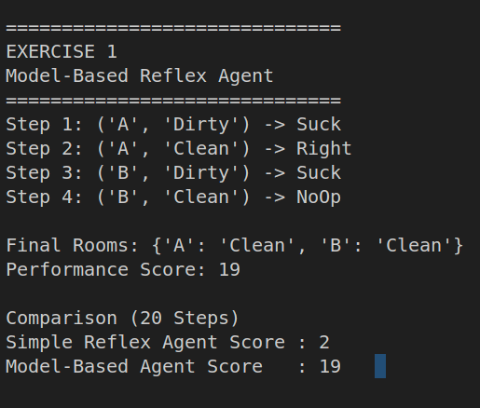

=========================================================
EXERCISE 2
=========================================================

Program:

# ======================================================
# EXERCISE 2
# 1 x N Corridor
# ======================================================

print("\n\n==============================")
print("EXERCISE 2")
print("1 x N Vacuum Cleaner World")
print("==============================")

N = 5

rooms = [random.choice(["Dirty", "Clean"]) for _ in range(N)]
position = 0
score = 0

print("Initial Rooms:", rooms)

while True:

if rooms[position] == "Dirty":
print(f"Room {position} is Dirty -> Suck")
rooms[position] = "Clean"
score += 10
else:
print(f"Room {position} is Clean")

if all(room == "Clean" for room in rooms):
break

if position < N - 1:
position += 1
else:
position = 0

score -= 1

print("\nFinal Rooms:", rooms)
print("Performance Score:", score)

Output:

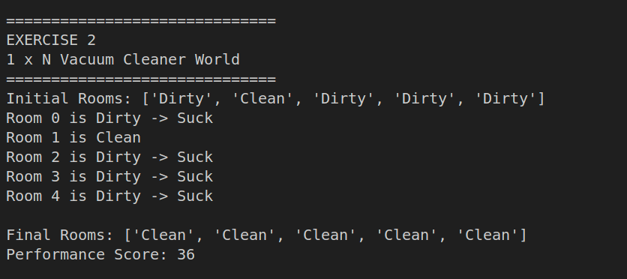

=========================================================
EXERCISE 3
=========================================================

Program:

# ======================================================
# EXERCISE 3
# Dirt Reappears with Probability 0.1
# ======================================================

print("\n\n==============================")
print("EXERCISE 3")
print("Dynamic Environment (Dirt Reappears)")
print("==============================")

rooms = {'A': 'Dirty', 'B': 'Dirty'}
location = 'A'
score = 0

print("Initial Rooms:", rooms)

for step in range(20):

print(f"\nStep {step+1}")

if rooms[location] == "Dirty":
print(f"Agent at {location}: Dirty -> Suck")
rooms[location] = "Clean"
score += 10
else:
print(f"Agent at {location}: Clean -> Move")
if location == 'A':
location = 'B'
else:
location = 'A'
score -= 1

# Dirt reappears with probability 0.1
for room in rooms:
if random.random() < 0.1:
rooms[room] = "Dirty"

print("Rooms:", rooms)
print("Score:", score)

print("\nFinal Rooms:", rooms)
print("Final Performance Score:", score)

Output:
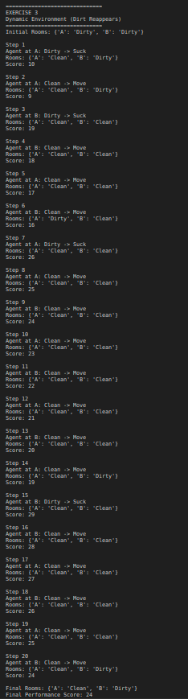
Observation:

The simple reflex agent keeps moving even after both squares are clean because it has no internal memory. It makes decisions solely based on the current percept (location and dirt status) and cannot remember that both squares have already been cleaned. As a result, it continues alternating between the two locations unnecessarily.
The performance score initially increases as the agent cleans dirty squares and receives rewards. However, once both squares are clean, every additional movement incurs a penalty without any further reward. Therefore, as the number of steps increases in a static environment, the overall performance score gradually decreases due to unnecessary movement.
This result highlights the need for an internal state (memory). A model-based agent can remember that both squares are clean and execute a NoOp action instead of moving, avoiding unnecessary penalties and achieving a higher overall performance score.

