

**Blog Management System (Basic Version) for even roll number**

**Description:**  
Create a simple blog system where users can view posts and add new ones.

**Requirements:**

* Use **Express.js** for routing.
* Serve **EJS templates** for rendering pages.
* Implement **GET** and **POST** routes:
  + GET /posts → Display all blog posts from a file (posts.json).
  + GET /post?id=1 → Display a single post based on query parameter.
  + POST /add-post → Add a new post (save data to posts.json).
* Use **middleware** to log request details.
* Use the **fs module** to read and write data to posts.json.

**Project Overview:**

The application will allow users to:

1. View all blog posts.
2. View a single blog post by its ID.
3. Add new blog posts.
4. Use middleware to log incoming requests.
5. Store blog posts in a JSON file (posts.json).

*You should use below folder structure-*

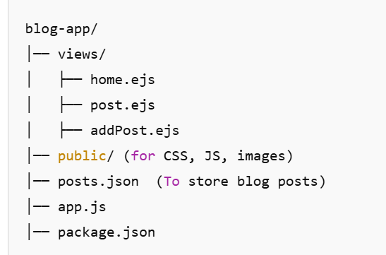

Figma Design Reference:-

https://www.figma.com/design/WjBT2MLvtdDZOJyif1wMWN/Free-Blog-Template--%7C-Modern-%26-Creative-design-(Community)?node-id=2101-21306&t=eVMnQDS5vrpgME5Y-1

**To-Do List App for odd roll number**

**Description:**  
Develop a backend for a to-do list application where users can add and view tasks.

**Requirements:**

* **GET /tasks** → Show all tasks (read from tasks.json).
* **GET /task?id=1** → Fetch a specific task.
* **POST /add-task** → Add a new task.
* Use **middleware** to log request timestamps.
* Use **EJS** to render tasks dynamically.
* Store tasks in a JSON file using **fs module**.

**Project Overview:**

Develop a backend for a simple **To-Do List application** where users can:

1. View all tasks.
2. View a specific task by ID.
3. Add new tasks.
4. Use middleware for request logging.
5. Store tasks in tasks.json.

*You should use below folder structure-*

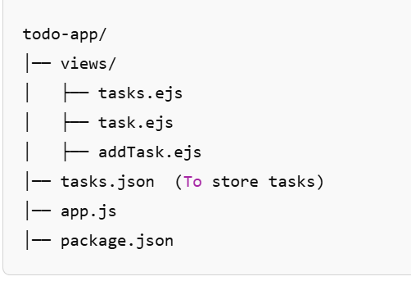

Figma Design Reference:-

https://www.figma.com/design/E8HPNTH0Tcfl0ZnWPX03zb/Simple-ToDo-List-Design-(Community)?node-id=1-2&t=OvwVB1kLagD8lL2b-1