*J.P.Dawar Institute of Information Science & Technology*

Relational Database Management System

*Topic of Submission:*

Cricket Management System

Semester: 4

Division: A

Team Members

|  |  |
| --- | --- |
| Roll no. | Name |
| 18 | Chauhan krishna |
| 28 | Desai Shivani |
| 32 | Dumasia khushnaaz |
| 33 | Gadhiya Yashvi |
| 35 | Gajera janki |

**Guided By:** Prof. Maitri Hingu.

Create Tables and Inserting Data:

**TABLE – 1: Team**

CREATE TABLE TEAM(team_id VARCHAR(30) PRIMARY KEY,

team_rank NUMERIC(3),

team_name VARCHAR(20) NOT NULL,

country_name VARCHAR(20),

no_of_wins NUMERIC(3),

no_of_loses NUMERIC(3),

no_of_draws NUMERIC(3),

no_of_bowlers NUMERIC(2),

no_of_batsmans NUMERIC(2));

INSERT INTO TEAM VALUES('IND1221', 1, 'MEN IN BLUE','INDIA', 5, 1, 0, 6, 7);

INSERT INTO TEAM VALUES('AUS2174', 4, 'KANGAROO','AUSTRAILA', 3, 3, 0, 5, 6);

INSERT INTO TEAM VALUES('SA5412', 3, 'PROTEA','SOUTH AFRICA', 3, 2, 1, 8, 5);

INSERT INTO TEAM VALUES ('NZ5687', 2, 'BLACK CAPS','NEW ZEALAND', 4, 2, 0, 6,7);

INSERT INTO TEAM VALUES('BAN9852', 5, 'TIGERS','BANGLADESH', 2, 4 , 0, 7, 7);

select * from team;

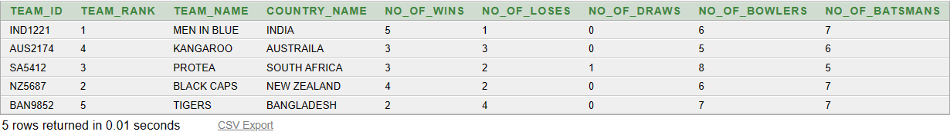

**TABLE – 2: wicket_keeper**

CREATE TABLE WICKET_KEEPER(

team_id VARCHAR(30),

wk_name VARCHAR(30),

foreign key(team_id) references team(team_id));

INSERT INTO WICKET_KEEPER VALUES('IND1221','MS Dhoni');

INSERT INTO WICKET_KEEPER VALUES('IND1221','Dinesh Kartik');

INSERT INTO WICKET_KEEPER VALUES('AUS2174','Tim Lee');

INSERT INTO WICKET_KEEPER VALUES('AUS2174','Peter Hegward');

INSERT INTO WICKET_KEEPER VALUES('AUS2174','Hefer Kingsly');

select * from wicket_keeper;

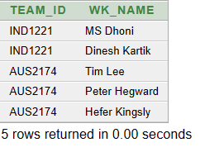

**TABLE – 3: umpire**

CREATE TABLE UMPIRE(

umpire_id VARCHAR(30) PRIMARY KEY,

umpire_name VARCHAR(30),

no_of_matches NUMERIC(4),

country VARCHAR(20));

INSERT INTO UMPIRE VALUES ('UMP41002', 'Kumar Dharmasena', 103, 'Sri Lanka');

INSERT INTO UMPIRE VALUES ('UMP74101', 'Aleem Dar', 207, 'Pakistan');

INSERT INTO UMPIRE VALUES ('Ump52410', 'Anil Chaudhary', 19, 'India');

INSERT INTO UMPIRE VALUES ('UMP85201', 'Ian Gould', 140, 'England');

INSERT INTO UMPIRE VALUES ('UMP55200', 'Tony Hill', 96, 'New Zealand');

select * from umpire;

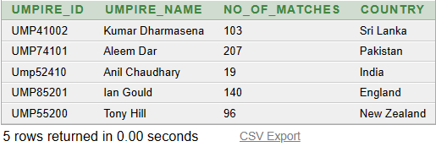

**TABLE – 4: player**

CREATE TABLE PLAYER (

player_id VARCHAR(30) PRIMARY KEY,

team_id VARCHAR(30),

no_of_matches NUMERIC(3),

no_of_t20 NUMERIC(3),

no_of_odi NUMERIC(3),

no_of_test NUMERIC(3),

no_of_wickets NUMERIC(2),

type_of_bowler VARCHAR(30),

economy NUMERIC(3,2),

foreign key(team_id) references team(team_id));

INSERT INTO PLAYER VALUES ('PLR17410', 'IND1221',13,74,120,20,1,'medium',3.2);

INSERT INTO PLAYER VALUES ('PLR74203', 'AUS2174',6,41,210,140 ,1,'slow',8.5);

INSERT INTO PLAYER VALUES ('PLR45987', 'SA5412', 4,24,63,65,1,'mslow',9.2);

INSERT INTO PLAYER VALUES ('PLR20147', 'NZ5687',12,52 ,10,74,1,'legspin',8.3);

INSERT INTO PLAYER VALUES ('PLR65200', 'BAN9852',9,77, 30,2,1,'fast',7.3);

INSERT INTO PLAYER VALUES ('PLR75401', 'IND1221', 11,56, 23,5,7,'fast',5.3);

select * from player;

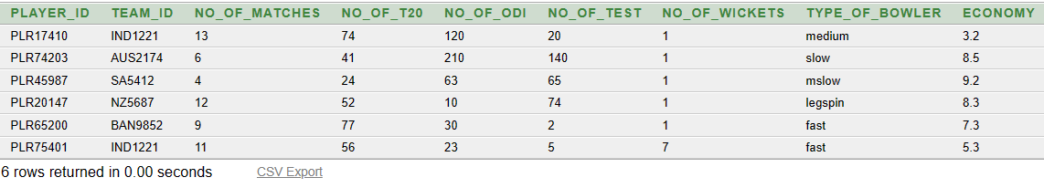

**TABLE – 5: matches**

CREATE TABLE MATCHES(

match_id VARCHAR(20) PRIMARY KEY,

match_date DATE,

team_1_name VARCHAR(30),

team_2_name VARCHAR(30),

loser VARCHAR(30),

winner VARCHAR(30),

stadium VARCHAR(30),

umpire_id VARCHAR(30) ,

foreign key(umpire_id) references umpire(umpire_id));

INSERT INTO MATCHES VALUES ('MAT101','12-Mar-2011','India','Bangladesh','Bangladesh','India','Feroz Shah Kotla','UMP55200');

INSERT INTO MATCHES VALUES ('MAT201','25-Mar-2011','England','Australia','England','Australia','Eden Gardens','UMP41002');

INSERT INTO MATCHES VALUES ('MAT301','21-Mar-2011','SriLanka','Bangladesh','Bangladesh','Sri Lanka','M.A. Chidambaram','UMP74101');

INSERT INTO MATCHES VALUES ('MAT401','23-Mar-2011','NewZealand','South Africa','South Africa','New Zealand','Sardar Patel','UMP85201');

INSERT INTO MATCHES VALUES('MAT501','26-Mar-2011','England','India','England','India','Wankhede','Ump52410');

select * from matches;

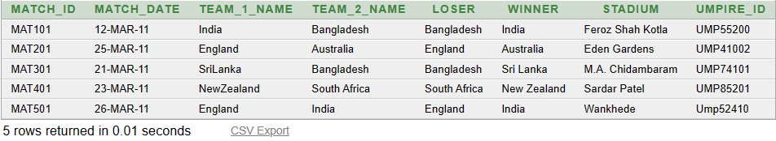

**TABLE – 6: coach**

CREATE TABLE COACH(

coach_id VARCHAR(30) PRIMARY KEY,

team_id VARCHAR(30),

coach_name VARCHAR(30),

foreign key(team_id) references team(team_id));

INSERT INTO COACH VALUES('CH417', 'IND1221', 'RAVI SHASTRI');

INSERT INTO COACH VALUES('CH140', 'AUS2174', 'JUSTIN LANGER');

INSERT INTO COACH VALUES('CH223', 'SA5412', 'OTTIS GIBSON');

INSERT INTO COACH VALUES('CH398', 'NZ5687', 'GARY STEAD');

INSERT INTO COACH VALUES('CH748', 'BAN9852', 'RUSSEL DOMINGO');

INSERT INTO COACH VALUES('CH596', 'IND1221', 'GARY KISTERN');

select * from coach;

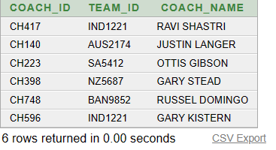

**TABLE – 7: captain**

CREATE TABLE CAPTAIN(

captain_id VARCHAR(30) PRIMARY KEY,

captain_name VARCHAR(30),

team_id VARCHAR(30),

player_id VARCHAR(30),

year_of_captaincy NUMBER(2),

no_of_wins NUMBER(4) ,

foreign key(team_id) references team(team_id));

INSERT INTO CAPTAIN VALUES('CAP11452', 'MS DHONI', 'IND1221','PLR44567',4,56);

INSERT INTO CAPTAIN VALUES('CAP21478', 'DALE STEYN', 'SA5412','PLR10235',7,74);

INSERT INTO CAPTAIN VALUES('CAP30214','MICHEAL CLARKE','AUS2174', 'PLR74138', 9,100);

INSERT INTO CAPTAIN VALUES('CAP14789','TAMIMIQBAL','BAN9852','PLR89562',2,20);

INSERT INTO CAPTAIN VALUES('CAP36957', 'ROSS TAYLOR', 'NZ5687','PLR957417',5,85);

select * from captain;

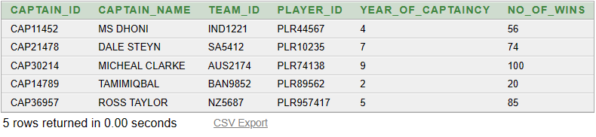

**Query List:**

**Q-1. Add column of total matches in the table TEAM. Update the rows using totalmatches= number of WNS+ number of LOSES + number of DRAWS.**

alter table team add total_matches NUMBER;

update team set total_matches=no_of_draws + no_of_wins + no_of_loses;

|  |  |  |  |  |  |  |  |  |  |
| --- | --- | --- | --- | --- | --- | --- | --- | --- | --- |
| **TEAM_ID** | **TEAM_RANK** | **TEAM_NAME** | **COUNTRY_NAME** | **NO_OF_WINS** | **NO_OF_LOSES** | **NO_OF_DRAWS** | **NO_OF_BOWLERS** | **NO_OF_BATSMANS** | **TOTAL_MATCHES** |
| IND1221 | 1 | MEN IN BLUE | INDIA | 5 | 1 | 0 | 6 | 7 | 6 |
| AUS2174 | 4 | KANGAROO | AUSTRAILA | 3 | 3 | 0 | 5 | 6 | 6 |
| SA5412 | 3 | PROTEA | SOUTH AFRICA | 3 | 2 | 1 | 8 | 5 | 6 |
| NZ5687 | 2 | BLACK CAPS | NEW ZEALAND | 4 | 2 | 0 | 6 | 7 | 6 |
| BAN9852 | 5 | TIGERS | BANGLADESH | 2 | 4 | 0 | 7 | 7 | 6 |

**Q-2. Display the name of the umpires who have not umpired matches in eden gardens.**

select u.umpire_name,m.stadium

from umpire u,matches m

where u.umpire_id=m.umpire_id and u.umpire_name not in(select u.umpire_name from umpire where m.stadium='Eden Gardens');

|  |  |
| --- | --- |
| **UMPIRE_NAME** | **STADIUM** |
| Tony Hill | Feroz Shah Kotla |
| Aleem Dar | M.A. Chidambaram |
| Ian Gould | Sardar Patel |
| Anil Chaudhary | Wankhede |

|  |
| --- |
|  |

Q-3. **Display the player_id of players who have same bowling action.**

select player_id from player where type_of_bowler in(select type_of_bowler from player group by type_of_bowler having count(*)>1);

|  |
| --- |
| **PLAYER_ID** |
| PLR65200 |
| PLR75401 |

Q-4. **Display name of coach who has coached a player with economy less than 5.**

select distinct coach_name from coach where team_id in(select team_id from player where economy<5 );

|  |
| --- |
| **COACH_NAME** |
| GARY KISTERN |
| RAVI SHASTRI |

Q-5. **Display the country,team_id whose players have economy less than 5.**

select country_name,team_id from team natural join player where economy<5;

|  |  |
| --- | --- |
| **COUNTRY_NAME** | **TEAM_ID** |
| INDIA | IND1221 |

|  |  |  |  |
| --- | --- | --- | --- |
|  |  |  |  |

Q-6. **Display the name of wicket_keeper who is also a captain of his team.**

Select wk_name from wicket_keeper where team_id in( select team_id from captain where captain_name=wk_name);



**Q-7. List total wins of each team.**

Select count(no_of_wins) From team Group by(team_id);

|  |
| --- |
| **COUNT(NO_OF_WINS)** |
| 1 |
| 1 |
| 1 |
| 1 |
| 1 |
|  |

**Q-8. Display all players of team india.**

Select t.team_id,t.team_name,t.country_name,p.player_id

From team t, player p

Where t.team_id=p.team_id and t.team_id='IND1221';

|  |  |  |  |
| --- | --- | --- | --- |
| **TEAM_ID** | **TEAM_NAME** | **COUNTRY_NAME** | **PLAYER_ID** |
| IND1221 | MEN IN BLUE | INDIA | PLR17410 |
| IND1221 | MEN IN BLUE | INDIA | PLR75401 |

**Q-9. Display details whose match on 12-Mar-2011.**

Select * from matches

Where match_date=’12-Mar-2011’;

|  |  |  |  |  |  |  |  |  |
| --- | --- | --- | --- | --- | --- | --- | --- | --- |
| **MATCH_ID** | **MATCH_DATE** | **TEAM_1_NAME** | | **TEAM_2_NAME** | **LOSER** | **WINNER** | **STADIUM** | **UMPIRE_ID** |
| MAT101 | 12-MAR-11 | India | | Bangladesh | Bangladesh | India | Feroz Shah Kotla | UMP55200 |
|  | | |  |  |

|  |  |  |  |
| --- | --- | --- | --- |
|  |  |  |  |

**Q-10. Display the coach name who leads team AUSTRAILA.**

Select t.team_id,t.team_name,c.coach_id,c.coach_name

From team t, coach c

Where t.team_id=c.team_id and t.team_id='AUS2174';

|  |  |  |  |
| --- | --- | --- | --- |
| **TEAM_ID** | **TEAM_NAME** | **COACH_ID** | **COACH_NAME** |
| AUS2174 | KANGAROO | CH140 | JUSTIN LANGER |

**Q-11. Display captain of all teams.**

Select t.team_id,t.team_name,c.captain_id,c.captain_name ,c.year_of_captaincy ,c.no_of_wins

From team t,captain c Where t.team_id=c.team_id ;

|  |  |  |  |  |  |
| --- | --- | --- | --- | --- | --- |
| **TEAM_ID** | **TEAM_NAME** | **CAPTAIN_ID** | **CAPTAIN_NAME** | **YEAR_OF_CAPTAINCY** | **NO_OF_WINS** |
| IND1221 | MEN IN BLUE | CAP11452 | MS DHONI | 4 | 56 |
| SA5412 | PROTEA | CAP21478 | DALE STEYN | 7 | 74 |
| AUS2174 | KANGAROO | CAP30214 | MICHEAL CLARKE | 9 | 100 |
| BAN9852 | TIGERS | CAP14789 | TAMIMIQBAL | 2 | 20 |
| NZ5687 | BLACK CAPS | CAP36957 | ROSS TAYLOR | 5 | 85 |

**Q-12. Display wicket keeper name of team AUSTRAILA.**

Select t.team_id,t.team_name,w.wk_name

From WICKET_KEEPER w,team t

Where w.team_id=t.team_id and team_name= ‘SOUTH AFRICA’;

|  |  |  |
| --- | --- | --- |
| **TEAM_ID** | **TEAM_NAME** | **WK_NAME** |
| AUS2174 | KANGAROO | Tim Lee |
| AUS2174 | KANGAROO | Peter Hegward |
| AUS2174 | KANGAROO | Hefer Kingsly |

**Q-13. Display details of player who is fast bowler and captain of the team has won more than 50 matches.**

Select t.team_id,t.team_name, p.player_id,p.type_of_bowler,c.captain_id,c.no_of_wins

from team t,player p,captain c

where t.team_id=p.team_id and t.team_id=c.team_id and p.team_id=c.team_id and p.type_of_bowler='fast' and c.no_of_wins>50;

|  |  |  |  |  |  |
| --- | --- | --- | --- | --- | --- |
| **TEAM_ID** | **TEAM_NAME** | **PLAYER_ID** | **TYPE_OF_BOWLER** | **CAPTAIN_ID** | **NO_OF_WINS** |
| IND1221 | MEN IN BLUE | PLR75401 | fast | CAP11452 | 56 |

**Q-14. Display wicket keepers from team AUSTRALIA who have team id= AUS2174 and are trained by a captain who has an experience of more than 5 years.**

Select w.wk_name as "Wicket Keeper",t.team_id,t.team_name,c.captain_name,c.year_of_captaincy

from team t,wicket_keeper w,captain c

where t.team_id=w.team_id and t.team_id=c.team_id and w.team_id=c.team_id and t.team_id='AUS2174' and c.year_of_captaincy>5;

|  |  |  |  |  |
| --- | --- | --- | --- | --- |
| **Wicket Keeper** | **TEAM_ID** | **TEAM_NAME** | **CAPTAIN_NAME** | **YEAR_OF_CAPTAINCY** |
| Tim Lee | AUS2174 | KANGAROO | MICHEAL CLARKE | 9 |
| Peter Hegward | AUS2174 | KANGAROO | MICHEAL CLARKE | 9 |
| Hefer Kingsly | AUS2174 | KANGAROO | MICHEAL CLARKE | 9 |