Machine Learning Models for Predicting Combustion Rate Constants of Ether and Ester Reactions


SUMMER INTERNSHIP PROJECT 2026

By:
Khushvant Chouhan
B.Tech 2023
Chemistry Department
IIT Patna,
Bihta, Patna-801106

CERTIFICATE

This is to certify that Mr. Khushvant Chouhan, a student of B.Tech 2023 batch, Department of Chemistry, IIT Patna, Bihar, has undertaken the summer internship at the Department of Chemistry, Indian Institute of Technology Patna under the supervision of Dr. ______________________.
He has conducted a study and completed the project titled, "Machine Learning Models for Predicting Combustion Rate Constants of Ether and Ester Reactions".
Mr. Khushvant Chouhan has shown good character and conduct during his stay at IIT Patna as a summer intern. He completed the designated tasks well, using his skills effectively. He worked hard and performed his duties properly. I wish him all the best in his future.

Dr. ______________________

ACKNOWLEDGEMENT

It gives me immense pleasure to express my heartfelt gratitude to all those who directly or indirectly contributed to the successful completion of my internship at IIT Patna. Their support, encouragement, and guidance have been invaluable throughout this journey.
I am deeply thankful to my supervisor for granting me the opportunity to undertake this internship and for the constant support and mentorship extended during my time at IIT Patna.
My sincere thanks go to the members of the research group for their guidance, cooperation, and the valuable time devoted to helping me complete this project and its report.
I am grateful to all the group members for their moral support, and to my friends and family, who shared in my daily experiences and offered thoughtful suggestions that helped improve my work.
Khushvant Chouhan
Date:

CONTENTS

1. Introduction
2. Literature Review
3. Dataset and Methodology
4. Model Development
5. Results and Discussion
6. Deployed Prediction Application
7. Conclusion
8. References

1. Introduction
Combustion chemistry underpins the design of cleaner, more efficient fuels, and ethers and esters are among the most important oxygenated compound classes used as biofuel additives and alternative fuels. Understanding how quickly these molecules react — expressed through the rate constant, k, of individual elementary reactions such as H-abstraction, O2 addition, unimolecular decomposition and beta scission — is essential for building predictive combustion kinetic mechanisms. Rate constants are conventionally obtained through high-level quantum-chemical calculations (e.g., transition-state theory combined with ab initio methods) or through dedicated experiments, both of which are time- and resource-intensive and do not scale easily to the very large number of reaction sites present in real fuel mechanisms.
Machine learning (ML) offers a complementary, data-driven route to this problem: once a modest but representative set of previously computed or measured rate constants is available, statistical and neural models can learn the relationship between a reaction's structural/electronic characteristics and its kinetic behaviour, and then generalise this relationship to new, unseen reactions and temperatures at negligible computational cost. This report describes the design, implementation and evaluation of such a framework for ether and ester combustion reactions, along with an interactive web application that makes the trained models directly usable for new predictions.
This report is organised as follows. Section 2 presents a brief review of existing approaches for combustion kinetics prediction. Section 3 describes the curated reaction dataset and the feature engineering methodology. Section 4 presents the five machine learning models developed in this work. Section 5 discusses the predictive performance of these models. Section 6 describes the deployed Streamlit prediction platform, while Section 7 concludes the report.
2. Literature Review
Combustion kinetics is essential for understanding fuel oxidation and developing reliable chemical reaction mechanisms. Accurate rate constants are required to predict important combustion characteristics such as ignition delay, flame propagation, and pollutant formation. Traditionally, these rate constants are obtained through experimental measurements or high-level quantum chemical calculations combined with Transition State Theory (TST). Although these methods provide accurate results, they are computationally expensive and time-consuming, especially for large combustion mechanisms containing thousands of reactions.
In recent years, machine learning has emerged as a promising alternative for predicting combustion rate constants. By learning the relationship between molecular structure, reaction conditions, and kinetic parameters from existing data, machine learning models can estimate rate constants rapidly without performing expensive quantum chemical calculations. Various regression techniques such as Linear Regression, Random Forest, XGBoost, and Neural Networks have been successfully applied to molecular property prediction due to their ability to capture complex nonlinear relationships.
Graph-based neural networks have gained particular attention because they represent molecules as graphs, where atoms and chemical bonds are treated as nodes and edges. This allows the model to automatically learn meaningful structural information instead of relying only on manually designed molecular descriptors. Such models have shown improved performance in many molecular prediction tasks.
Motivated by these advancements, this work develops and compares five machine learning models—Linear Regression, Random Forest, XGBoost, Feedforward Neural Network (FNN), and Graph Feedforward Neural Network (GFNN)—for predicting combustion rate constants of ether and ester reactions. The trained models are further integrated into a Streamlit-based application, enabling fast and user-friendly prediction of rate constants for new reactions.

3. Dataset and Methodology
3.1 Dataset Collection
The reaction dataset used in this study was compiled from 20 primary combustion kinetics literature sources and previously reported Arrhenius parameters for ether and ester compounds. For each reaction, the pre-exponential factor (A), temperature exponent (n), activation energy (Ea), valid temperature range (Tmin–Tmax), reaction class, reactant and product SMILES strings, fuel family, and literature source DOIs were systematically collected and verified before inclusion in the dataset.
To generate sufficient training samples, the modified Arrhenius equation was evaluated at multiple temperature points within the reported valid temperature range of each reaction. This produced temperature-dependent rate constants, which were converted into log10(k) values and used as the prediction target. The final dataset included reactions belonging to multiple combustion reaction classes and represented both cyclic and acyclic ether and ester compounds. Before model development, the collected data were checked for missing values, duplicate entries, and inconsistent reaction information to ensure a reliable dataset for machine learning.
3.1 Reaction Dataset
A curated dataset of 36 elementary combustion reactions of ethers and esters was assembled from literature-reported and calculated Arrhenius parameters (pre-exponential factor A, temperature exponent n, and activation energy Ea), together with the valid temperature range (Tmin–Tmax) over which each expression applies. Each entry records the fuel name and family, whether the parent fuel is cyclic or acyclic, the reactant and product-radical SMILES strings, the reaction class, and the literature source. Sampling the modified-Arrhenius expression k(T) = A·T^n·exp(–Ea/RT) at multiple temperatures within its valid range generates the target variable used for model training: log10(k).
The reactions span five mechanistically distinct classes, summarised in Table 1. H-abstraction and the related overall-OH-reaction class dominate the dataset, reflecting their central role in low- and high-temperature oxidation chemistry, while unimolecular decomposition, O2 addition and beta-scission reactions form a smaller but mechanistically important complement.
Reaction Class | Count
H-abstraction / overall OH reaction | 15
H-abstraction | 11
Unimolecular decomposition | 5
O2 addition | 3
Beta scission | 2
Table 1. Distribution of reaction classes in the curated combustion-kinetics dataset (36 reactions).
3.2 Feature Engineering
Two complementary featurisation strategies were used depending on the model family:
- Descriptor-based features (used for Linear Regression, Random Forest, XGBoost and the FNN): each reactant SMILES string was parsed with RDKit, and an initial set of 15 physicochemical descriptors was computed (molecular weight, exact mass, LogP, topological polar surface area, heavy-atom count, H-bond donor/acceptor counts, rotatable-bond count, ring counts, fraction of sp3 carbons, Labute accessible surface area, Balaban index and valence-electron count). Highly correlated descriptors (pairwise correlation above a fixed threshold) were removed to reduce redundancy. These were combined with an inverse-temperature term (1000/T, capturing the Arrhenius temperature dependence), a binary cyclic/acyclic flag, and one-hot encodings of the reaction class.
- Graph-based features (used for the GFNN): each molecule was represented directly as a molecular graph, with per-atom features (atomic number, degree, hybridisation, aromaticity, formal charge and hydrogen count) and per-bond features derived with RDKit, allowing the model to learn its own structural representation via message passing rather than relying on hand-engineered descriptors.
In both cases the prediction target was log10(k), the base-10 logarithm of the rate constant, which linearises the exponential Arrhenius temperature dependence and stabilises training across the several orders of magnitude spanned by the raw rate constants.
3.3 Cross-Validation Strategy
Because multiple temperature samples were generated from the same underlying reaction, a standard random K-fold split would leak information between the training and test sets. To avoid this, all five models were evaluated with 5-fold GroupKFold cross-validation, grouped by reaction_id, so that all samples belonging to a given reaction always fall entirely within either the training or the test fold. Out-of-fold (OOF) predictions were aggregated across all five folds to compute the overall performance metrics reported in Section 4, giving an honest estimate of how each model generalises to reactions it has not seen during training.
4. Model Development

Five regression approaches of increasing structural complexity were implemented and compared on the same data splits, in order to determine how much predictive benefit is gained by moving from simple linear models to descriptor-based ensembles and, ultimately, to learned graph representations.
Linear Regression
Linear Regression was used as the baseline model to establish a reference for prediction performance. It learns a linear relationship between the molecular descriptors, temperature, and the target variable log10(k), providing a simple benchmark against which more advanced models can be compared.
Random Forest (RF)
Random Forest is an ensemble learning algorithm that combines multiple decision trees to model complex nonlinear relationships between molecular descriptors and combustion rate constants. It also provides feature importance scores, making the model easier to interpret.
XGBoost
XGBoost is a gradient-boosting algorithm that sequentially builds decision trees to minimize prediction errors. Its regularization techniques improve generalization performance and reduce overfitting, making it a strong alternative to Random Forest.
Feedforward Neural Network (FNN)
The Feedforward Neural Network is a fully connected deep learning model trained on the standardized molecular descriptors. It captures nonlinear relationships between input features and log10(k) through multiple hidden layers, offering greater flexibility than traditional regression models.
Graph Feedforward Neural Network (GFNN)
The Graph Feedforward Neural Network (GFNN) was implemented in PyTorch to learn molecular representations directly from graph-structured data. Instead of relying on manually engineered molecular descriptors, the model represents atoms as nodes and chemical bonds as edges, allowing it to learn structural information through message-passing operations. The learned graph features are combined with temperature and reaction-class information to predict log10(k). This graph-based representation enables the model to capture complex molecular relationships more effectively, resulting in the highest predictive performance among all the models evaluated.
All models were trained and evaluated using the same 5-fold GroupKFold cross-validation strategy to ensure a fair comparison. Random seeds were fixed wherever applicable to improve reproducibility, while feature standardization was applied only to models requiring scaled inputs, such as Linear Regression, FNN, and GFNN. Hyperparameters were selected using standard machine learning practices and kept consistent throughout the study.
5. Results and Discussion
5.1 Overall Model Comparison
Table 2 summarises the out-of-fold R², RMSE and MAE achieved by each of the five models across all reactions and sampled temperatures.
Model | Overall R² | Overall RMSE | Overall MAE
Linear Regression | 0.6946 | 2.7999 | 1.7521
Random Forest | 0.8159 | 2.1740 | 1.0489
XGBoost | 0.7776 | 2.3890 | 1.1359
FNN (descriptor-based) | 0.3011 | 4.2354 | 2.5233
GFNN (graph-based) | 0.9242 | 1.3949 | 0.8072
Table 2. Overall out-of-fold performance of the five models on log10(k) prediction.
The Graph Feedforward Neural Network (GFNN) achieved the best overall performance, with an out-of-fold R² of 0.924, RMSE of 1.395, and MAE of 0.807 — a substantial improvement over every descriptor-based model. Random Forest was the strongest of the descriptor-based models (R² = 0.816), closely followed by XGBoost (R² = 0.778), while plain Linear Regression achieved a moderate R² of 0.695, confirming that the relationship between molecular structure/temperature and log10(k) is meaningfully non-linear. The plain FNN performed worst of all five models (R² = 0.301), which is consistent with fully connected networks being prone to overfitting on a dataset of this size (36 reactions) when trained on hand-engineered descriptors without the added structural inductive bias that the graph representation provides to the GFNN.
These results indicate that (i) tree-based ensembles offer a strong, reliable improvement over a linear baseline for this task, and (ii) learning a task-specific molecular representation directly from the reaction graph, as done by the GFNN, is the most effective strategy of the five when data is limited, likely because it avoids the descriptor-selection bottleneck and can exploit local structural patterns that are not captured by the fixed RDKit descriptor set.
5.2 Parity Plots
Figure 1 compares predicted versus experimental/reference log10(k) values (out-of-fold) for all five models. Points lying close to the diagonal indicate accurate predictions; the tightening of the point cloud around the diagonal from Linear Regression through to the GFNN visually confirms the ranking observed in Table 2.
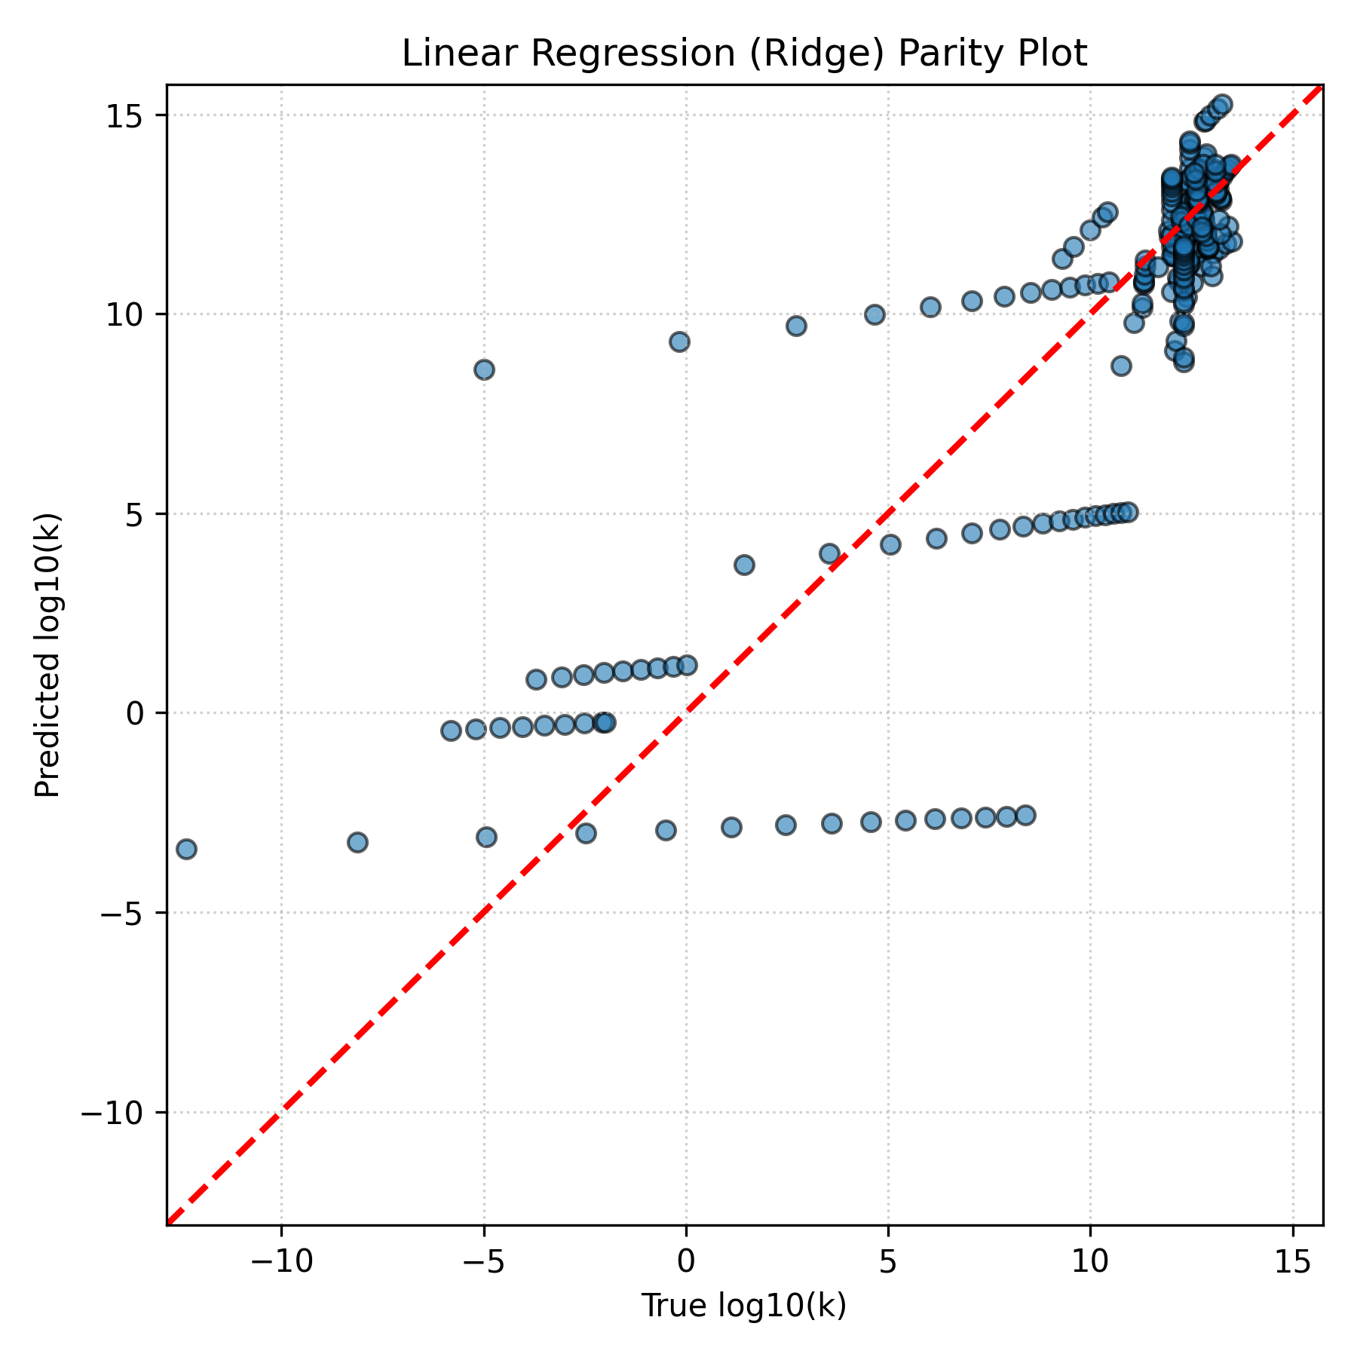
Figure 1a. Parity plot — Linear Regression (out-of-fold predictions vs. reference log10(k)).
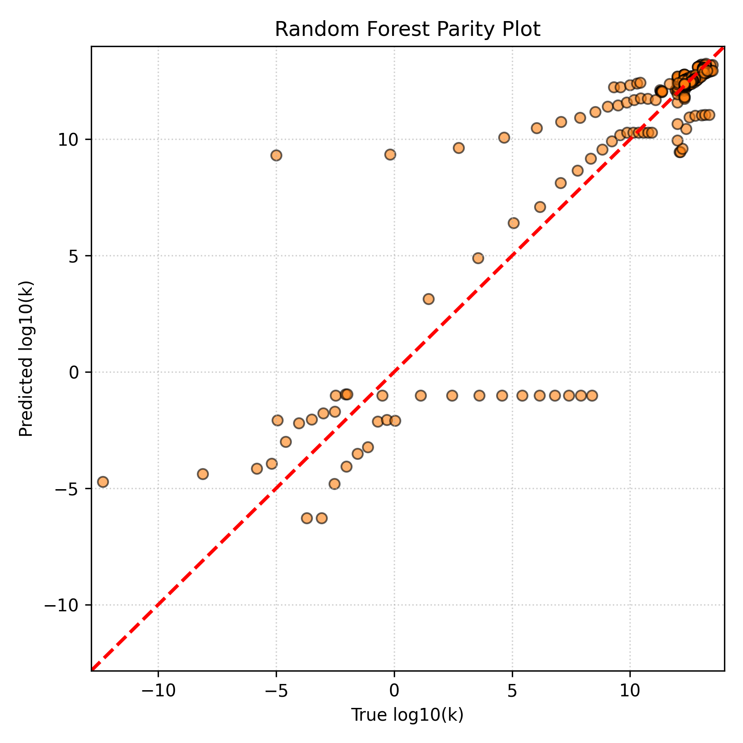
Figure 1b. Parity plot — Random Forest.
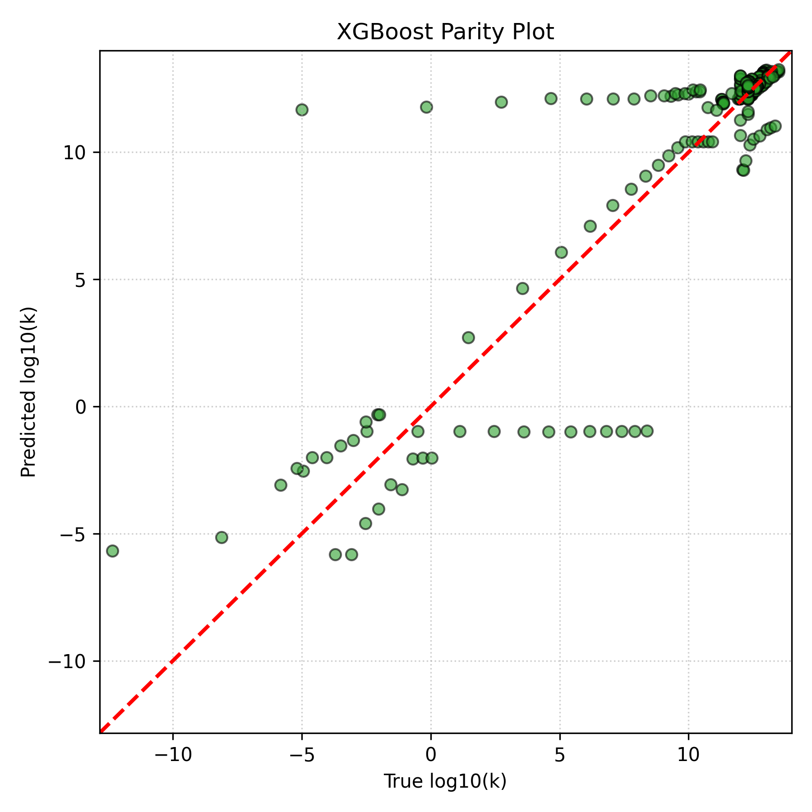
Figure 1c. Parity plot — XGBoost.
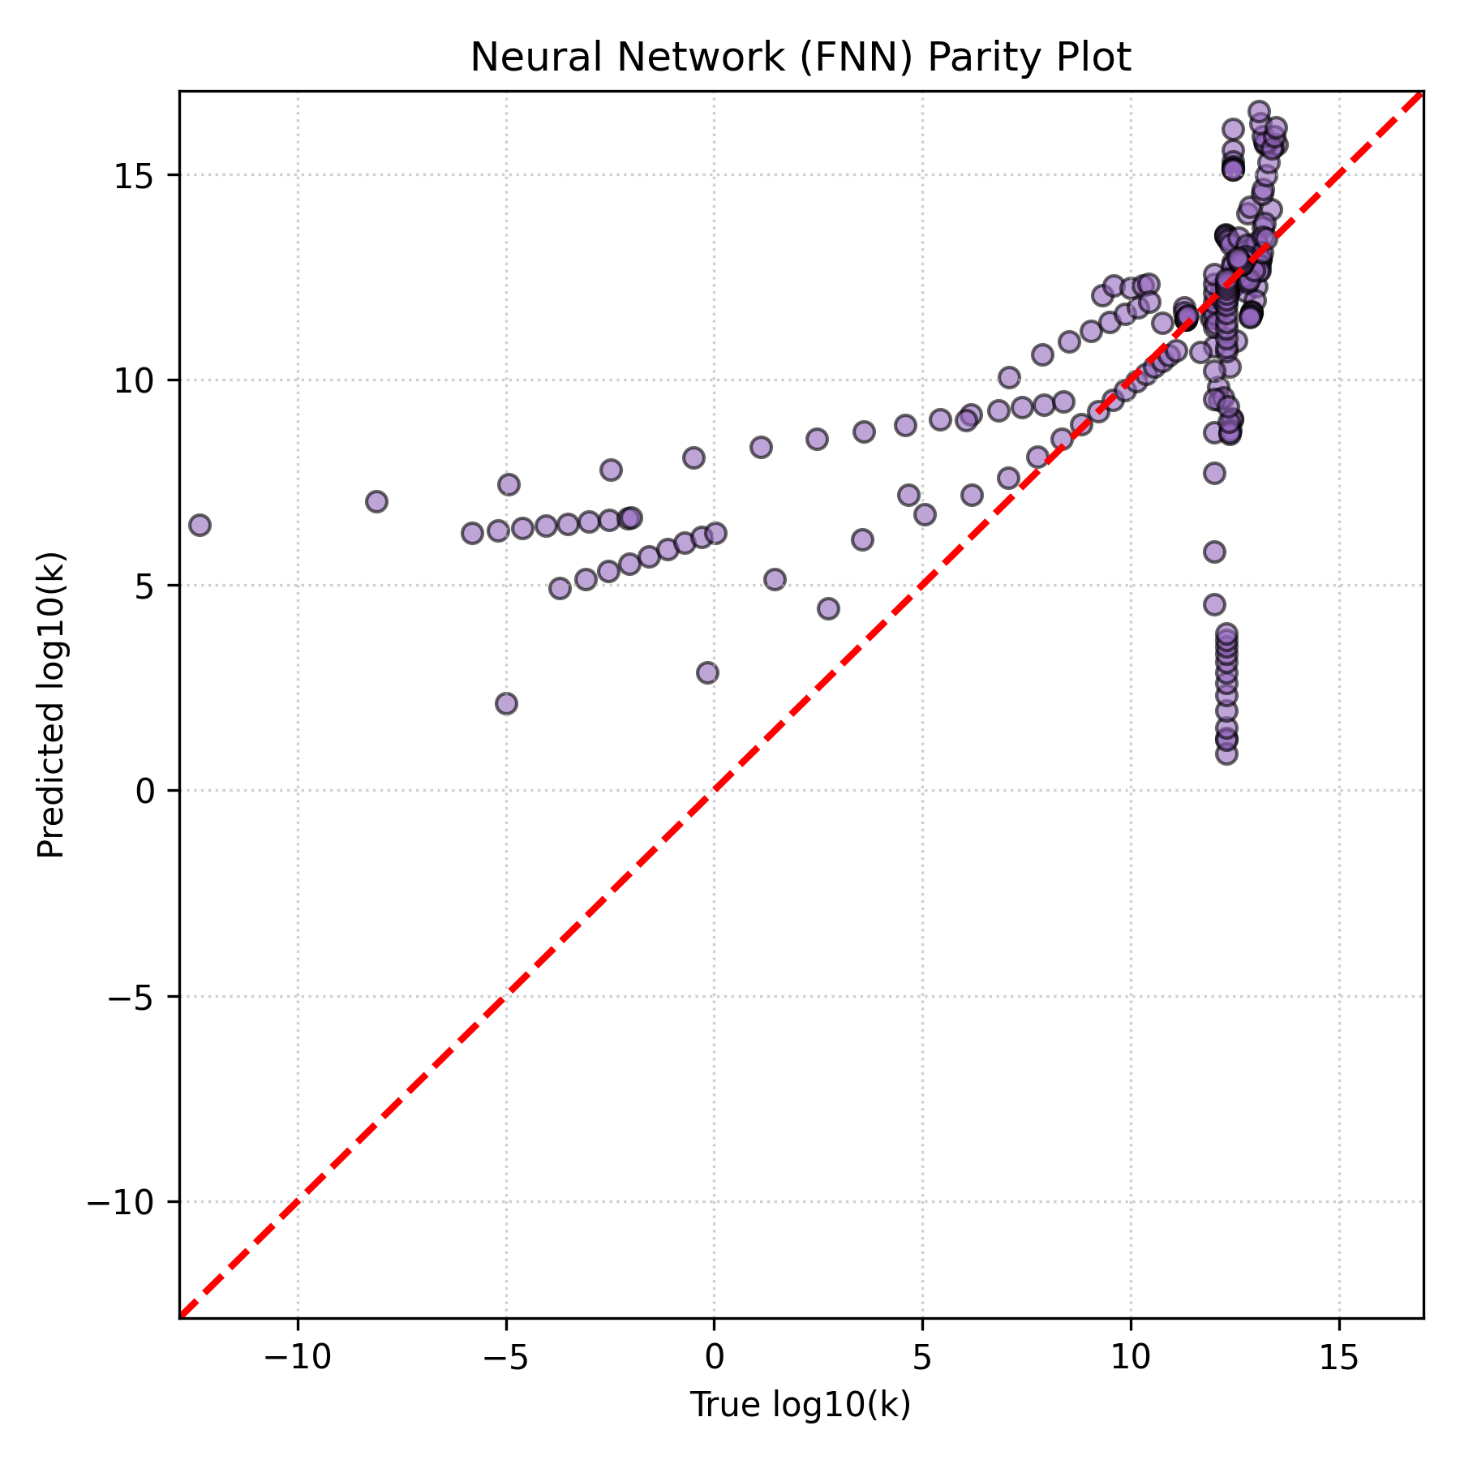
Figure 1d. Parity plot — Feedforward Neural Network (FNN).
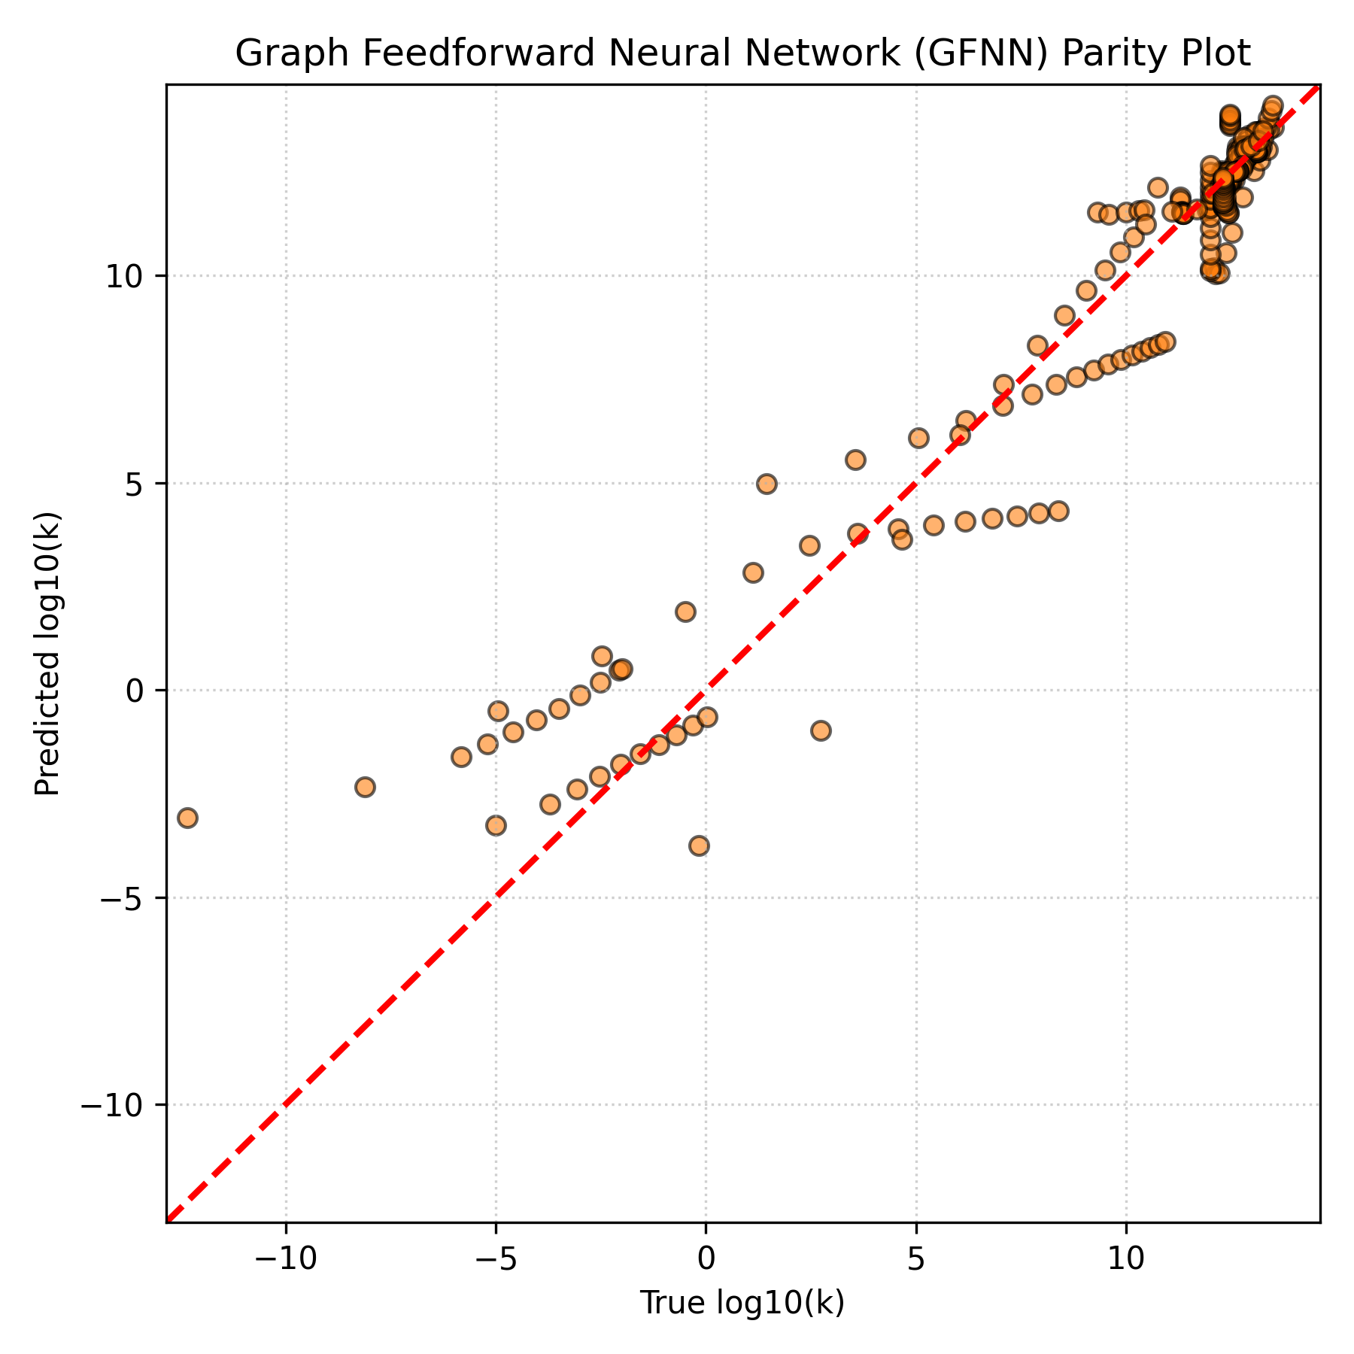
Figure 1e. Parity plot — Graph Feedforward Neural Network (GFNN), the best-performing model.
5.3 Training Behaviour of the Neural Models
Figure 2 shows the training/validation loss curves for the FNN and GFNN. The GFNN converges to a substantially lower validation loss than the plain FNN, reflecting its better generalisation behaviour reported in Table 2; the GFNN required approximately 469 seconds to train across the 5-fold cross-validation procedure.
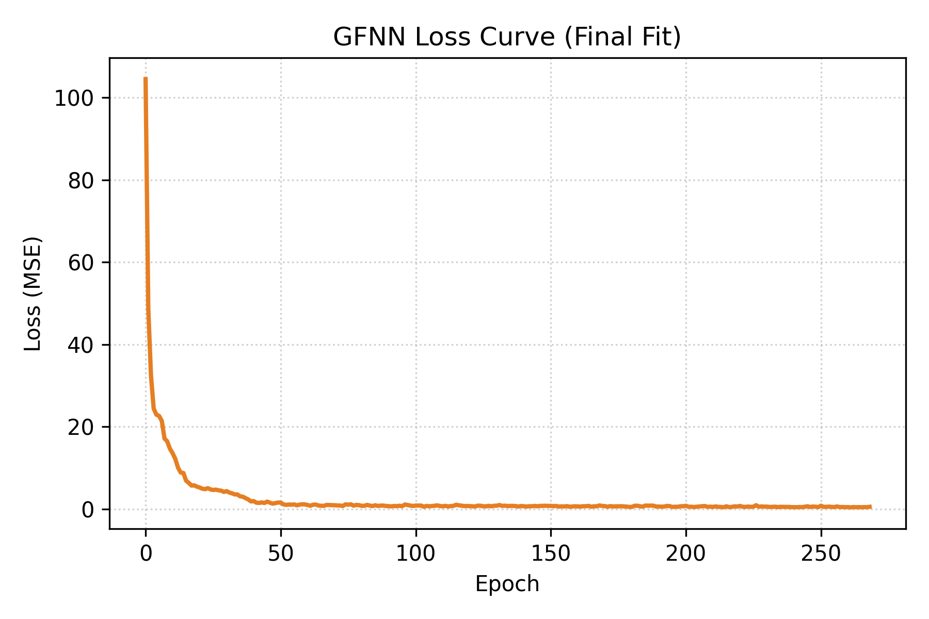
Figure 2a. GFNN training/validation loss curve.
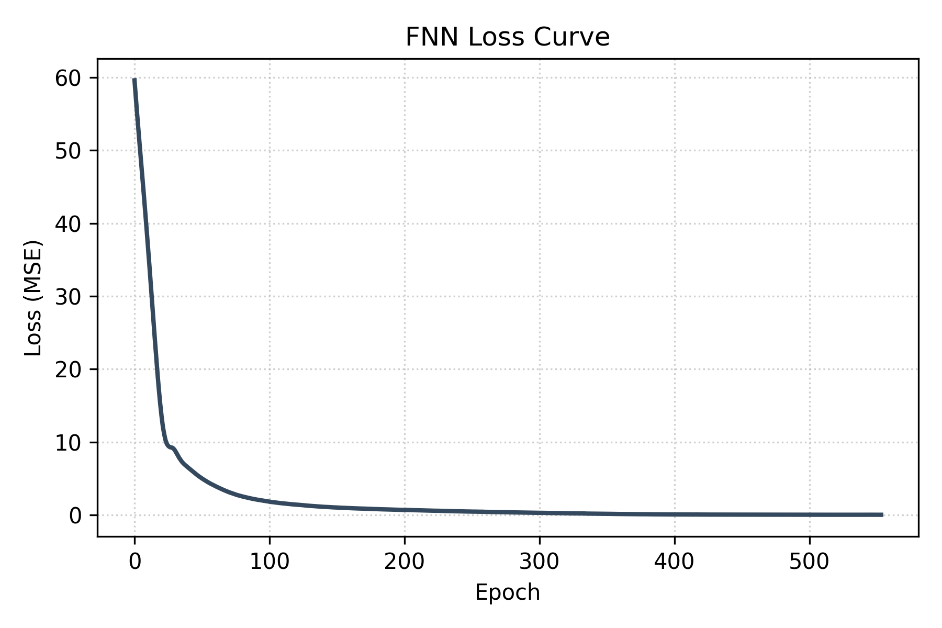
Figure 2b. FNN training/validation loss curve.
5.4 Feature Importance (Random Forest)
To understand which structural and process variables most strongly influence the predicted rate constants, SHAP (SHapley Additive exPlanations) values and partial-dependence plots were computed for the Random Forest model, the best-performing interpretable model in this study.
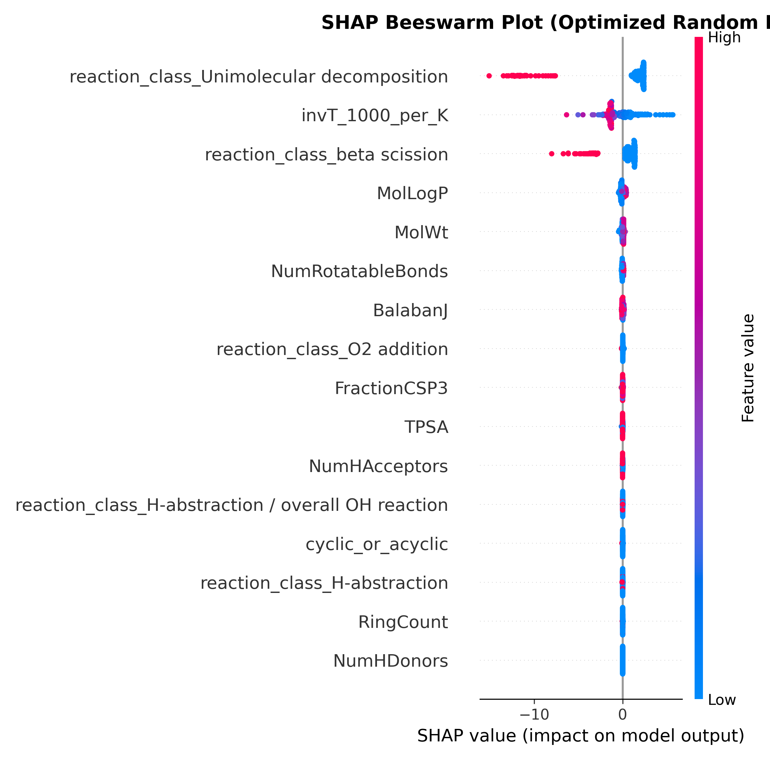
Figure 3. SHAP summary plot for the Random Forest model, ranking the contribution of each feature to the predicted log10(k).
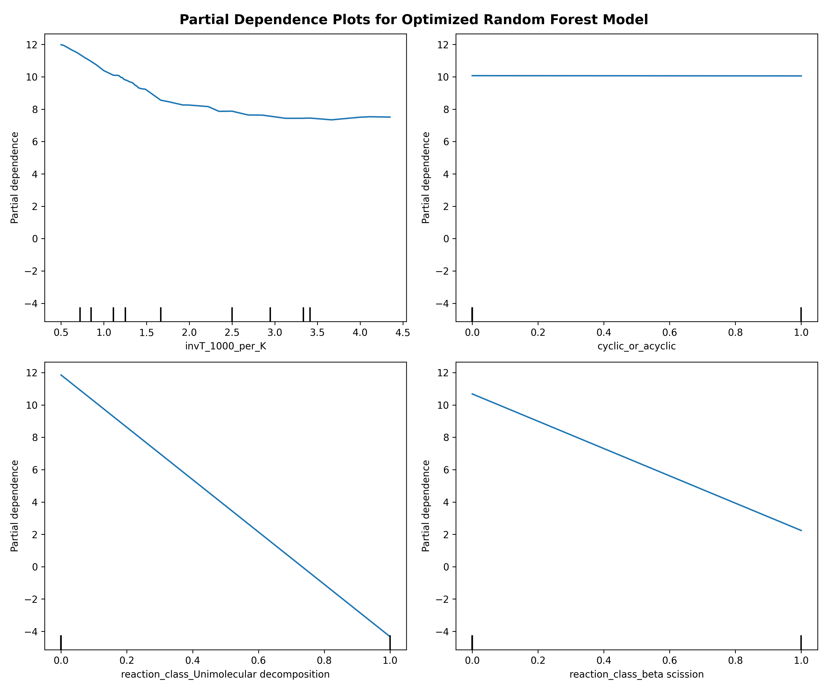
Figure 4. Partial-dependence plots for the Random Forest model, showing the marginal effect of the inverse-temperature term, the cyclic/acyclic flag, and the top molecular descriptors on the predicted log10(k).
Consistent with Arrhenius behaviour, the inverse-temperature term (1000/T) is among the most influential variables, confirming that the models correctly learn the expected physical temperature dependence of the rate constant, in addition to structure-derived molecular descriptors that differentiate reaction classes and fuel families.
6. Deployed Prediction Application
To make the trained models directly usable without requiring users to retrain them, all five models (and the associated preprocessing pipelines) were serialised and packaged into an interactive Streamlit web application (app.py). The application allows a user to:
- Upload a reaction dataset in .xlsx or .csv format containing, at minimum, the reactant SMILES string, the reaction class, and the temperature in Kelvin for each reaction of interest.
- Optionally supply a reaction ID and an experimental/reference log10(k) value, in which case the application automatically computes R², RMSE and MAE against the model predictions and renders a parity plot for the uploaded reactions.
- Obtain instant log10(k) predictions from the pre-trained models without needing to install RDKit-based featurisation pipelines locally beyond the app's own dependencies.
Because the serialized models (saved_models/) are loaded directly at runtime, the application launches and produces predictions immediately, while the underlying training scripts (train_rf.py, train_xgb.py, train_fnn.py, train_gfnn.py) remain available for users who wish to reproduce the cross-validation results or retrain the models on an updated dataset.
7. Conclusion
A machine-learning framework for predicting combustion rate constants of ether and ester reactions was successfully developed and evaluated. A curated dataset of 36 literature-derived reactions, spanning five mechanistic classes, was featurised in two complementary ways — RDKit-derived molecular descriptors and direct molecular-graph representations — and used to train and rigorously cross-validate five regression models under a reaction-grouped cross-validation scheme that prevents data leakage.
Among the models compared, the custom Graph Feedforward Neural Network (GFNN) achieved the best predictive performance (out-of-fold R² = 0.924, RMSE = 1.395, MAE = 0.807), outperforming all descriptor-based approaches, including the strong Random Forest and XGBoost ensembles. This demonstrates that, even on a comparatively small kinetics dataset, learning a task-specific graph representation can outperform hand-engineered molecular descriptors for rate-constant prediction. Feature-importance analysis on the Random Forest model further confirmed that the models correctly recover the expected Arrhenius-type temperature dependence, lending physical credibility to the learned relationships.
The trained models were packaged into an interactive Streamlit application, providing an accessible platform for rapid, on-demand rate-constant prediction for new ether and ester reactions. Future extensions of this work could include expanding the underlying reaction dataset, incorporating additional reaction classes and fuel families, and exploring uncertainty quantification alongside the point predictions reported here.
8. References
- RDKit: Open-source cheminformatics software, used for molecular descriptor calculation and graph featurisation (https://www.rdkit.org).
- Pedregosa, F. et al. Scikit-learn: Machine Learning in Python. Journal of Machine Learning Research, 12, 2825–2830 (2011).
- Chen, T. and Guestrin, C. XGBoost: A Scalable Tree Boosting System. Proceedings of the 22nd ACM SIGKDD International Conference on Knowledge Discovery and Data Mining (2016).
- Paszke, A. et al. PyTorch: An Imperative Style, High-Performance Deep Learning Library. Advances in Neural Information Processing Systems 32 (2019).
- Lundberg, S. M. and Lee, S.-I. A Unified Approach to Interpreting Model Predictions (SHAP). Advances in Neural Information Processing Systems 30 (2017).
- Streamlit Inc. Streamlit: A faster way to build and share data applications (https://streamlit.io).
Bänsch, M., Kiecherer, J., Szőri, M., Olzmann, M. High-Temperature Kinetics of the Reaction of OH Radicals with Dimethyl Ether: Experimental and Theoretical Study. J. Phys. Chem. A, 117(35), 8343–8351 (2013). DOI: 10.1021/jp405724a.
Bänsch, M. and Olzmann, M. Kinetics of the reaction of OH radicals with dimethoxymethane at elevated temperatures. Chem. Phys. Lett., 720, 36–40 (2019). DOI: 10.1016/j.cplett.2019.01.053.
Mach, R. et al. Shock-Tube and Kinetic Modeling Study of Methyl Formate and Oxymethylene Ether (OME2) Oxidation. J. Phys. Chem. A / Int. J. Chem. Kinet. (2025). DOIs: 10.1021/acs.jpca.4c02524, 10.1002/kin.21794.
Lee, J. H. Absolute Rate Constants for the Reaction of OH Radicals with Dimethyl Ether over the Temperature Range 245–370 K. J. Chem. Phys., 74, 4456 (1981). DOI: 10.1063/1.441456.
Belmekki, M. et al. High-Temperature Shock Tube and Kinetic Modeling Investigation of Diethyl Ether Ignition and Oxidation. Energy & Fuels, 35, 14040 (2021). DOI: 10.1021/acs.energyfuels.1c01408.
Mellouki, A., Téton, S., Le Bras, G. Kinetics of OH Radical Reactions with Aliphatic Ethers over the Temperature Range 230–370 K. Int. J. Chem. Kinet., 27, 791–805 (1995). DOI: 10.1002/kin.550270806.
Arif, M., Dellinger, B., Taylor, P. H. Thermal Reaction Kinetics of Methyl tert-Butyl Ether (MTBE) with OH Radicals. J. Phys. Chem. A, 101, 2440 (1997). DOI: 10.1021/jp963119w.
Lam, K. Y., Davidson, D. F., Hanson, R. K. Shock Tube Study of the Reactions of OH with Methyl Esters (Methyl Formate, Methyl Acetate, Methyl Propanoate, Methyl Butanoate). J. Phys. Chem. A, 116, 12229 (2012). DOI: 10.1021/jp310256j.
El Boudali, A., Le Calvé, S., Le Bras, G., Mellouki, A. Kinetic Study of the Reactions of OH Radicals with a Series of Esters (Methyl, Ethyl, n-Propyl, n-Butyl, and n-Pentyl Acetates). J. Phys. Chem., 100, 12364 (1996). DOI: 10.1021/jp9606218.
Curran, H. J. et al. A Comprehensive Modeling Study of Dimethyl Ether Oxidation & Low-Temperature Kinetics. Int. J. Chem. Kinet., 30, 229 (1998); 32, 741 (2000). DOIs: 10.1002/1097-4601(2000)32:12<741::AID-KIN2>3.0.CO;2-9, 10.1002/(SICI)1097-4601(1998)30:3<229::AID-KIN9>3.0.CO;2-U.
Auzmendi-Murua, I. and Bozzelli, J. W. Thermochemical Properties and Kinetic Analysis for Hydroperoxy Radical Reactions with Tetrahydrofuran Radicals. J. Phys. Chem. A, 118, 5147 (2014). DOI: 10.1021/jp412590g.
Westbrook, C. K. et al. Detailed Chemical Kinetic Reaction Mechanisms for Biofuel Oxidation: Esters and Cyclic Ethers. Proc. Combust. Inst., 32, 221 (2009). DOI: 10.1016/j.proci.2008.06.106.
Yamamoto, T. et al. Unimolecular Thermal Decomposition of γ-Butyrolactone in Shock Waves. Bull. Chem. Soc. Jpn., 65, 3112 (1992). DOI: 10.1246/bcsj.65.3112.
Blades, A. T. The Kinetics of the Pyrolysis of Ethyl Acetate. Can. J. Chem., 32(4), 366–372 (1954). DOI: 10.1139/v54-049.
Yang, X. et al. Kinetic study of beta-scission decomposition of methyl acetate radicals. Combust. Flame, 160, 2681 (2013). DOI: 10.1016/j.combustflame.2013.06.017.
Hochgreb, S. and Dryer, F. L. Thermal Decomposition of 1,3,5-Trioxane in Flow Reactors. J. Phys. Chem., 96, 7310 (1992). DOI: 10.1021/j100180a055.
Saheb, V. and Bahadori, M. Theoretical investigation on the kinetics of H-abstraction reactions from 1,3,5-trioxane by H, OH, and CH3 radicals. High Temp. Mat. Proc., 24, 89 (2020). DOI: 10.1177/1468678319899252.
Le Calvé, S., Hitier, D., Le Bras, G., Mellouki, A. Kinetic Study of the Reactions of OH Radicals with a Series of Alkyl Esters (Methyl Propionate, Methyl Butyrate, Methyl Valerate, and Methyl Caproate). J. Phys. Chem. A, 101, 9337–9341 (1997). DOI: 10.1021/jp972369p.
J. Phys. Chem. A. Unimolecular Decomposition Kinetics of 2-Methyltetrahydrofuran. J. Phys. Chem. A, 125, 4100 (2021). DOI: 10.1021/acs.jpca.0c11490.
Liu, P. and Farooq, A. High-temperature oxidation kinetics of gamma-valerolactone: Shock tube measurements and kinetic modeling. Combust. Flame, 255, 112771 (2023). DOI: 10.1016/j.combustflame.2023.112771.

