Design, Synthesis and Characterization of Multifunctional Porous Organic Polymers for Broad-Spectrum Environmental Remediation


SUMMER INTERNSHIP PROJECT 2026

By:
Supervision:
Dr. Neeladri Das Associate Professor
Department of Chemistry
IIT Patna, Bihta,
Patna-801106
Yash vardhan tyoharia
B.Tech 2023
Chemical science and technology
IIT Patna,
Bihta, Patna-801106

CERTIFICATE

This is to certify that Mr. Yash vardhan Tyoharia, a student of B.tech 2023 batch, Department Chemical science and technology, IIT Patna, Bihar, has undertaken the summer internship at the Department of Chemistry, Indian Institute of Technology Patna from 11th May, 2026 to 15th July 2026 under the supervision of Dr. Neeladri Das. He has conducted a study & completed the Project titled, “Design, Synthesis and Characterization of Multifunctional Porous Organic Polymers for Broad-Spectrum Environmental Remediation”.

Mr. Yash vardhan Tyoharia has shown good character and conduct during his stay in IIT Patna as a summer intern. He completed the designated tasks well, using his skills effectively. He worked hard and performed his duties properly. I wish him all the best in his future.

Dr. Neeladri Das

ACKNOWLEDGEMENT

It gives me immense pleasure to express my heartfelt gratitude to all those who directly or indirectly contributed to the successful completion of my internship at IIT Patna. Their support, encouragement, and guidance have been invaluable throughout this journey.
I am deeply thankful to Dr. Neeladri Das for granting me the opportunity to undertake this internship and for his constant support and mentorship during my time at IIT Patna.
My sincere thanks go to Mr. Mustafa Maqbool for his unwavering guidance, cooperation, and motivation, which greatly enriched my learning experience. I also extend my appreciation to Mr. Sk Abdul Wahed, Mr. Biplove Kumar and Mr. Subhadip Mondal for their insightful suggestions and the valuable time devoted to helping me complete my project report.
I am grateful to all the group members for their moral support, and to my friends and family, who shared in my daily experiences and offered thoughtful suggestions that helped improve my work.

Yash vardhan Tyoharia
Date: 10/07/2026

CONTENTS:

1. Introduction.
2. Project 1
3. Project 2
4. Conclusion

Introduction
Triptycene- and azo-linked porous organic polymers (POPs) represent an important class of advanced functional materials that combine the exceptional structural features of triptycene with the versatile chemical properties of azo linkages. Porous organic polymers are permanently porous, highly cross-linked organic networks that have attracted significant attention because of their high surface area, excellent thermal and chemical stability, low density, and tunable pore structures. Among the various building blocks used in POP synthesis, triptycene stands out due to its rigid three-dimensional paddlewheel-shaped framework, which provides a large internal free volume, prevents dense molecular packing, and promotes the formation of intrinsic microporosity. At the same time, the incorporation of azo (-N=N-) linkages introduces extended π-conjugation, structural rigidity, and unique optical and electronic properties, making azo-linked POPs attractive for a wide range of applications.
The combination of triptycene and azo linkages results in porous materials with enhanced physicochemical properties, including high porosity, excellent thermal stability, good chemical resistance, and efficient mass transport. The rigid triptycene framework maintains permanent porosity, while the azo groups contribute to electronic communication within the polymer network and provide active sites for interactions with guest molecules. These complementary characteristics make triptycene and azo-linked POPs promising candidates for applications such as gas storage and separation, heterogeneous catalysis, pollutant adsorption, chemical sensing, energy storage, and environmental remediation.
Recent advances in synthetic methodologies have enabled the preparation of a wide variety of triptycene-based azo-linked POPs with precisely controlled structures and tailored functionalities. By selecting suitable monomers and polymerization strategies, researchers have been able to fine-tune pore size, surface area, and chemical functionality, thereby improving the performance of these materials for specific applications. In particular, their high adsorption capacity, recyclability, and stability have generated considerable interest for the removal of toxic dyes, heavy metals, and other environmental contaminants, as well as for carbon dioxide capture and selective gas separation.
This report presents a comprehensive overview of triptycene- and azo-linked porous organic polymers, focusing on their structural features, synthesis, characterization, and structure–property relationships. Furthermore, it discusses the recent developments and emerging applications of these materials in environmental, catalytic, and energy-related fields. Inspired by recent progress in porous organic polymer research, this report also describes the synthesis and characterization of a newly triptycene-based azo-linked porous organic polymer, highlighting its design, physicochemical properties, and potential applications in advanced materials science.

Project-1

Introduction
Water is the foundation of all life, yet access to clean, safe freshwater is becoming a global challenge. The rapid rise of agriculture and industry has led to the severe contamination of water systems by a complex mixture of inorganic and organic pollutants, posing a critical threat to environmental stability. Among these, the presence of active iodine species, particularly the triiodide anion (I₃⁻), introduces significant toxicological risks. Originating from industrial discharge and chemical processes, I₃⁻ can severely disrupt biological systems and form highly hazardous disinfection byproducts during conventional water treatment. Compounding this inorganic threat is the widespread presence of persistent organic pollutants, specifically cationic dyes. Crystal violet, a widely used industrial dye is highly soluble and chemically stable. These positively charged organic contaminants readily wash into surface and groundwater, resisting natural degradation and creating chronic, toxic pollution in aquatic ecosystems. Therefore, finding an effective way to remove I₃⁻, crystal violet from water is an urgent environmental priority.
To address this, adsorption has emerged as one of the most effective and practical water-treatment technologies. Acting like a chemical sponge, adsorption is cost-effective, easy to operate, and does not create secondary pollution. Recently, porous organic polymers (POPs) have gained significant attention as advanced adsorbents. Because they are built from cost-effective building blocks and are highly stable in various conditions, POPs can be custom-designed at the molecular level to capture specific pollutants from complex aqueous matrices.
To successfully capture both triiodide (I₃⁻) and positively charged, water-soluble organics dye like crystal violet, an adsorbent must be highly porous and possess a strong, diverse chemical affinity for the target molecules. In this study, we report the design and synthesis of a newely, functionalized porous organic polymer (YVT-1). This material is constructed using rigid triptycene units cross-linked with phloroglucinol via methylene (CH₂) bridges.
This unique structural design seamlessly integrates several key advantages for water remediation into a single framework. The three-dimensional "paddlewheel" architecture of triptycene prevents the polymer from collapsing, ensuring a high surface area and open channels for water to flow through rapidly. Simultaneously, the incorporation of phloroglucinol introduces a dense network of active hydroxyl (–OH) groups into the framework. These oxygen-rich –OH groups make the polymer highly polar and hydrophilic, allowing it to efficiently draw in and bind the positively charged dye crystal violet, molecules through strong non-covalent interactions, such as ion-dipole interactions and hydrogen bonding, while also accommodating the adsorption of I₃⁻. By combining a robust porous framework with targeted chemical binding sites, YVT-1 serves as a highly efficient and stable adsorbent for the rapid, simultaneous removal of diverse toxic pollutants from aqueous environments.

Materials
Triptycene, Phloroglucinol, anhydrous iron (III) chloride (FeCl₃), Dimethoxymethane were purchased from Sigma-Aldrich and used without additional purifications. Dichloroethane(DCE), acetone, methanol, were procured locally.

Chemicals Required:
Compounds | Weight/vol. Taken | Molecular weight (g/mol) | Milli mole
Triptycene | 254.33 mg | 254.33 | 1
Phloroglucinol | 126.11 mg | 126.11 | 1
Dimethoxymethane (DMM) | 5 ml | 76.09
Dichloroethane (DCE) | 35 ml | 98.96
FeCl₃ | 1.6 g | 162.2 | 10

Synthesis of YVT-1. Triptycene (TP) and Phloroglucinol were used as monomeric building blocks in a well-known Friedel−Crafts alkylation reaction to synthesize YVT-1(Scheme1). In a typical reaction, equimolar amounts (1mmol each) of TP and Phloroglucinol were placed in a 100mL round-bottom flask under a nitrogen (N₂) atmosphere, after which 35mL of dichloroethane (DCE) was added. Subsequently, anhydrous iron (III) chloride (FeCl₃, 10mmol) serving as a Lewis acid catalyst and 5 ml of dimethoxymethane was added to the reaction mixture. The reaction mixture was subsequently refluxed (85°C) for 24h, resulting in precipitate formation. After the reaction mixture cooled to room temperature, the resulting crude solid was collected by filtration. The obtained product was washed thoroughly with methanol and distilled water (10 times), indicating effective removal of soluble impurities. The washed product was further purified by Soxhlet extraction with methanol for 24h. Finally, the obtained material was dried under vacuum at 120°C to yield a brown solid (YVT-1) in good yield.
Scheme-1: Synthesis of YVT-1

RESULTS AND DISCUSSION
The YVT-1 is thoroughly characterized utilizing several molecular, morphological, analytical and spectroscopic techniques, including Fourier transform infrared spectroscopy (FT-IR), powder X-ray diffraction (PXRD), low temperature N₂ sorption analysis, and thermo gravimetric analysis (TGA).
The FT-IR spectra of YVT-1 are provided in Figure1a. The successful Friedel-Crafts alkylation between the monomeric building blocks to yield the cross-linked network YVT-1 was confirmed from the FT-IR spectrum of the final polymer. For example, the emergence of bands due to the newly formed methylene (–CH₂–) cross-links, specifically the aliphatic C–H stretching vibrations (typically around 2920 and 2850 cm⁻¹), were clearly observed in the FT-IR spectrum of YVT-1. Furthermore, the presence of a broad, strong O–H stretching band (3200–3500 cm⁻¹) and the C–O stretching vibration (around 1150–1250 cm⁻¹) confirmed the successful incorporation and retention of the phenolic hydroxyl groups from the phloroglucinol units within the polymeric skeleton. The bonds such as O-H bonds (3200-3400cm⁻¹), aromatic C-H bonds (3000-3100cm⁻¹), sp³ C-H bonds (2850-2930cm⁻¹), C=C bonds (1600-1500cm⁻¹), were observed in the FT-IR spectrum of YVT-1.
N2 sorption isotherms were recorded for YVT-1 at low temperatures (77K) (Figure1c) to gain insights related to the surface area and porosity of these hyper-cross-linked polymers. The YVT-1 has a BET surface area of 1088.038 m²/g. PXRD of pristine samples of YVT-1 indicated that these polymers are amorphous (Figure1b).
Furthermore, the thermal stability of YVT-1 was measured from TGA of the respective sample (Figure1d).

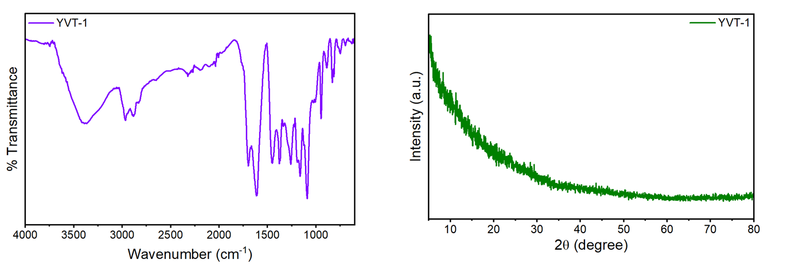
b)
a)
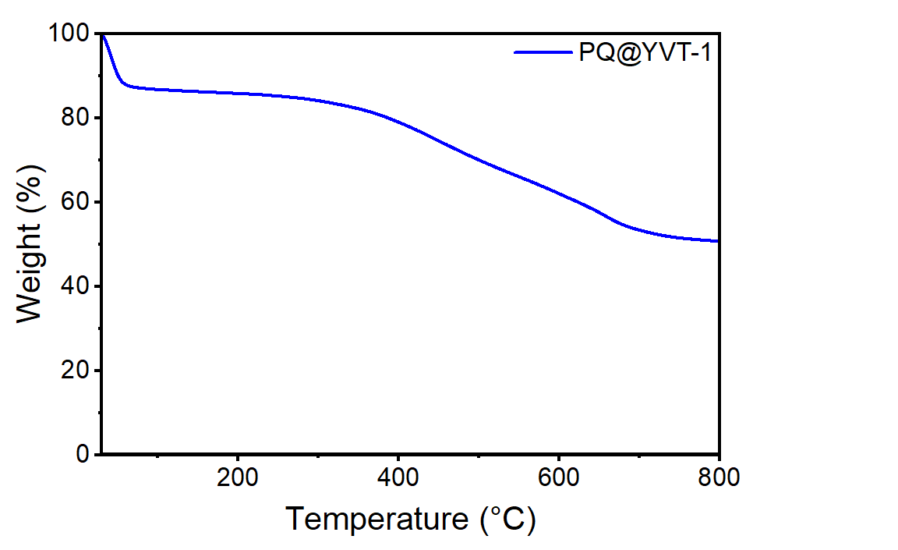
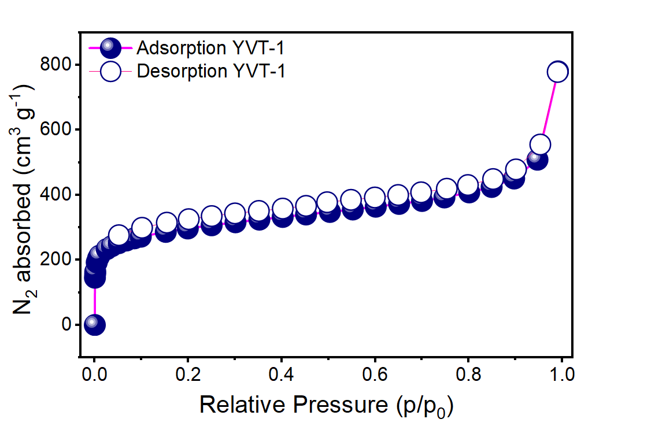
d)
c)
Figure1. Structural characterization of YVT-1 a) FT-IR spectra, b) PXRD patterns, c) Nitrogen adsorption−desorption isotherms at 77 K, d) TGA spectra

Application:
Crystal violet capture from aqueous medium-
The presence of a dense network of polar hydroxyl (–OH) groups in YVT-1 makes it an excellent candidate as an adsorbent for cationic dye capture from aqueous media. In water, crystal violet exists as a highly soluble, positively charged organic molecule. This study investigates the potential of YVT-1 as an adsorbent to capture crystal violet using UV-Vis spectroscopy. A crystal violet solution was prepared by dissolving the dye in water, resulting in an intense purple solution.
The kinetics of crystal violet removal from water was studied by measuring changes in absorbance. Initially, 10 mL of crystal violet solution was taken, and 5 mg of YVT-1 polymer was added. The mixture was stirred, and at set time intervals, 2 mL aliquots were withdrawn for UV-Visible analysis (Fig. 2a). UV-Vis spectra were recorded at various time intervals. A strong absorption peak appeared around 590 nm, which gradually decreased as the solution color faded from deep purple to almost colorless, indicating effective removal of the dye molecules. The YVT-1 showed nearly 98.7% crystal violet removal within 5 minutes (Fig. 2b).

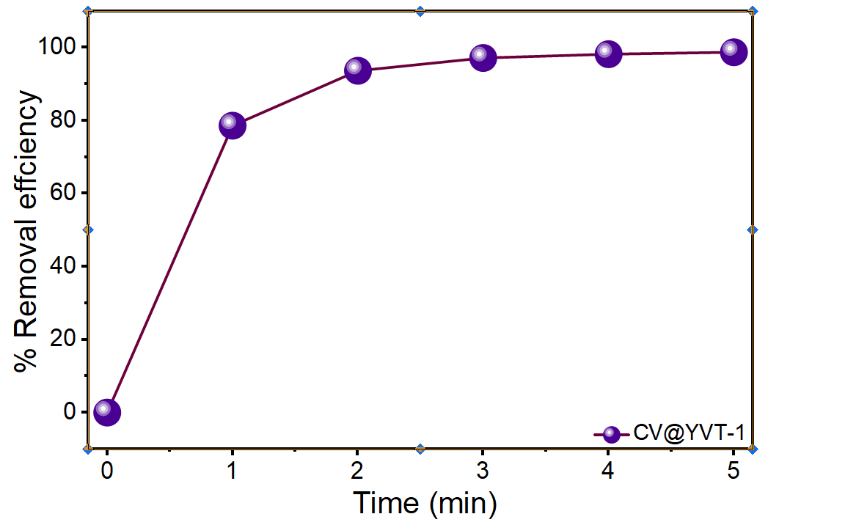
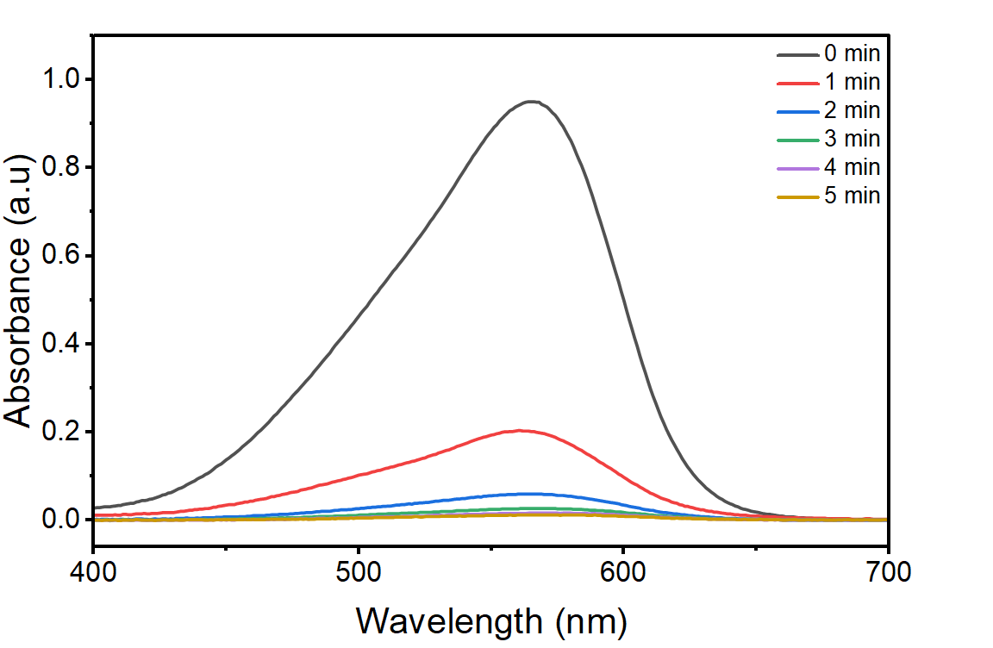
a)
b)

Figure-2: (a) UV-vis adsorption spectra of crystal violet (b) Removal efficiency of crystal violet from aqueous solutions.
Iodide captures from aqueous medium-
The presence of a dense network of polar hydroxyl (–OH) groups in YVT-1 makes it an excellent candidate as an adsorbent for I₃⁻ capture from aqueous media. In water, iodine typically exists in its stable polyiodide form (I₃⁻). This study investigates the potential of YVT-1 as an adsorbent to capture I₃⁻ ions using UV-Vis spectroscopy. An I₃⁻ solution was prepared by dissolving iodine (I₂) in water along with potassium iodide, resulting in a pale-yellow solution.
The kinetics of I₃⁻ removal from water were studied by measuring changes in absorbance. Initially, 10 mL of freshly prepared I₃⁻(50 ppm) solution was taken, and 5 mg of YVT-1 polymer was added. The mixture was stirred, and at set time intervals, 2 mL aliquots were withdrawn for UV-Visible analysis (Fig. 3a). UV-Vis spectra were recorded at various time intervals. A strong absorption peak appeared around 352 nm and 290 nm, which gradually decreased as the solution color faded from pale yellow to almost colorless, indicating effective removal of iodide ions. The TP-Fe-HCP showed nearly 98% iodide removal within 60 minutes (Fig. 3b).
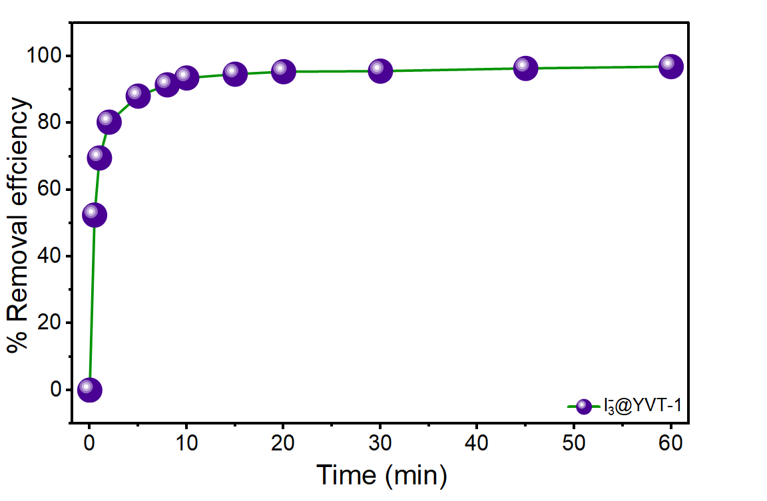
a)
b)
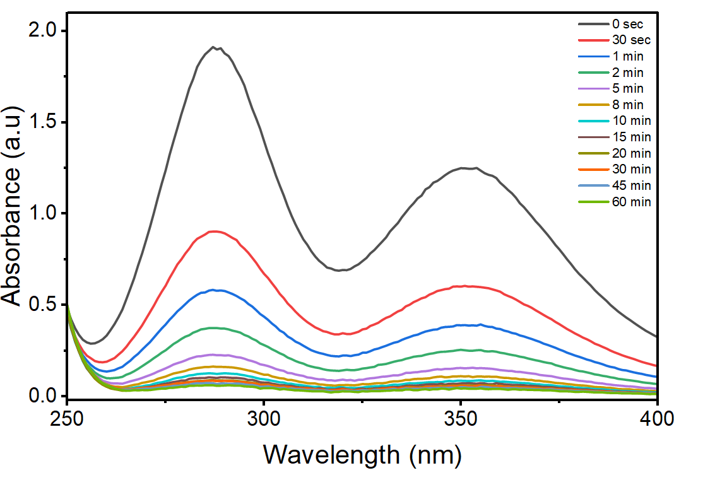

Figure-3: (a) UV-vis adsorption spectra of I₃⁻, (b) Removal efficiency of I₃⁻ from aqueous solutions.

Project-2
Introduction
The increasing contamination of aquatic ecosystems by emerging pollutants poses a critical threat to global environmental and public health. Among these contaminants, the presence of active iodine species, particularly the triiodide anion (I₃⁻​), introduces significant environmental and toxicological risks. Triiodide is a highly reactive in aqueous environments. It is frequently discharged into water systems through industrial effluents from chemical manufacturing, the production of polarizing films, and the widespread use of iodine-based disinfectants. Furthermore, the capture of iodine species, which can exist as polyiodides in aqueous nuclear waste, remains a critical challenge in radioactive waste management and environmental safety. High concentrations of I₃⁻​ in water bodies can severely disrupt biological systems, leading to severe thyroid dysfunction and metabolic imbalances in humans, while also exhibiting acute toxicity toward aquatic flora and fauna.
Compounding these inorganic threats are persistent organic pharmaceuticals, which present their own unique ecological challenges. Norfloxacin, a widely prescribed fluoroquinolone antibiotic, frequently escapes conventional wastewater treatment. Its distinct molecular structure, characterized by a quinolone ring, a piperazine ring, and a carboxylic acid group, allows it to persist in aquatic environments and bio accumulate, contributing heavily to the severe global crisis of antimicrobial resistance.
While various remediation techniques exist, adsorption remains one of the most effective and thermodynamically favorable methods for removing complex trace contaminants from water. Traditional adsorbents, however, often suffer from limited capacity, poor selectivity, or difficulties in regeneration when confronted with mixed-pollutant matrices containing both highly reactive inorganic anions and bulky organic molecules. This creates a significant demand for advanced materials engineered with specific active sites and tailored structural properties capable of simultaneously engaging different classes of molecules through multiple binding mechanisms.
To address these limitations, a novel azo-linked polymer network was synthesized via the diazotization and cross-coupling of 1,5-diaminonaphthalene with phloroglucinol. This synthetic route yields a highly functionalized polymeric framework. The resulting molecular architecture is exceptionally rich in hydroxyl groups derived from the phloroglucinol moieties, integrated with an extended π-conjugated system of naphthalene rings and azo linkages.
These strategically incorporated structural features are critical for targeted adsorption. The abundant hydroxyl and azo groups provide excellent hydrogen-bonding and electrostatic interaction sites, which are highly effective for capturing the charged ₃​ species as well as the diverse functional groups of norfloxacin. Furthermore, the extensive electron-rich aromatic network facilitates strong π−π stacking interactions with the quinolone core of the antibiotic. By deliberately designing this chemical tunability, the synthesized azo-polymer maximizes the available active binding sites, ensuring high affinity and capacity for both targets. The primary objective of this study is to systematically investigate the adsorption behavior, kinetics, and thermodynamic properties of this custom material, demonstrating its viability as a robust and scalable solution for complex water purification challenges.

Scheme-2: Synthesis of AZO-A

Chemicals Required:
Compounds | Weight/vol. Taken | Molecular weight (g/mol) | Milli mole
Phloroglucinol | 126.11 mg | 126.11 | 1
1,5-diaminonapthalene | 237 mg | 158.19 | 1.5
NaNO₂ | 276 mg | 68.99 | 4
Na₂CO₃ | As required | 105.98
HCl | 2 ml | 36.46

Synthesis of AZO-A: Phloroglucinol and naphthalene-1,5-diamine were used as monomeric building blocks in a classic diazotization and azo coupling reaction to synthesize the extended azo-network AZO-A. In a typical procedure, Put 237 mg of naphthalene-1,5-diamine in 150 ml of RB and add 2 ml of concentrated hydrochloric acid.30ml of water was then added, and a magnetic bar was placed. After that, I placed RB inside a bowl of ice and stirred until the temperature dropped to between 0 and 5 degrees.In extremely frigid temperature Weigh 276 mg of NaNO2, then add 30 ml of water to another RB or beaker. After thoroughly mixing it, add the NaNO2 + water combination to the reaction mixture very gradually for about 30 minutes using a dropper.Next, combine Na2CO3 and water in a vial, sonicate for five minutes, and then add to the reaction mixture (RB) to neutralize it. Mix dropwise, then use a ph paper to verify it. Weigh compound Phloroglucinol 126mg and 30ml water in another RB, then add to the reaction mixture slowly. After adding all stirring for 24hr Then filter out and washed precipitate with water. Dry the precipitate and Soxhlet for 24hr in presence of methanol. After Soxhlet dry the precipitate in oven at 120 degree for 24 h.

RESULTS AND DISCUSSION
The AZO-A is thoroughly characterized utilizing several molecular, morphological, analytical and spectroscopic techniques, including Fourier transform infrared spectroscopy (FT-IR), solid-state NMR (13CNMR) spectroscopy, powder X-ray diffraction (PXRD), low temperature N₂ sorption analysis, field emission scanning electron microscopy(FE-SEM) followed by energy dispersive X-ray analysis(EDX), X-ray photoelectron spectroscopy(XPS) analysis, thermo gravimetric analysis (TGA).
The FT-IR spectra of AZO-A are provided in Figure1a. The consumption of the naphthalene-1,5-diamine monomer was evident from the significant reduction or absence of the characteristic double bands assigned to the stretching vibrations of the primary amine (–NH₂) group (typically around 3300–3500 cm⁻¹) in the FT-IR spectrum of MM-2. The successful azo coupling to yield MM-2 was confirmed from the FT-IR spectrum of the newly formed polymer. For example, the bands due to the newly formed azo linkage, such as the –N=N– stretch (1400–1480 cm⁻¹, medium) and the aromatic C–N stretch (1100–1150 cm⁻¹, medium), were clearly observed in the FT-IR spectrum of AZO-A, alongside the broad O–H stretch (3200–3500 cm⁻¹) from the retained phenolic groups. The bonds such as O-H bonds (3200-3500cm⁻¹), aromatic C-H bonds (3000-3100cm⁻¹), C=C bonds (1600-1500cm⁻¹), -N=N-(azo) stretching (1400-1480cm⁻¹), C-O stretching (1150-1250 cm⁻¹), C-N ) stretching(1100-1150 cm⁻¹), aromatic C-H out of plane bending (700-850cm⁻¹) were observed in the FT-IR spectrum of AZO-A.
Solid-state ¹³C CP-MAS NMR data were helpful in the molecular-level characterization of the synthesized azo polymer (AZO-A), providing information on the various carbon nuclei present in the material (Figure-4c). The incorporation of the phloroglucinol units and the successful azo coupling were confirmed by the appearance of signals centered around 150–165 ppm and 135–145 ppm, which are attributed to the oxygen-bound phenolic carbons (C–OH) and the azo-linked aromatic carbons (C–N=N), respectively. The presence of the remaining sp²-hybridized aromatic and bridgehead carbons from the naphthalene and phloroglucinol moieties in the AZO-A skeleton is responsible for the broad signals observed between 115 and 135 ppm. Overall, the solid-state ¹³C NMR (CP-MAS) and FT-IR results showed the successful formation of the extended polymeric network AZO-A via the azo coupling of phloroglucinol and naphthalene-1,5-diamine.
Sample of AZO-A was subjected to XPS analyses, and the corresponding survey spectra are provided in Figure. The simultaneous presence of the O 1s and N 1s peaks, along with that of C 1s, provided additional evidence of the successful azo coupling between the phloroglucinol and diazonium components to yield the highly conjugated polymer network AZO-A.
N₂ sorption isotherms were recorded for AZO-A at low temperatures (77K) (Figure-4d) to gain insights related to the surface area and porosity of these hyper-cross-linked polymers. The AZO-A has a BET surface area of 39.094 m²/g. PXRD of pristine samples of AZO-A indicated that these polymers are amorphous.
FE-SEM data of AZO-A (Figure-4g) was recorded to obtain insights related to the morphology of the material. AZO-A is present as large nano dimensional irregularly shaped aggregates (Figure-4h). EDX was used to investigate the elemental composition and spatial distribution of elements within the polymer AZO-A (Figure4g). The EDX spectrum of AZO-A displays peaks corresponding to C, O, and N, as expected for the framework. The thermal stability of AZO-A was measured from TGA of the respective sample (Figure-4b).
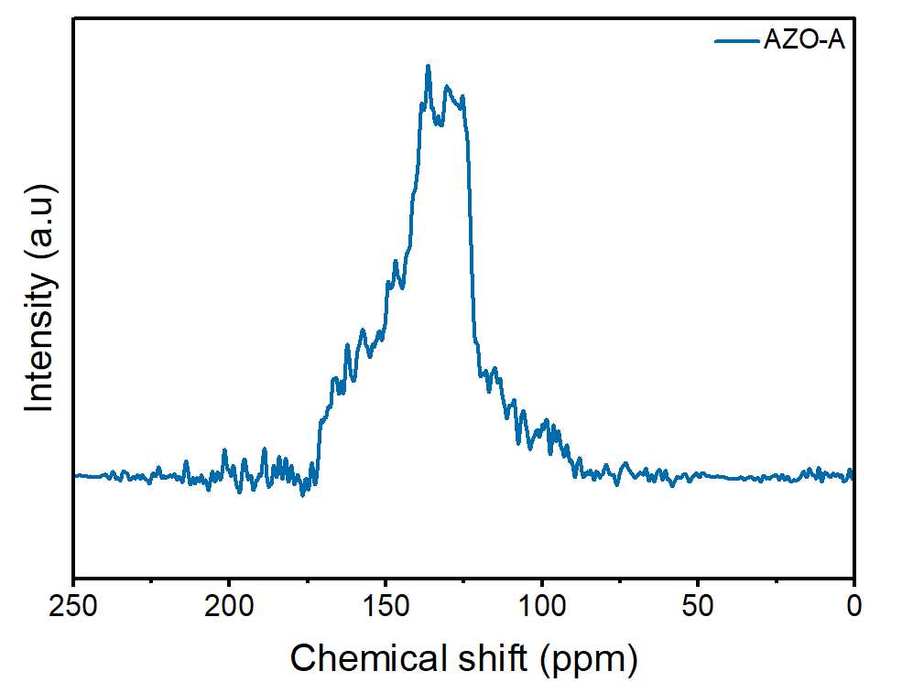
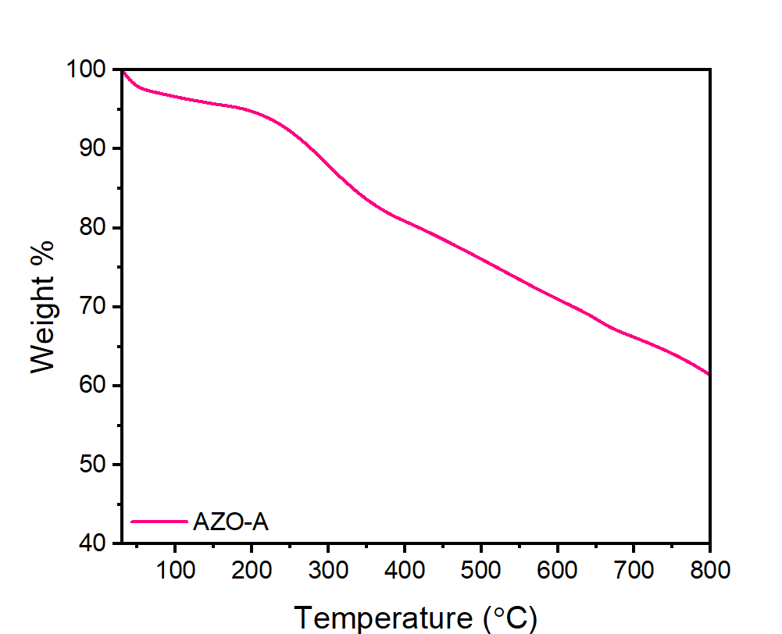
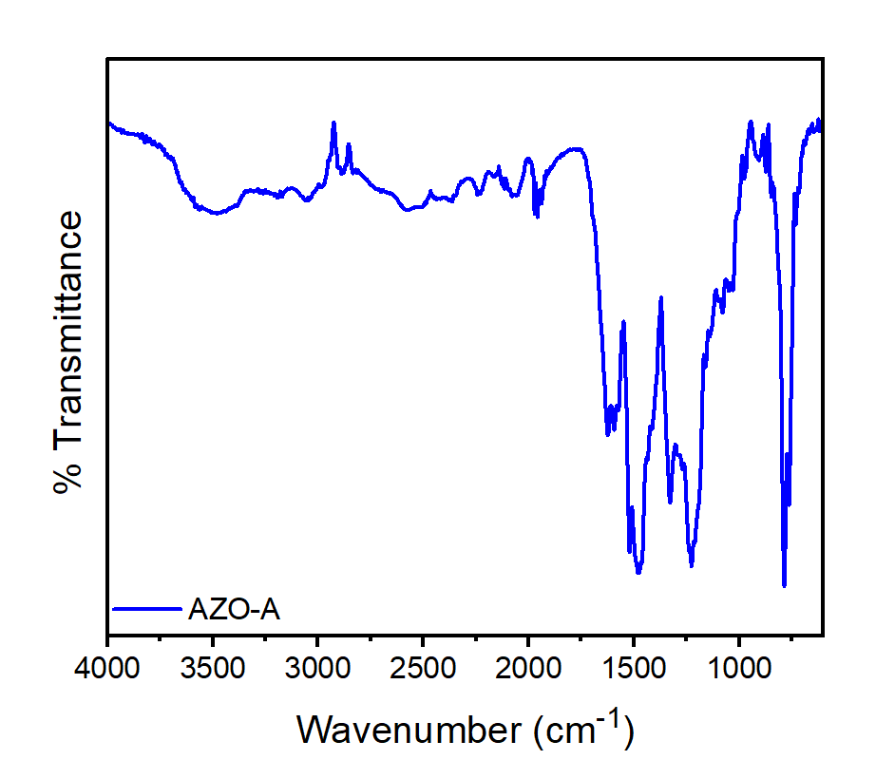
c)
b)
a)

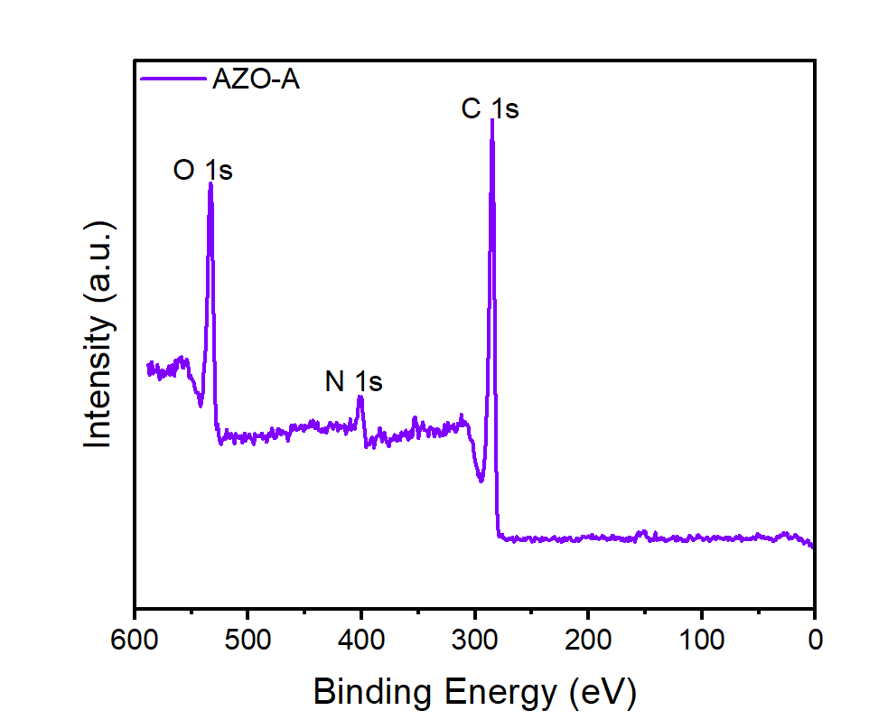
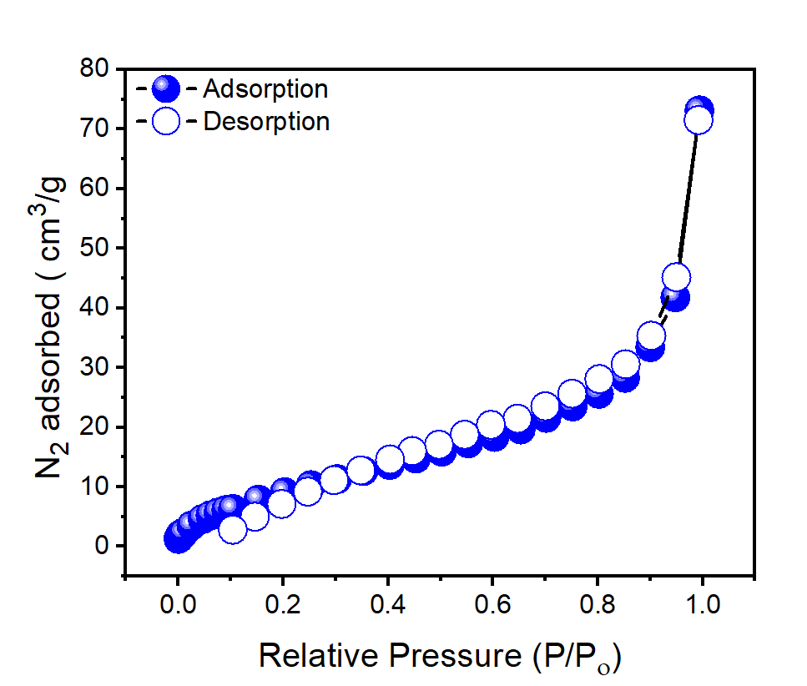
e)
f)
d)
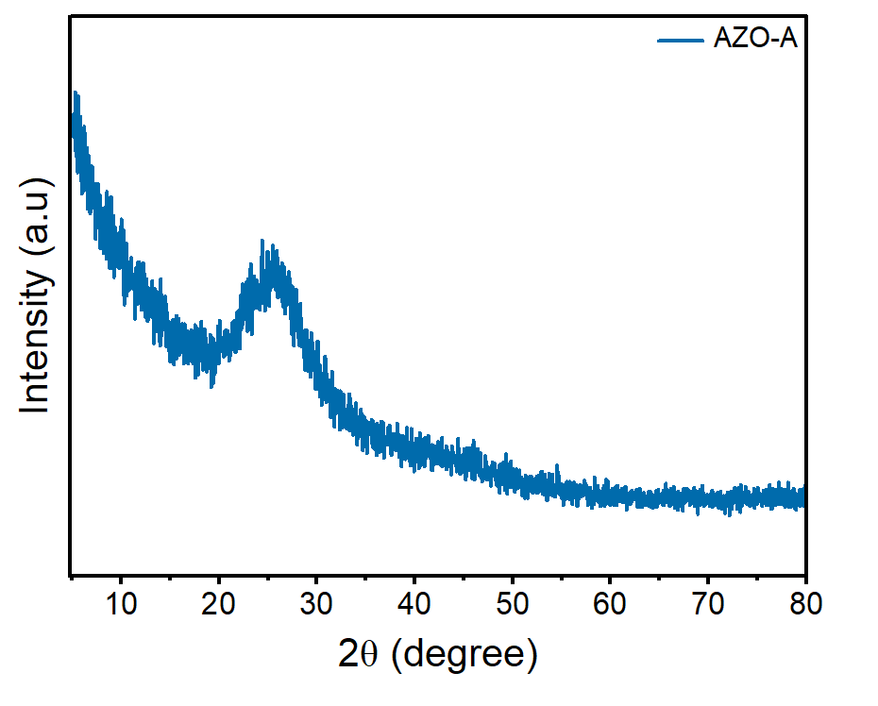
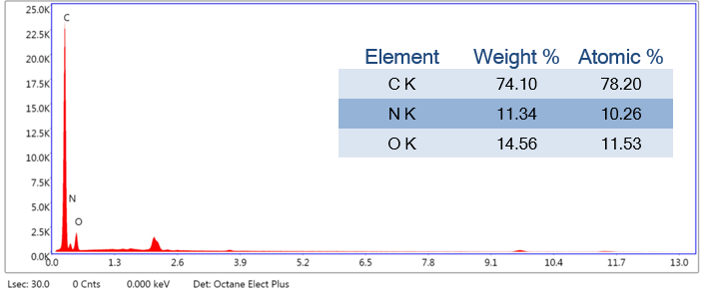
g)
h)

Figure4. Structural characterization of AZO-A a) FT-IR spectra, b) TGA spectra, c) FE-SEM image, d) Nitrogen adsorption−desorption isotherms at 77 K, e) PXRD patterns, f) XPS survey spectrum, and g) FE-SEM EDX survey spectrum, h) Solid state 13C-NMR (CP/MAS) of AZO-A
Application:
Iodide captures from aqueous medium-
The presence of π-electron-rich environments in AZO-A makes it an excellent candidate as an adsorbent for iodide capture from aqueous media. In water, iodine typically exists in its stable polyiodide form (I₃⁻). This study investigates the potential of AZO-A as an adsorbent to capture I₃⁻ ions using UV-Vis spectroscopy. An I₃⁻ solution was prepared by dissolving iodine (I₂) in water along with potassium iodide, resulting in a pale-yellow solution.
The kinetics of I₃⁻ removal from water was studied by measuring changes in absorbance. Initially, 10 mL of freshly prepared I₃⁻ solution was taken, and 5 mg of YVT-1 polymer was added. The mixture was stirred, and at set time intervals, 2 mL aliquots were withdrawn for UV-Visible analysis (Fig. 5a). UV-Vis spectra were recorded at various time intervals. A strong absorption peak appeared around 352 nm and 290 nm, which gradually decreased as the solution color faded from pale yellow to almost colorless, indicating effective removal of iodide ions. The TP-Fe-HCP showed nearly 99.5% iodide removal within 120 minutes (Fig. 5b).
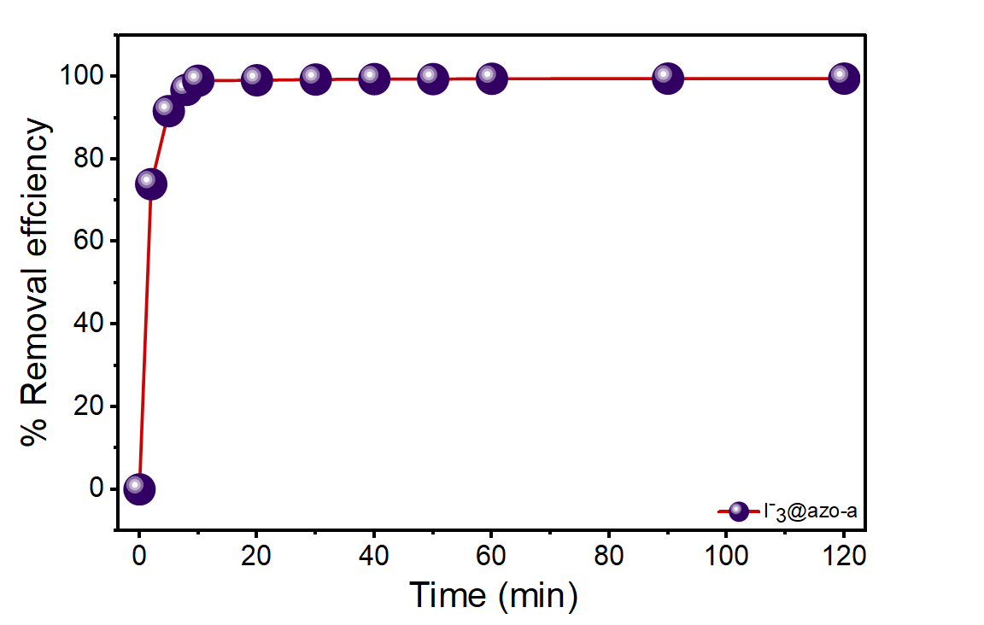
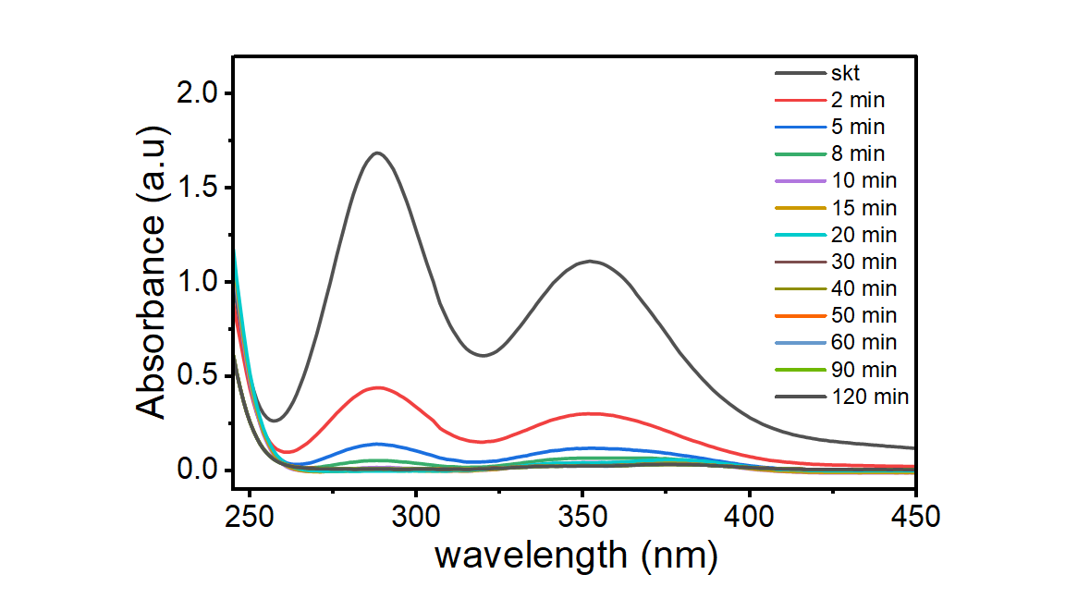
a)
b)

Figure-5: (a) UV-vis adsorption spectra of I₃⁻, (b) Removal efficiency of I₃⁻ from aqueous solutions.

Norfloxacin capture from aqueous medium-
In water, norfloxacin exists as a persistent, moderately soluble organic molecule. This study investigates the potential of the azo-linked polymer as an adsorbent to capture norfloxacin using UV-Vis spectroscopy. A norfloxacin solution was prepared by dissolving the antibiotic in water.
The kinetics of norfloxacin removal from water was studied by measuring changes in absorbance. Initially, 50 mL of freshly prepared norfloxacin solution was taken, and 25 mg of the azo-linked polymer was added. The mixture was stirred, and at set time intervals, 2 mL aliquots were withdrawn for UV-Visible analysis (Fig. 6a). UV-Vis spectra were recorded at various time intervals. A strong absorption peak appeared around 275 nm, which gradually decreased over time, indicating effective removal of the antibiotic molecules from the solution. The azo-linked polymer showed nearly 79% norfloxacin removal within 120 minutes (Fig. 6b).
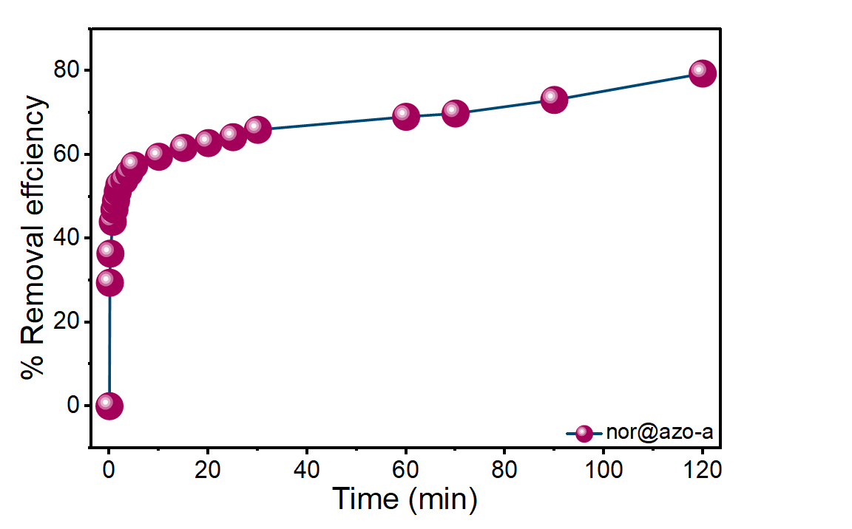
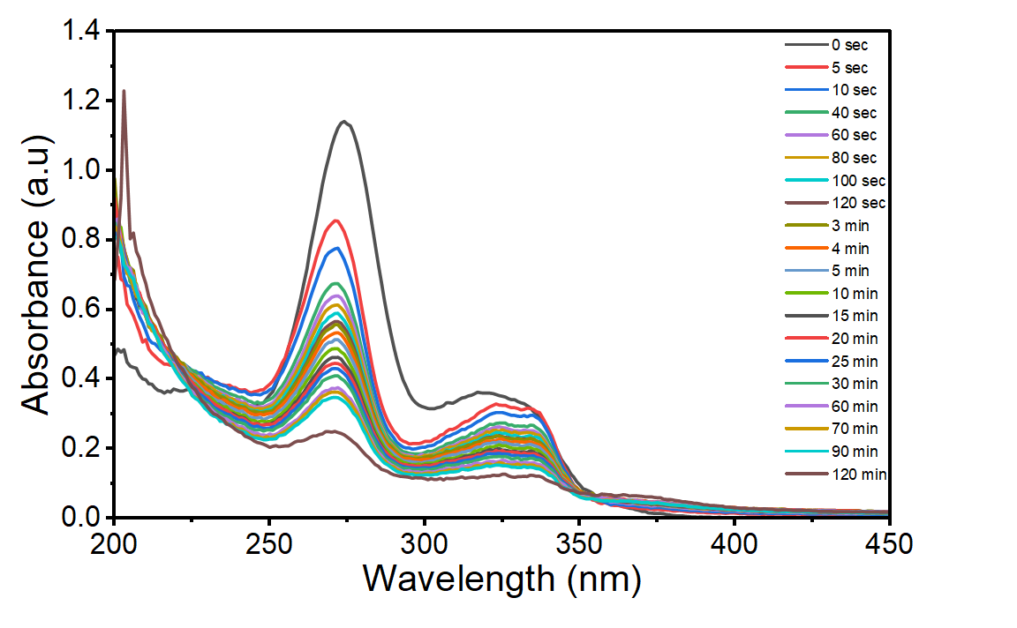
a)
b)

Figure-6: (a) UV-vis adsorption spectra of norfloxacin, (b) Removal efficiency of norfloxacin from aqueous solutions.

Conclusion
Triptycene-based porous organic polymers were successfully synthesized via Friedel–Crafts reaction and using FeCl₃ as a catalyst. The structural and thermal analyses, including FT-IR, XRD, and TGA, confirmed the formation of the polymer, its amorphous nature, and good thermal stability. The inherent rigidity and three-dimensional structure of triptycene impart excellent robustness and structural integrity to the polymer framework, making the polymer promising for advanced applications like adsorption of triiodide within 60 minutes and crystal violet with 5 minutes.
In another project, azo-linked polymer was successfully synthesized via green synthesis reaction under mild conditions. Selective cross-coupling between 1,5-diaminonaphthalene and phloroglucinol yielded the target polymeric framework efficiently. The structure and purity were confirmed by solid-state ¹³C CP-MAS NMR spectroscopy, FT-IR, XRD, and TGA, confirmed the formation of the polymer. The compound was obtained in good yield, making the polymer promising for advanced applications like adsorption of triiodide and norfloxacin within 120 minutes.

References:

- ACS Appl. Polym. Mater. 2026, 8, 10, 7490–7499

- ACS Appl. Polym. Mater. 2019, 1, 959−968

- Chemical Engineering Journal 427 (2022) 130950J. Am. Chem. Soc. 1989, 111, 5962– 5964

- Microporous and Mesoporous Materials 323 (2021) 111242

