Name:-Khushveer Singh Gurjar

Dockerfile creation steps

1.Firstly we need to create a app.py

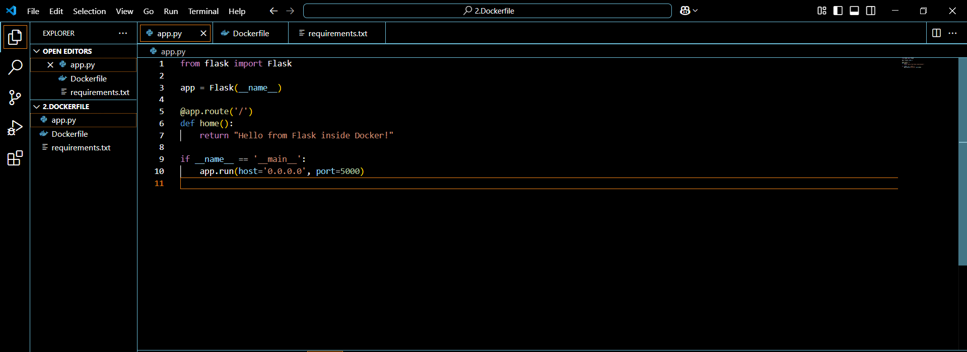

2.Then create a Dockerfile.

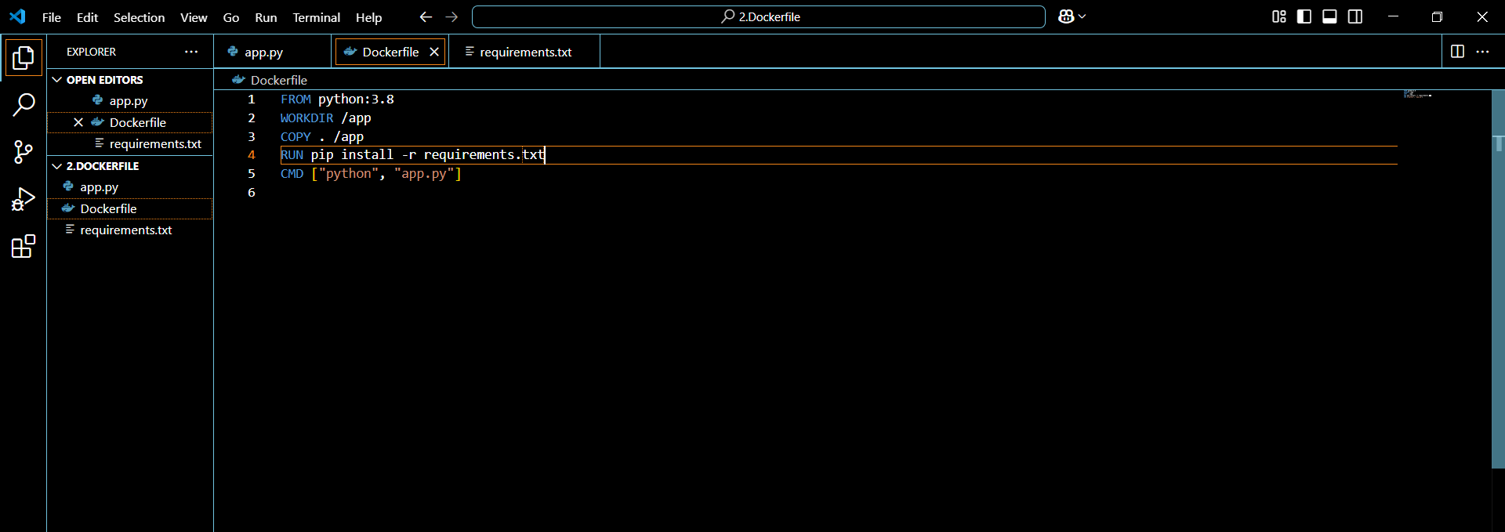

3.Then in terminal after creating the requirement.txt we need to write docker build –t flask-docker-app,so that our docker image is created.

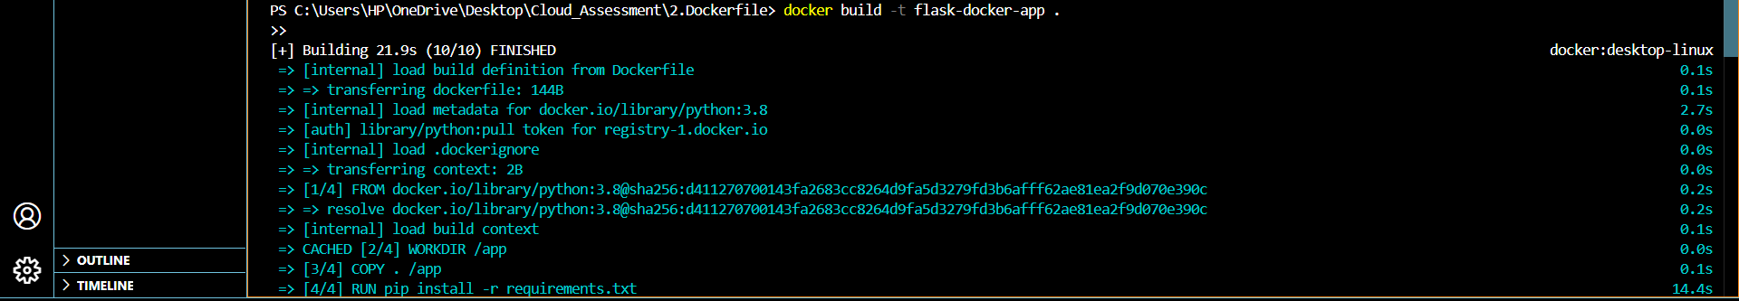

4.Once the docker image is created we will get the IPs to run the app.



5. Run the IPs and you will get the message.

