Truck planner – Coding task

# Class diagram

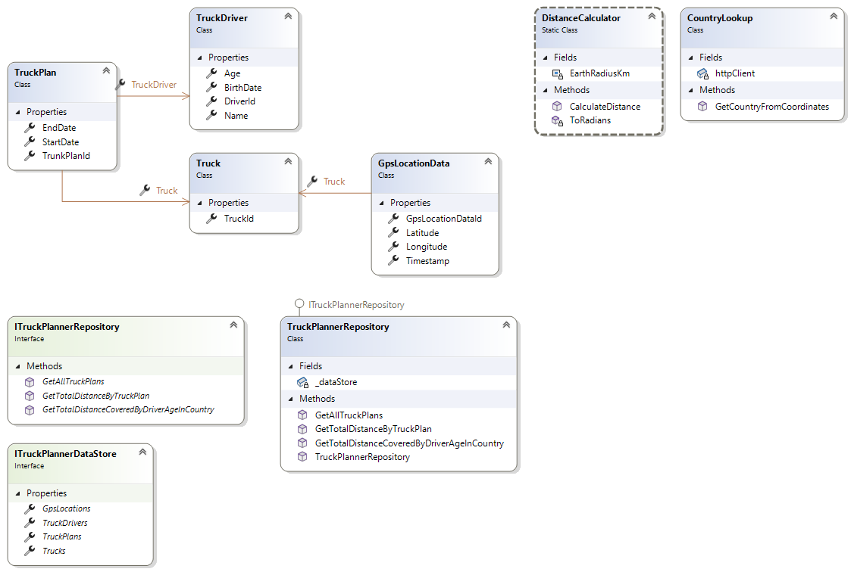

# Assumptions

* It has been assumed that each Truck has non-removable GPS device. Based on this assumption, GPS location data has Truck as the Reference key.
* The solution does not represent underlying database setup.
* It has been assumed that to calculate total distance, all the GPS locations involved between a given Truck plan have been used.
* Only required properties have been exposed.

# Out of scope

* Data store / Data base management. For example, the model is not designed to support fast generation for various look ups.
* Error handling / logging.