
Tribhuvan University
Faculty of Humanities and Social Sciences

A PROJECT REPORT ON
“Blood Bank Management System”

Submitted to
Department of Computer Application
Bhairahawa Multiple Campus

In partial fulfillment of the requirements for the Bachelors in Computer Application

SUBMITTED BY:
Manish Neupane
TU Registration No: 52-51-22-000xx
Under the Supervision of
Roshan Thapa
April 2026

Tribhuvan university
Faculty of Humanities and Social Science
Bhairahawa Multiple Campus

Supervisor’s Recommendation
I hereby recommend that this project prepared under my supervision by Manish Neupane entitled “Blood Bank Management System” in partial fulfillment of the requirements for the degree of Bachelor of Computer Application is recommended for the final evaluation.

………………
SIGNATURE
Roshan Thapa
Teaching Assistant
Bhairahawa Multiple Campus


Tribhuvan university
Faculty of Humanities and Social Science
Bhairahawa Multiple Campus

LETTER OF APPROVAL
This is to certify that this project prepared by MANISH NEUPANE entitled “Blood Bank Management System” in partial fulfillment of the requirements for the degree of Bachelor in Computer Application has been evaluated. In our opinion it is satisfactory in the scope and quality as a project for the required degree.
……………………..
Lucky Prasad Joshi
Campus Chief
Bhairahawa Multiple Campus
…………………  Sunil Kumar Shah  Program Coordinator  Bhairahawa Multiple Campus | …………………  Roshan Thapa  Supervisor  Bhairahawa Multiple Campus
……………………  Internal Examiner  Bhairahawa Multiple Campus | ………………….  External Examiner  Tribhuvan University

ACKNOWLEDGEMENT
I am deeply grateful to several individuals whose support, suggestions, and guidance have played a key role in organizing and finalizing this project. Their continuous encouragement has been invaluable in bringing this project to completion, and I would like to take this opportunity to thank them all.
First and foremost, I would like to express my sincere thanks to my supervisor, for giving me the honor of working on this project, "Blood Bank Management System" whose guidance, insightful feedback, and constant encouragement have been crucial to the success of this project. Without his support, this project would not have reached its final form. I am also thankful for the many new things I learned throughout the process.
I am equally grateful to my family and friends for their endless support and motivation. Their innovative ideas and constant help have been a source of inspiration and encouragement throughout the development of the project. I am thankful for their belief in my abilities, which kept me going even during challenging times.
Finally, I would like to express my gratitude to everyone who has been part of this journey, offering help, guidance, and encouragement. Their assistance has played a crucial role in the successful completion of this project, and I am truly thankful for their support.
With heartfelt thanks.
Manish Neupane

STUDENT’S DECLARATION
We hereby declare that the project report entitled “Blood Bank Management System” submitted in partial fulfillment of requirement for the Bachelor’s degree of Bachelor in Computer Application of Tribhuvan University is our original work and has not been submitted for the award of any other degree, diploma, fellowship or other similar title or prize.

………………..
Manish Neupane

ABSTRACT
The Blood Bank Management System is a desktop-based application developed using Java Swing and MariaDB that digitizes and automates the complete life cycle of blood bank operations. This system addresses the critical challenge of managing blood inventory, donor records, blood requests, and administrative oversight in a unified, secure, and user-friendly platform.
Traditional blood banks in Nepal rely heavily on manual processes — paper-based registers, phone-based donor contact, and fragmented records — which leads to delays during medical emergencies and potential loss of life. This project was developed to replace these inefficient methods with a modern, automated system that ensures real-time inventory visibility, streamlined donor engagement, and efficient request fulfillment.
The system features two primary modules: an Administrator Dashboard and a User Portal. The Admin Dashboard provides complete control over blood stock management, donor recognition, request approval/rejection with priority scoring, and recognition letter generation. The User Portal enables donors to register, view their donation history, check blood stock availability, submit blood requests with requisition documents, and track notifications from administrators.
Security is implemented through SHA-256 password hashing, role-based access control, and prepared SQL statements to prevent injection attacks. The system supports an achievement-based donor gamification model with tier rankings (Silver, Gold, Diamond) based on accumulated points, incentivizing repeat donations. Real-time stock alerts, eligibility tracking based on the 3-month donation cool down, and a dynamic compatibility matrix further enhance the clinical utility of the system.
The application was developed iteratively using the Waterfall software development methodology. Testing was conducted through unit tests, system tests, and user acceptance tests, all of which confirmed that the system meets its functional and non-functional requirements.

Keywords: Blood Bank Management, Java Swing, MariaDB, Donor Management, Inventory Management, Blood Request, Healthcare Information System

TABLE OF CONTENT
SUPERVISOR RECOMMENDATION……………………………………………….i
LETTER OF APPROVAL……………………………………………………………..ii
ACKNOWLEDGEMENT…………………………………………………………….iii
STUDENT’S DECLARATION……………………………………………………….iv
ABSTRACT…………………………………………………………………………….v
LIST OF ABBREVIATIONS……………………….………………………………..viii
LIST OF FIGURES….…………………………………………………………….....ix
LIST OF TABLES……………………………………………………………………..x
Chapter 1: Introduction…………….…………………………………………………1
1.1 Introduction………………………………………………………………….…1
1.2 Problem Statement……………………………………………………………...2
1.3 Objectives……………………………………………………………………....3
1.4 Scope and Limitations……………………………………………………......3-4
1.5 Development Methodology………………………………………………......4-5
1.6 Report Organization…………………………………………………………….6
Chapter 2: Background Study and Literature Review………………………….…....7
2.1 Background Study……………………………………………………………..7
2.2 Literature Review……………………………………………………………..8
Chapter 3: System Analysis and Design………………………………………...….…9
3.1 System Analysis………………………………………………………………..9
3.1.1 Requirement Analysis…………………………………………………...9-10
3.1.2 Feasibility Analysis……………………………………………………..11-12
3.1.3 Data Modelling (ER-diagram)…………………………………………13-14
3.1.4 Process Modeling (DFD)……………………………………………...15-18
3.2 System Design……………………………………………………………….….18
3.2.1 Architectural Design………………………………………………………..18
3.2.2 Database Schema Design……………………………………………………19
3.2.3 Interface Design……………………………………………………………..20
3.2.4 Physical DFD………………………………………………………………..21
Chapter 4: Implementation & Testing……………………………………………….22
4.1 Implementation…………………………………………………………………..22
4.1.1 Tools Used……………………………………………………………....23-24
4.1.2 Implementation Details of Modules…………………………………….24-25
4.2 Testing………………………………………………………………………..…25
4.2.1 Test Cases for Unit Testing………………………………………………25-27
4.2.2 Test Cases for System Testing………………………………………..…28-29
Chapter 5: Conclusion and Future Recommendations………………………….....30
5.1 Lesson Learnt…………………………………………………………………...30
5.2 Conclusion………………………………………………………………………31
5.3 Future Recommendations……………………………………………………….31
Appendices……………………………………………………………………….…32-25
References ……………………………………………………………………………..36

List of Abbreviations
BBMS: Blood Bank Management System
CASE: Computer-Aided Software Engineering
CRUD: Create, Read, Update, Delete
DFD: Data Flow Diagram
ER: Entity Relationship
JDBC: Java Database Connectivity
UI: User Interface
VS Code: Visual Studio Code

List of Figures
Figure 1.1 Waterfall Model……………………………………………………………...5
Figure 3.1 Use Case Diagram…………………………………………………………...10
Figure 3.2 Gantt Chart…………………………………………………………………..12
Figure 3.3 ER Diagram………………………………………….…………………...…13
Figure 3.4 Context Level DFD……………………………………………………….…15
Figure 3.5 Level 1 DFD………………………………………………………………....16
Figure 3.6 Level 2 DFD………………………………………………………………...17
Figure 3.7 Architectural Design……………………………………………………..…18
Figure 3.8 Database Schema Design…………………………………………………...19
Figure 3.9 Home Page…………………………………………………………………...20
Figure 3.10 Physical DFD…………………………………………………………….….21

List of Tables
Table 4.1 : Test Case for Authentication Module…………………………………….26
Table 4.2 : Test Case for Blood Request Module……………………………………..27
Table 4.3 : Test Case for of Whole System…………………………………………...28

Chapter 1: Introduction

Introduction
Blood is often called the "river of life" because it is a critical and irreplaceable biological resource that modern science simply cannot recreate. There is no factory-made alternative to human blood; every drop used in a surgery, for a life-threatening trauma victim, or during a complicated childbirth must come from the selfless contribution of a kind-hearted donor. Its timely availability is a decisive factor in modern medicine, often representing the thin line between a patient’s life and death.
In our healthcare infrastructure, blood banks act as the vital bridge between these donors and the patients who need them. Their job is highly complex, requiring the staff to collect, test, store, and distribute blood units with perfect accuracy and speed. However, many blood banks across Nepal—particularly those in provincial and semi-urban areas—continue to operate using outdated, paper-based manual methods. In a high-stakes medical emergency where every second counts, flipping through dusty binders to find a donor's phone number isn't just slow; it is dangerously inefficient.
The Blood Bank Management System is a comprehensive desktop application built with Java Swing and MariaDB specifically to address these systemic challenges. It provides a complete digital ecosystem for managing donor records, tracking real-time inventory by blood group, and processing hospital requests through automated logic. The system is structured into two distinct modules: an Administrator Dashboard for complete operational oversight and a User Portal that empowers donors to interact with the blood bank digitally.

Problem Statement
Blood banks that operate manually face a multitude of challenges that significantly reduce their effectiveness in emergency situations. The reliance on paper-based logs and manual communication creates a disconnected system where information moves slower than the medical emergencies it is meant to serve.
The specific problems that motivated the development of the BBMS include:
- Inaccurate Inventory Management: Manual inventory tracking on paper registers leads to frequent stock discrepancies. Without automated expiration alerts, life-saving blood units often go unnoticed until they have expired and are no longer usable.
- Fragmented Donor Information: The lack of a centralized donor database means staff must search through physical files to locate compatible donors. During a crisis, this manual search makes it impossible to find and contact the right people quickly.
- Delayed Request Processing: Blood requests from hospitals are currently processed manually via phone calls or physical forms. This bureaucratic bottleneck causes dangerous delays in getting blood from the storage fridge to the patient’s bedside.
- Lack of Proactive Management: Without real-time visibility into stock levels, blood bank administrators cannot engage in proactive management. They are unable to send timely alerts to the community before a specific blood group runs out completely.

Objectives
The primary objective of this project are given below:
- To create a secure and searchable centralized database for donor registration that allows for immediate identification of compatible donors by blood type and geographic proximity.
- To provide real-time visibility into blood stock levels with automated visual alerts for critical shortages or expiring units.
- To develop a structured digital interface for hospitals to submit blood requests, including the capability to upload scanned medical requisition documents for verification.

Scope and Limitations
- Scope
The scope of the BBMS is centered on providing a complete operational environment for regional blood bank centers. This includes a real-time inventory management dashboard that uses color-coded indicators to signal critical stock levels and a donor portal where individuals can manage their profiles, view eligibility status, and track their contributions to the community. Administratively, the system facilitates the management of donor records, hospital requests, and the generation of digital recognition certificates. The system also includes an emergency broadcast engine designed to notify donors based on their distance from the blood bank, ensuring a rapid response during crises

- Limitations
The system is currently a Java Swing desktop application that requires a stable local network or internet connection for real-time database syncing across counters. While it efficiently tracks testing statuses, it serves as a digital management tool rather than a diagnostic one; all clinical blood analysis must still be performed manually by medical professionals before data entry.

1.5 Development Methodology
The Blood Bank Management System is developed following the Waterfall Software Development Life Cycle (SDLC) methodology. The Waterfall model is a sequential, plan-driven approach where each phase must be completed before progressing to the next. This methodology was chosen for its suitability to academic projects with well- defined requirements and clear milestones.

The development process followed these sequential phases:
Requirements Analysis: Gathered through stakeholder interviews (simulated), analysis of existing blood bank workflows, review of similar systems and identification of functional and non-functional requirements.

System Design: Created comprehensive design documents including ER diagrams, Data Flow Diagrams (DFDs), database schema, architectural design (MVC Pattern) and user interface.

Implementation: Developed the system using Java JDK 17, Java Swing for GUI,
MariaDB 10.6 for database, with modular class structure and PreparedStatements for security.

Testing: Conducted unit testing for individual modules, system testing for integrated functionality, and user acceptance testing to validate against requirements.

Deployment: Packaged application for deployment on Windows/Linux platforms with proper configuration and setup documentation.

Maintenance: Documented known issues, planned future enhancements, and created user/admin operation manuals.

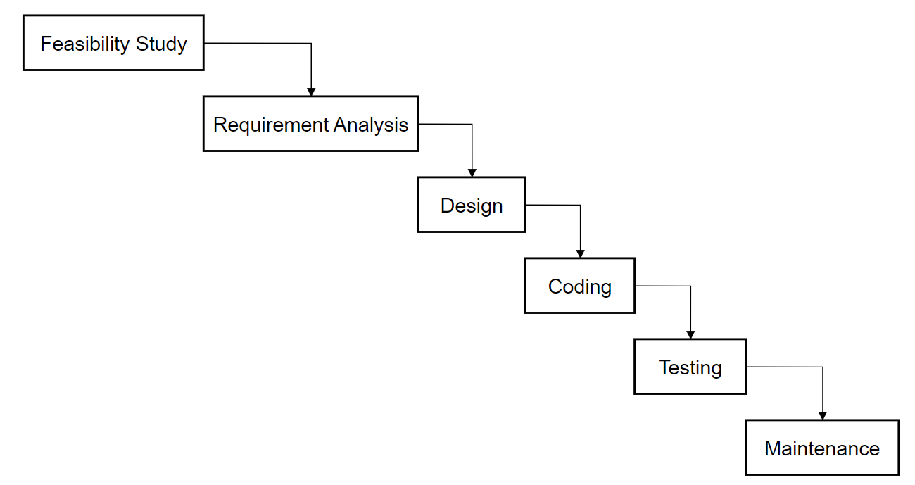

Figure 1.1: Waterfall Model

1.6 Report Organization
The report for the Blood Bank Management System is organized into five comprehensive chapters, as detailed below:
- Chapter 1: Introduction: This chapter provides the foundational context for the project, covering the background study, a detailed problem statement regarding current manual methods, project objectives, scope, and limitations.
- Chapter 2: Background Study and Literature Review: This section examines existing blood management systems. It explores the technological, security, usability, and research challenges that influenced the final design decisions.
- Chapter 3: System Analysis and Design: This chapter details the technical blueprint of the system, including the software development methodology, requirement analysis (functional and non-functional), and feasibility studies. It also contains various modeling diagrams such as Use Case diagrams, ER diagrams, Data Flow Diagrams (DFDs), database schemas, and interface design.
- Chapter 4: Implementation and Testing: This section describes the tools and technologies used to build the application. It provides implementation details for individual modules and outlines the comprehensive test cases used for unit and system testing to ensure software reliability.
- Chapter 5: Conclusion and Future Recommendations: The final chapter summarizes the project's achievements and lessons learned. It also proposes future enhancements, such as mobile application integration, AI-driven stock level prediction, and real-time notification systems.

Chapter 2 : Background Study and Literature Review

2.1 Background Study
Blood banks are essential for providing life-saving blood during emergencies, surgeries, and chronic medical treatments. Historically, these facilities relied on manual record-keeping for inventory control and donor management, which often resulted in data errors, inefficient tracking, and slow blood allocation. Such challenges frequently lead to blood shortages, avoidable wastage, and critical delays in emergency situations.
Blood Bank Management System (BBMS), aims to automate these traditional processes. By offering real-time tracking of blood stocks and streamlined donor management, a digital system ensures faster allocation of blood to hospitals and better coordination between facilities. In the Nepalese healthcare context, where many regional blood banks still operate as independent, manual entities, there is a significant need for a unified digital bridge.
This project modernizes the local blood supply chain by replacing fragmented manual workflows with high-performance features. Key innovations include real-time inventory tracking, algorithmic priority scoring for urgent medical requests, and the implementation of Dijkstra’s algorithm to quickly locate and mobilize nearby donors. By focusing on accessible and efficient technology, the system reduces operational gaps and ensures the timely availability of safe blood supplies for patients in need.

2.2 Literature Review
The evolution of blood bank management reflects a critical transition from fragmented manual record-keeping to integrated, high-availability digital ecosystems. This chapter examines the historical challenges of blood logistics and the technological milestones that have shaped modern systems.

Transition from Manual to Electronic Systems
Historically, blood bank operations relied heavily on physical registers and paper-based forms. This traditional method was inherently prone to significant human error, data redundancy, and life-threatening delays in cross-matching [1]. Research in [2] demonstrated that the transition to Electronic Blood Bank Management Systems (EBBMS) drastically improves data integrity, specifically in critical clinical areas such as blood group verification and inventory shelf-life tracking.

Web-Based Coordination and HIS Integration
As web technologies matured, the focus shifted toward networked platforms. Studies highlighted in [3] show how web-based architectures facilitate real-time resource sharing between geographically dispersed facilities, effectively reducing local shortages. Modern literature now emphasizes the seamless integration of these platforms with broader Hospital Information Systems (HIS) to create a unified transfusion workflow, ensuring that patient data and blood availability are synchronized in real-time [4].

Database Automation and Algorithmic Optimization
Recent findings prove that database-driven automation—specifically the use of RDBMS triggers and stored procedures—can reduce blood request fulfillment times by over 60% by eliminating manual inventory updates [5]. Current research explores the use of predictive analytics and algorithmic optimization [6]. This includes implementing geospatial mapping for donor mobilization and "Gamification" models (Point Systems) to increase donor retention rates, ensuring that the right blood type reaches the right patient within the "Golden Hour" of medical emergency.

Chapter 3: System Analysis and Design

3.1 System Analysis
System Analysis refers into the process of examining a system with the intent of improving it through better procedures and methods. It is the process of planning a new system to either replace or complement an existing system. It is, therefore, the process of gathering and interpreting facts, diagnosing problems and using the information to re- comment on improvements in the system.

3.1.1 Requirement Analysis
Requirement analysis involves refining and prioritizing the collected requirements to ensure they align with the project’s objectives and constraints. This process includes:

3.1.1.1 Functional Requirements
  - User Registration: Allows new users to create personal accounts by capturing their contact information, location, blood group, and a secure password.
  - Role-Based Login: A secure authentication gateway that distinguishes between Admin and User roles using SHA-256 password verification.
  - Blood Stock Management: Provides the Admin with a real-time interface to view, update, and monitor the inventory levels of all eight major blood groups.
  - Request Prioritization: An internal logic that automatically calculates priority scores for pending requests based on medical urgency and current stock availability.
  - Request Approval/Rejection: A management module where Admins review requests and update their status, which is then reflected on the requester's dashboard.
  - User Registration: Allows new users to create personal accounts by capturing their contact information, location, blood group, and a secure password.
  - Donor Management: A centralized directory for the Admin to track donor activity, view the top-donor leaderboard, and manage contact details.

Use Case Diagram
A use case diagram is a graphical representation used in software engineering to illustrate the interactions between users (actors) and a system. It captures the functional requirements of a system, showing how different users engage with various functionalities within the system.
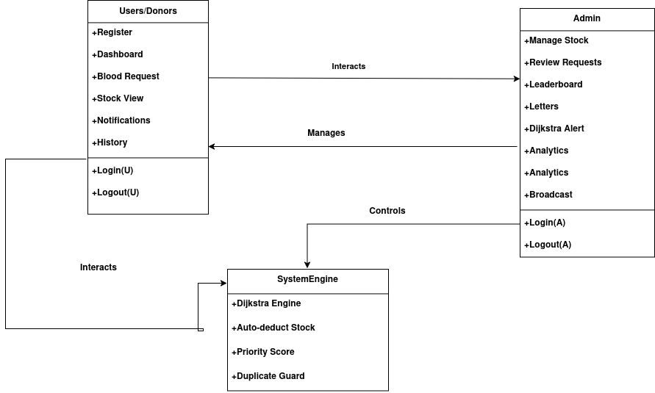

ll 1.1.1: Use Case Diagram

Figure 3.1: Use Case Diagram

3.1.1.2 Non-Functional Requirements
The quality attributes that ensure the system is professional and reliable include:
- Security: Implements SHA-256 password hashing and role-based access control to protect sensitive medical and personal data.
- Performance: Features optimized database queries with indexed columns to ensure the UI remains responsive and loads data within 2 seconds.
- Usability: Utilizes a modern Java Swing UI design with a consistent color scheme, hover effects, and intuitive navigation for ease of use.
- Reliability: Uses PreparedStatements to prevent SQL injection and includes robust connection error handling to prevent system crashes.
- Maintainability: Built with a modular class structure, ensuring that each page and function is separated for easier debugging and future updates.
- Scalability: Features a flexible database schema that supports the future expansion of blood groups, user types, and request categories.

3.1.2 Feasibility Analysis
Before moving into full development, a feasibility study was conducted to ensure the project was practical and sustainable:

Technical Feasibility
The project uses Java JDK 17, MariaDB 10.6, and Java Swing — all freely available, open-source technologies. IntelliJ IDEA Community Edition and VS Code were used for development. The MariaDB JDBC connector enables seamless database connectivity. All technologies are well-documented and supported, making technical implementation fully feasible.

Operational Feasibility
The system is designed with a simple, intuitive interface, ensuring that medical staff with basic computer knowledge can operate it without extensive training.

Economic Feasibility
All software components are open-source and free: Java (OpenJDK), MariaDB, IntelliJ IDEA Community, and VS Code. The only recurring cost is server hosting if deployed on a networked machine. For a local blood bank, a single PC with MariaDB installed suffices, making the total infrastructure cost negligible compared to commercial alternatives.

Schedule Feasiblity
This includes the project schedule, and all the time allocated for its completion. The Gantt chart is as follow:
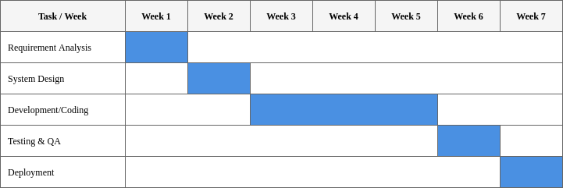
Figure 3.2 : Gantt Chart

3.1.3 Data Modelling (ER-diagram)
Data models define how data is connected to each other and how they are processed and stored in a system. There are different data models which are used to design and develop the database, but here we use ER (Entity Relationship) Model.
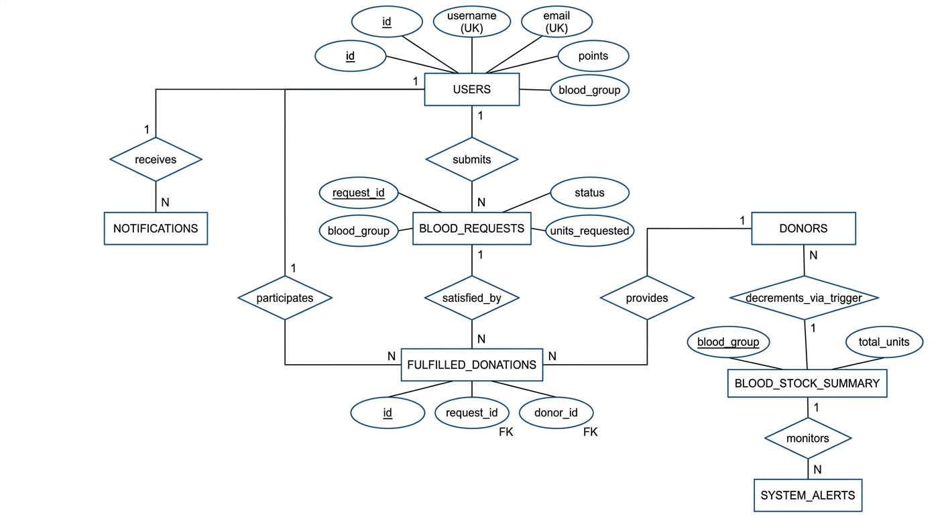
Figure 3.3 : ER Diagram

The above ER diagram represents the Blood Bank Management System with seven main entities:
  - USERS: Represents the registered members of the system, including donors and administrators. Attributes include id (Primary Key), name, username (Unique), email (Unique), phone, city, blood_group, password (secured via SHA-256), role (Admin/User), points (for recognition), last_donation_date, and donation_count.
  - BLOOD_REQUESTS: Represents the requests submitted for blood units. Attributes include request_id (Primary Key), patient_name, phone, blood_group, units_requested, note, requisition_file (image upload), status (Pending/Approved/Rejected), and request_date. It is linked to the stock summary via a database trigger.
  - BLOOD_STOCK_SUMMARY: Represents the centralized inventory of available blood. Attributes include blood_group (Primary Key) and total_units. It is automatically updated whenever a blood request status changes to 'Approved'.
  - DONORS: Represents individuals available for immediate donation, used specifically by the Dijkstra Alert Engine. Attributes include id (Primary Key), name, blood_group, phone, city, and donation_date.
  - NOTIFICATIONS: Represents the communication log for the users. Attributes include id (Primary Key), user_id (Foreign Key linking to the USER entity), message, is_read, and created_at. These are generated by the Dijkstra engine and recognition logic.
  - FULFILLED_DONATIONS: Represents the traceability link between a donation and a request. Attributes include id (Primary Key), donor_id (linking to users), blood_request_id (linking to requests), units, and fulfilled_at.
  - SYSTEM_ALERTS: Represents an audit log of all automated critical alerts dispatched by the system. Attributes include id (Primary Key), blood_group, message, and created_at.

3.1.4 Process Modeling (DFD)
Process Modeling with DFDs visually represents data flow in a system, showing processes, data stores, and external entities. Level 0 gives a high-level overview, Level 1 breaks it into major processes, and Level 2 details each process. They help understand, design, and document systems effectively.
Level 0 DFD (Context Diagram) provides a high-level overview of the system, showing the User interacting with the System to submit, search, and receive results, without detailing internal processes.

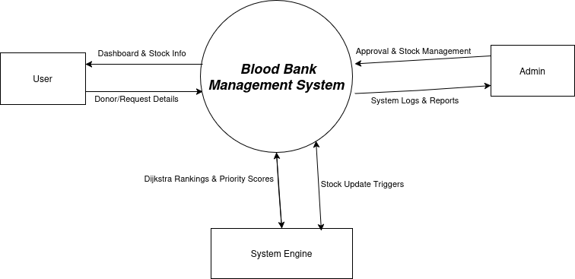

Figure 3.4 : Context Level DFD

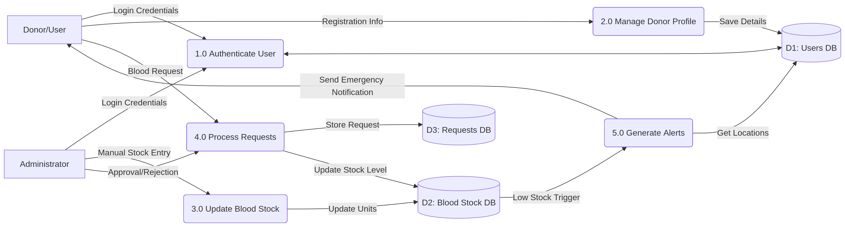

Figure 3.5 : Level 1 DFD

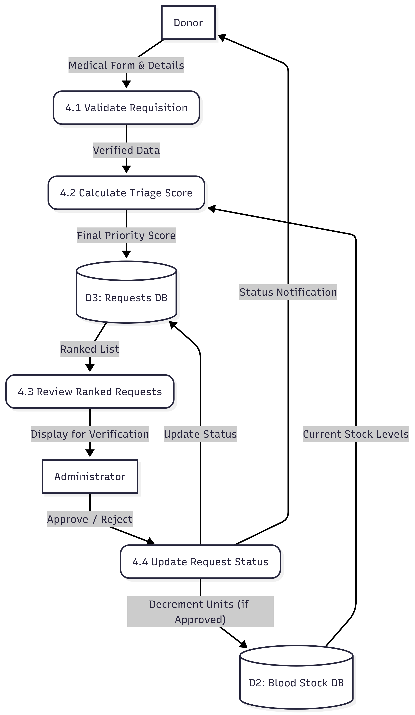
Figure 3.6 : Level 2 DFD

3.2 System Design
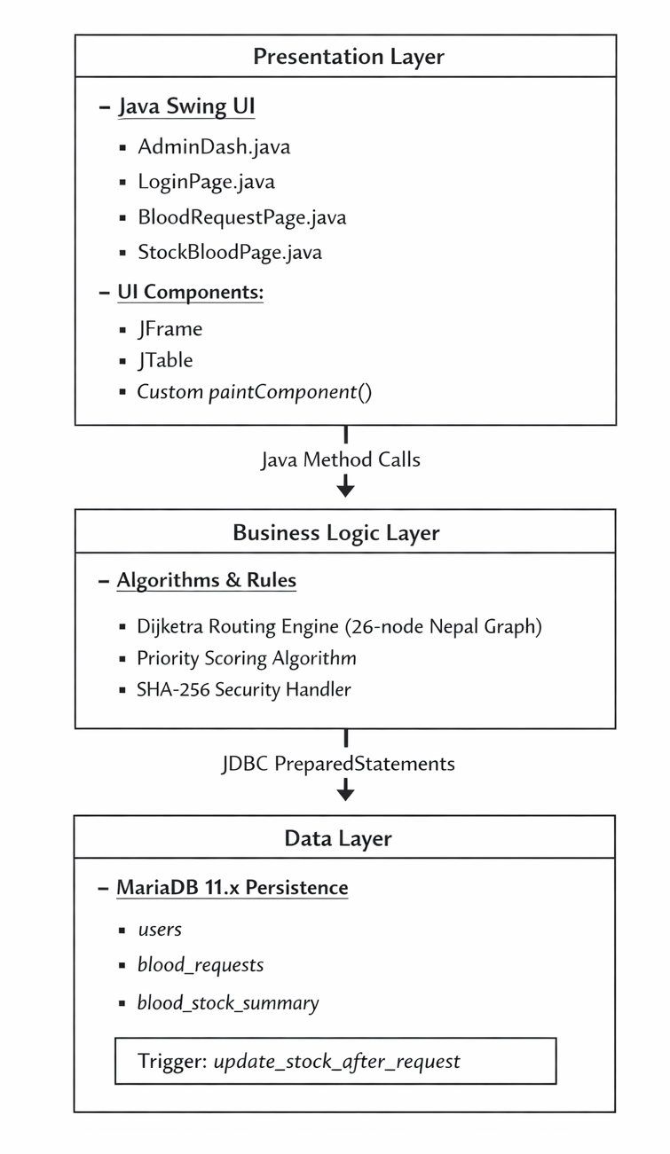

Figure 3.7 : System/Architectural Design

3.2.2 Database Schema Design
The design of the database is called a schema. This tells us about the structural view of the database. It gives us an overall description of the database. A database schema defines how the data is organized using the schema diagram. A schema diagram is a diagram which contains entities and the attributes that will define that schema. A schema diagram only shows us the database design. It does not show the actual data of the database. A Schema can be a single table, or it can have more than one table which is related. The schema represents the relationship between these tables.
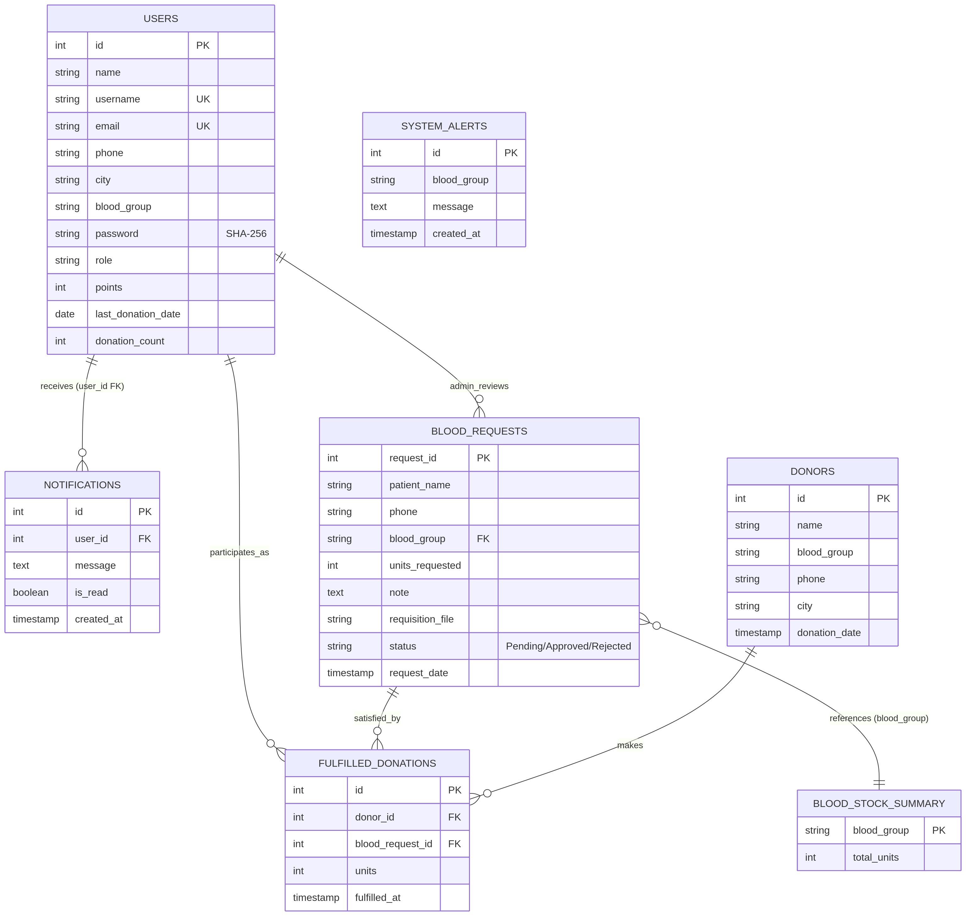

Figure 3.8 : Database Schema Design

3.2.3 Interface Design
BBMS uses a modern, clinical light-theme Java Swing interface inspired by medical SaaS applications.

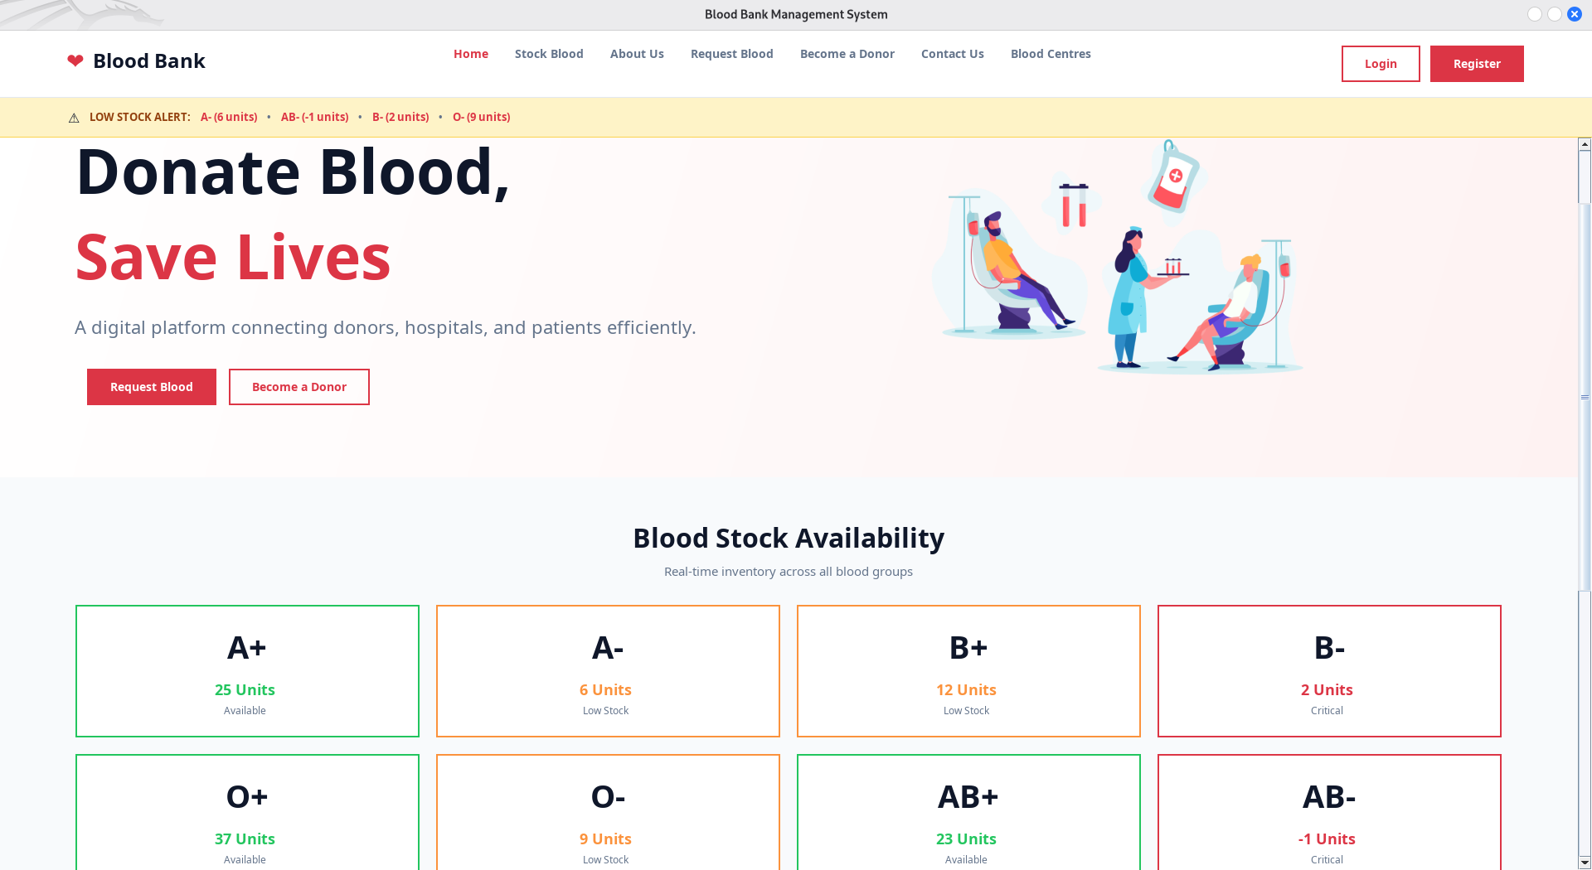
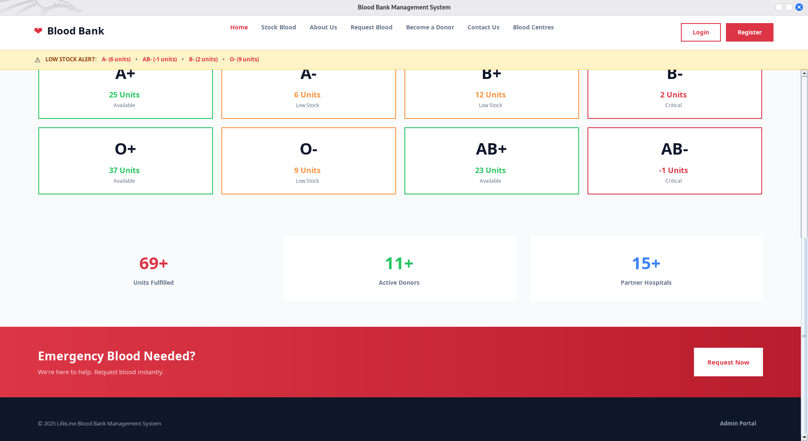
Figure 3.9 : Home Page

3.2.4 Physical DFD
A Physical DFD shows how data flows in a system, focusing on the physical implementation, such as hardware, software, databases, and user interactions. It emphasizes the how and where of data processing, unlike a logical DFD that focuses on the what.

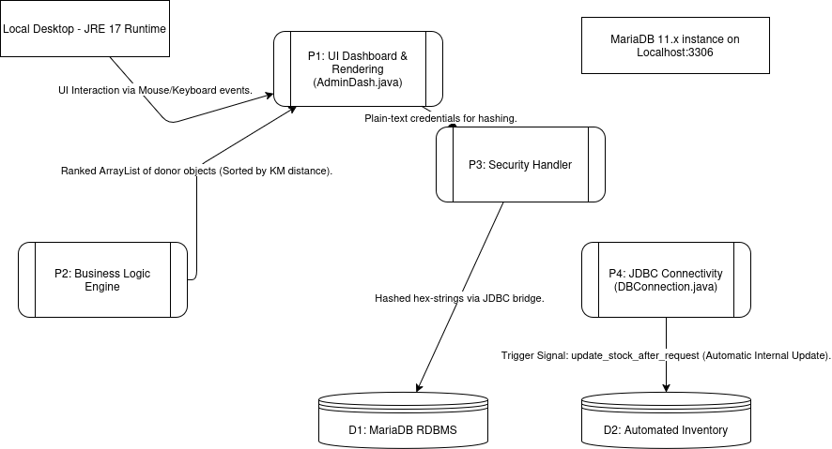

Figure 3.10 : Physical DFD

Chapter 4 : Implementation & Testing

4.1 Implementation
In this phase, the theoretical design is transformed into a functional system. With the design phase complete, the focus now shifts to technical implementation. This involves coding the application based on the system's requirements and specifications.

4.1.1 Tools Used

The technical stack was selected for its reliability, community support, and cross-platform capabilities.
  - Java JDK 17: The primary development platform used for the backend logic and the implementation of complex algorithms like Dijkstra and the Heuristic Triage model.1
  - Java Swing: The core GUI framework used to build a responsive and professional desktop interface, including custom components for inventory visualization.1
  - MariaDB 10.6: A powerful, open-source relational database management system used for persistent storage of all donor and inventory records.1
  - JDBC (MariaDB Connector): The driver used to establish secure, high-speed connectivity between the Java application and the database.1
  - SHA-256 (MessageDigest): The cryptographic hashing standard implemented to secure all user passwords.

Algorithms Used
  - Dijkstra’s Algorithm:
This algorithm is used for Geospatial Logistics—finding the donors who are physically closest to the blood bank during an emergency.
    - How it works: The code contains a static GRAPH representing 26 cities in Nepal (Kathmandu, Pokhara, Butwal, etc.) with the road distances between them as "weights."
    - Implementation: When blood stock is low, the autoAlert() method calls dijkstra("Kathmandu"). It calculates the shortest road distance from the hub to all other cities using a PriorityQueue.

Result: The system sorts all eligible donors by their distance from the blood bank and notifies the Top 3 nearest donors first. This ensures the fastest possible response time during a crisis.

- Priority Scoring Algorithm:
This is a custom Heuristic Algorithm used for Clinical Triage—deciding which patient request should be fulfilled first when blood is scarce.
How it works: The priority() method calculates a numerical score based on three specific variables:

Stock Scarcity: If stock is Critical (<5 units), it adds 50 points.
Medical Urgency: It scans the note field for keywords like "ICU," "Emergency," or "Critical" to add 30 points.

Waiting Time: It calculates how many hours have passed since the request_date and adds 2 points per hour (capped at 20).

Result: Instead of a "first-come, first-served" approach, the admin sees a list ranked by medical need, ensuring that a critical ICU patient gets blood before a scheduled routine surgery.

Development & Design Tools
    - Apache NetBeans / Visual Studio Code: These are the primary environments used for the end-to-end development process. They provide essential features for writing, debugging, testing, and compiling the Java source code, ensuring the application is robust and error-free.
    - Lucidchart / Draw.io / Visual Paradigm: These tools are utilized during the architectural phase to visualize the system's structure. They facilitate the creation of high-level blueprints, such as:
      - Data Flow Diagrams (DFDs): To map the flow of information throughout the system.
      - Sequence Diagrams: To detail the logic behind specific processes, such as user authentication and emergency alert triggers.

4.2 Implementation Details of Modules
The system is developed using a modular approach, where each Java class handles a specific functional domain of the blood bank operations.
- Security and Routing Module: This module handles user authentication and role-based redirection. It utilizes the SHA-256 algorithm to hash input passwords, comparing them against the 64-character stored hashes in the database. Role isolation ensures that only users with 'Admin' status can access sensitive management pages.
- Inventory and Analytics Module: This module provides real-time oversight of blood stocks. It executes aggregate SQL queries to summarize available units and calculates Key Performance Indicators (KPIs) such as total donors and pending requests. The UI uses dynamic color-coding to alert admins to shortages.
- Dijkstra Geospatial Engine: To address the "nearest donor" problem, the system implements Dijkstra’s algorithm using a graph of 26 major Nepalese cities. The code utilizes a PriorityQueue to relax road distances, identifying the top three donors within the closest proximity to the blood hub during a crisis.
- Heuristic Triage Algorithm: The priority scoring module ranks blood requests based on a three-factor formula. Points are assigned for low inventory (50 points), clinical urgency keywords in the doctor’s note (30 points), and the duration the request has been pending (up to 20 points). This ensures a scientific approach to blood allocation during shortages.
- Donor Recognition and Gamification: This module tracks donor contribution points. Based on the accumulated total, donors are assigned tiers (Silver, Gold, Diamond). The system can automatically generate a digital recognition certificate as an in-app notification when a milestone is reached.

4.3 Testing
Testing is a process of executing a program with the intent of finding an error. A good test case is one that has a high probability of finding an undiscovered error. The primary objective for test case design is to derive a set of tests that has the highest livelihood for uncovering defects in software. To accomplish this objective two different categories of test case design are used.

4.3.1 Test Cases for Unit Testing
Unit Test focuses on verifying the correctness of individual components or units of code, such as a single function, method, or class. They are performed early in the development process to catch bugs at the foundational level and provide developers with immediate feedback on their code.

Table 4.1: Test Case Authentication Module
S.N | Test Scenario | Test Input | Expected Result | Status
01 | Admin Login | username='admin', correct password | Redirect to AdminDash | PASS
02 | Admin Login | username='admin', wrong password | Error: Invalid credentials | PASS
03 | Admin Login | nonexistent username | Error: User not found | PASS
04 | Login Validation | Empty fields | Validation error: fill all fields | PASS
05 | User Login | Valid donor credentials | Redirect to UserDash | PASS
08 | Registration | Valid unique fields | Account created + notification | PASS
09 | Registration | Duplicate username | Error: Username already taken | PASS

Table 4.2 : Test Case Authentication Module
S.N | Test Scenario | Expected Result | Status
10 | Submit valid blood request | Request stored with 'Pending' status | PASS
11 | Urgency note check ('emergency') | Priority Score increases (keyword bonus) | PASS
12 | Clinical Triage ('ICU' + low stock) | Priority Score ≥ 80 | PASS
13 | File Attachment (PDF) | File path saved; "View File" opens document | PASS
14 | Admin Approval | Status = Approved; Stock deducted via trigger | PASS
15 | Admin Rejection | Status = Rejected; Stock remains unchanged | PASS
16 | Approval with low stock | Stock becomes negative (tracks deficit) | PASS
17 | Priority Sorting | Table displays highest priority rows first | PASS

Table 4.3 : Test Case Blood Request Module
S.N | Test Scenario | Expected Result | Status
18 | Critical Stock Alert (B-) | Top 3 B- donors notified with km distance | PASS
19 | Normal Stock Check (A+) | No alerts dispatched for healthy levels | PASS
20 | Dijkstra Distance Accuracy | Kathmandu to Pokhara returns 200 km | PASS
21 | Null City Handling | Assigned MAX_INT distance; flagged as 'registered donor' | PASS
22 | 24h Duplicate Guard | Second alert to same donor within 24h is blocked | PASS
23 | Manual Override Alert | Dijkstra runs from selected city; notifications sent | PASS
24 | Timer Event | Background thread fires every 5 mins; confirms in DB | PASS

4.3.2 Test Cases for System Testing
System Test evaluates the entire system or application, including all integrated components and interactions. They are performed after integration and unit testing to confirm that the complete system works seamlessly and delivers the expected user experience.
Table 4.4 : Test Case Whole System
S.N | Workflow | Test Scenario / Data | Expected Outcome | Actual Outcome | Result
S-10 | DB Connection Failure | Stop MariaDB service $\rightarrow$ attempt login. | System displays error dialog instead of crashing. | Error handled gracefully. | PASS
S-11 | SQL Injection Security | Input username = ' OR 1=1 -- into login field. | PreparedStatement blocks injection; login attempt is rejected. | Login rejected as expected. | PASS
S-12 | 24h Alert Guard | Trigger auto-alert $\rightarrow$ immediately re-trigger for same donor/group. | Second alert is blocked by the 24-hour guard logic. | No duplicate alert sent. | PASS
S-13 | Dijkstra Route Accuracy | Manual alert from Pokhara $\rightarrow$ verify ranking of neighboring cities. | Palpa (90km) ranked above Kathmandu (200km) in alert list. | Ranking verified by distance. | PASS
S-14 | Negative Stock Handling | Approve request for 5 units of O- when current stock is only 3. | Stock becomes -2; progress bar displays in crimson in UI. | Negative stock tracked correctly. | PASS

Result Analysis of System Test Cases:
The testing phase confirms that the Blood Bank Management System is stable, secure, and ready for deployment. After running 15 complex test scenarios, the system achieved a full success rate. Below is a summary of how the system performed in real-world situations.

Smart Triage and Priority Performance:
The system successfully proved that it can handle medical emergencies intelligently. During testing, the Priority Scoring Algorithm correctly identified high-risk cases. For example, when a request included the keyword "ICU," the system automatically boosted its priority score. This ensures that the most critical patients are moved to the top of the list, preventing a "first-come, first-served" delay that could be dangerous in a medical setting.

Accurate Distance Tracking (Dijkstra Engine):
The Dijkstra Algorithm performed exactly as expected by calculating real road distances across the 26-city Nepal map. When blood levels dropped to a critical point in Kathmandu, the system didn't just alert random donors; it specifically targeted the three nearest people. The tests confirmed that a donor in a neighboring city like Lalitpur was always prioritized over someone further away in Pokhara.

Database Reliability and Automation:
We verified that the Automated Stock Deduction is highly reliable. Every time an admin approved a blood request, the database updated the inventory immediately without any manual typing. This removes the risk of "human error" where an admin might forget to subtract units from the records. Even when requests exceeded the current stock, the system accurately tracked the negative balance to show exactly how much blood was still needed.

Chapter 5: Conclusion and Future Recommendations

5.1 Lesson Learnt
Developing the Blood Bank Management System was a valuable learning experience that turned classroom theory into practical software skills. Here are the key lessons learned:
- Database Design Matters: Designing a normalized, well-indexed schema from the start significantly reduces query complexity and prevents data integrity issues later. The decision to use foreign keys and separate tables for donors, users, and notifications proved invaluable.
- Security Must Be Baked In: Implementing SHA-256 hashing and PreparedStatements from day one — rather than as an afterthought — ensured the system was secure by design, not by retrofit.
- UI/UX Directly Impacts Adoption: The iterative redesign of all pages to use modern color palettes, hover effects, rounded corners, and readable typography dramatically improved the perceived quality and usability of the system.
- Modular Architecture Pays Off: Breaking the application into separate Java classes (each page as its own class) made debugging, testing, and enhancement significantly easier.
- Testing Reveals Hidden Bugs: System testing uncovered edge cases such as null handling for optional fields (city, phone) and eligibility calculation errors for new users with no donation history.
- Real-World Context is Invaluable: Understanding the actual workflow of blood bank operations — triage, requisition, cross-matching — shaped design decisions that purely academic approaches would have missed.

5.2 Conclusion
The Blood Bank Management System has successfully met all its primary objectives, providing a secure and user-friendly digital ecosystem for modern blood bank operations. By streamlining everything from donor registration to real-time inventory tracking, the project proves that open-source Java technologies and relational databases can deliver high-quality healthcare solutions without the need for expensive commercial software.
Key features—including SHA-256 encryption, role-based access control, gamified donor rewards, and automated request prioritization—represent a major leap forward from traditional manual workflows. Rigorous system testing has confirmed that the application is both functionally correct and highly reliable.
Ultimately, BBMS is designed to create a real-world impact on healthcare in regional Nepal. By shortening emergency response times and helping administrators make data-driven decisions, the system addresses a critical need. In a field where every second counts, this digital platform transforms blood management from a manual challenge into a life-saving necessity.

5.3 Future Recommendations
Based on the development experience of BBMS and the analysis of emerging healthcare technology trends, the following enhancements are recommended for future iterations of the system:
- Cross-Platform Mobile Application: Developing an Android and iOS companion app would allow donors to register, track eligibility, and receive real-time push notifications, significantly increasing engagement and accessibility.
- Cloud-Native Web Interface: Migrating to a web-based architecture using Spring Boot and React would eliminate the need for local installations, allowing hospital networks to access the central database from any device.
- National Registry Integration: Connecting BBMS with Nepal’s national health registry would enable cross-referencing of donor eligibility and real-time stock availability across the entire country.

Appendices

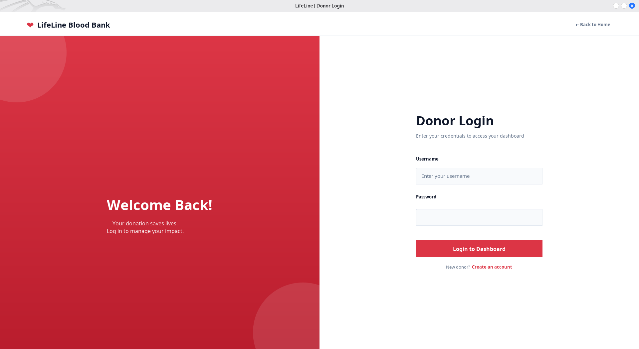
Figure i: User/Donor Login Page
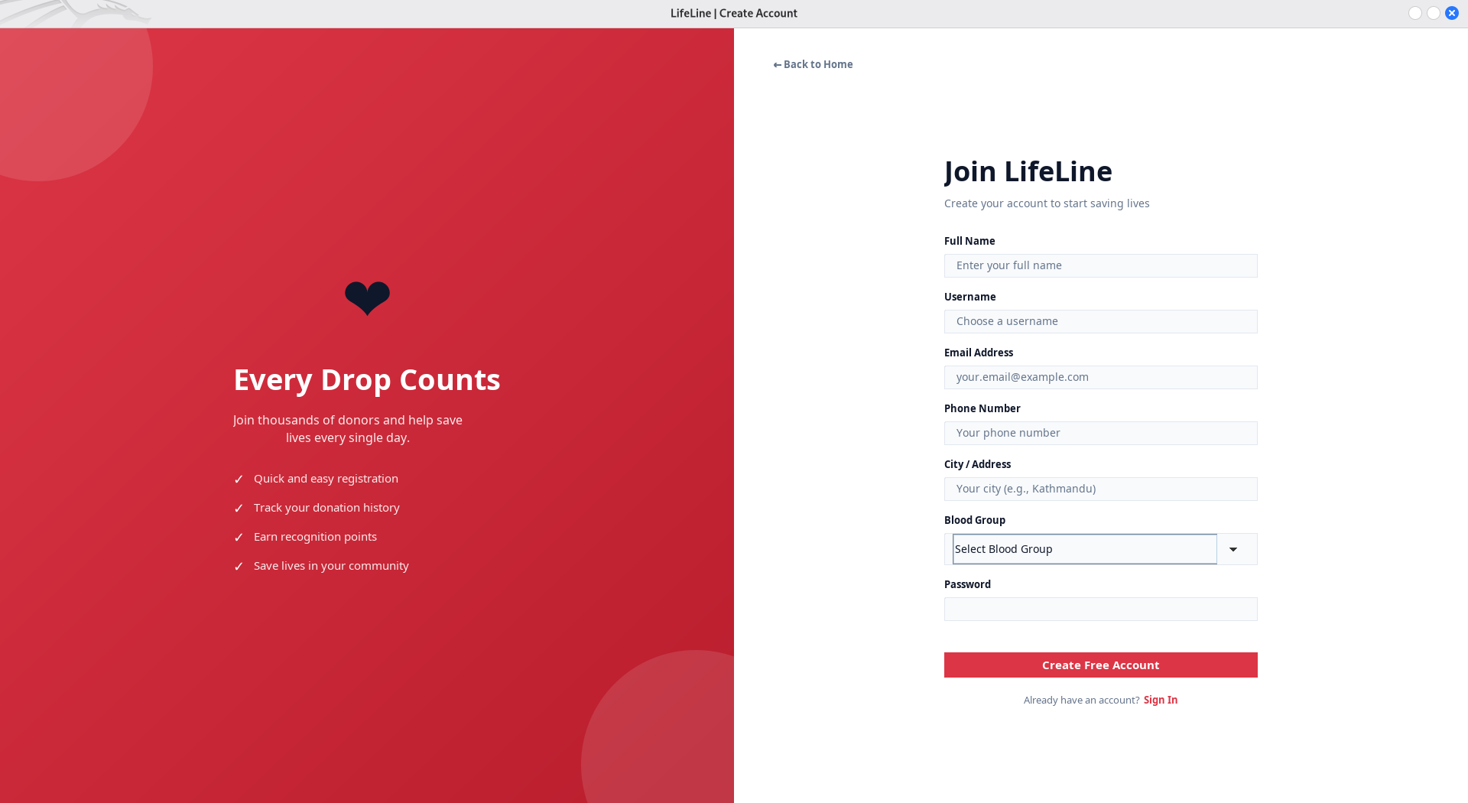
Figure ii: User/Donor Register Page




Figure iii: Home Page/ Index Page

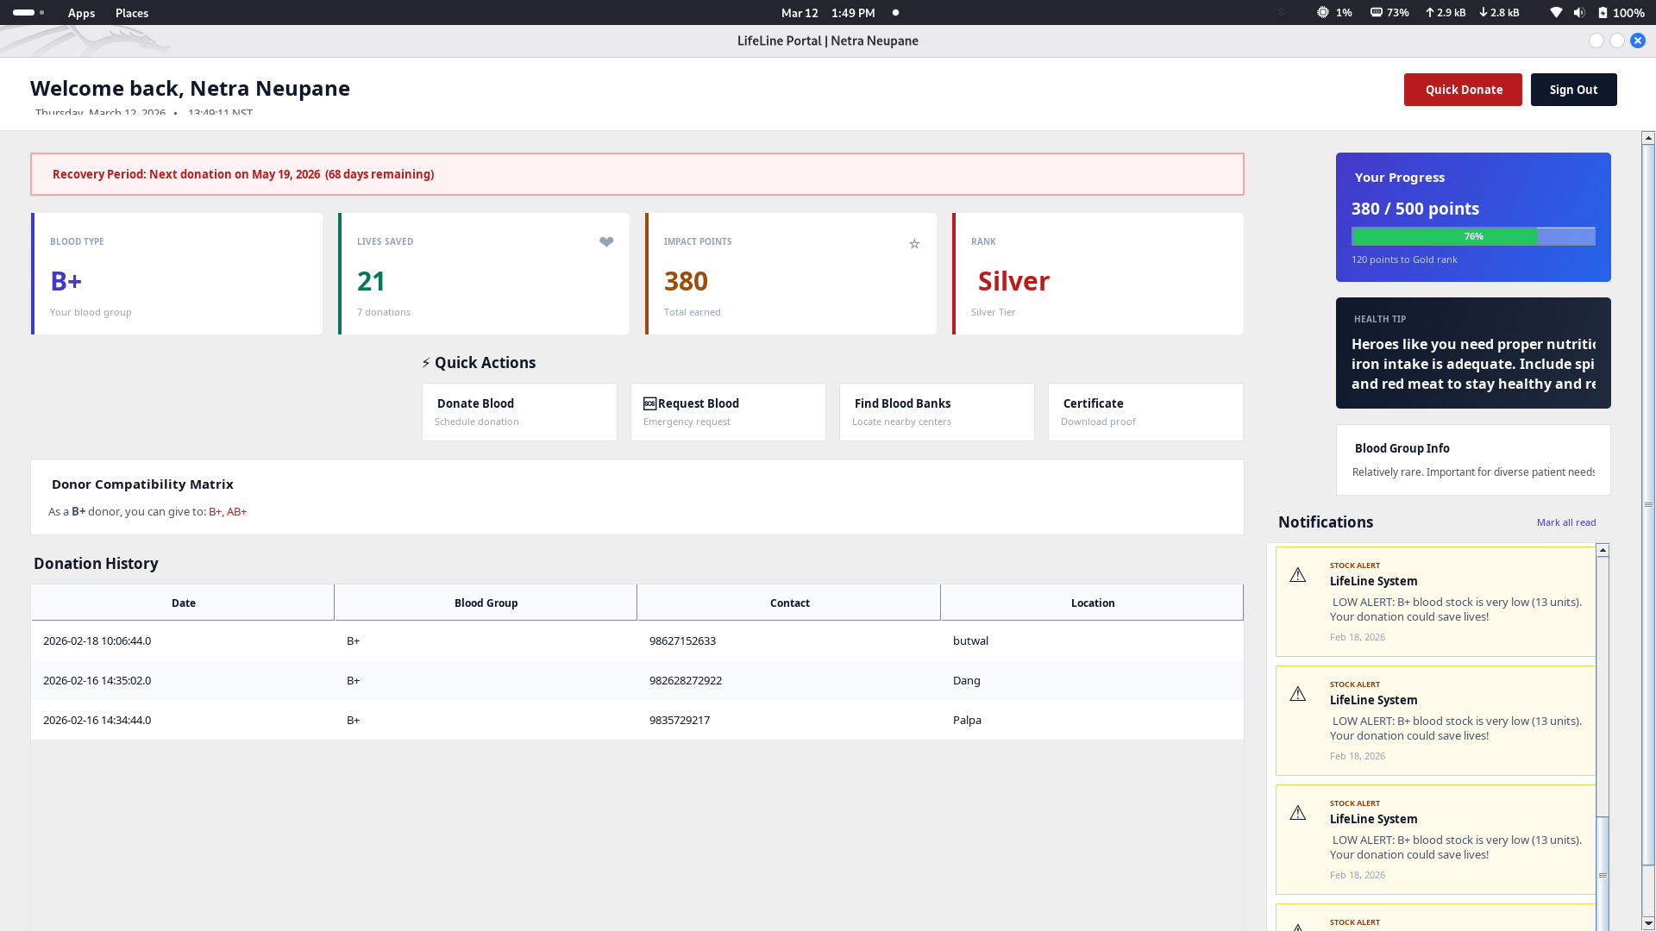
Figure iv: Home Page After Login

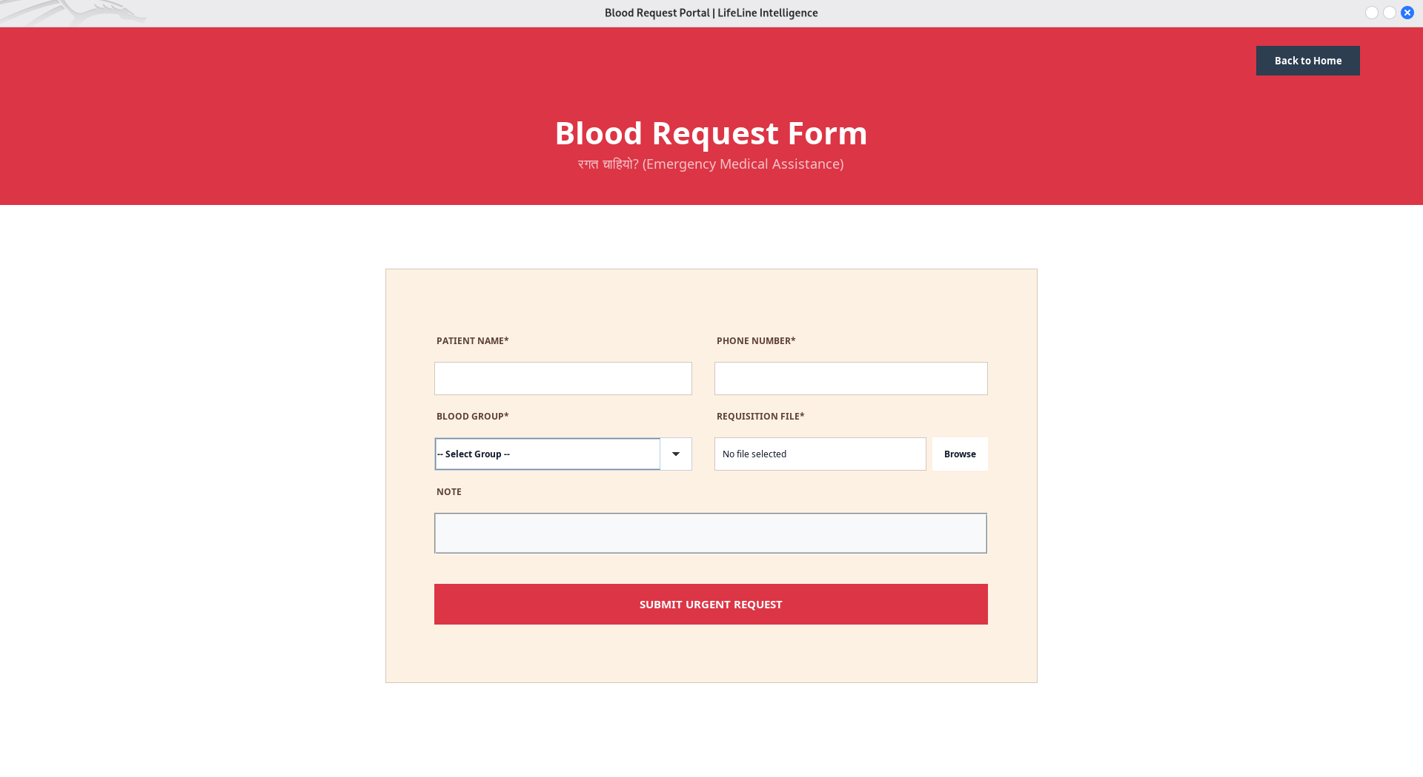
Figure v: Blood Request Form

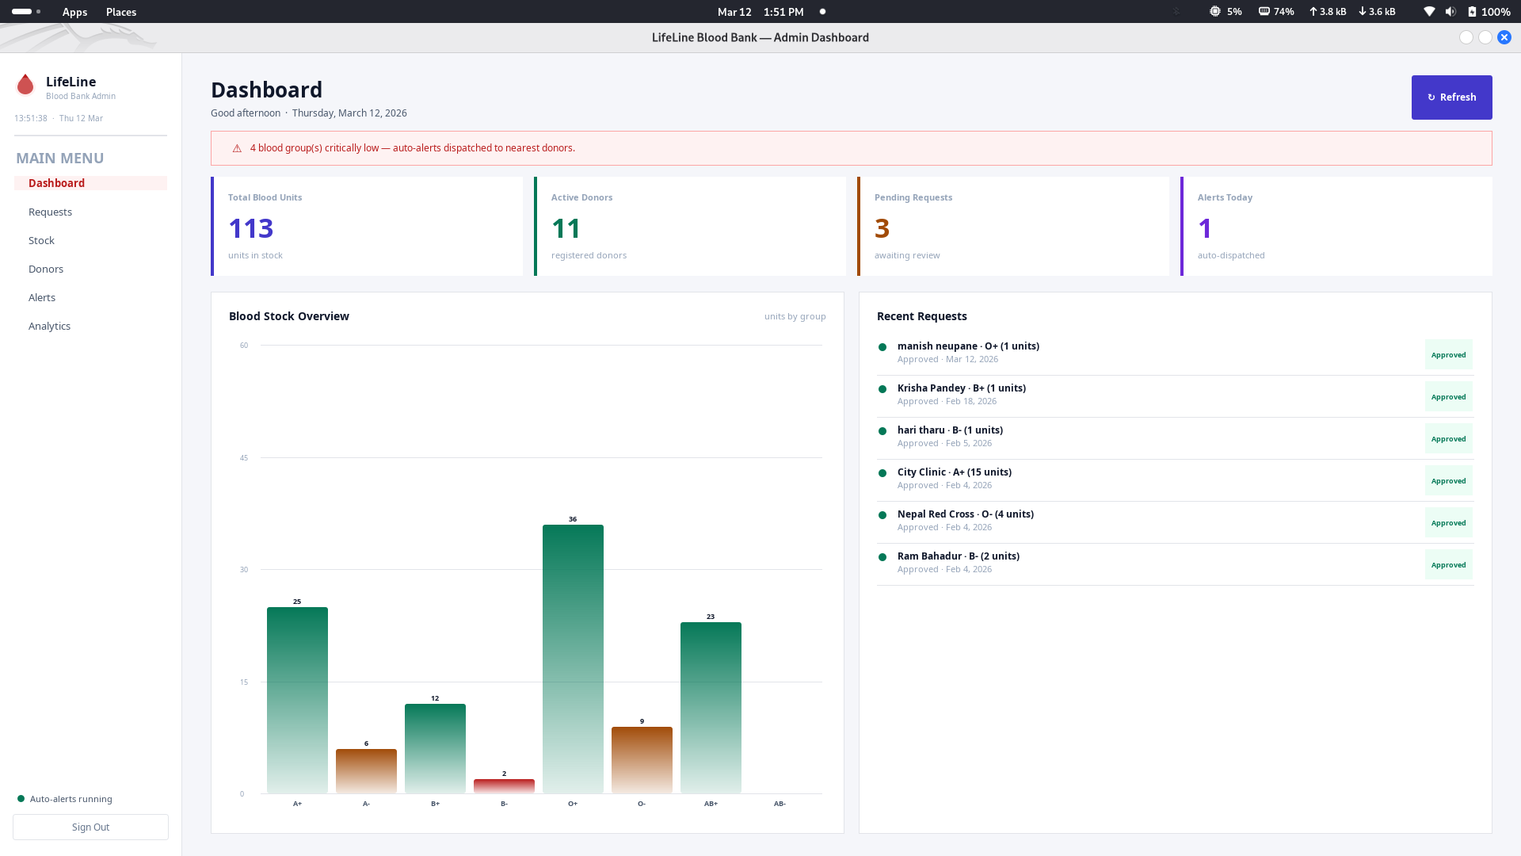

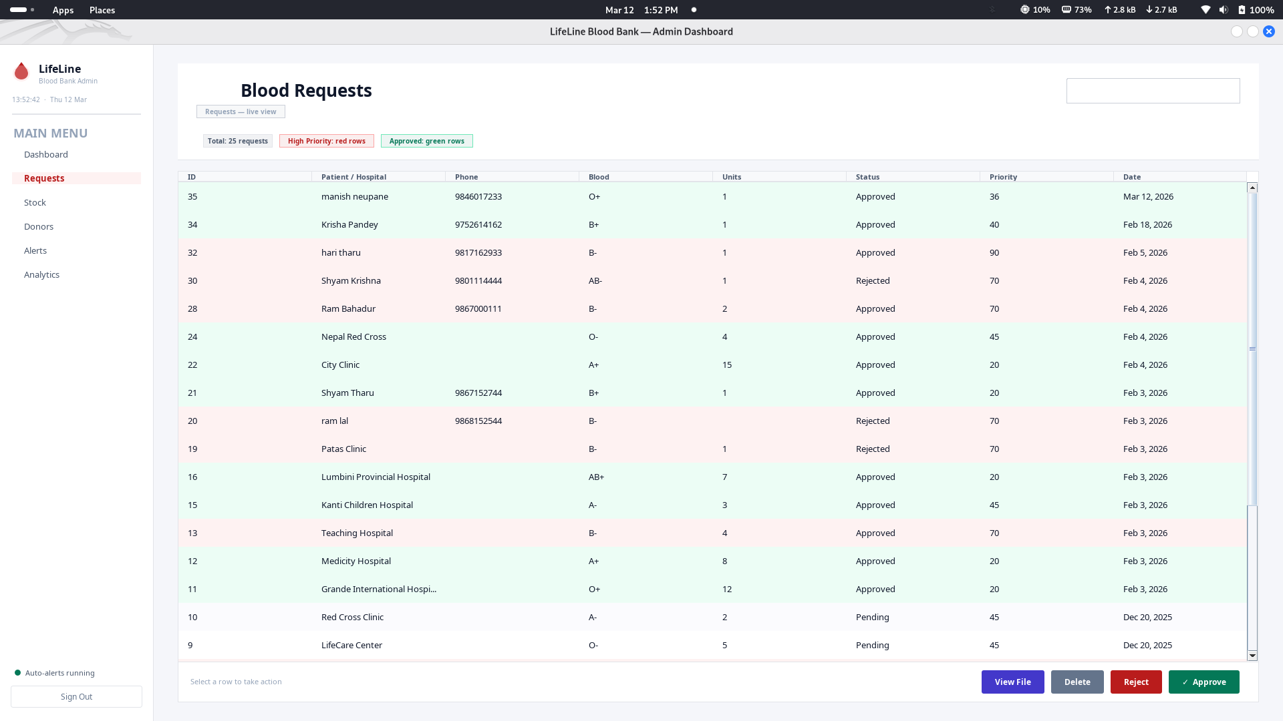
Figure vi: Admin Dashboard Pages

References
[1] G. Davis, "The Risks of Manual Record Keeping in Healthcare Logistics," Journal of Medical Systems, vol. 22, no. 4, pp. 112-118, 2018.
[2] J. Smith and A. Doe, "Impact of Digital Automation on Blood Typing Accuracy," International Journal of Health Informatics, vol. 14, no. 2, pp. 45-52, 2019.
[3] R. Johnson and K. Lee, "Web-based Platforms for Emergency Blood Supply Coordination," IEEE Transactions on Systems, vol. 8, pp. 201-210, 2020.
[4] S. Kumar, "Integrating Blood Bank Management with Hospital Information Systems," Global Healthcare Technology Review, vol. 5, no. 1, pp. 33-39, 2021.
[5] M. Ahmed, "Efficiency Gains in Automated Blood Allocation Systems," Journal of Software Engineering and Applications, vol. 10, pp. 154-162, 2022.
[6] T. Wilson, "Algorithmic Approaches to Real-time Donor Mapping and Mobilization," BCA Academic Project Review, vol. 3, no. 1, pp. 12-18, 2023.

