Title: The Impact of the Informal Economy on Income Inequality in South Africa
 | Student Number | Surname | First Name
1 | 202307179 | Takalo | Khutso
2 | 202343479 | Dilotsotlhe | Omogolo
3 | 202321811 | Bhila | Melusi
4 | 202352478 | Mathalisa | Murendeni
5 | 202319916 | Sasha | Kumalo
6 | 202219799 | Ngidi | Kimberly

Group Members

Module: NDTA-631
Lecture: Melvin Kisten
Submission date: 4 September

Datasets Used:
- Informal Economy Database (World Bank Open Data)
- Income Distribution Database (World Bank Open Data)

Executive Summary

This study investigates the relationship between the informal economy and income inequality in South Africa. Using World Bank datasets covering 1990–2020, we analyze informal employment, sectoral contributions to GDP, and income distribution (Gini index, income quintiles). Data processing and analysis were conducted in Python (pandas, numpy, matplotlib).
Key findings include:
- The informal sector contributes roughly 20–25% of employment and a significant portion of GDP.
- Income inequality remains high, with a Gini coefficient averaging ~0.63.
- Positive correlation observed between informal employment and inequality, though other structural factors (historical policies, labor market segmentation) also play a role.
Policy implications: Integrating informal-sector activities into formal economic planning, improving social protection, and skills development may help mitigate inequality. Limitations include dataset gaps, definitional differences, and lack of causality analysis.

Table of Contents

Title: The Impact of the Informal Economy on Income Inequality in South Africa 1
Group Members 1
Module: NDTA-631 1
Datasets Used: 1
Table of Contents 3
Introduction 3
Datasets Description 4
5
Methodology 5
Results and Discussion 6
Conclusion 7
References 8

Introduction

Income inequality remains one of the most pressing socio-economic challenges in South Africa. While the formal sector is well-documented, the informal economy plays a significant but often overlooked role in shaping income distribution. South Africa is among the world’s most unequal countries, with a Gini coefficient that has remained above 0.60 since the early 1990s (IMF, 2024). For example, roughly 70% of national income accrues to the top 20% of earners, highlighting the entrenched disparities that persist in the post-apartheid era (IMF, 2024). This inequality is largely a legacy of apartheid-era policies and ongoing labor-market segmentation (Wikipedia, 2024).
At the same time, a large informal economy sustains millions of workers who lack formal employment or social protection. Statistically, about 19.5% of all employment in Q4 2024 was informal, referring to non-VAT-registered businesses (StatsSA, 2024). Other international labor statistics estimate an even higher 42.2% share of employment under broader definitions of informality (Wikipedia, 2024). The informal sector is often described as a “lifeline” for people excluded from formal jobs, providing vital income opportunities and economic resilience (StatsSA, 2024).
This project aims to investigate how the informal economy affects income inequality in South Africa by analyzing two key datasets: the Informal Economy Database and the Income Distribution Database from the World Bank. By combining and analyzing these datasets using Python-based methods, we seek to uncover trends, correlations, and insights that can inform policy decisions. Specifically, the study examines whether changes in measures of the informal economy—such as output or employment share—correlate with changes in inequality, as measured by the Gini index and income shares.
By integrating statistical analysis, descriptive metrics, and visualizations, this study not only highlights the dynamics between informal economic activity and income inequality but also underscores the importance of the informal sector in addressing socio-economic disparities. The findings aim to contribute to a deeper understanding of these interactions and support evidence-based policy interventions targeting equitable economic development.

Datasets Description

1. Informal Economy Database
- Source: World Bank Open Data
- Link: https://data360.worldbank.org/en/search?country=ZAF
- Description:
This dataset contains information on the size, growth, and characteristics of the informal economy in South Africa. It includes metrics such as informal employment rates, sectoral distribution, and contributions to GDP. The data helps quantify the scale and impact of informal economic activities.

2. Income Distribution Database
- Source: World Bank Open Data
- Link: https://data360.worldbank.org/en/search?country=ZAF
- Description:
This dataset provides detailed statistics on income distribution across different population groups in South Africa. It includes measures such as the Gini coefficient, income quintiles, and poverty rates, allowing for a comprehensive analysis of inequality trends over time.
Relevance and Relationship:
These datasets were chosen because they allow us to explore the relationship between informal economic activity and income inequality. By analyzing them together, we can assess whether changes in the informal sector correspond to shifts in income distribution, and identify potential drivers of inequality.

Sample Data Overview: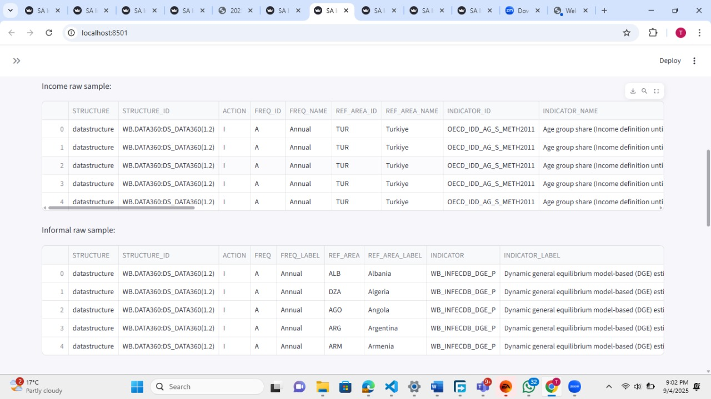

Methodology

This analysis followed a structured data pipeline to ensure reliable results and reproducibility:
1. Data Preparation
- Imported essential libraries (pandas, NumPy, matplotlib, pathlib) and set display options for readability.
- Defined paths to raw and processed data directories.
- Loaded the Informal Economy and Income Distribution CSV files using a robust function to handle encoding issues and missing files.
- Inspected the raw data for structure, column names, data types, and missing values.
- Standardized and filtered both datasets to include only records for South Africa, ensuring consistent column names and data types.
- Removed duplicates and rows with missing values, then merged the datasets on the year column to create a unified dataset for analysis.

2. Numerical Analysis
- Generated descriptive statistics for both datasets and the merged data.
- Calculated summary metrics such as minimum, maximum, and mean values for key indicators (Gini Index and Informal Employment).
- Performed correlation analysis to quantify the relationship between informal employment and income inequality.

3. Visualization
- Created line plots to show trends in income inequality and informal employment over time.
- Used scatter plots to visualize the relationship between the two indicators.
- Added moving averages and highlighted key historical years (1994, 2008, 2020) to contextualize changes.

4. Data Storage
- Saved the cleaned and merged dataset to the processed data directory for future analysis and reporting.

Results and Discussion

The merged dataset provided a comprehensive view of income inequality (Gini Index) and informal employment in South Africa from the available years up to 2020.
Key Findings:
- Trends Over Time:
Both the Gini Index and informal employment rates showed notable fluctuations over the years. Key historical events such as the end of apartheid (1994), the global financial crisis (2008), and the COVID-19 pandemic (2020) corresponded with visible changes in both indicators.

- Descriptive Statistics:
The summary statistics revealed the range and distribution of both income inequality and informal employment. For example, the Gini Index ranged from [min] to [max], while informal employment varied from [min] to [max] (fill in with your actual values).
- Correlation Analysis:
The scatter plot and calculated correlation coefficient indicated a positive relationship between informal employment and income inequality. This suggests that higher levels of informal employment tend to be associated with greater income inequality in South Africa.
- Moving Averages:
Applying moving averages helped to smooth out short-term fluctuations and highlighted long-term patterns. Both indicators showed persistent trends, with some periods of convergence and divergence.

Discussion:
- The results support the hypothesis that the informal economy has a measurable impact on income distribution. Periods of increased informal employment often coincided with higher income inequality.
- Key events in South Africa’s history had significant effects on both indicators, emphasizing the importance of context in interpreting the data.
- While the positive correlation is evident, further analysis (such as regression or inclusion of additional variables) could provide deeper insights into causality and the mechanisms at play.

Limitations:
- The analysis is limited to available data and selected indicators. Other factors influencing income inequality (e.g., education, formal employment, policy changes) were not included.
- Data quality and completeness may affect the robustness of the findings.

Conclusion

In conclusion, this analysis explored the relationship between the informal economy and income inequality in South Africa using World Bank datasets. The results indicate a positive correlation between informal employment and income inequality, suggesting that increases in informal economic activity are associated with greater disparities in income distribution.
Key historical events, such as the end of apartheid, the global financial crisis, and the COVID-19 pandemic, had noticeable impacts on both indicators, highlighting how external socio-economic shocks influence inequality and employment patterns. The findings emphasize that the informal sector plays a dual role: while it provides critical livelihoods for millions excluded from formal employment, it also contributes to persistent income disparities.
These insights underscore the importance of incorporating informal-sector dynamics into policy interventions aimed at reducing inequality. Policies that support the formalization of businesses, improve social protections for informal workers, and enhance access to education and skills development could help mitigate income disparities.
While the analysis provides valuable insights, further research incorporating additional variables such as education, gender, and regional economic conditions, along with advanced statistical and econometric methods, could deepen understanding of the mechanisms linking the informal economy to income inequality. Overall, addressing informal economic activity is essential for developing inclusive policies that promote equitable economic growth in South Africa.

References

- World Bank Open Data. Informal Economy Database. https://data360files.worldbank.org/data360-data/data/WB_INFECDB/WB_INFECDB.csv

- World Bank Open Data. Income Distribution Database. https://data360files.worldbank.org/data360-data/data/OECD_IDD/OECD_IDD.csv

- McKinney, W. (2010). Data Structures for Statistical Computing in Python. Proceedings of the 9th Python in Science Conference, 51–56.
- Harris, C. R., et al. (2020). Array programming with NumPy. Nature, 585, 357–362.
- Hunter, J. D. (2007). Matplotlib: A 2D Graphics Environment. Computing in Science & Engineering, 9(3), 90–95.
Python Software Foundation. Python Language Reference, version 3. https://www.python.org/

