**Q1:** Read in 20 numbers in an array, each of which is in between 10 and 100 if the number is not in this range, ask user to re-enter. As each number is read by the program, print it only if it is not a duplicate of a number already read.

**CODE:**

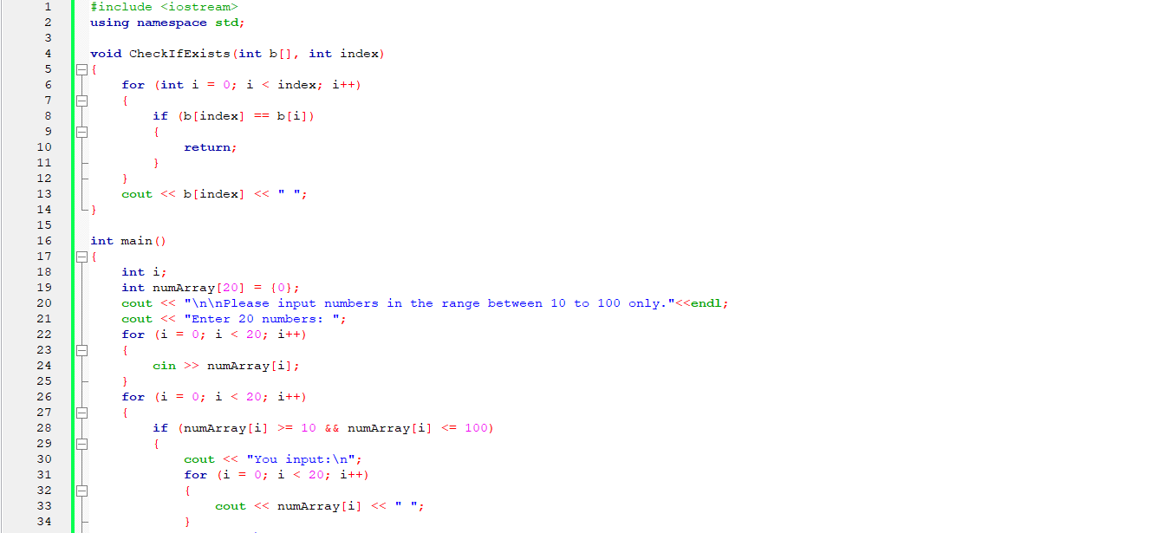

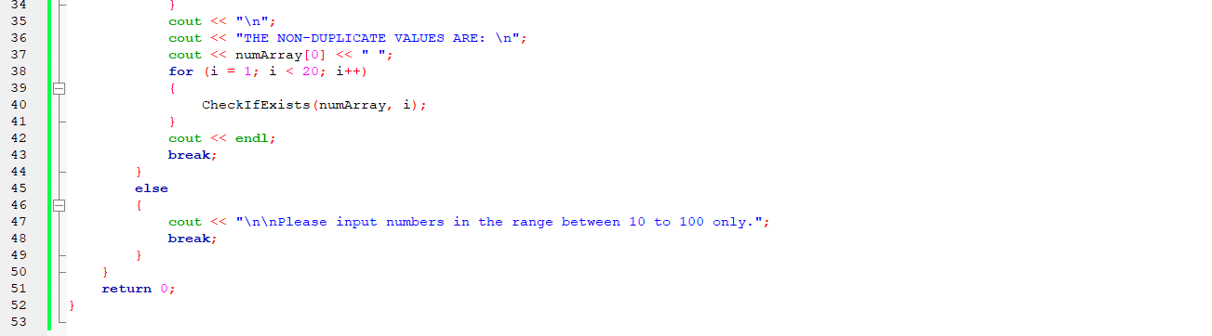

**OUTPUTS:**

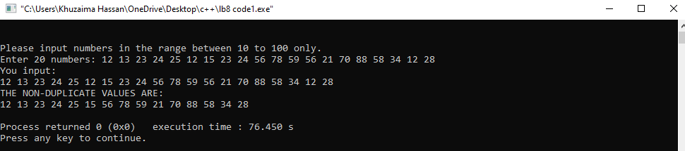

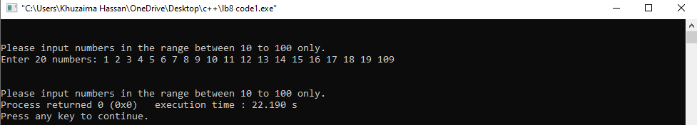

Q2 Write a simple database program that stores name, roll no., and cgpa in FE , all in separate arrays, for 25 students. The program should be able to let the user enter records, display records and replace any one of the records (switch()-case can be used to give these options to user). The program must continue until ESC is pressed. [Note: A single ‘record’ means name, roll no., and cgpa of one student]..

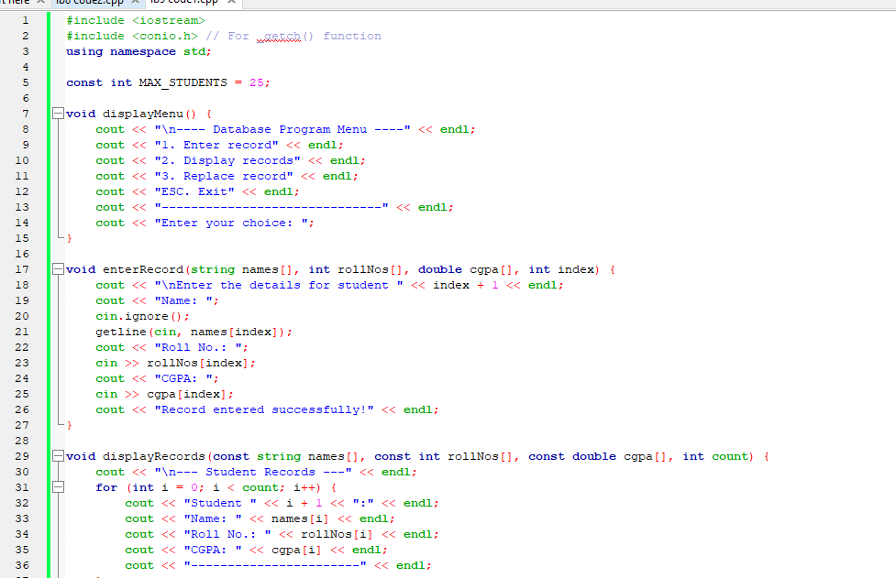**CODE:**

**gghhg**

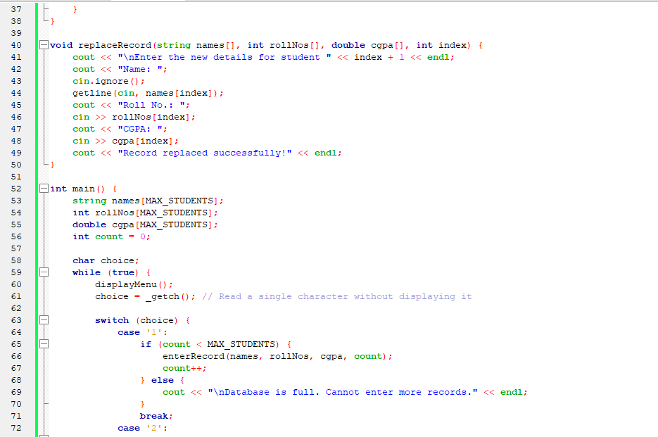

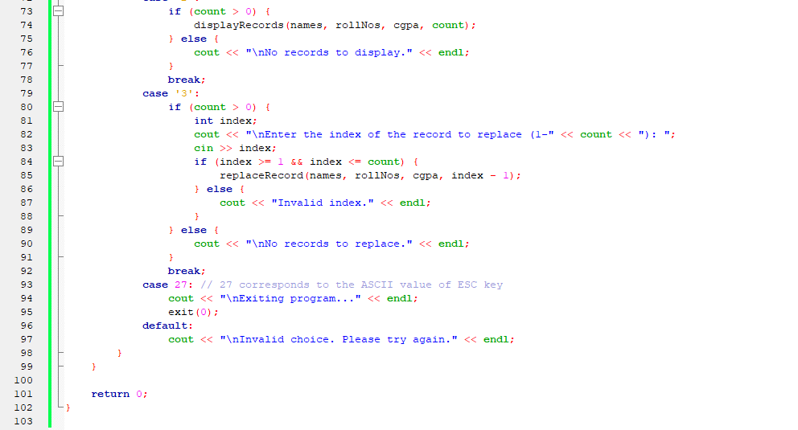

**OUTPUT:**

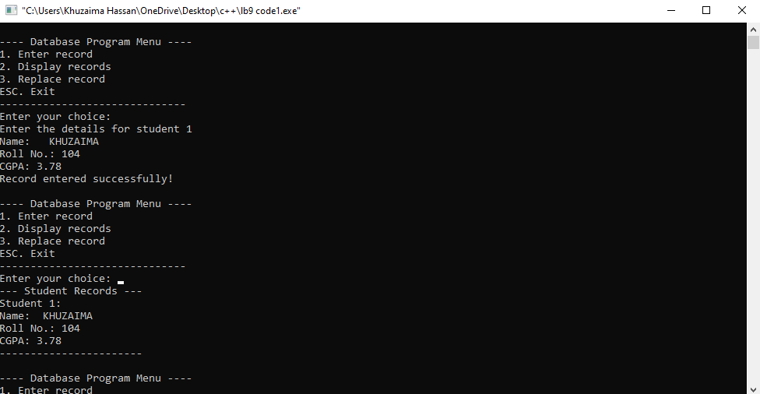

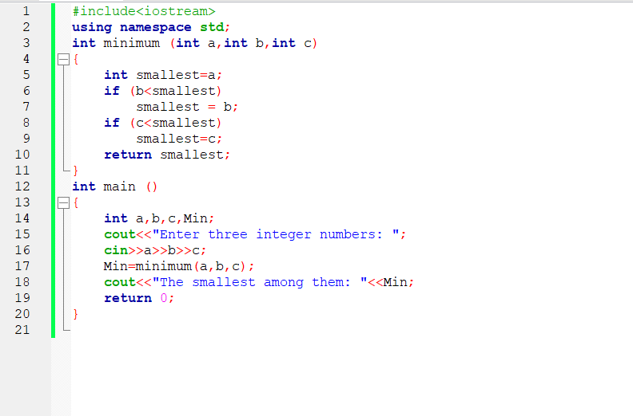**CODE:**

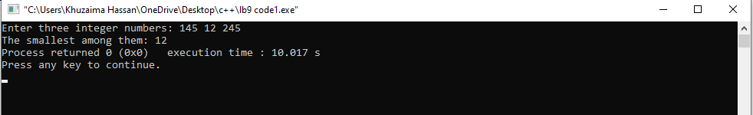**OUTPUT**



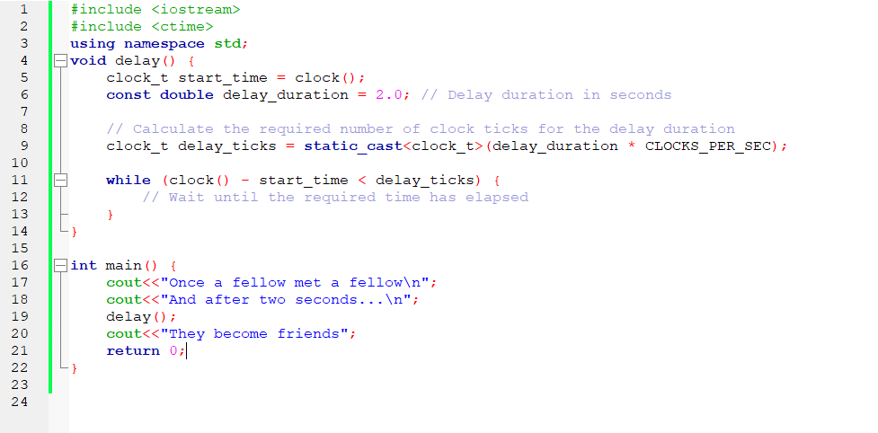**CODE:**

**OUTPUT:**

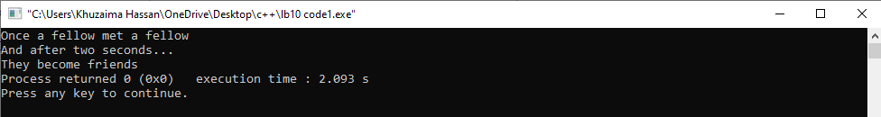

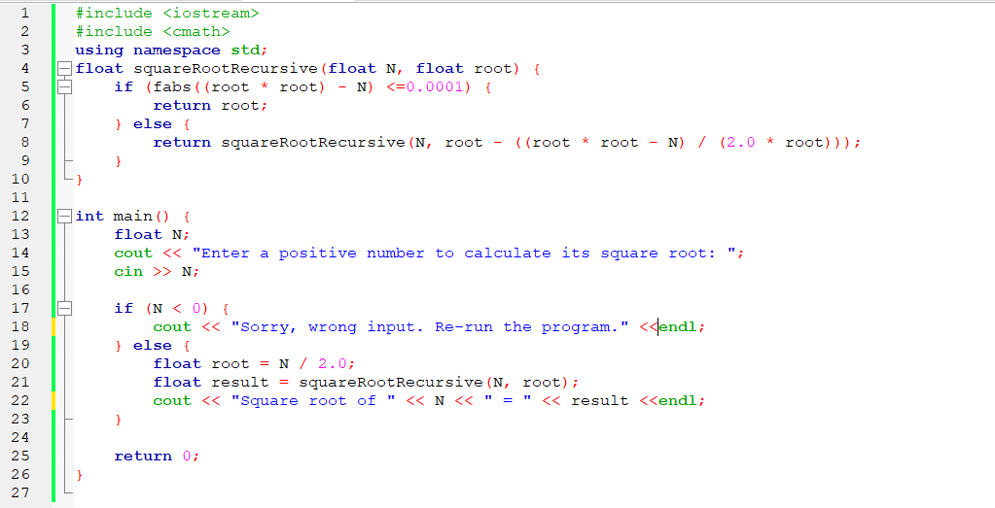**CODE:**

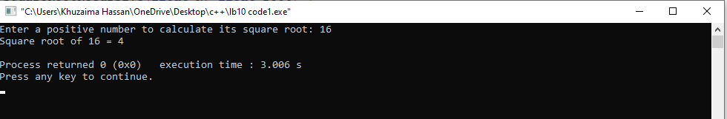**OUTPUT:**



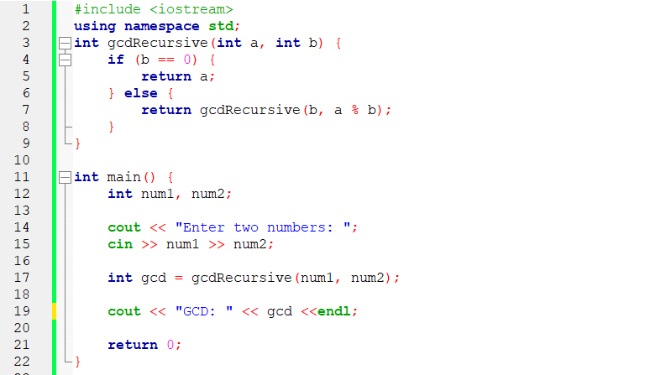**CODE:**

**OUTPUT:**

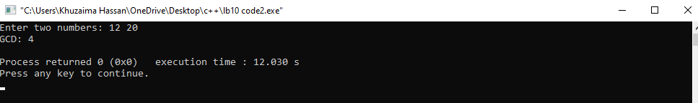

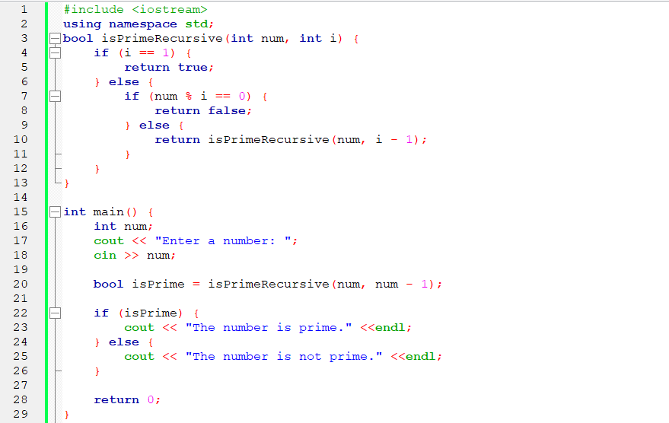**CODE:**

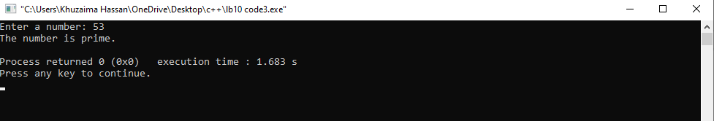**OUTPUT**

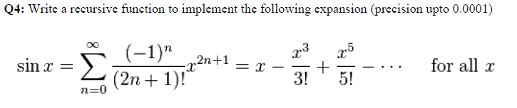

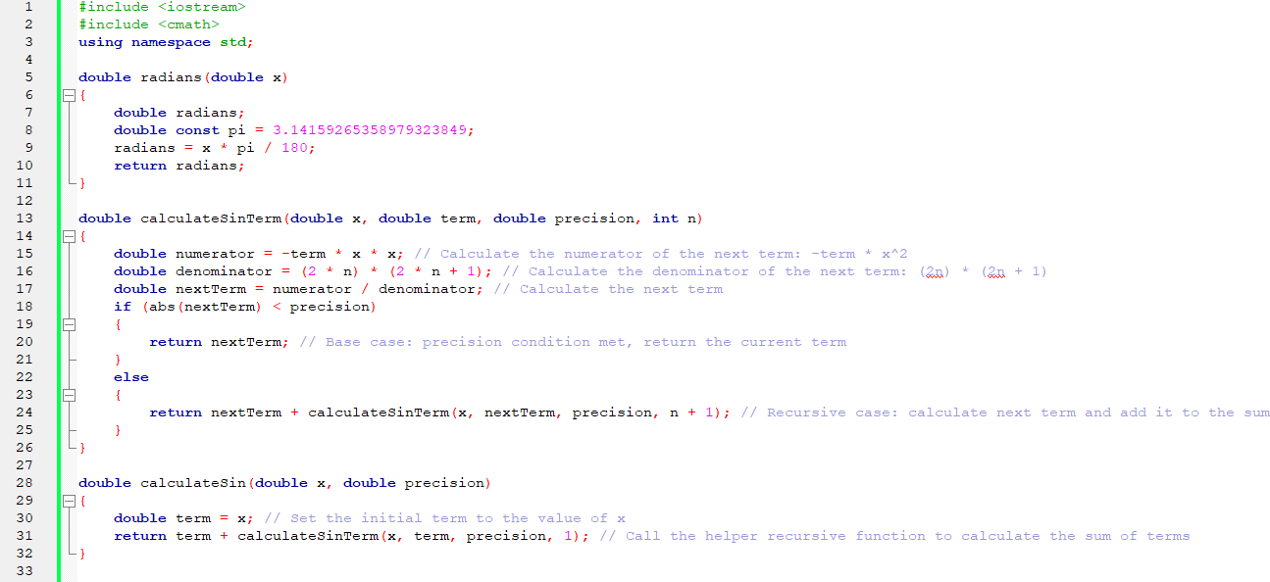**CODE**:

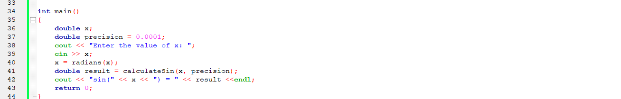

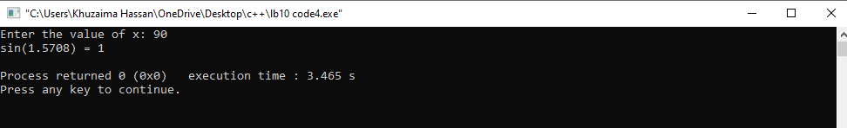**OUTPUT**