

**COMPUTERS AND PROGRAMMING**

(EE-163)

**PBL**

**NAME: MUHAMMAD KHUZAIMA HASSAN**

**ROLL NO: EE-22104**

**SECTION: C**

**DEPARTMENT: ELECTRICAL ENGINEERING**

**LAB INSTRUCTOR NAME: SIR IQBAL AZEEM**

**SUBMISSION DEADLINE: 14-JULY-2023**

**SEMESTER: SPRING**

**YEAR: FE**

**BATCH: 2022**

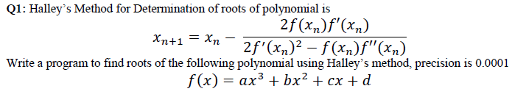

**CODE:**

#include <iostream>

#include <cmath>

using namespace std;

double halleyMethod(double a, double b, double c, double d) {

double x = 1.0;

double f, f1, f2;

do {

f = a * pow(x, 3) + b * pow(x, 2) + c * x + d;

f1 = 3 * a * pow(x, 2) + 2 * b * x + c;

f2 = 6 * a * x + 2 * b;

x -= (2 * f * f1) / ((2 * pow(f1, 2)) - (f * f2));

} while (fabs((2 * f * f1) / ((2 * pow(f1, 2)) - (f * f2))) > 0.0001);

return x;}

int main() {

double a, b, c, d;

double x;

cout << "Enter the coefficients of the equation: ";

cin >> a >> b >> c >> d;

x = halleyMethod(a, b, c, d);

cout << "THE ROOT OF THE EQUATION IS: " << x << endl;

return 0;

}

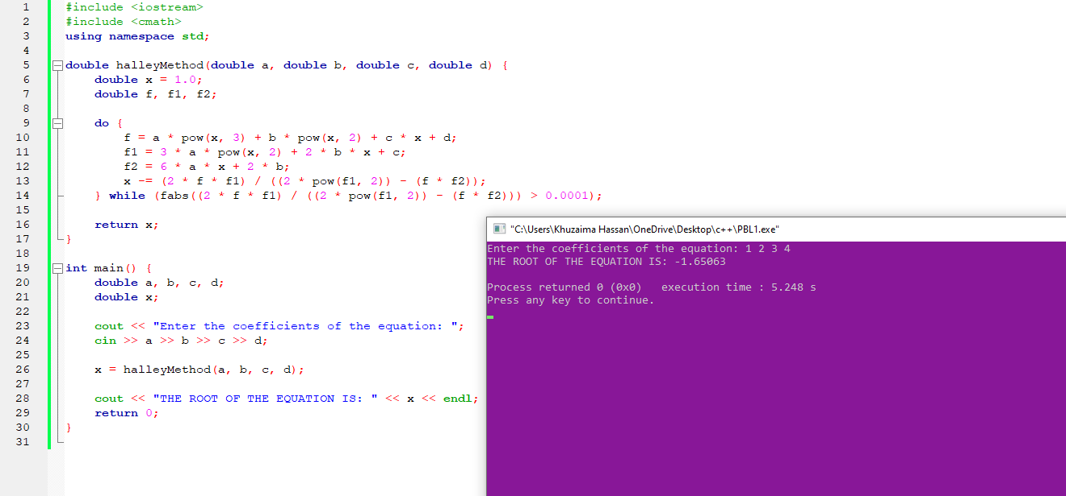**OUTPUT:**

**Q2:** Write an iterative algorithm to implement the following expansion (precision upto 0.0001)



**CODE:**

#include <iostream>

#include <cmath>

using namespace std;

// Function to calculate sin(x) using the expansion formula: sin(x) = Σ (-1)^n / ((2n + 1)!) * x^(2n + 1)

double radians(double x)

{

double radians;

double const pi = 3.14159265358979323849;

radians=x*pi/180;

return radians;

}

double calculateSin(double x, double precision)

{

double result = x; // Set the initial result to the value of x

double term = x; // Set the initial term to the value of x

int n = 1; // Initialize the counter

while (abs(term) >= precision)

{

double numerator = -term * x * x; // Calculate the numerator of the next term: -term * x^2

double denominator = (2 * n) * (2 * n + 1); // Calculate the denominator of the next term: (2n) * (2n + 1)

term = numerator / denominator; // Calculate the next term

result += term; // Add the next term to the result

n++; // Increment the counter

}

return result;

}

int main()

{

double x;

double precision = 0.0001;

cout << "Enter the value of x: ";

cin >> x;

x=radians(x);

double result = calculateSin(x, precision);

cout << "sin(" << x << ") = " << result << std::endl;

return 0;}

**OUTPUT:**

