Job Finder Platform - Project Progress Report

Executive Summary
The Job Finder platform is a comprehensive AI-powered job search and application preparation tool. This report details the progress achieved over the first three weeks of development, covering infrastructure setup, core backend/frontend implementations, and advanced AI feature integration.

1. Week 1: Core Infrastructure & Data Ingestion
- - Set up Next.js frontend with TailwindCSS and Fastify/FastAPI backend.
- - Configured Supabase for PostgreSQL database and Authentication.
- - Implemented Job Fetcher services connecting to various platforms (RemoteOK, Remotive, JobSpy) to aggregate a comprehensive job pool.

2. Week 2: User Profiles & Intelligent Job Matching
- - Implemented Supabase Auth (Google OAuth & Email/Password) and protected routes.
- - Built the PDF Resume Parser utilizing Gemini to extract structured data (skills, experience, education).
- - Developed the intelligent Job Matching engine utilizing Google's Gemini embeddings (`models/embedding-001`) to compute a cosine similarity score between user profiles and job requirements.

3. Week 3: AI Co-Pilot Integrations
The third week focused on integrating Gemini 2.5 Flash to provide actionable AI-driven insights on the Job Detail page:
- - ATS Compatibility Score: Analyzes the user's resume against the job description to provide a 0-100 score, complete with matching and missing keywords.
- - AI Cover Letter Generator: Automatically crafts a highly personalized 3-paragraph cover letter tailored to the target role.
- - Skills Gap Analysis: Identifies crucial missing skills and recommends targeted, free online courses to bridge the gap.
- - Interview Preparation: Generates 5 high-probability interview questions specific to the job and the user's background, alongside ideal answer structures.

System Architecture & Design
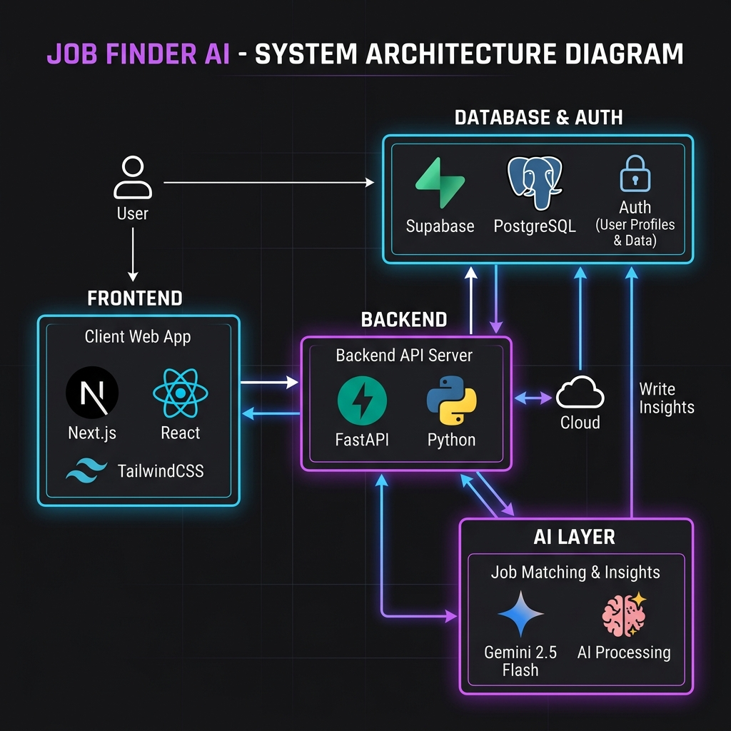
The architecture follows a decoupled client-server model:
- Frontend (Next.js): Handles UI rendering, user authentication state (Supabase JS client), and API interactions.
- Backend (FastAPI): Exposes RESTful endpoints, orchestrates job fetching, manages the Supabase Admin client, and communicates with the Gemini API.
- Database (Supabase/PostgreSQL): Stores user profiles, parsed resumes (raw text and JSON structure), and auth tokens.
- AI Layer (Google Gemini): Powers text extraction, semantic embeddings, and all generative Co-Pilot features.

Next Steps & Roadmap
- - Performance optimization for embedding caching and retrieval.
- - Expand Job Fetcher capabilities to include direct scraping for specific enterprise platforms.
- - Conduct end-to-end user testing for the newly integrated AI features.

