

**SOFTWARE ENGINEERING**

**Sequence Diagram**

**Activity Diagram**

**State Diagram**

**Gantt Chart**

**Section:**

**V20**

**Name:**

**Khuzaima Tajammal (F2023266890)**

**Noor Ul Huda (F2023266853)**

**Nimra Maqbool (F2023266852)**

**Sequence Diagram:**

**Key Elements in the Diagram**

1. **Main Categories:**
   * The diagram organizes requirements into the following categories:
     + **General Requirements**
     + **Functional Requirements**
     + **Performance Requirements**
     + **Hardware Requirements**
     + **Software Requirements**
2. **Stakeholders and Components:**
   * **User:** Responsible for ensuring usability and accessibility of the system.
   * **Admin:** Oversees system functionality like alerts, database management, and analytics.
   * **System:** Represents the hardware and software components needed to implement the system.
3. **Detailed Requirements:**
   * **General Requirements** (from User):
     + **Ease of Use:** The system must be user-friendly.
     + **Accessibility:** It should be accessible to a wide range of users.
     + **Reliability:** The system must perform consistently without errors.
     + **Scalability:** It should handle an increasing number of users or data efficiently.
   * **Functional Requirements** (from Admin):
     + **Facial Recognition:** Identifying individuals based on facial features.
     + **Attribute Recognition:** Recognizing specific features (e.g., age, gender).
     + **Re-Identification Across Cameras:** Tracking individuals across multiple cameras.
     + **Real-Time Alerts:** Notifying admins of specific events as they occur.
     + **Database Integration:** Storing and retrieving data efficiently.
     + **Reporting and Analytics:** Providing insights from captured data.
   * **Performance Requirements** (from System):
     + **Accuracy:** Ensuring the system identifies faces correctly.
     + **Response Time:** Processing data and providing results quickly.
     + **Fault Tolerance:** The ability to operate smoothly in case of partial system failures.
   * **Hardware Requirements** (from System):
     + **Surveillance Cameras:** Capturing images for recognition.
     + **Computing Power:** Supporting AI and processing.
     + **Storage:** For storing image data and analytics.
     + **Networking:** Connecting cameras, servers, and users.
   * **Software Requirements** (from System):
     + **AI Algorithms:** Algorithms for facial recognition and feature extraction.
     + **Facial Recognition Libraries:** Prebuilt libraries or SDKs for facial recognition.

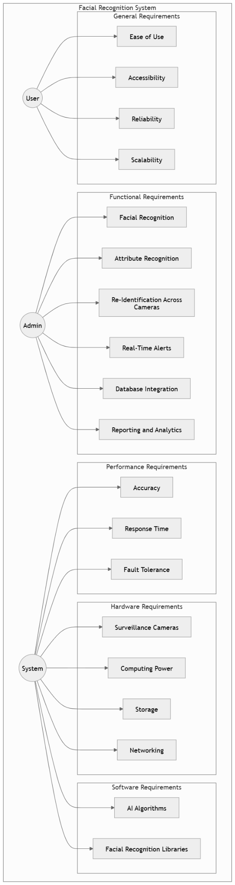

**Activity Diagram:**

**Key Components in the Diagram**

1. **General Requirements (GR):**
   * These are high-level requirements focused on usability and availability:
     + **GR-1:**
       - Text: The system should have a simple interface that is easy for anyone to understand.
       - Risk: Low
       - Verification: Inspection
     + **GR-2:**
       - Text: It should be available on both web and mobile platforms so users can access it.
       - Risk: Medium
       - Verification: Analysis
     + **GR-3:**
       - Text: The system should work consistently and provide accurate results when identifying.
       - Risk: High
       - Verification: Test
2. **Functional Requirements (FR):**
   * **FR-1:**
     + Text: The system should recognize people based on facial features, ensuring accuracy.
     + Risk: High
     + Verification: Test
   * This requirement is directly linked to a **general requirement** (GR-1), meaning the system’s functionality must align with usability.
3. **Performance Requirements (PR):**
   * **PR-1:**
     + Text: The system must achieve at least 98% accuracy for recognizing faces and matching.
     + Risk: High
     + Verification: Analysis
   * This performance requirement is verified through its connection to the **functional requirement (FR-1)**.
4. **Hardware Requirements:**
   * **Type:** Hardware Requirements
   * Contains documentation references (Doc Ref: system_requirements/hardware).
   * Indicates that hardware elements are essential for meeting system needs.
5. **Software Requirements:**
   * **Type:** Software Requirements
   * Contains documentation references (Doc Ref: system_requirements/software).
   * Software, including algorithms and libraries, is integral to satisfying functional and performance requirements.

**Relationships in the Diagram**

1. **General Requirements to Functional Requirements:**
   * GR-1 **satisfies** FR-1: Usability and simplicity are foundational for facial recognition functionality.
2. **Functional Requirements to Performance Requirements:**
   * FR-1 **verifies** PR-1: The system's functionality is key to achieving the high accuracy specified.
3. **Hardware and Software Dependencies:**
   * Both hardware and software components **contain** elements essential to fulfilling the system requirements.

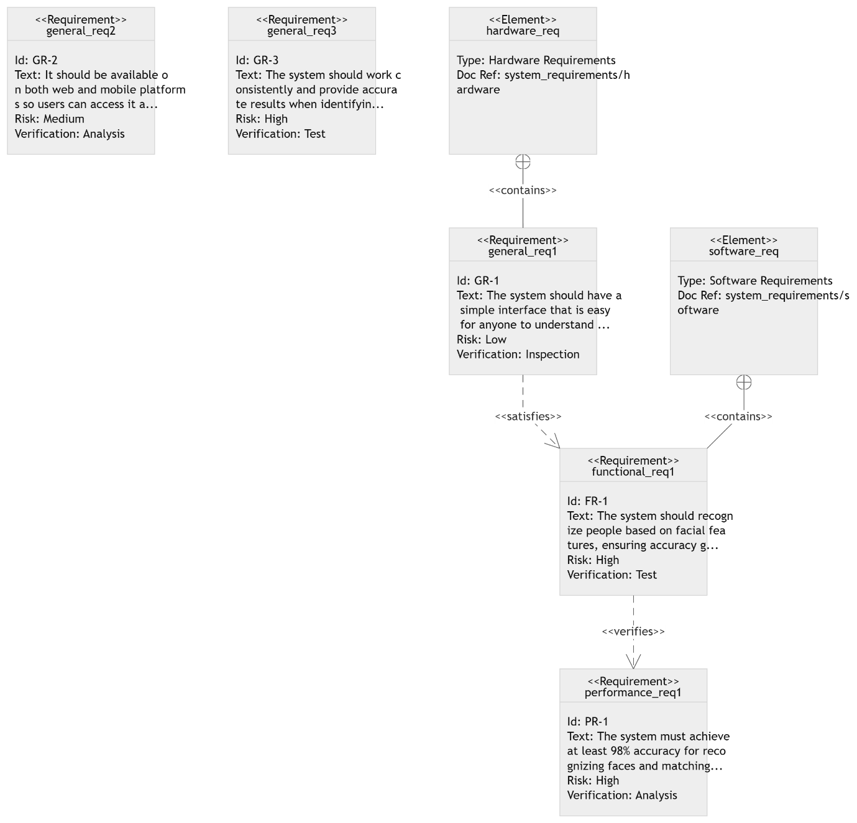

### State Diagram:

### Components in the Diagram

1. **General Requirements:**
   * **Ease of Use:** The system should provide a simple and intuitive interface for all users.
   * **Accessibility:** The system should be available across platforms (e.g., mobile and web).
   * **Reliability:** It should function consistently without errors.
   * **Scalability:** The system must support growing demands, such as increasing users or data.

These are overarching goals applicable to the entire system.

1. **Functional Requirements:**
   * **Facial Recognition:**
     + The core functionality, which involves identifying individuals based on facial features.
     + **Tools Used:** OpenCV, TensorFlow, and AWS Rekognition are listed as enabling technologies or frameworks for implementing facial recognition.
   * **Attribute Recognition:** Identifying specific traits such as age, gender, or expressions.
   * **Reidentification:** Tracking and identifying the same individual across different cameras or scenes.
   * **Real-Time Alerts:** Sending notifications or alerts when specific events occur.
   * **Database Integration:** Ensures the system connects with databases for storing and retrieving information.
   * **Reporting and Analytics:**
     + Provides insights and visualizations.
     + Includes subcomponents:
       - **Detailed Reports:** Detailed summaries and logs of data.
       - **Visual Tools:** Graphs or charts for easier data interpretation.

3.**Performance Requirements:**

* + **Accuracy:** The system must achieve at least 98% accuracy in recognizing faces.
  + **Response Time:** The system should provide quick feedback or results.
  + **Fault Tolerance:** The ability to continue functioning correctly even if parts of the system fail.

**Key Relationships:**

1. **General Requirements ↔ Functional Requirements:**
   * **Ease of Use** and **Accessibility** are closely tied to how the system’s functional components, such as facial recognition and reporting tools, are implemented.
2. **Functional Requirements ↔ Performance Requirements:**
   * Functional requirements like **Facial Recognition** directly affect performance metrics like **Accuracy**, **Response Time**, and **Fault Tolerance**.
   * For example:
     + **Facial Recognition Tools** (OpenCV, TensorFlow, AWS Recognition) are critical to achieving high **Accuracy**.
     + **Real-Time Alerts** depend on a low **Response Time** for effectiveness.

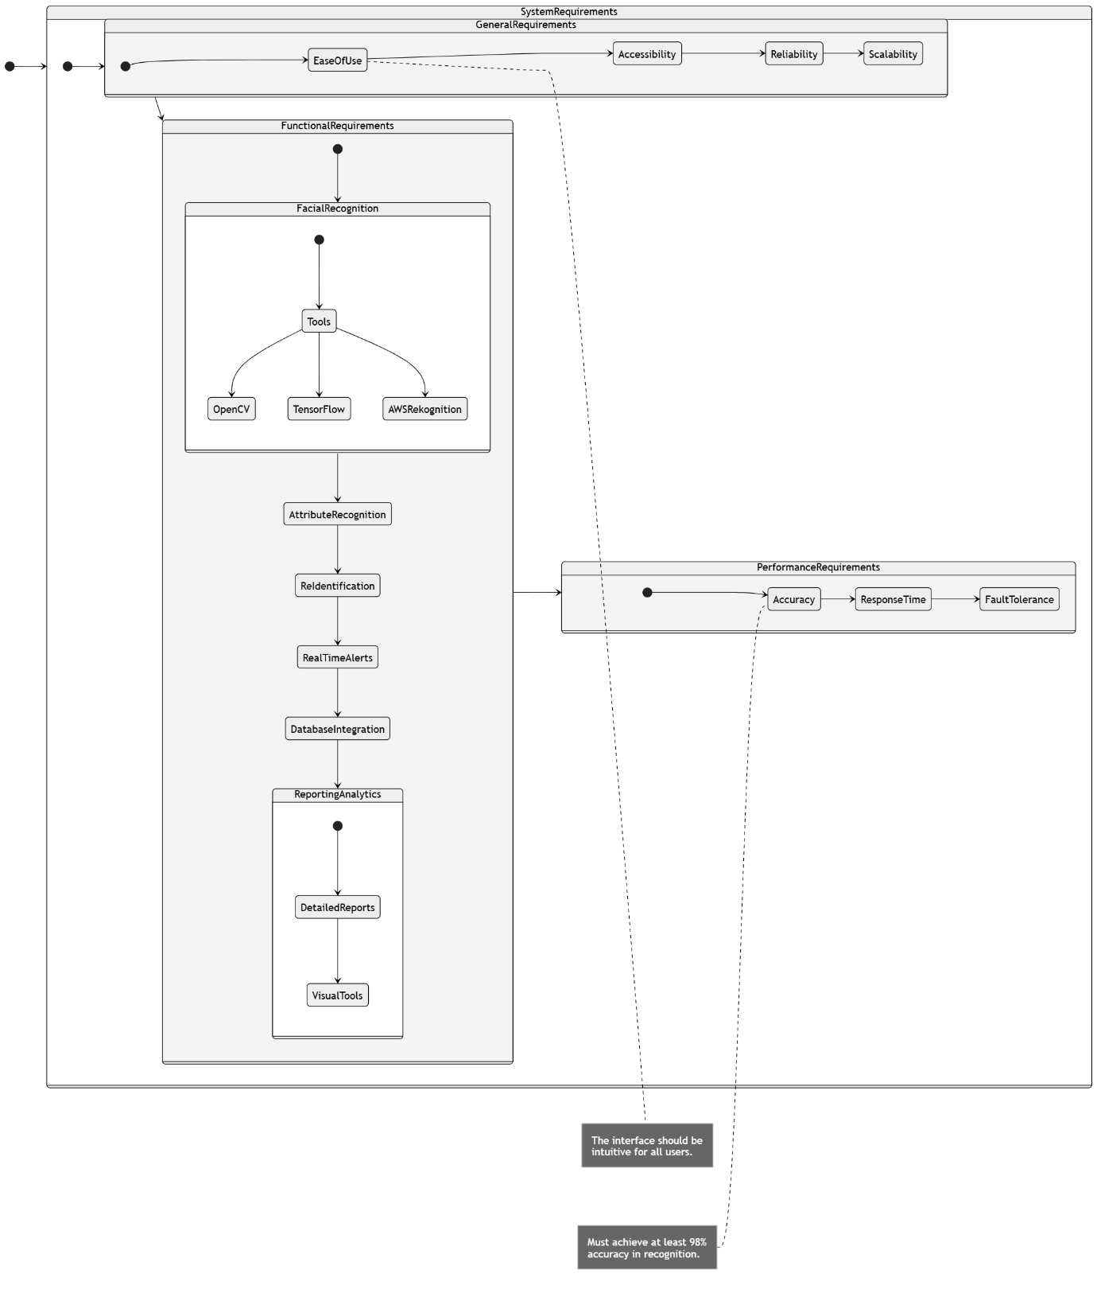

**Gantt Chart:**

The diagram uses a tree-like structure to organize different types of requirements. The top level categorizes requirements into General, Hardware, and Software. These categories then branch out into more specific requirements.

**Requirement Types**

* **General Requirements (GR)**: These are high-level requirements that apply to the entire system. For example:
  + **GR-2:** The system should be available on both web and mobile platforms.
  + **GR-3:** The system should work consistently and provide accurate results when identifying individuals.
* **Hardware Requirements (HW)**: These specify the hardware components needed for the system to function. In the diagram, only the type is mentioned, but specific requirements for hardware components would be listed here.
* **Software Requirements (SW)**: These outline the functionalities and characteristics of the software components. Again, only the type is shown, but specific software requirements would be listed.
* **Functional Requirements (FR)**: These describe the specific functions the system must perform. For example:
  + **FR-1:** The system should recognize people based on facial features, ensuring accuracy.
  + **FR-2:** The system should identify individuals based on details such as clothing and accessories.
* **Performance Requirements (PR)**: These define the system's performance expectations. For example:
  + **PR-1:** The system must achieve at least 98% accuracy for recognizing faces and matching them to existing records.

**Relationships**

The diagram uses arrows to indicate relationships between requirements:

* **Contains:** This shows that a higher-level requirement includes or encompasses lower-level requirements. For example, General Requirements contain both Functional and Performance Requirements.
* **Satisfies:** This indicates that a lower-level requirement helps fulfill a higher-level requirement. For example, Functional Requirements satisfy General Requirements.
* **Derives:** This shows that a lower-level requirement is derived from or implied by a higher-level requirement. For example, Performance Requirements are derived from Functional Requirements.

**Risk and Verification**

Each requirement is associated with a risk level (Low, Medium, or High) and a verification method (Inspection, Demonstration, Test, or Analysis). These indicate the potential impact of not meeting the requirement and how to ensure that the requirement is met.

