**Question 1:**

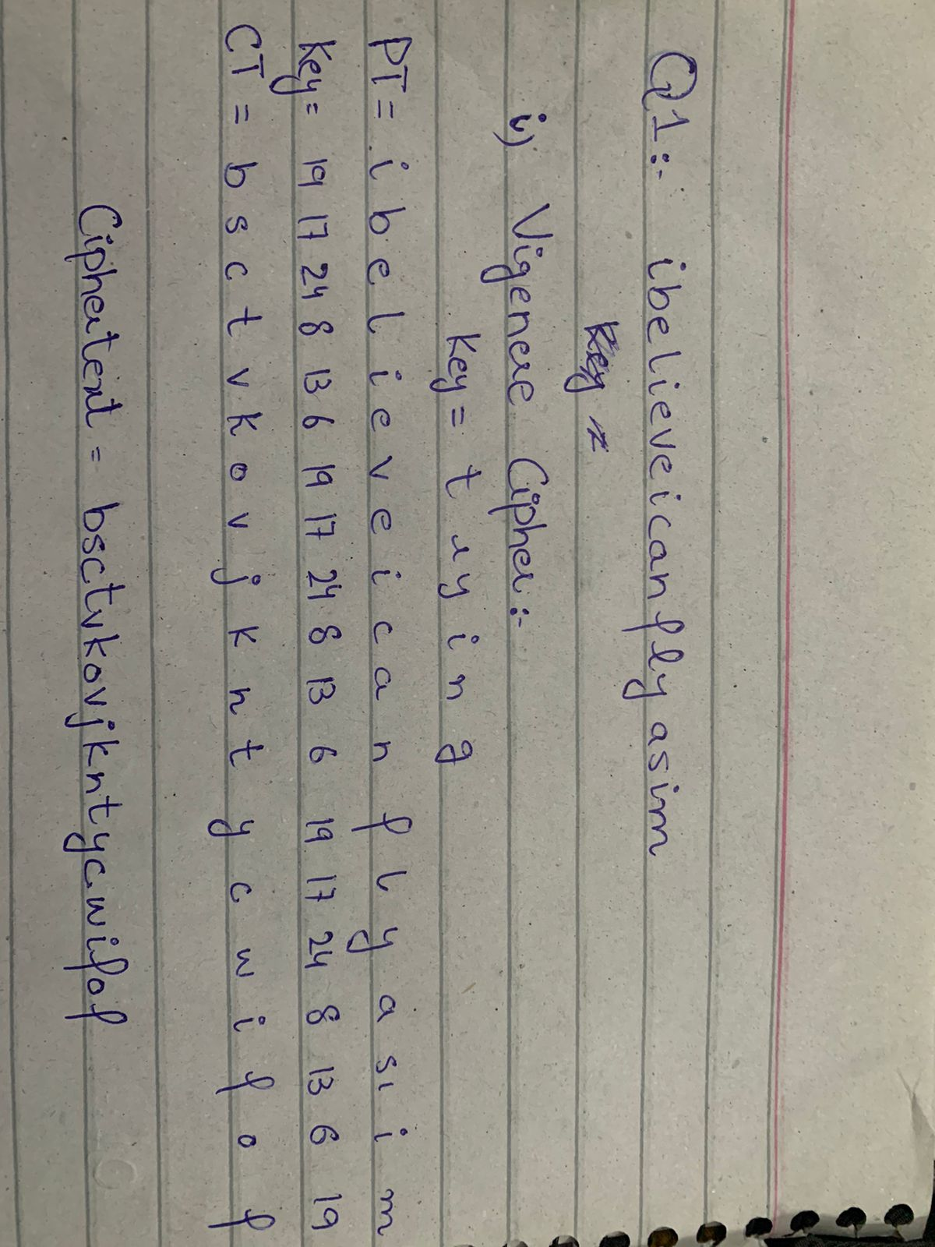

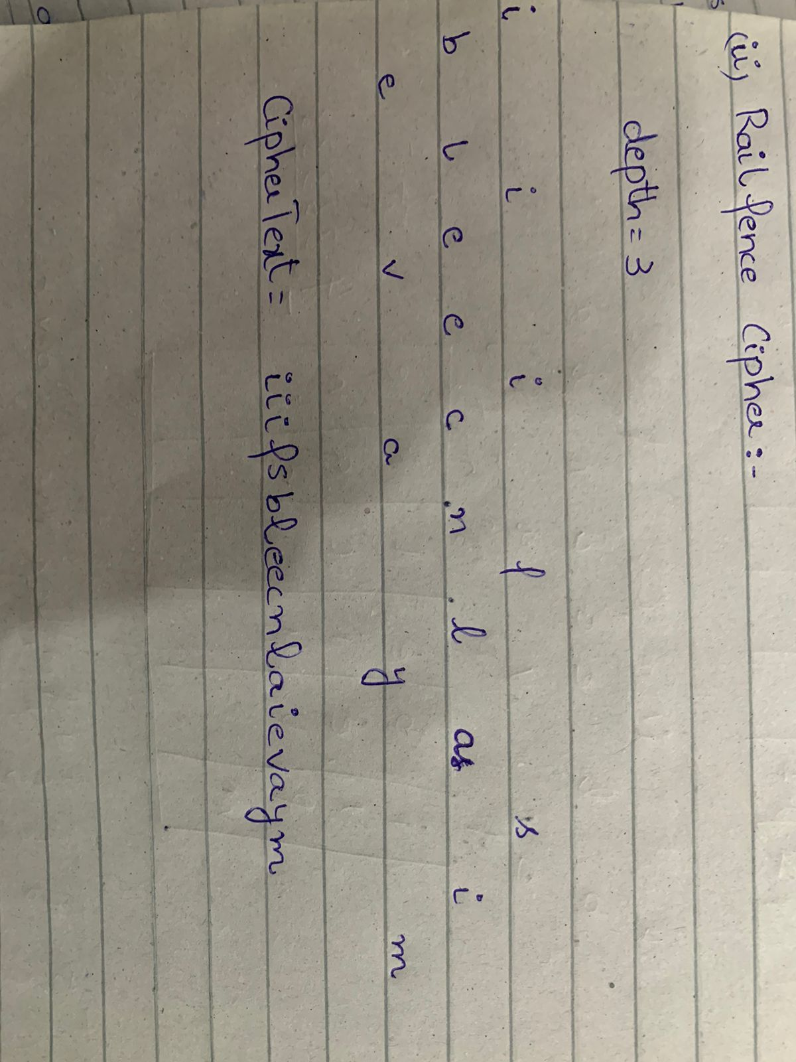

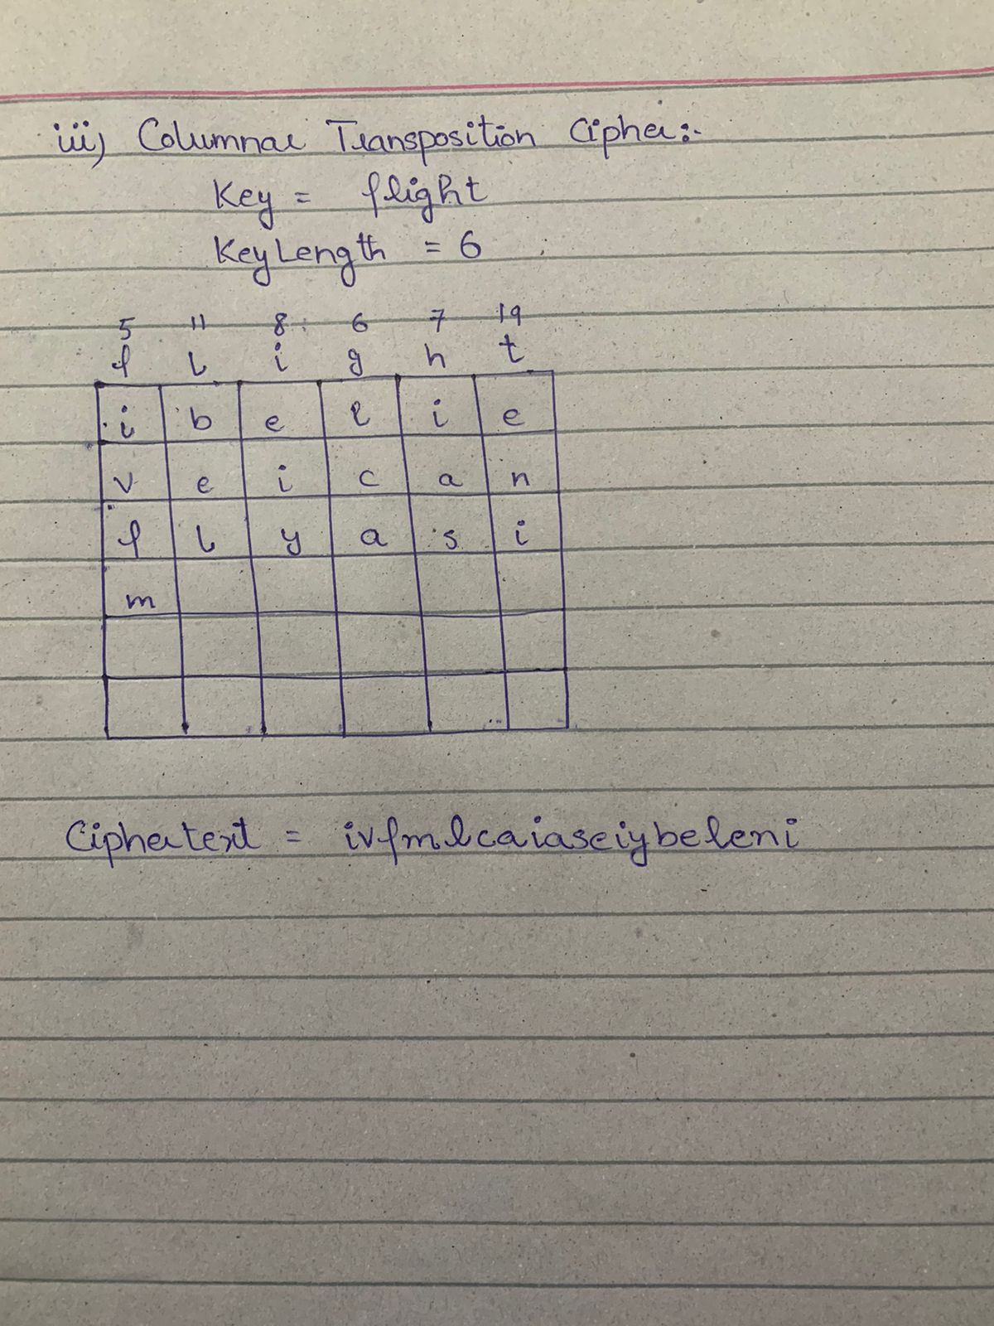

**Question 2:**

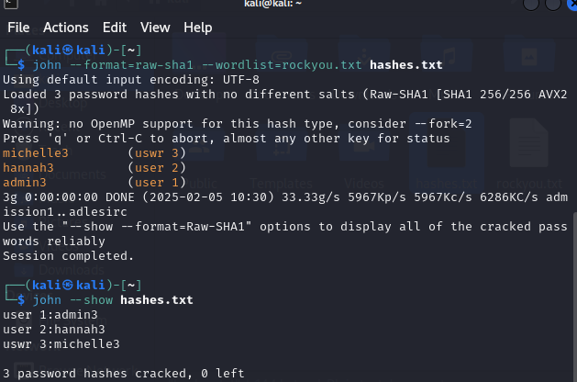

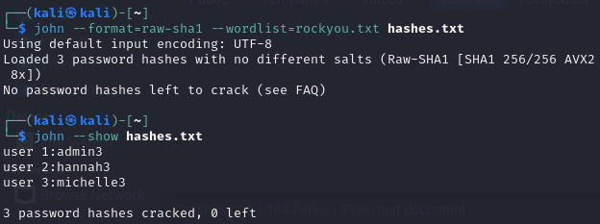

|  |  |  |
| --- | --- | --- |
| **USER** | **HASH** | **CRACKED PASS** |
| **User 1** | **33aab3c7f01620cade108f488cfd285c0e62c1ec** | **admin3** |
| **User 2** | **9bc15a68e741507ed7767a412c673ebad17aed4c** | **hannah3** |
| **User 3** | **2eacef825c7c0e0f5780cbefad0cd340beecd6c1** | **michelle3** |