**AFFIDAVIT**

**Muhammad Hamza Asim**

**35202-3631696-7**

**House no 16b street no 4 z block scheme no 2 Wassanpura Lahore**

**To Whom It May Concern:**

I, Muhammad Hamza Asim, son of Asim Mehmood Bhatti, bearing CNIC Number **35202-3631696-7** and residing at **House no 16b street no 4 z block scheme no 2 Wassanpura Lahore**

, being duly sworn, depose and state as follows:

* I hereby affirm that the information provided in support of my application is accurate and complete to the best of my knowledge, information, and belief. I understand that the submission of any false or misleading information may result in the disqualification of my application and/or the revocation of any laptop awarded to me.
* I acknowledge that I am solely responsible for ensuring the accuracy and correctness of the data entered into the application system.
* I further acknowledge that the Higher Education Department (HED) assumes no liability for any errors, omissions, or inaccuracies resulting from incorrect data entry on my part.
* I understand and agree that any consequences arising from the submission of incorrect information shall be my sole responsibility. Should my data be inaccurate, I will compensate for all monetary penalties incurred by HED, including returning the laptop and settling any additional fines imposed on me.
* I hereby declare that I have not previously received a laptop under the Prime Minister's Laptop Scheme or any other similar laptop distribution program. I understand that should this declaration be found to be false; my application may be subject to immediate cancellation.
* I hereby agree to and confirm all of the above statements. I make this affidavit in good faith, believing it to be true, and I understand that any false information or misrepresentation contained herein may lead to my disqualification from the CM Laptop Program and may subject me to legal action.

**Deponent**

**Muhammad Hamza Asim**

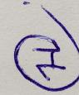

**Witnessed by:**

**Sajjad Hussain**

**House # 3 street # 23 sultanpura post office chahmira Lahore**

**35202-2412749-5**

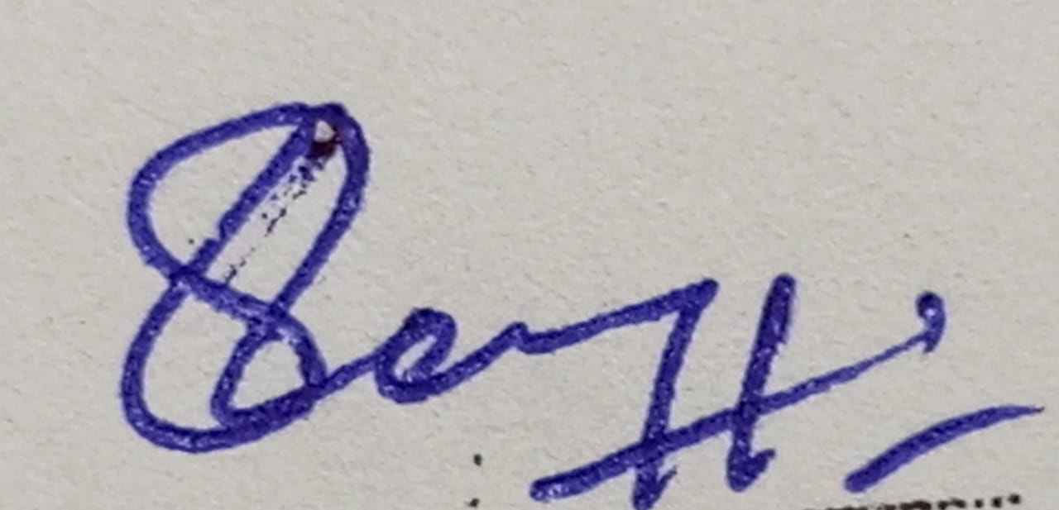

**2025-03-12**

**Lahore**