**PROJECT PLANNING**

|  |  |
| --- | --- |
| **Date** | 18-06-2025 |
| **Project Name** | Empowering Career Progression with Tailored Cover Letters |
| **Team ID** | SWTID1749741458 |
| **Maximum Marks** | 5M |

**Project Overview**

The Smart AI Cover Letter Generator is a Streamlit-based web application designed to assist job applicants in generating personalized and professional cover letters. It provides two methods:

* Form-Based Input: Manually entering user details.
* Resume-Based Input: Uploading a resume from which details are extracted automatically.

The backend uses Google’s Gemini-1.5-Flash model for text generation. The system enables customization, generation, and export of tailored cover letters through a user-friendly interface.

**Work breakdown structure**

**Phase01: Project Initialization**

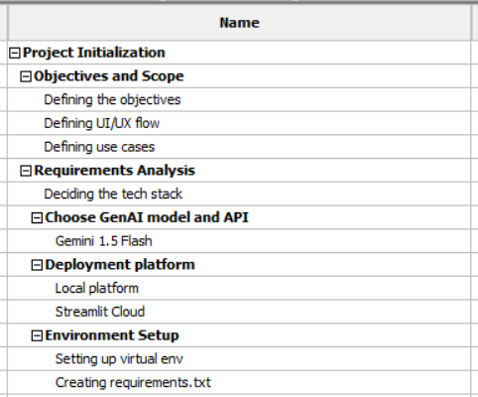

**Phase02: UI development – Front End**

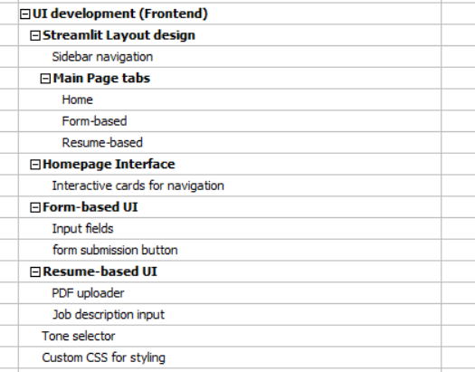

**Phase03 – Backend Development**

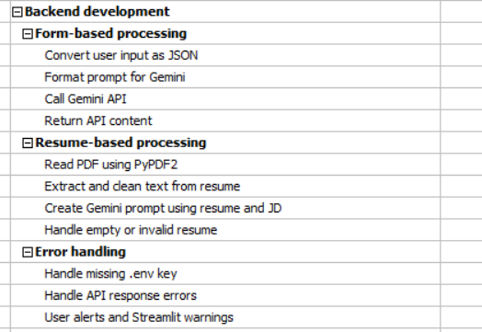

**Phase04 – Output Management**

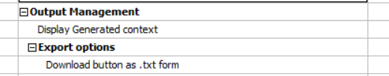

**Phase05 – Testing and Debugging**

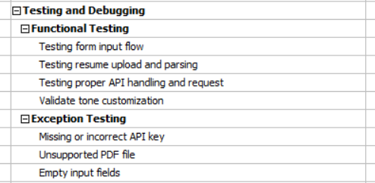

**Phase06 – Deployment and Documentation**

