**Requirement gathering and analysis**

|  |  |
| --- | --- |
| **Date** | 18-06-2025 |
| **Project Name** | Empowering Career Progression with Tailored Cover Letters |
| **Team ID** | SWTID1749741458 |
| **Maximum Marks** | 10M |

**DATA FLOW DIAGRAM:**

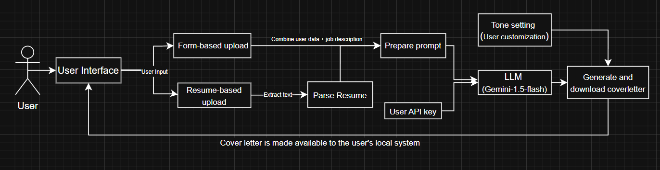

**TECHNOLOGY STACK**

|  |  |  |
| --- | --- | --- |
| **Layer** | **Tech/Library** | **Purpose** |
| Frontend(UI) | Streamlit | Interactive web app interface |
| Styling | Custom CSS via st.markdown() | Card-based layouts, buttons and sidebar styling |
| Backend(Logic) | Python 3.x | Core application logic |
| LLM Integration | Google.generativeai (Gemini API) | Generates AI cover letters |
| Environment | Python-dotenv | Load Gemini API key securely from .env |
| File Handling | PyPDF2 | Read and extract text from uploaded PDF resumes |
| Package Management | requirements.txt + virtualenv | Manage dependencies |

**SOLUTION REQUIREMENTS (FUNCTIONAL AND NON-FUNCTIONAL)**

1. **Functional Requirements**

|  |  |  |
| --- | --- | --- |
| **FR No.** | **Functional Requirement (Epic)** | **Sub Requirement (Story/Sub-task)** |
| FR-01 | Homepage Navigation | Display homepage with options for “Form-Based” and “Resume-Based” cover letter generation. |
| FR-02 | Sidebar Navigation | Provide navigation buttons in sidebar to switch between pages. |
| FR-03 | Form-based Cover Letter Generation | Accept user inputs like name, skills, job description, and generate a personalized cover letter. |
| FR-04 | Gemini API Integration | Use Google Gemini (gemini-1.5-flash) to generate content from user prompts. |
| FR-05 | Resume-based Cover Letter Generation | Allow user to upload a resume and job description to generate a cover letter. |
| FR-06 | Resume PDF Parsing | Extract text from uploaded PDF using PyPDF2. |
| FR-07 | Prompt Engineering | Feed extracted resume + job description to Gemini API and fetch generated output. |
| FR-08 | Tone Selection | User selects a preferred tone for generating the cover letter (e.g., Formal, Confident, friendly etc). |
| FR-09 | Cover Letter Output | Display generated letter in a text area and provide download option. |
| FR-10 | Error and Validation Handling | Notify users when required inputs are missing or Gemini API fails. |

1. **Non-Functional Requirements**

|  |  |  |
| --- | --- | --- |
| **NFR No.** | **Non-Functional Requirement** | **Description** |
| NFR-01 | Usability | The UI should be simple and intuitive using Streamlit’s components and custom CSS. |
| NFR-02 | Performance | The app should generate cover letters quickly using Gemini’s 1.5-flash model. |
| NFR-03 | Security | API keys should be securely loaded using .env and not exposed in the code. |
| NFR-04 | Scalability | The system should support future extension to include chat-based guidance or Linkedln parsing. |
| NFR-05 | Portability | The app should run locally or be deployable on platforms like Streamlit Cloud, Render, or HuggingFace. |
| NFR-06 | Maintainability | Modular codebase (homepage.py, form_based.py, resume_based.py) for ease of maintenance. |
| NFR-07 | Error Resilience | Proper error messages and exception handling for smoother UX during failures. |

**USER STORIES:**

|  |  |  |  |  |  |
| --- | --- | --- | --- | --- | --- |
| **User Type** | **Functional Requirement (Epic)** | **User story Number** | **User Story / Task** | **Acceptance criteria** | **Priority** |
| Job Seeker | Home Page Navigation | USN-01 | As a job seeker, I can navigate between Home, Form-based and Resume-based modes | I can click buttons in the sidebar or cards to switch modes | High |
| Job Seeker | Form-Based Cover Letter | USN-02 | As a job seeker, I can manually input my details to generate a custom cover letter. | A personalized cover letter is generated and viewable. | High |
| Job Seeker | Resume Upload Cover Letter | USN-03 | As a job seeker, I can upload a PDF resume and job post to generate a cover letter. | Cover letter is generated based on parsed resume content. | High |
| Admin/Dev | Environment Config Management | USN-04 | As a developer, I can ensure GEMINI_KEY is loaded from .env file. | App throws error if key is missing; proceeds only if valid | High |
| Job Seeker | Download Cover Letter | USN-05 | As a job seeker, I can download the generated cover letter. | I can click a button to download the letter as a .txt file. | Medium |
| Job Seeker | Tone Personalization | USN-06 | As a job seeker, I can choose a preferred tone for the generation of cover letter | The selected tone is reflected in the cover letter text | Medium |
| Job Seeker | Resume Text Limiting | USN-07 | As a job seeker, I want my resume text to be properly limited if too long | Only first 3000 characters of the resume are used | Low |