**EWA** PRACTICAL 1(Documentation)

Khyati Dhawan

ArrayList

**___**

ArrayList

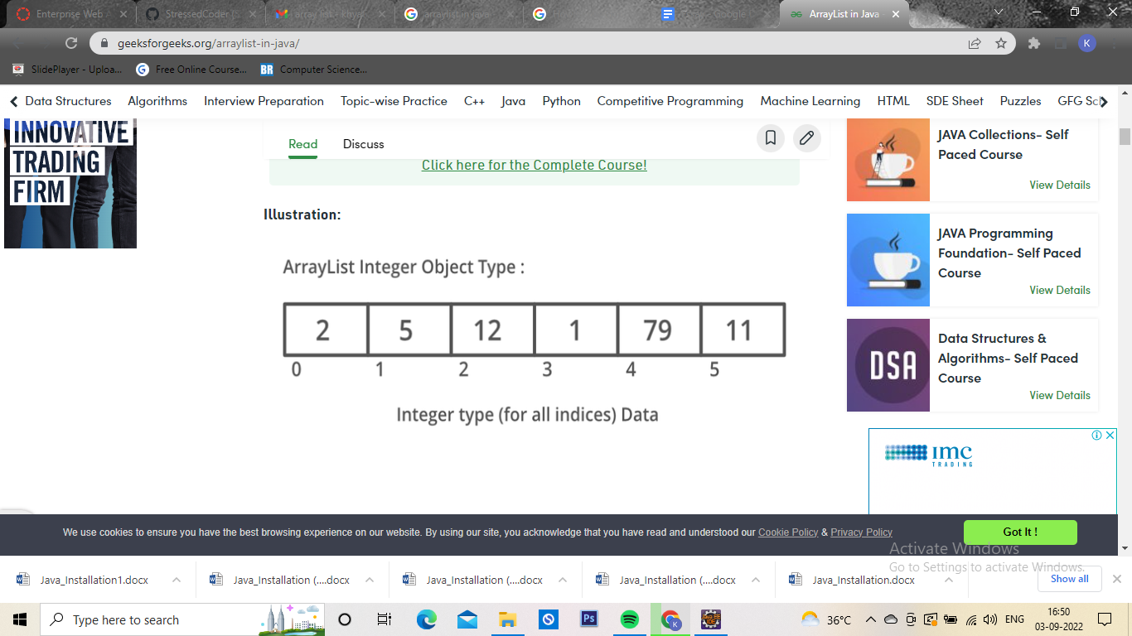

# INTRODUCTION:

So far we have used many sorts of variables, but it has always been true that each variable stores one value at a time – one int or one String or one boolean.

The Java ArrayList class can store a group of many objects. This capability will greatly expand what our programs can do.

Java has a whole suite of "Collection" classes that can store groups of objects in various ways.

The ArrayList is the most famous and commonly used type of collection, and it is the one we will use the most.

An ArrayList is an object that can store a group of other objects for us and allow us to manipulate those objects one by one. For example, we could use an ArrayList to store all the String names of the pizza toppings offered by a restaurant, or we could store all the URLs that make up a user's favorite sites.

Code to print an array and Code to Print an arraylist:

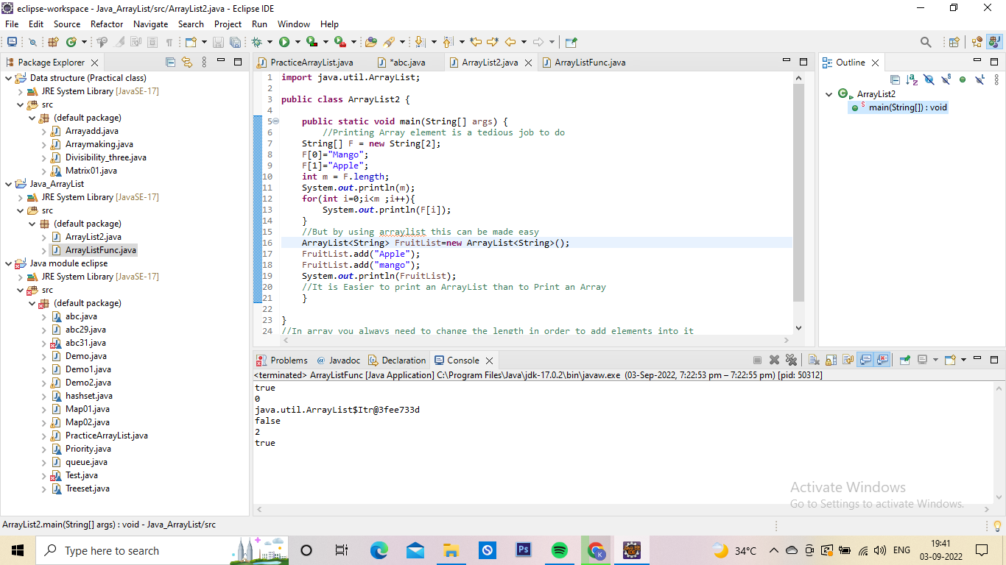

|  |  |
| --- | --- |
| ARRAY | ARRAYLIST |
| 1.printing complicated(need to use for loop ) | 1.Printing easier(Direct Print) |
| 2.Less Flexible.  Needs to append the length first in order to add elements | 2.More Flexible  Need not to mention the length , can be extended to any limit. |
| 3. Syntax:  Type [ ] name= new Type[ ];  Eg: int[ ] arr = new int[ ]; | 3.Syntax:  ArrayList<Type> name = new ArrayList<Type>( ) ;  Eg:  ArrayList<String> Fruits = new ArrayList<String> ( ) ; |

## Functions in ArrayList:

For more Functions : [ArrayList (Java SE 17 & JDK 17) (oracle.com)](https://docs.oracle.com/en/java/javase/17/docs/api/java.base/java/util/ArrayList.html#get(int))

|  |  |  |
| --- | --- | --- |
| Functions | Purpose | Syntax (F is any arraylist) |
| 1.Add(Element_name)  Add(index , Element) | To add elements into the existing arraylist. | F.add(12);  F.add(0, 13); |
| 2. Remove(Index) | To remove the element at the mentioned index | F.remove(0); |
| 3.Get(Index) | Take indexes as parameters .  Return value | F.get(0); |
| 4.Clear() | Remove all elements | F.clear(); |
| 5.Isempty() | True or False  Works with sysout | F.Isempty(); |

## 

## 