Name:Khyati Dhawan

Rollno.: 21csu047

Subject : EWA

Section:FS- A

Group : 1

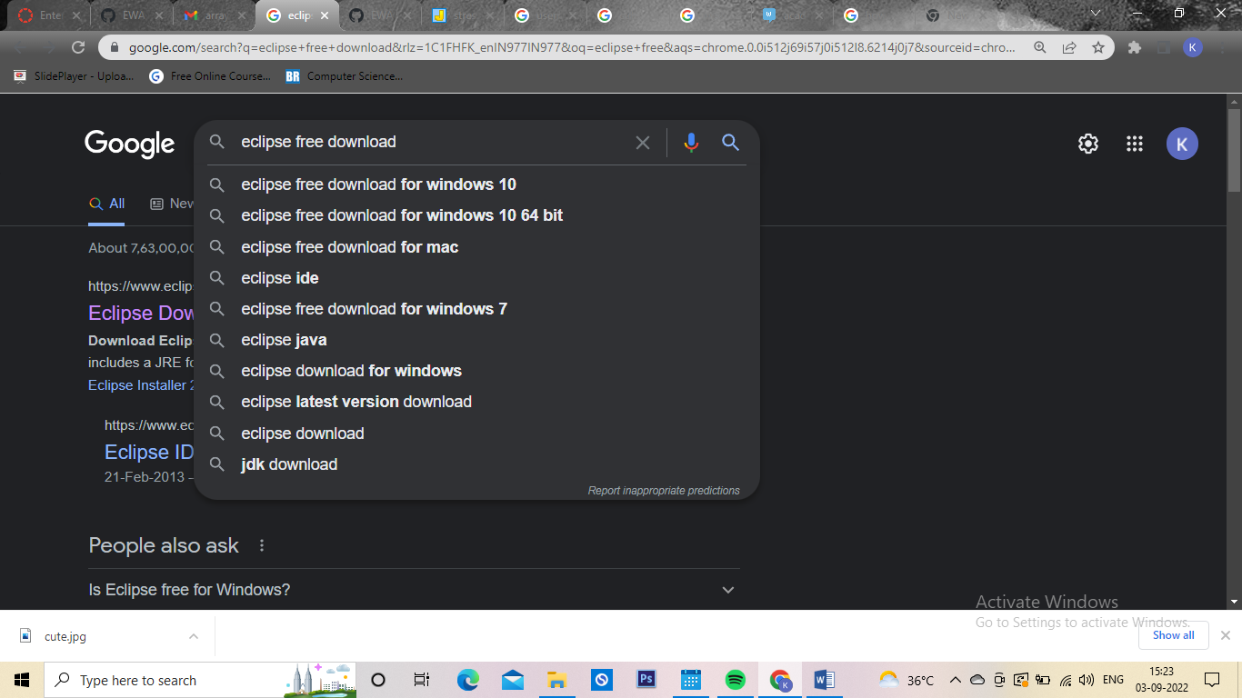Step 1 : On google Type Eclipse free download.

Step2: Click on the very first link that follows.

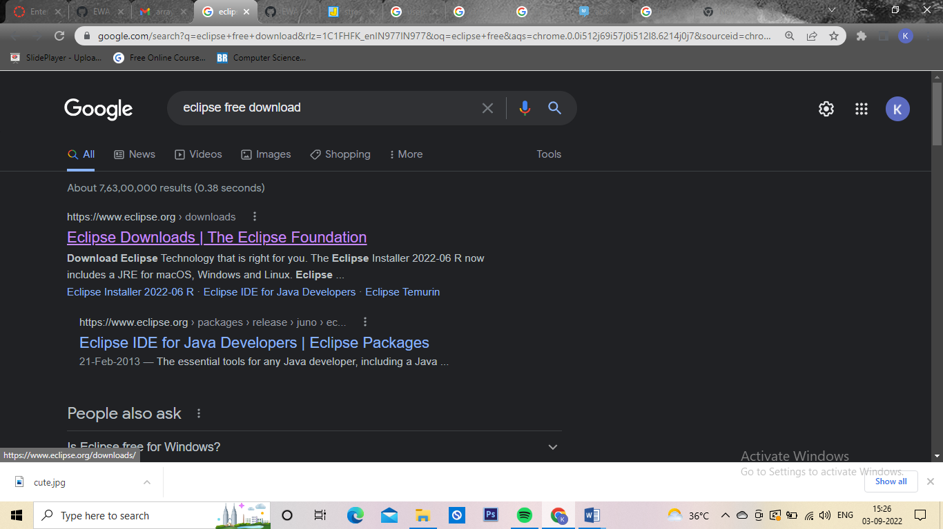

### Step3: Now Click on the Get Eclipse IDE 2022‑06

Install your favorite desktop IDE packages.

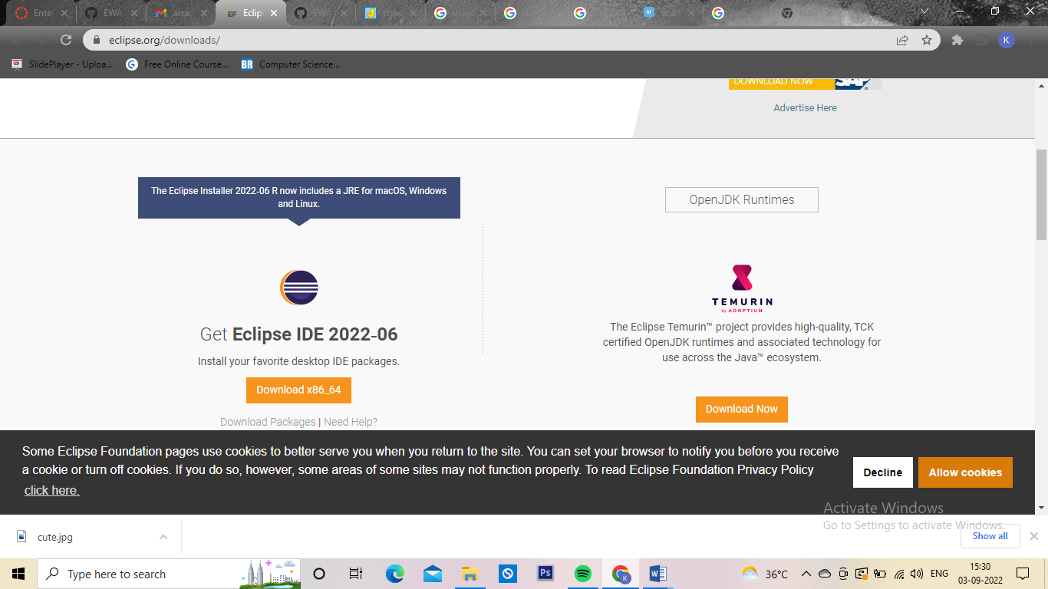

Step4: Now it will direct you to a page shown below.Simply Click Download to proceed.

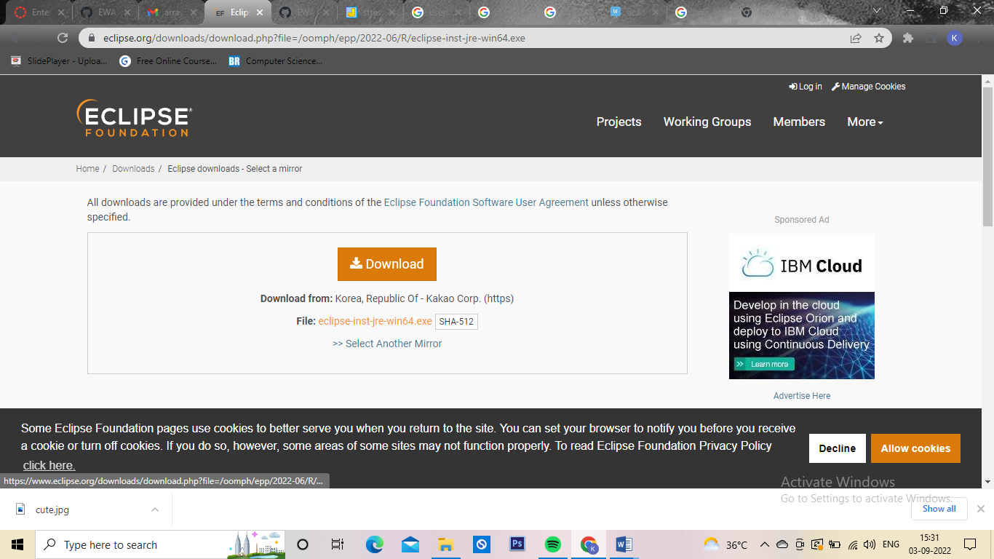 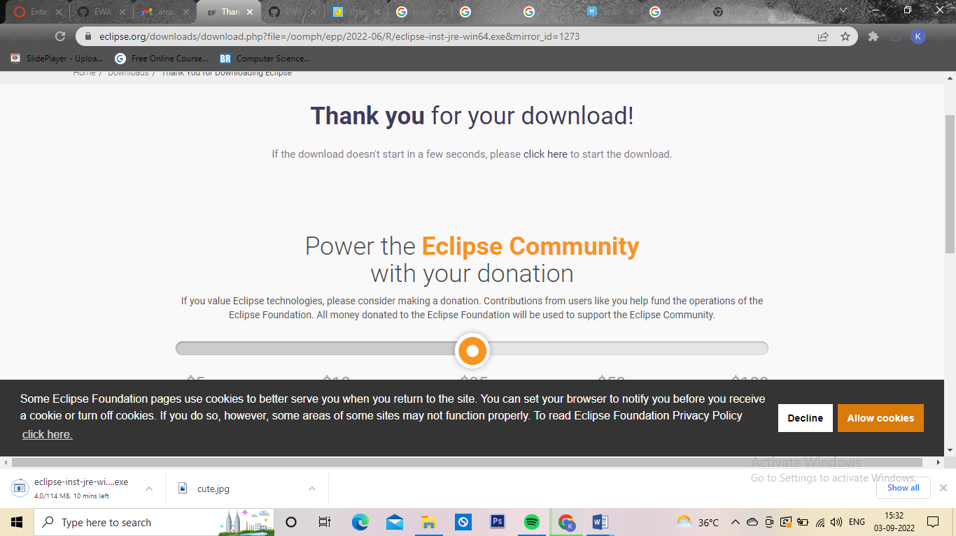

Step 5: Start the Eclipse Installer executable

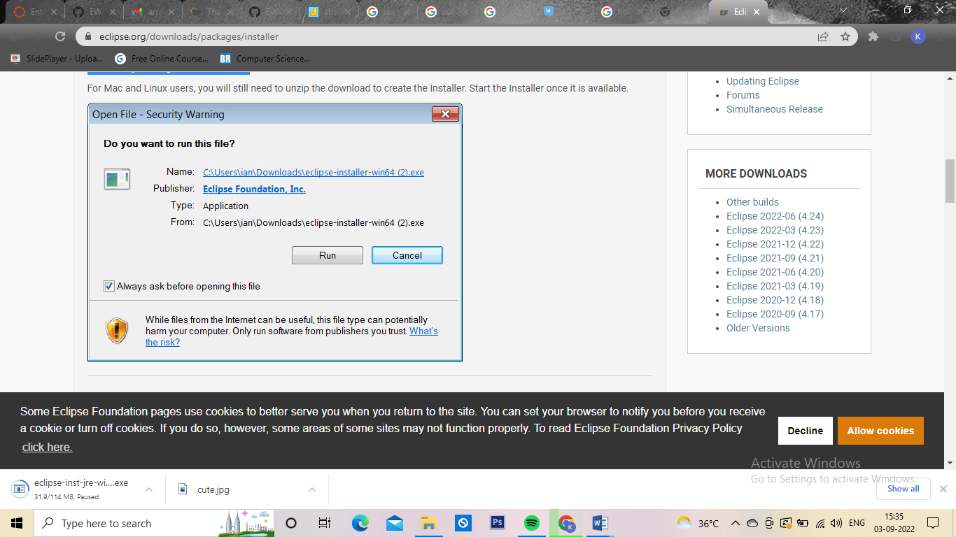For Windows users, after the Eclipse Installer executable has finished downloading it should be available in your download directory. Start the Eclipse Installer executable. You may get a security warning to run this file. If the Eclipse Foundation is the Publisher, you are good to select Run.

Step 6: Select the package to install .The new Eclipse Installer shows the packages available to Eclipse users. You can search for the package you want to install or scroll through the list.Select and click on the package you want to install. Click on java EE

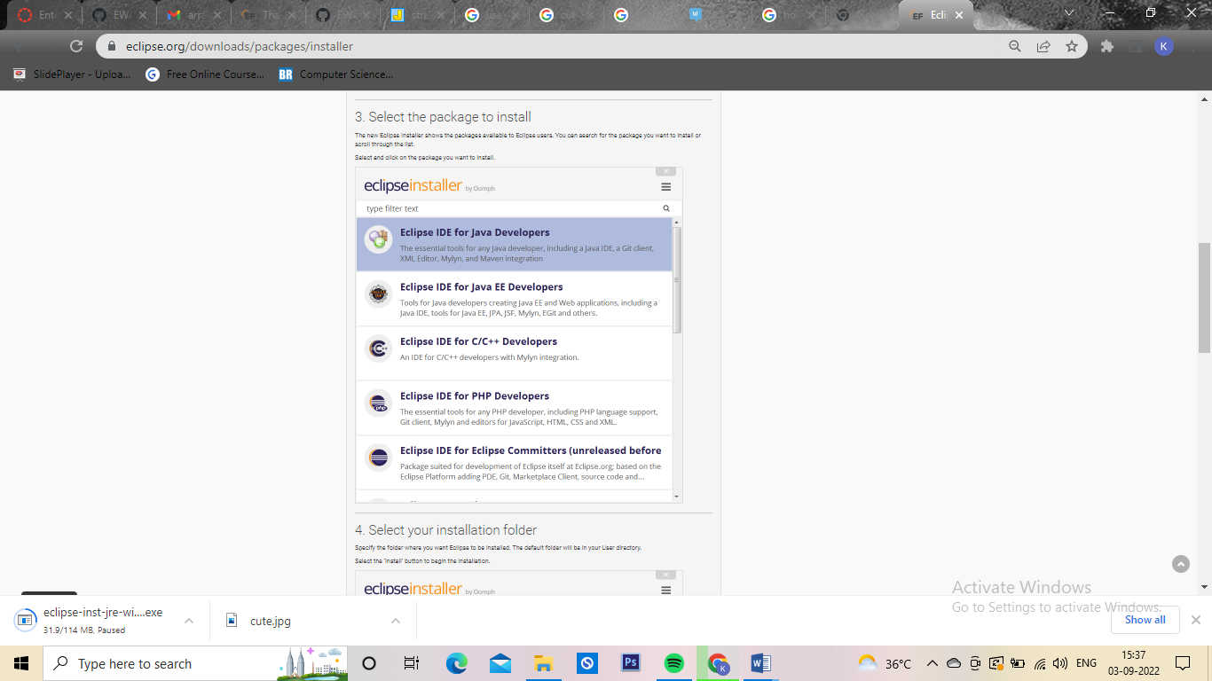

Step 7: Select your installation folder

Specify the folder where you want Eclipse to be installed. The default folder will be in your User directory.Select the ‘Install’ button to begin the installation. 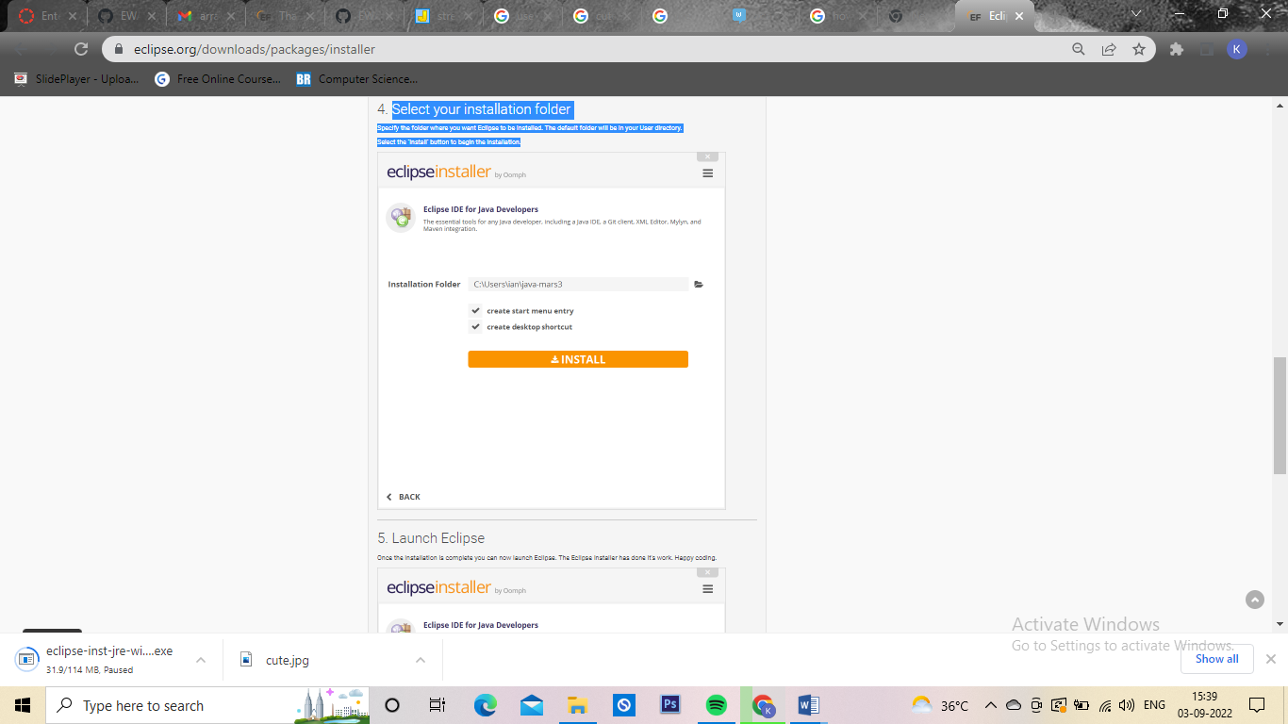

Step 8: Launch Eclipse.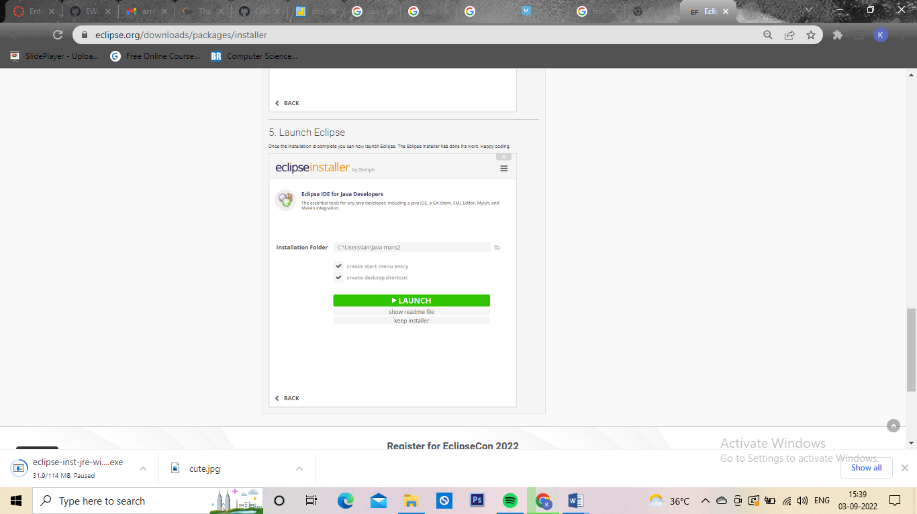Once the installation is complete you can now launch Eclipse. The Eclipse Installer has done it's work. Happy coding.