Project Setup Documentation

# 1. Project Overview

This is a full-stack label management system developed using Angular and ASP.NET Core Web API. The backend is built on .NET 6+ with Entity Framework Core and SQL Server using a code-first approach. The frontend is developed using Angular 19.2.0 and utilizes Bootstrap and AG Grid for UI components.

# 2. Technology Stack & Versions

* Backend: ASP.NET Core Web API (Version: 8.0)
* Frontend: Angular (Version: 19.2.0)
* Database: SQL Server 2022 (RTM) - 16.0.1000.6
* UI Libraries: Bootstrap 5.3.6, AG Grid 33.3.1

# 3. Prerequisites

* Visual Studio 2022
* Node.js v18
* Angular CLI (v19.2.0)
* SQL Server Management Studio

# 4. Backend Setup (ASP.NET Core Web API)

1. Clone the backend repository.

2. Open the solution in Visual Studio 2022 or later.

3. Update the `appsettings.json` file with your SQL Server connection string.

4. Open Package Manager Console and run the following commands:

- `Update-Database` (to create the database)

5. Press F5 or click 'Start Debugging' to run the Web API.

# 5. Frontend Setup (Angular)

1. Open a terminal and navigate to the Angular project folder.

2. Run `npm install` to install dependencies.

3. Run `ng serve` to start the development server.

4. Open your browser and navigate to `http://localhost:4200`.

# 6. Database Model

The system uses a code-first approach with the following entities:

- Email

- Label

- EmailLabel (many-to-many relationship)

Use SSMS or a database diagram tool to view the actual ERD after running the migrations.

# 7. Screenshots

1. Main screen:

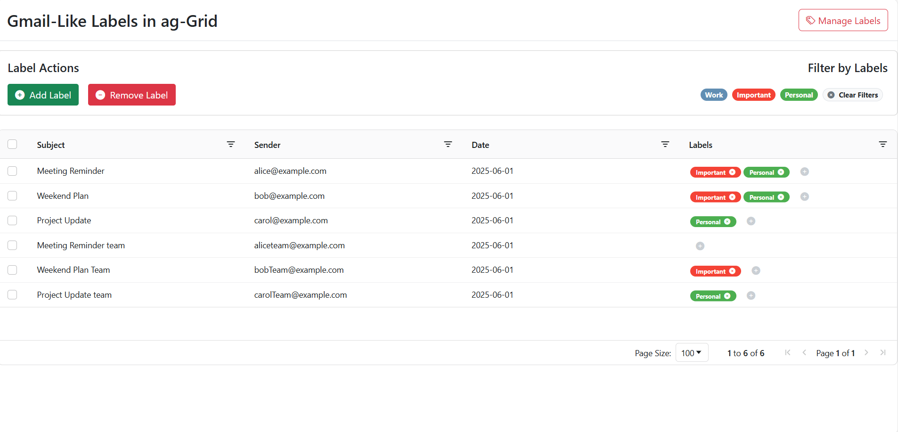

2. Manage Labels form ( Add Label)

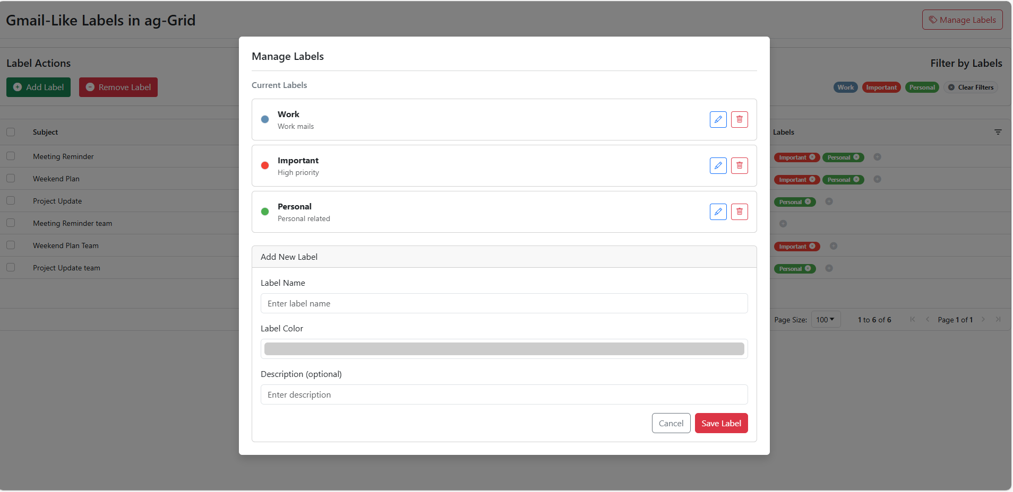

3. Manage Label form ( Edit Label )

4. Label Actions ( Add Label )

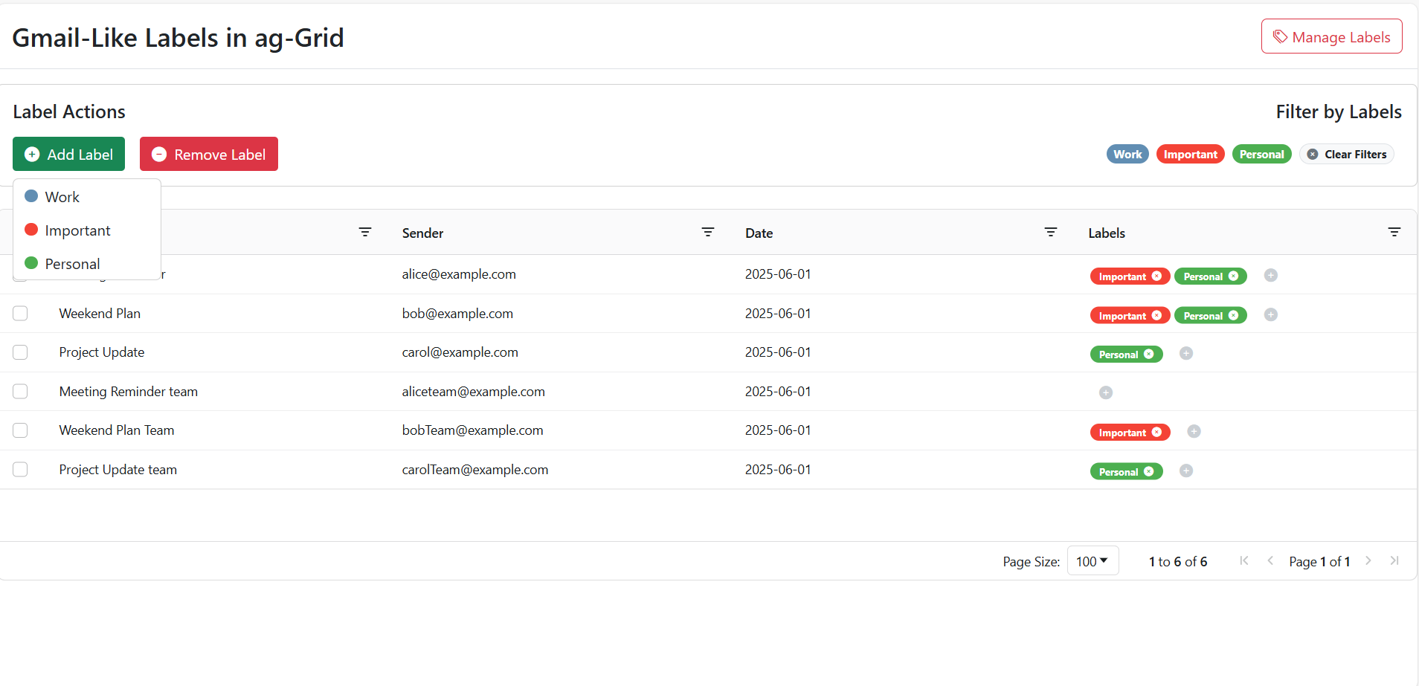

5. Label Actions ( Remove Label )

6. Grid Add Button

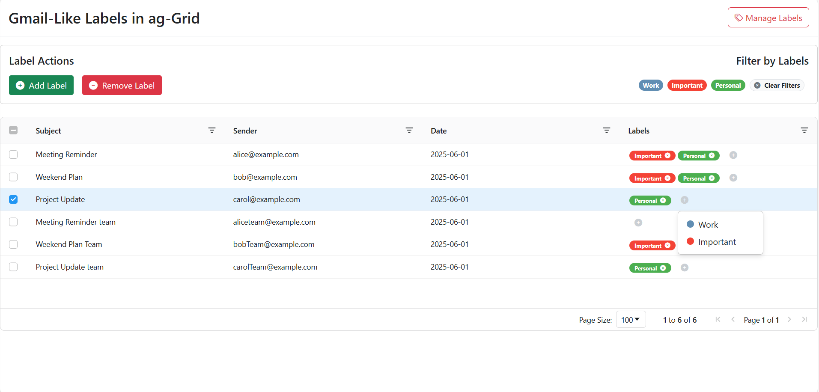

7. Toastr message

