Khyle Calpe

405016683

10/02/2017

Math 31A Lecture Notes: Limits

Introduction: Consider the function $f(x)=\frac{sin(x)}{x}$. When x is equivalent to 0, the f(x) is indeterminate because the function is equivalent to $\frac{0}{0}$. However, as x approaches 0, f(x) reaches the value. To attain this value, we set a range of arbitrary numbers in which the limit exists. Hence, we achieve a value for f(x) even though the exact f(x) may or may not exist.

Definition; *Limit*: Assume that f(x) is defined in an open interval around some c (except for maybe c). We determine the limit of f(x) as x approaches c is equal to the number L. $\left|f\left(x\right)-L\right|$ (the distance between f(x) and L) can be made arbitrarily small for all x sufficiently close to c. Hence, $\lim_{x →c}{f\left(x\right)=L}$.

Example 1: f(x) = 5;

$\left|f\left(x\right)-5\right| = \left|5 - 5\right| = \left|0\right| = 0$ for all x => $\lim_{x → 7}{f\left(x\right)=5}$.

Example 2: $\lim_{x → 4}{f\left(x\right)=3x + 1}$

$$\left|f\left(x\right)-13\right| = \left|3x + 1 - 13\right| = \left|3x - 12\right| = 3\left|x - 4\right|$$

The distance can be made arbitrarily small for x sufficiently close to 4 so $\lim_{x → 4}{f\left(x\right)=13}$.

Theorem 1: Let c, k be some constant numbers.

$\lim_{x → c}{k = k}$ AND $\lim_{x → c}{x = c}$

Example 3: Let $f(x) = sin(\frac{1}{x})$

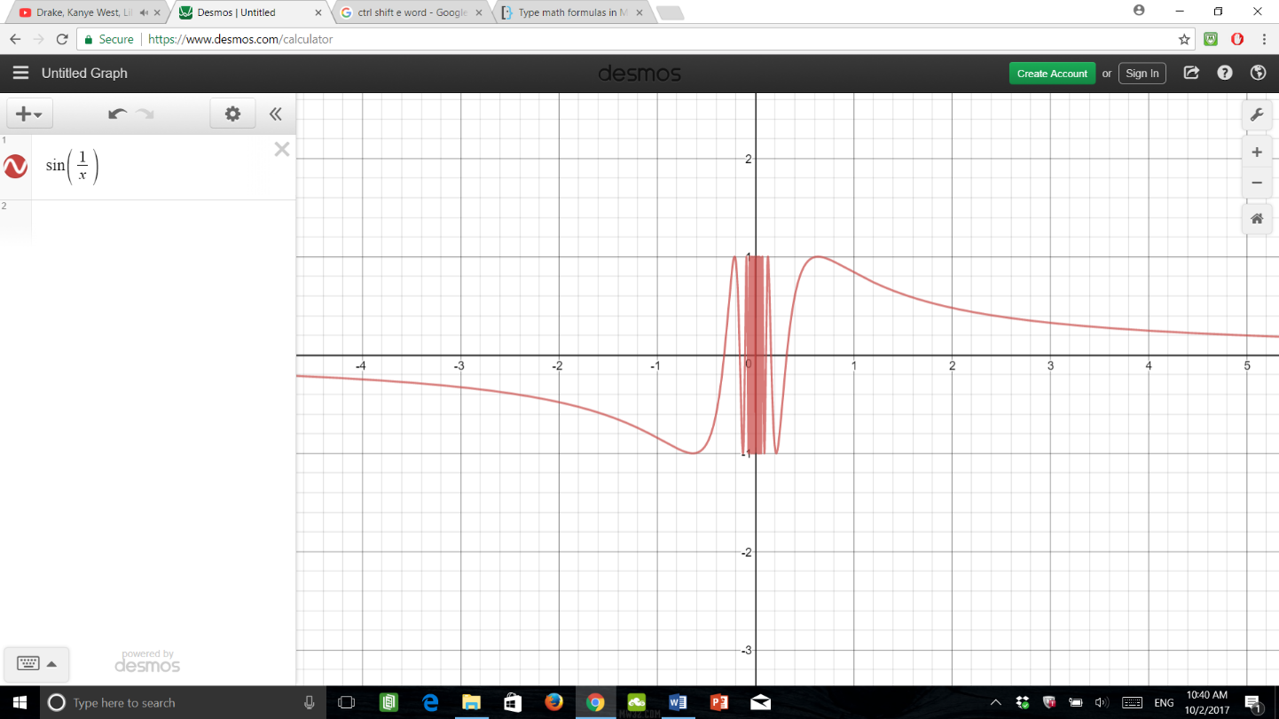The limit of the f(x) does not exist because the value of the limit oscillates to the value of 1. For instance, lets determine the limit of f(x) as x approaches 0. $\lim_{x → 0}\left|\sin\left(\frac{1}{x}\right)- 0\right| = \frac{1}{2}$. However, since the f(x) oscillates between -1 and 1 at x, the limit is more than 0.5. Hence, the limit does not exist.

Example 4: Let f(x) = $\frac{x}{\left|x\right|}$

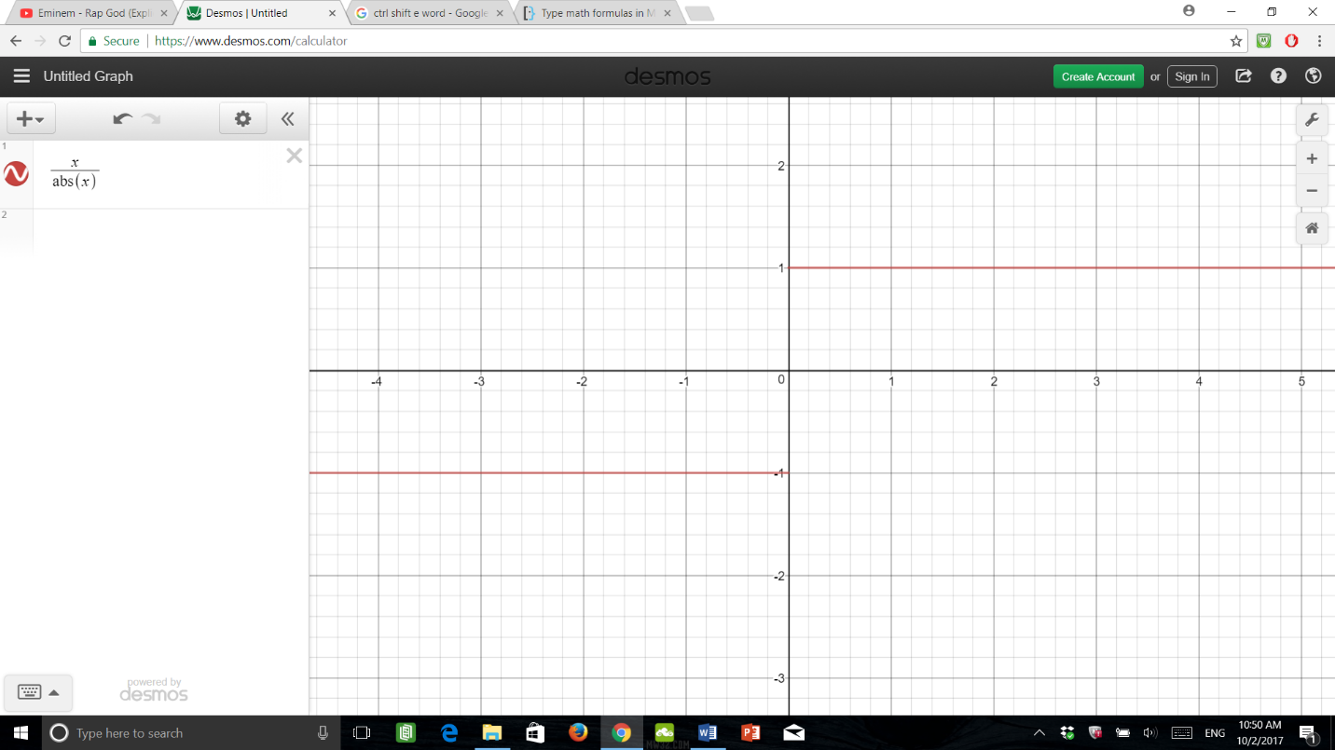For this problem, two limits exist. However, the limit also doesn’t exist. As x approaches 0 from negative infinity, the limit is clearly -1. However, as x approaches 0 from positive infinity, the limit is clearly 1. Say we attempt to determine the limit of f(x) as x approaches 0 from both infinities, we arrive at the conclusion that a limit does not exist because there are different values for each side.

*One-Sided Limit*: Let $\lim_{x→c^{-}}{f(x) = L}$ ($\lim_{x→c^{+}}{f(x) = L}$) if f(x) approaches L for x smaller (bigger) than C.

Examples 6 and 7: Let f(x) = $\frac{1}{x^{2}}$ and g(x) =

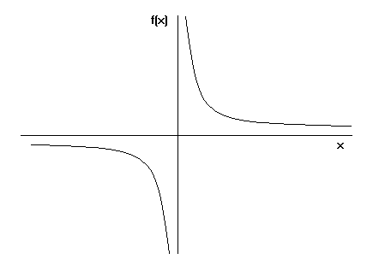

Lim = ∞ Lim = -∞

Postulate:

Let $\lim_{x→c}{f\left(x\right)=∞}$ if f(x) increases without bounds for x $→$ c.

Let $\lim_{x→c}{f\left(x\right)=-∞}$ if f(x) decreases without bounds for x $→$ c.

