Khyle Calpe

405016683

10/04/2017

Math 31A Lecture Notes: Continuity

Definition; *Continuity of a function*: Assume that f(x) is defined in an open interval around x = c (including c). Then, f(x) us continuous at x = c if the limit as x approaches c exists and .

Definition; *Continuity at all points*: A function f(x), which is continuous in its domain for all x = c, is called continuous.

Example 1: The function f(x) = k, k is a constant, is continuous.

Example 2: The function f(x) = x is continuous.

Three Types of Limit Discontinuity:

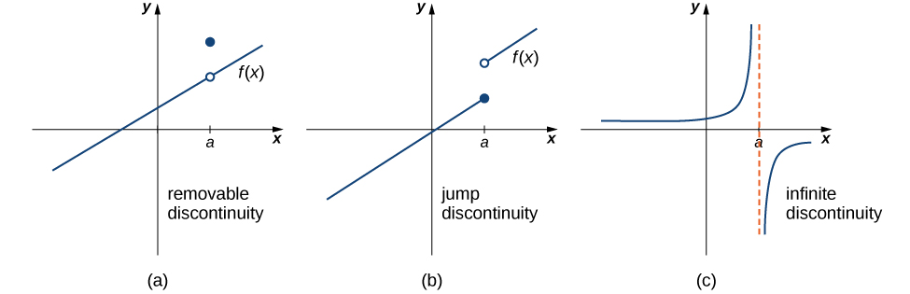

1. Removable discontinuity
   1. The limit of f(x) as x approaches c exists BUT the limit is NOT equal to f(c).
2. Jump discontinuity
   1. The limit of f(x) as x approaches c from negative infinity AND the limit of f(x) as x approaches c from positive infinity exist BUT the limits from both sides are NOT equal.
      1. Right continuous:
      2. Left continuous:
3. Infinite discontinuity
   1. The limit of f(x) as x approaches c is equal to either positive or negative infinity.

Theorem 1: If f(x) and g(x) are continuous around x = c, then so are:

1. f(x) + g(x)
2. h \* f(x)
3. f(x) \* g(x)
4. if g(x) ≠ 0,
5. f(x)n, , f(x)p/q

Theorem 2: Let P(x), Q(x) be polynomials

1. P(x), Q(x) are continuous
2. is continuous at all points where Q(x) ≠ 0.

Definition; *Indeterminate Forms*: The function f(x) has an *indeterminate form* at x = c if f(c) yields one undefined expression of types:

1. ∞ \* 0
2. ∞ - ∞.

Exercise 1: Exercise 2:

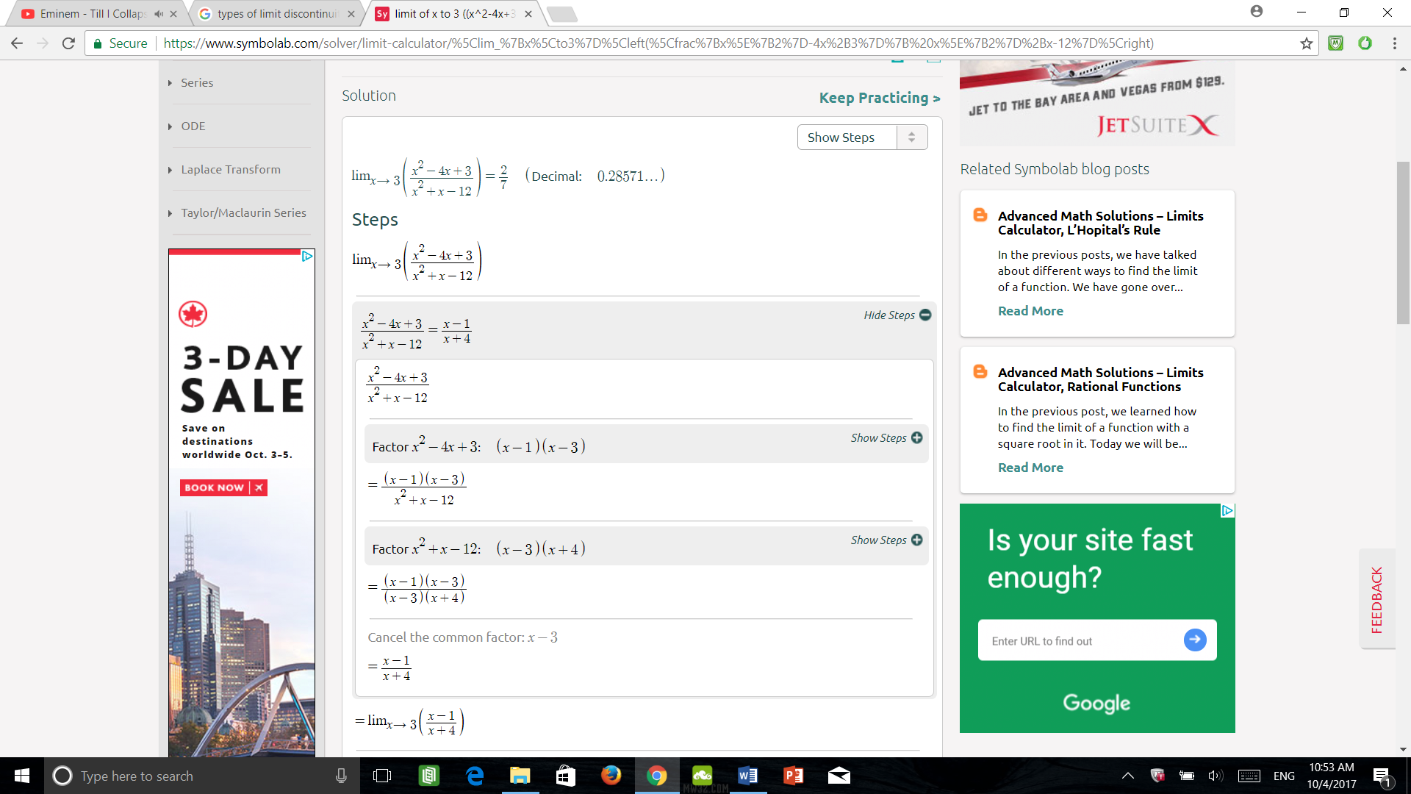 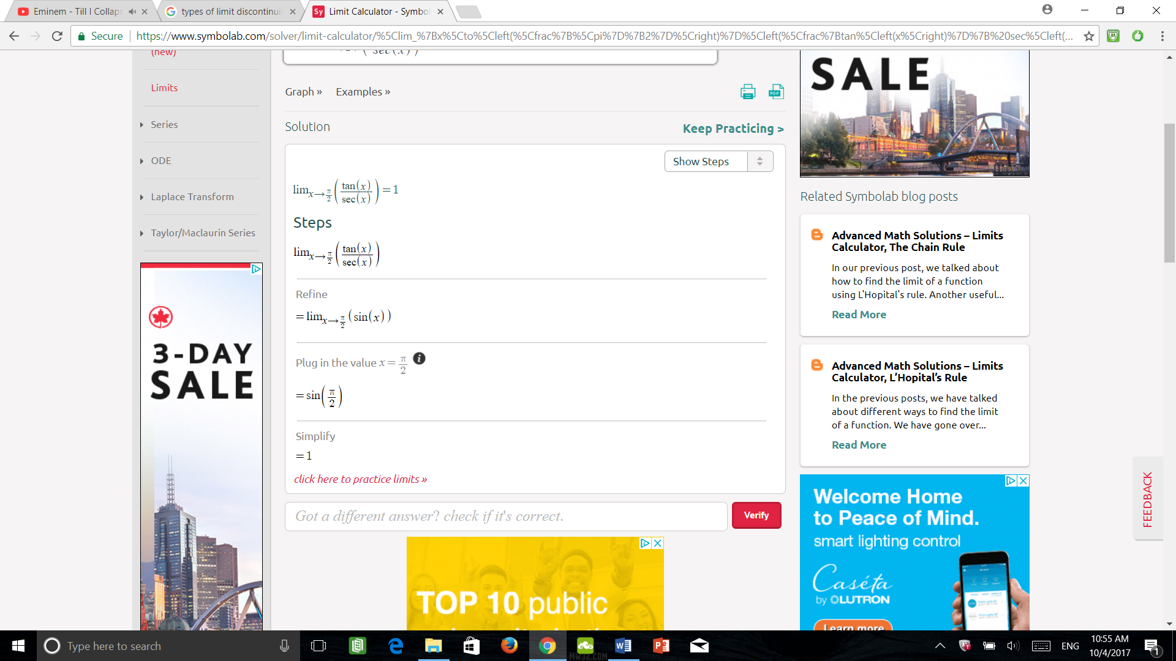

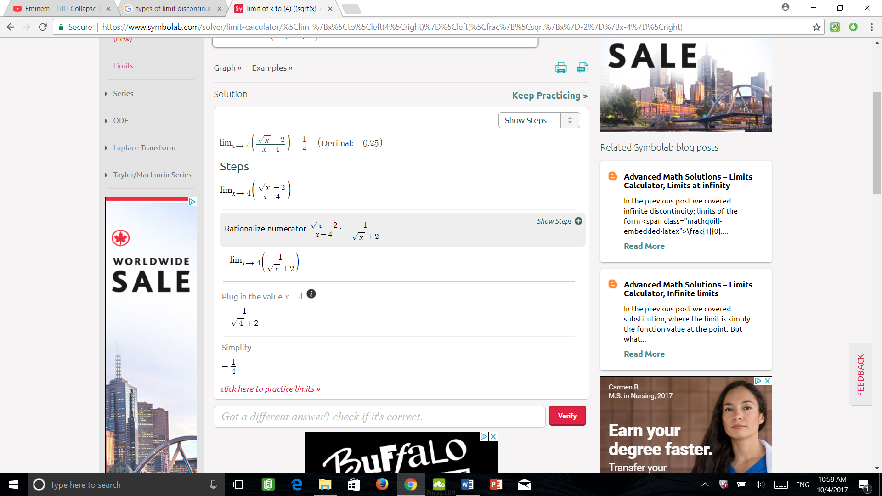Exercise 3: Exercise 4:

