Khyle Calpe

405016683

10/06/2017

Math 31A Lecture Notes: Limits of Infinity

Definition; *Limits of Infinity*:

* $\lim_{x → ∞}{f(x) = L}$ if f(x) gets closer and closer to L as x approaches ∞.

$\lim_{x → -∞}{f(x) = L}$

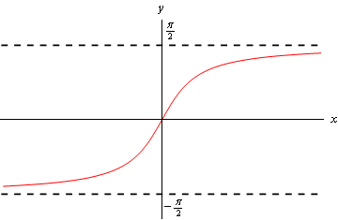

Theorem:

n > 0; $\lim_{x → ∞}{x^{n}=} ∞$ $\lim_{x → -∞}{x^{-}n=0}$

If n is a positive whole number,

$\lim_{x → -∞}{x^{n}=} \left\{\begin{aligned}∞ n even \\ -∞ n odd\end{aligned}\right.$ $\lim_{x → -∞}{x^{-n}=0}$

Theorem: Limit laws also hold for limits of infinity.