Khyle Calpe

4050160683

10/06/2017

Math 31A Lecture Notes: Trigonometric Limits

Example 1: Calculate $\lim_{x → 2}{\frac{x^{2} - x + 5}{x - 2}}$

f(2) is undefined and leads to an expression of the form $\frac{7}{0}$. The one-sided limits are:

$\lim_{x→2^{-}}{\frac{x^{2} - x + 5}{x - 2}} = -∞$ $\lim_{x → 2^+}{\frac{x^{2} - x + 5}{x - 2} = +∞}$

Example 2: Calculate $\lim_{h → 0}{\frac{{\left(h + a\right)}^{2} - a^{2}}{h}}$, where a is a number.

Solution: We have the indeterminate form $\frac{0}{0}$ at h = 0 since

numerator: (h + a)2 – a2 = a2 – a2 for h = 0

denominator: h = 0 for g = 0

Step 1: Transform

$\frac{{\left(h + a\right)}^{2} – a^{2}}{h} = \frac{h^{2} + 2ah +{ a}^{2} – a^{2}}{h} = h + 2a$

Step 2: Use continuity

$\lim_{h → 0}{\frac{{\left(h + a\right)}^{2} – a^{2}}{h}} = \lim_{h → 0}{h + 2a = 2a}$

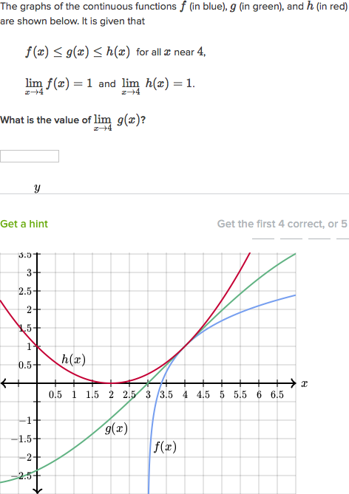

Theorem; *Squeeze Theorem*: Assume that in some open interval around x = c

* l(x) ≤ f(x) ≤ u(x)

$\lim_{x → c}{u(x)}=\lim_{x → c}l(x) = L$

Then: $\lim_{x → c}{f(x)}= L$

Example 3: f(x) = x sin ($\frac{1}{x}$)

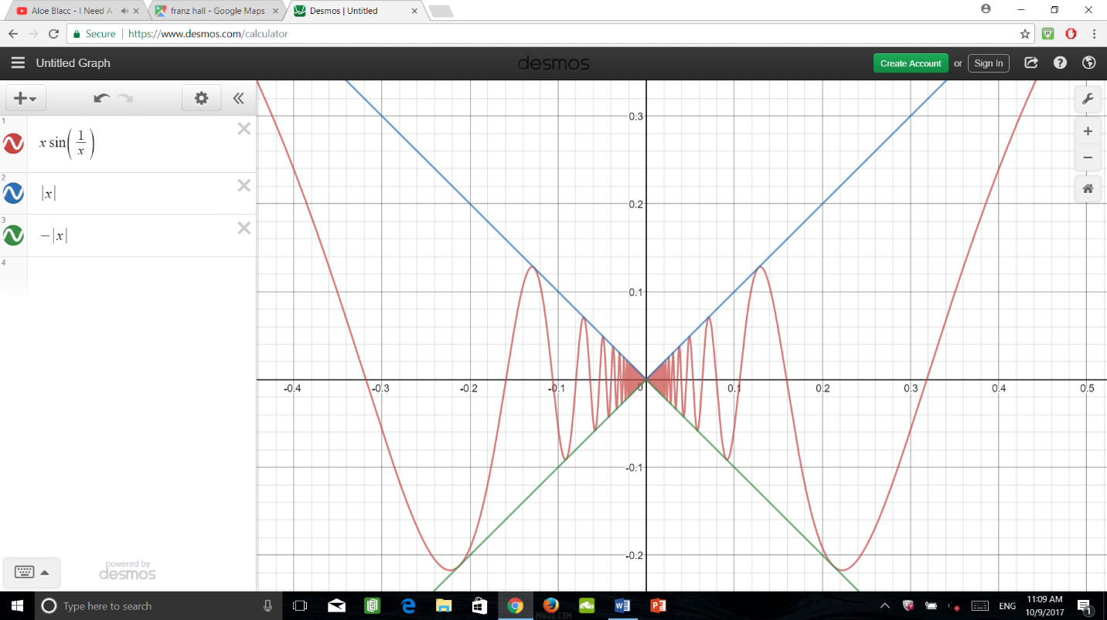f(x) = sin ($\frac{1}{x}$)

1: Since $-1 ≤ sin (\frac{1}{x}) ≤ 1 for all x$,

2: $-\left|x\right| ≤ sin (\frac{1}{x}) ≤ \left|x\right|$

3: $\lim_{x → 0}{-\left|x\right|=0}= \lim_{x → 0}\left|x\right|$ By Squeeze Theorem

4: $\lim_{x → 0}{xsin(\frac{1}{x})}$ = 0

Theorem 1: $\cos\left(θ\right)≤\frac{\sin\left(θ\right)}{θ}≤1$ for $-\frac{π}{2}<θ<\frac{π}{2}$

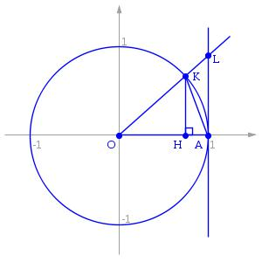

The diagram shows different triangles with different heights that corresponds to the given functions in the inequality statement. ΔKOH’s height is sin(θ) and ΔLOA’s height is tan(θ). In between is the area sector OAB. By applying the concept of the Squeeze Theorem and the formula of the area of a triangle, we get this inequality:

Area of ΔKOH ≤ Area of sector OAB ≤ Area of ΔLOA

$\frac{1}{2}\sin\left(θ\right)$ ≤ $\frac{1}{2}θ$ ≤ $\frac{1}{2}\tan\left(θ\right)$

This works for $0<θ<\frac{π}{2}$, $\frac{\sin\left(θ\right)}{θ}≤1$, $\frac{1 - cos\left(θ\right)}{θ}≤\frac{\sin\left(θ\right)}{θ}$ (Similar for $-\frac{π}{2}<θ<0$)

Theorem 2: $\lim_{θ→0}{\frac{\sin\left(θ\right)}{θ}=1}$ and $\lim_{θ→0}{\frac{1-cos\left(θ\right)}{θ}=0}$

Example 4: $\lim_{h → 0}{\frac{\sin\left(4h\right)}{h}} → θ= 4h →4\lim_{θ → 0}{\frac{\sin\left(θ\right)}{θ}} = 4$