Khyle Calpe

405016683

10/18/2017

Math 31A Lecture Notes: Implicit Differentiation

Example: $x^{2}+y^{2}=1$, $x=\frac{3}{5}$, $y=\frac{4}{5}$

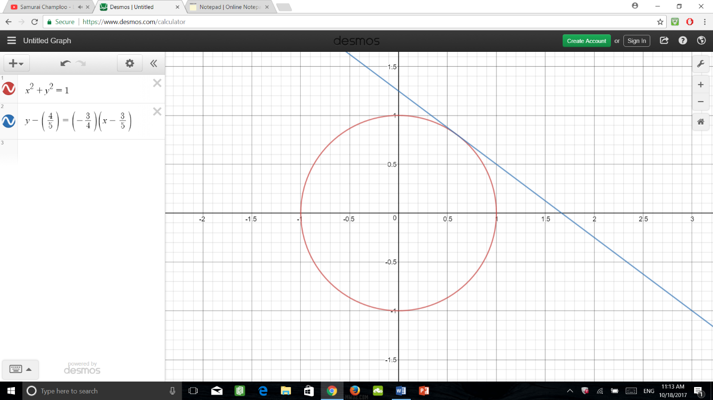Steps:

1: $y=±\sqrt{1-x^{2}}$

2: $\frac{d}{dx}\left(x^{2}+y^{2}\right)=\frac{d}{dx}1$

3: $\frac{dx^{2}}{dx}+\frac{dy^{2}}{dx}=0$

4: $2x+2x\frac{dy}{dx}=0$

5: $\frac{dy}{dx}=-\frac{x}{y}$

6: Slope of the tangent line of f(x) is $-\frac{3/5}{4/5}=-\frac{3}{4}$

$\frac{dy}{dx}\sin\left(y\right)=\cos\left(y\right)$; $\frac{d}{dx}\sin\left(y\right)=\cos\left(y\right)\frac{dy}{dx}$

$\frac{d}{dx}y^{4}=4y^{3}$; $\frac{dy^{4}}{dx}=4y^{3\frac{dy}{dx}}$

Example 1: Calculate the slope of the tangent line of the curve $y^{4}+xy=x^{3}-x+2$

$y^{4}+xy$ = $x^{3}-x+2$

$4y^{3\frac{dy}{dx}}+x\frac{dy}{dx}$ = $3x-1+0$

$4y^{3\frac{dy}{dx}}+x\frac{dy}{dx}$ = $3x-y-1$

$\frac{dy}{dx}\left(4y^{3}+x\right)$ = $3x-y-1$

$\frac{dy}{dx}$ = $\frac{3x-y-1}{4y^{3}+x}$