Khyle Calpe

405016683

10/21/2017

Math 31A Lecture Notes: Branching

Chain Rule:

$${\left(f∘g\right)}^{'}\left(x\right)=f^{'}\left(g\left(x\right)\right)x*\left(x\right)$$

$$y=f\left(u\right),u=g\left(x\right)$$

$$\frac{dy}{dx}=\frac{dy}{du}*\frac{du}{dx}$$

Branching:

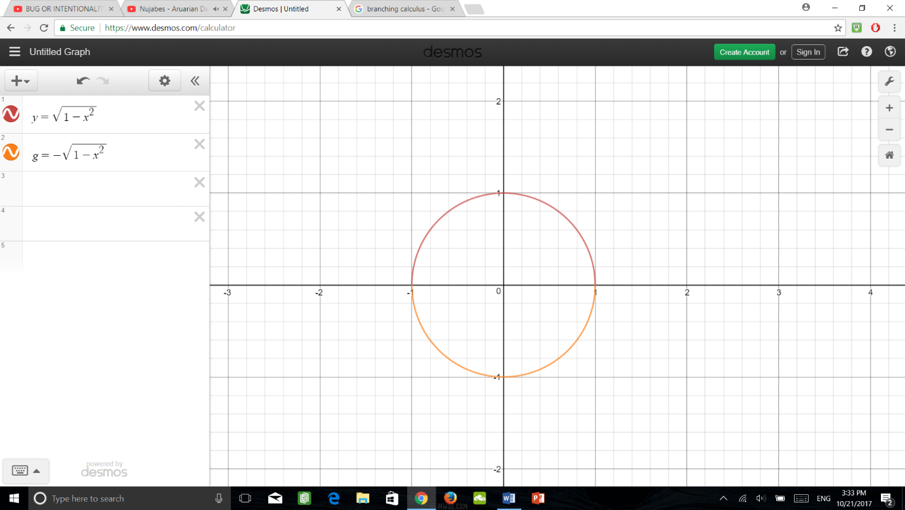 $x^{2}+y^{2}=1$

$$y=±\sqrt{1-x^{2}}$$

For branch red:

$$\frac{dy}{dx}=\frac{-2x}{2\sqrt{1-x^{2}}}$$

$$=\frac{-x}{y}$$

Example 2: Compute $\frac{dy}{dx}|_{p}$ for P(0, $\frac{5π}{2}$) for the curve given by $y*\cos\left(y+t+t^{3}\right)=t^{3}$

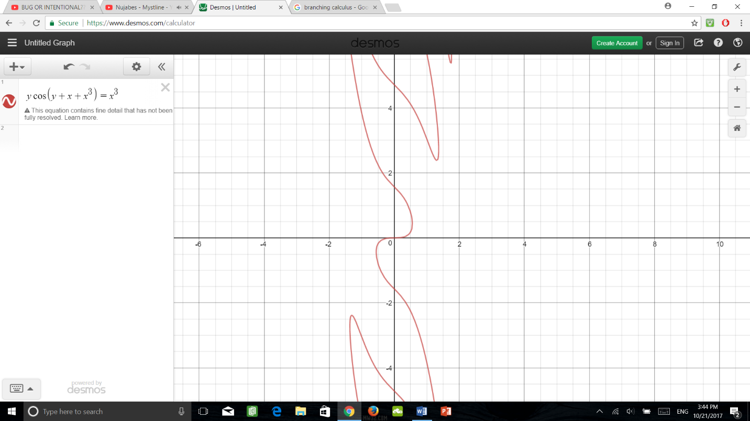

Step 1: Apply $\frac{d}{dt}$

$\frac{dy}{dt}\left(y*\cos\left(y+t+t^{3}\right)\right)=\frac{d}{dt}t^{3}$

$\frac{dy}{dt}\left(\cos\left(y+t+t^{3}\right)\right)+y\frac{d}{dt}\left(\cos\left(y+t+t^{3}\right)\right)=3t^{2}$

$\frac{dy}{dt}\left(\cos\left(y+t+t^{3}\right)\right)+y\left(-\sin\left(y+t+t^{3}\right)*\frac{d}{dt}\left(y+t+t^{3}\right)\right)=3t^{2}$

$\frac{dy}{dt}\left(\cos\left(y+t+t^{3}\right)\right)+y\left(-\sin\left(y+t+t^{3}\right)*\left(\frac{dy}{dt}+1+3t^{2}\right)\right)=3t^{2}$

Step2: Plug in P and then solve for $\frac{dy}{dx}|_{P}$

$\frac{dy}{dt}|_{P}*\cos\left(\frac{5π}{2}+0+0^{3}\right)+\left(-\frac{5π}{2}\right)\sin\left(\frac{5π}{2}\right)\sin\left(\frac{5π}{2}+0+0^{3}\right)\left(\frac{dy}{dt}|_{P}+1+3\left(0^{2}\right)\right)=0$

$-\frac{5π}{2}\left(\frac{dy}{dt}|_{P}+1\right)=0;$ Hence, $\frac{dy}{dx}|_{P}=-1$

Works with $\frac{d^{2}y}{dx^{2}}=\frac{d}{dx}\left(\frac{d}{dx}\left(…\left(\frac{dy}{dx}\right)\right)\right)$; n times

Example 3: Find $\frac{d^{2}y}{dx^{2}}$ for $x^{2}+4y^{2}=7$ (horizontal elipse)

Step 1: Compute $\frac{dy}{dx}$

Step 1a: Apply $\frac{d}{dx}$ to the equation:

$\frac{d}{dx}\left(x^{2}+4y^{2}\right)=\frac{d}{dx}7$

$\frac{dx^{2}}{dx}+\frac{d4y^{2}}{dx}=0$

$2x+4*2y^{2}*\frac{dy}{dx}=0$

Step 1b: Solve for $\frac{dy}{dx}$

$\frac{dy}{dx}=-\frac{x}{4y}$

Step 2a: Apply $\frac{d}{dx}$ to the equation

$\frac{d}{dx}\left(\frac{dy}{dx}\right)=\frac{d}{dx}\left(-\frac{x}{4y}\right)$

$\frac{d^{2}y}{dx^{2}}=-\frac{\left(\frac{dx}{dx}*4y\right)-\left(x*\frac{d4y}{dx}\right)}{{\left(4y\right)}^{2}}$

Step 2b: Plug in $\frac{dy}{dx}=-\frac{x}{4y}$

$\frac{d^{2}y}{dx^{2}}=-\frac{4y-\left(x\left(\frac{x}{4y}\right)\right)}{{\left(4y\right)}^{2}}$