Khyle Calpe

405016683

10/23/17

Math 31A Lecture Notes: Related Rates

Example 1:  Air is being pumped into a spherical balloon at a rate of 5 cm3/min.  Determine the rate at which the radius of the balloon is increasing when the diameter of the balloon is 20 cm.

$Given: \frac{dV}{dt}=5cm^{3}/min$ $d=20cm\left(r=10cm\right)$

$Find: \frac{dr}{dx}$ $Formula:V=\frac{4}{3}πr^{3}$

$$Solution:$$

Step 1: Differentiate the formula $\frac{dV}{dt}=\frac{4}{3}π*3r^{2\frac{dr}{dt}}$

Step 2: Substitute known values $5=\frac{4}{3}π*3{\left(10\right)}^{2}\frac{dr}{dt}$

Step 3: Solve for $\frac{dr}{dt}$ $5=4π\left(100\right)\frac{dr}{dt}$

$\frac{dr}{dt}=5*\frac{1}{400π}$

$\frac{dr}{dt}=\frac{1}{80π}cm/min$

Example 2: A 15-foot ladder is resting against the wall. The bottom is initially 10 feet away from the wall and is being pushed towards the wall at a rate of $\frac{1}{4}ft/sec$. How fast is the top of the ladder moving up the wall 12 seconds after we start pushing?

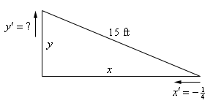

$Given:x^{2}+y^{2}={15}^{2}$ $x=10$ $\frac{dx}{dt}=-\frac{1}{4}ft/sec$ $t=12sec$

$Find: \frac{dy}{dt}$ $Formula:x^{2}+y^{2}=225$

$$Solution:$$

Step 1: Differentiate the formula $2x\frac{dx}{dt}+2y\frac{dy}{dt}=0$

Step 2: Find x at 12 second $distance=rate*time=\frac{1}{4}*12=3$

$$x=10-\left(\frac{1}{4}\right)*12=7$$

Step 3: Find y $y=\sqrt{225-x^{2}}$

$y=\sqrt{225-7^{2}}$

$y=\sqrt{225-49}=\sqrt{176}$

Step 4: Substitute known values $\left(2\left(7\right)\left(-\frac{1}{4}\right)\right)+\left(2\left(\sqrt{176}\right)\frac{dy}{dt}\right)=0$

$\left(-\frac{7}{2}\right)+2\sqrt{176}\frac{dy}{dt}=0$

$\frac{dy}{dt}=\frac{7}{2}*\frac{1}{2\sqrt{176}}=0.1319 ft/sec$

Example 3: Two people are 50 feet apart. One of them starts walking north at a rate so that the angle shown in the diagram below is changing at a constant rate of 0.01 rad/min. At what rate is the distance between the people changing when θ = 0.5 radians?

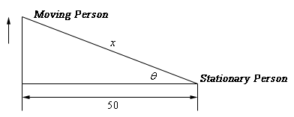

$Given: \frac{dθ}{dt}=0.01{rad}/{min}$ $d=50 feet$ $θ=0.5 radians$

$Find: \frac{dx}{dt}$ $Formula:\sec^{2}{θ}=\frac{x}{50}$

$$Solution:$$

Step 1: Apply trig formulas $cosθ=\frac{50}{x}$ $secθ=\frac{x}{50}$

Step 2: Differentiate the formula $secθtanθ\frac{dθ}{dt}=\frac{1}{50}\frac{dx}{dt}$

Step 3: Substitute known values $50*sec\left(0.5\right)\tan\left(0.5\right)\left(0.01\right)=\frac{dx}{dt}$

$\frac{dx}{dt}=0.311254 ft/min$

Example 4: A tank of water in the shape of a cone is leaking at a constant rate of $2{ft^{3}}/{hr}$. The base radius of the tank is 5 ft. and the height of the tank is 14 ft.

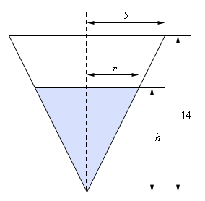

$Given: \frac{dV}{dt}=-2{ft^{3}}/{hr}$ $r_{0}=5ft$ $h=14ft$ $Formula:V=\frac{1}{3}πr^{2}h$

1. At what rate is the depth of the water in the tank changing when the depth of the water is 6 ft.?

$$Find: \frac{dh}{dt} when h=6$$

$$Solution:$$

Step 1: Find r using proportions $\frac{r}{h}=\frac{5}{14}$

$r=\frac{5h}{14}$

Step 2: Substitute known values $V=\left(\frac{1}{3}\right)\left(π\right){\left(\frac{5h}{14}\right)}^{2}h$

$V=\frac{1}{3}\left(π\right)\left(\frac{25h^{3}}{196}\right)$

Step 3: Differentiate the formula $\frac{dV}{dt}=\frac{25π}{588}\left(3h^{2}\right)\frac{dh}{dt}$

Step 4: Find $\frac{dh}{dt}$ $-2=\frac{25π}{196}\left(6^{2}\right)\frac{dh}{dt}$

$\frac{dh}{dt}=-2*{\left(\frac{900π}{196}\right)}^{-1}=-0.1386 ft/hr$

Step 5: Solution The height is decreasing at the rate of 0.1386 ft/hr.

ype eqat h = tute the ula of .a

1. At what rate is the radius of the top of the water in the tank changing when the depth of the water is 6 ft.?

$$Find: \frac{dr}{dt} when h=6$$

$$Solution:$$

Step 1: Find r using proportions $\frac{r}{(6)}=\frac{5}{14}$

$r=\frac{15}{7}$

Step 2: Substitute known values $V=\left(\frac{1}{3}\right)\left(π\right)r^{2}\left(\frac{14r}{5}\right)$

$V=\left(\frac{1}{3}\right)π\left(\frac{14r^{3}}{5}\right)$

Step 3: Differentiate the formula $\frac{dV}{dt}=\frac{14π}{15}*3r^{2\frac{dr}{dt}}$

$\frac{dV}{dt}=\frac{14r^{2}π}{5}\frac{dr}{dt}$

Step 4: Find $\frac{dr}{dt}$ $\frac{dr}{dt}=\left(-2\right)\left(\frac{5}{14r^{2}π}\right)=-\frac{5}{7{\left(15/7\right)}^{2}π}=-0.04951$

Step 5: Solution The radius of the top of the water decreases at the rate of 0.04951 ft/hr.

Example 5: A light is on the top of a 12-ft. tall pole and a 5’6” tall person is walking away from the pole at a rate of 2 ft./sec.

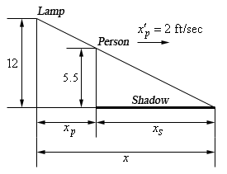

$$Given:y{}_{Lamp}=12,y_{Person}=5.5,\frac{dx_{Person}}{dt}=2ft/sec$$

$$Formula:x=x{}_{p}+x_{s}$$

1. At what rate is the tip of the shadow moving away from the pole when the person is 25 ft. from the pole?

$$Find:\frac{dx}{dt} when x_{p}=25$$

$$Solution:$$

Step 1: Apply proportions to get xs

Step 2: Solve for x­s

Step 3: Apply xs to the equation $x=x_{p}+\frac{11}{13}x_{p}=\frac{24}{13}x_{p}$

Step 4: Differentiate the formula $\frac{dx}{dt}=\frac{24}{13}\frac{dx_{p}}{dt}$

$\frac{dx}{dt}=\frac{24}{13}*2=3.6923 ft/sec$

1. At what rate is the tip of the shadow moving away from the person when the person is 25 ft. from the pole?

$$Find:\frac{dx_{s}}{dt} when x_{p}=25$$

$$Solution:$$

Step 1: Differentiate the formula $\frac{dx}{dt}=\frac{dx_{p}}{dt}+\frac{dx_{s}}{dt}$

Step 2: Substitute known values $3.6923=2+\frac{dx_{s}}{dt}$

$\frac{dx_{s}}{dt}=1.6923$

Step 3: Solution The tip of the shadow is moving away from the person at the rate of 1.6923 ft./sec.