Khyle Calpe

405016683

10/25/2017

Math 31A Lecture Notes: Extreme Values

Definition; *Extrema*: maximum or minimum

Definition; *Extreme Values*: Let f be a function on an interval I and a ϵ I. We say d is the:

* Absolute maximum of f on I if $f\left(a\right)≥f\left(x\right)$ for all $x ϵ I.$
* Absolute minimum of f on I if $f\left(a\right)≤f\left(x\right)$ for all $x ϵ I.$

Counter Examples:

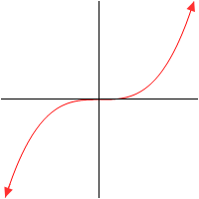 

Has no abs. max. on (a, b) Has no abs. max on [a, b]

Theorem: A continuous function defined in a closed interval has both absolute min and max.

Definition; *Local Extrema*: We say f(c) is a:

* Local max of f at x = c if f(c) is the abs. max of f in some open interval containing c.
* Local min of f at x = c if f(c) is the abs. min of f in some open interval containing c.

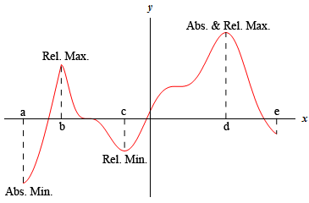

Definition; *Critical Point*: A number c in the domain of f is called critical point if either

$f^{'}\left(c\right)=0$ OR $f^{'}\left(c\right) does not exist$

Example 1: Find critical points of the function $f\left(x\right)=x^{3}-9x^{2}+24x-10$

f is differentiable everywhere, hence the critical points c are solutions to

$$0=f^{'}\left(x\right)=3x^{2}-18x+24=3\left(x-2\right)\left(x-4\right)$$

Hence, f has critical points c = 2, c = 4.

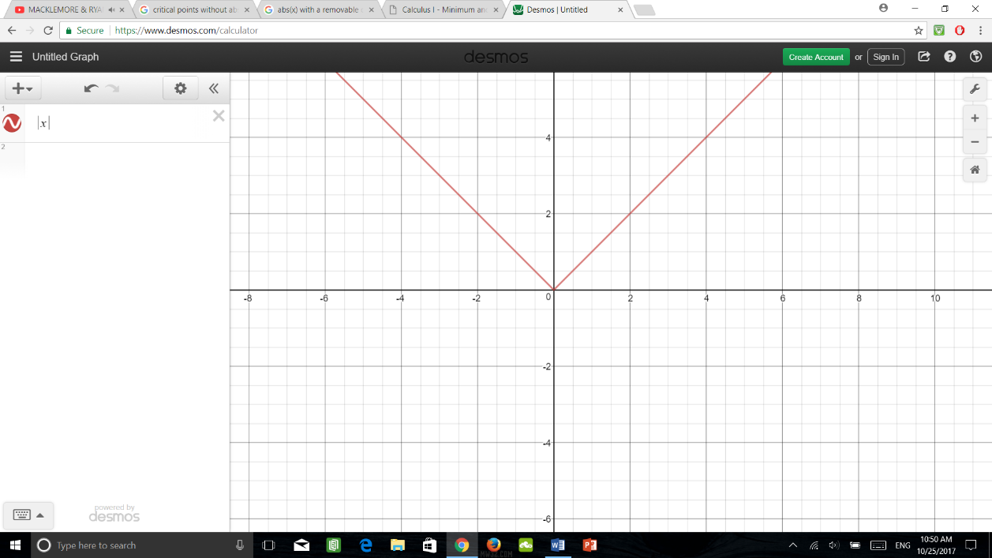Example 2: $f\left(x\right)=\left|x\right|$

$f^{'}\left(x\right)=-1≠0$ if x < 0

$f^{'}\left(x\right)=1≠0$ if x > 0

But $f^{'}\left(c\right)$ does not exist.

Hence, f has critical points c = 0.

Theorem: If f(c) is a local min or max then c is a critical point of f.

Proof: Assume f(c) is a local min.

Case 1: $f^{'}\left(c\right)$ does not exist. Then, c is the critical point by definition of a critical point.

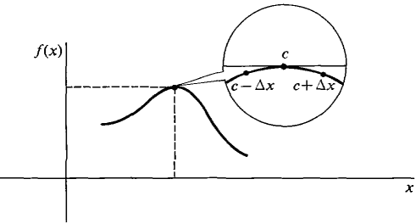Case 2: $f^{'}\left(c\right)$ exists. We have to show $f^{'}\left(c\right)=0$. Since f(c) is a local min, we have $f\left(c\right)≤f\left(c+h\right)$ for h sufficiently small. Hence:

$\frac{f\left(c+h\right)-f\left(c\right)}{h}≥0$ if h > 0

$\frac{f\left(c+h\right)-f\left(c\right)}{h}≤0$ if h < 0

Hence: $f^{'}\left(c\right)=\lim_{h→0^{+}}{\frac{f\left(c+h\right)-f\left(c\right)}{h}}≥\lim_{h→0^{+}}{0=0}$

$$f^{'}\left(c\right)=\lim_{h→0^{-}}{\frac{f\left(c+h\right)-f\left(c\right)}{h}}≥\lim_{h→0^{-}}{0=0}$$

Hence, $f^{'}\left(c\right)=0$ and c is a critical point.

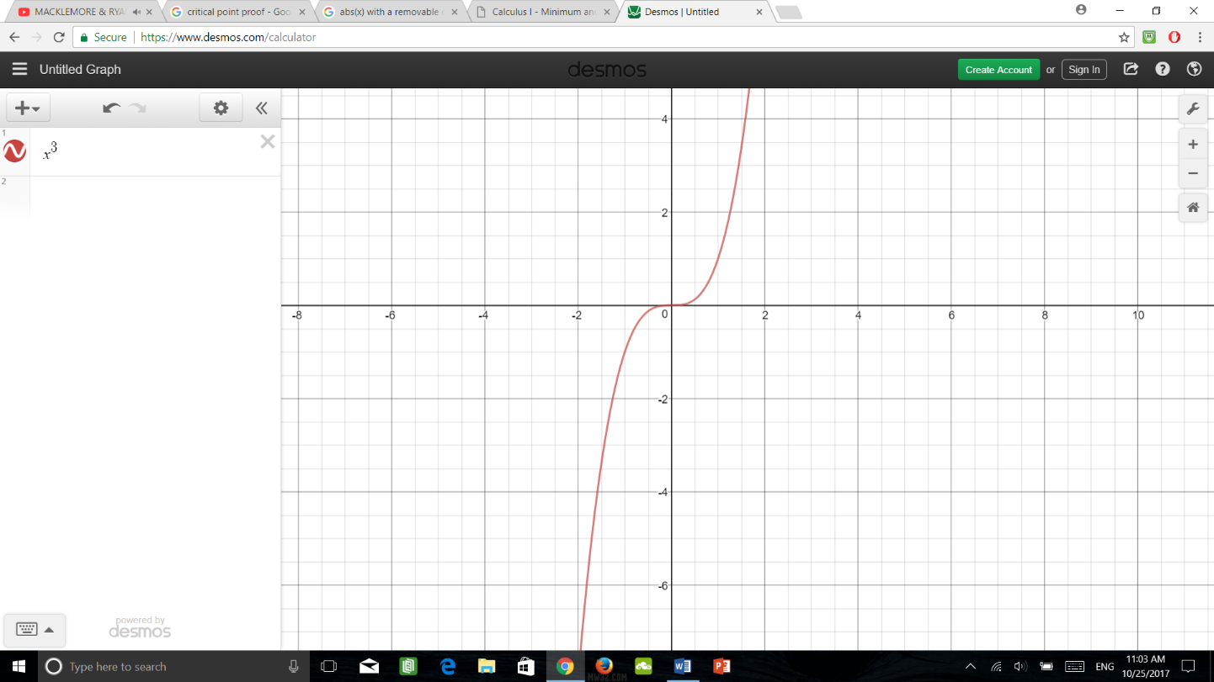Warning: Not all critical points yield a local min or max.

Example 3: $f\left(x\right)=x^{3}$ $f^{'}\left(x\right)=3x^{2}$

Hence, $f^{'}\left(c\right)=0$ and c is a critical point.