Khyle Calpe

405016683

10/25/2017

Math 31A Lecture Notes: Linear Approximation

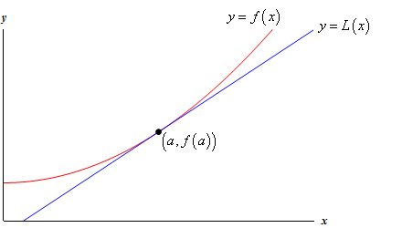

$$f^{'}\left(a\right)=\lim_{x→a}{\frac{f\left(x\right)-f\left(a\right)}{x-a}}$$

$For x close to a:$ $f^{'}\left(a\right)≈\frac{f\left(x\right)-f\left(a\right)}{x-a}$

$f\left(x\right)≈f\left(a\right)+f^{'}\left(a\right)\left(x-a\right)$

Definition; *Linear approximation of f at a*: Assume f(x) is differentiable at x = c, then

$$L\left(x\right)=f\left(a\right)+f^{'}\left(a\right)\left(x-a\right)$$

How far is $L\left(a+∆x\right)$ from $f\left(a+∆x\right)?$

\*How large is the error between the approximation and the tangent line?

$E\left(∆x\right)=\left|f\left(a+∆x\right)-L\left(a+∆x\right)\right|$

Theorem: $E\left(∆x\right)≤\frac{1}{2}K{\left(∆x\right)}^{2}$

K = maximum value of $\left|f"(x)\right|$ in the interval [a, a + Δx]

Assume that f is twice differentiable.

Hence, E is small if $f"(x)$ is small

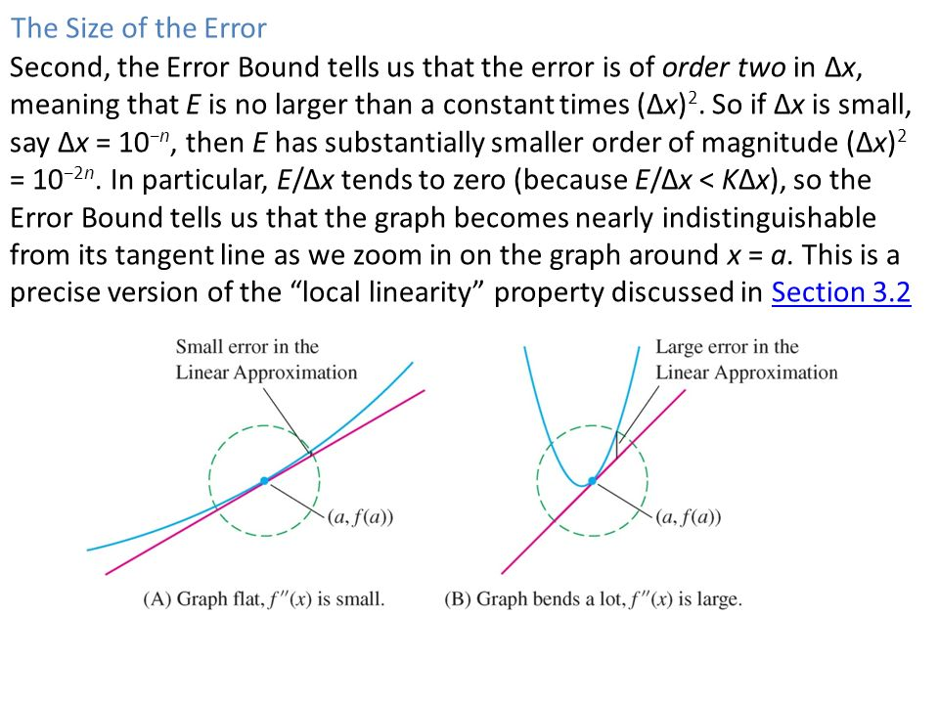

Correlation:

If $f"=0$ on an interval [a, b] the f = L on [a, b] and if, furthermore, $f^{'}\left(x\right)=0$ on [a, b], then f is constant.

Aside:

$f\left(x\right)≈f\left(a\right)+f^{'}\left(a\right)\left(x-a\right)$

$+ \frac{1}{2}f"(a)(x-a)^2$

$+\frac{1}{6}f^{'''}\left(a\right){\left(x-a\right)}^{3}$

.....

$+\frac{1}{n!}f^{\left(n\right)}{\left(x-a\right)}^{\left(m\right)}$ $E=\frac{1}{\left(n+1\right)!}K{\left(∆x\right)}^{m+1}$

\*