Khyle Calpe

405016683

10/27/2017

Math 31A Lecture Notes: Critical Points

Definition; *A critical point c of function f*: either:

* $f^{'}\left(c\right)$ does not exist

$f^{'}\left(c\right)=0$

Theorem: If f(c) is a local min/max of f, then c is a critical point.

Theorem: Assume f is continuous on an interval [a, b] and f(c) is the absolute minimum or maximum of f on [a, b]. Then, c is either:

* A critical point

$c=a or c=b$

Example 1: Find the extrema of f on [0, 6]; $f\left(x\right)=2x^{3}-15x^{2}+24x+7$

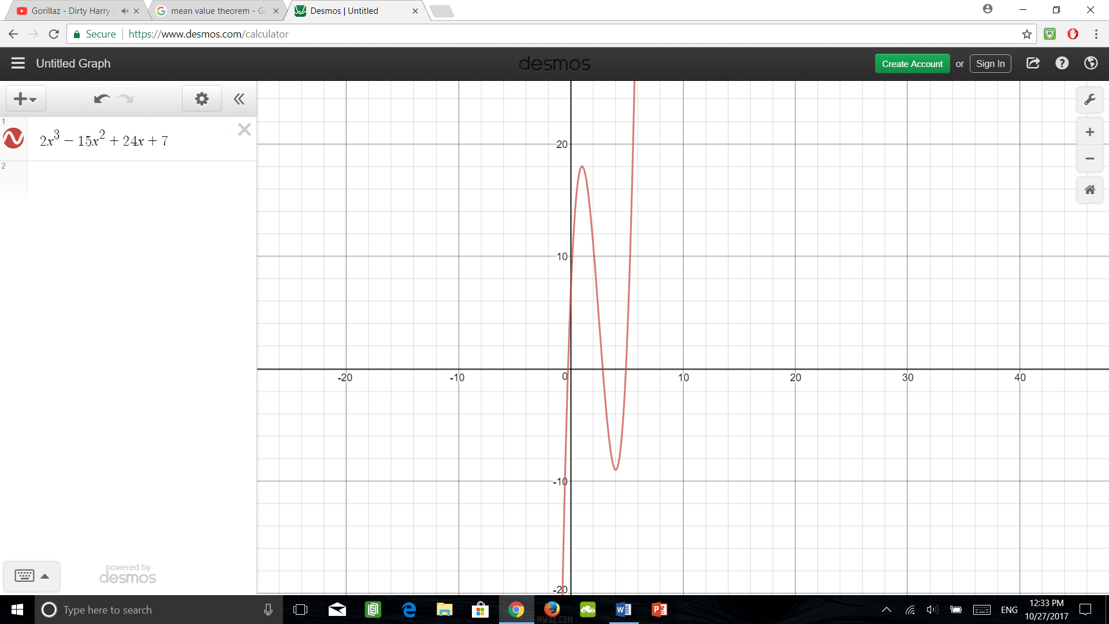

$f^{'}\left(x\right)=6x^{2}-30x+24$

$f^{'}\left(x\right)=6\left(x-1\right)\left(x-4\right)$

Critical points: c = 1 and c = 4

|  |  |
| --- | --- |
| x | f(x) |
| 1 (critical point) | 18 |
| 4 (critical point) | -9 |
| 0 (end point) | 7 |
| 6 (end point) | 43 |

Example 2: Find the extrema of f on [-1, 2]; $f\left(x\right)=1-{\left(x-1\right)}^{2/3}$

$f^{'}\left(x\right)=-\frac{2}{3}{\left(x-1\right)}^{\left(-1/3\right)}=-\frac{2}{3{\left(x-1\right)}^{\left(1/3\right)}}$

Critical points: c = 1

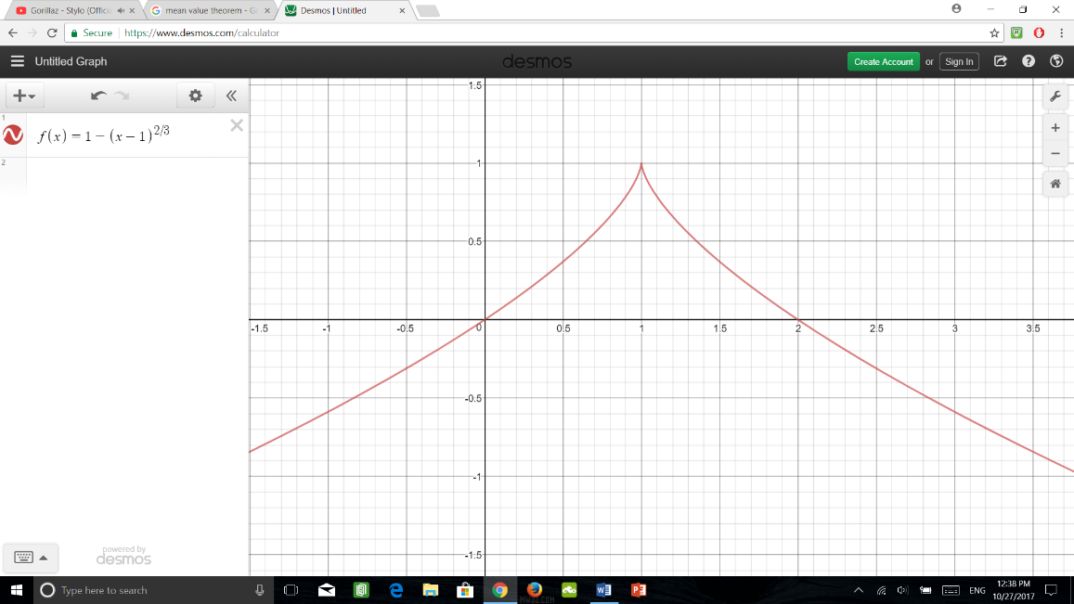

|  |  |
| --- | --- |
| x | f(x) |
| 1 (critical point) | 1 (max) |
| -1 (end point) | -0.59 (min) |
| 2 (end point) | 0 |

Example 3: Find the extreme values of $f\left(x\right)=\frac{x}{x^{2}+5}$ on [4, 8]

$$f^{'}\left(x\right)=\frac{\left(x\right)'\left(x^{2}+5\right)-\left(x\right){\left(x^{2}+5\right)}^{'}}{{\left(x^{2}+5\right)}^{2}}$$

$f^{'}\left(x\right)=\frac{5-x^{2}}{{\left(x^{2}+5\right)}^{2}}$

Critical points: $c=±\sqrt{5}$

Critical points are outside of the interval.

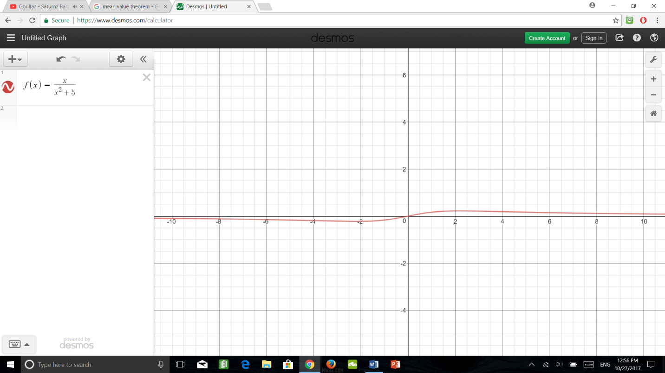

|  |  |
| --- | --- |
| x | f(x) |
| 4 | 4/21 (min) |
| 8 | 8/69 (max) |

Example 4: Find the min/max of $f\left(x\right)=\sin\left(x\right)+\cos^{2}\left(x\right)$ on [0, 2 $π$]

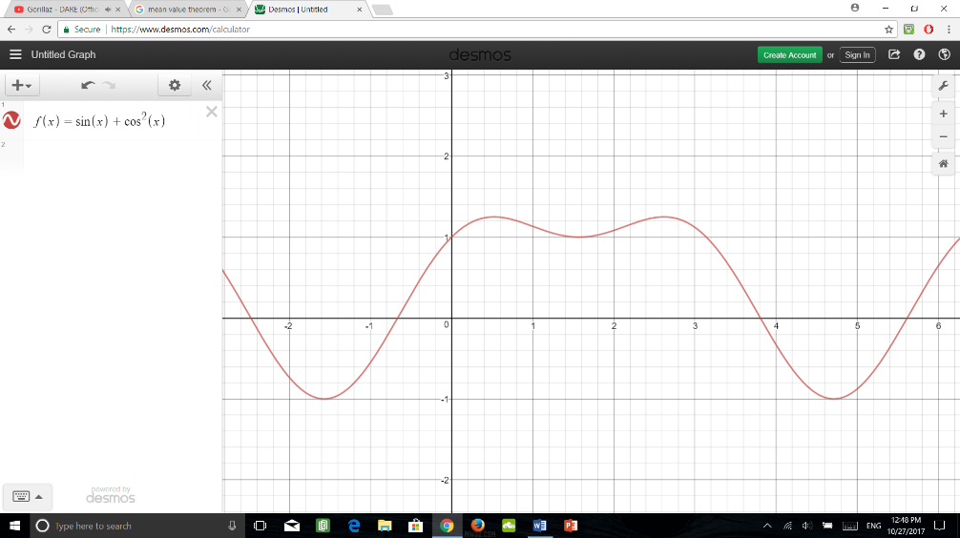 $f^{'}\left(x\right)=\cos\left(x\right)-2\sin\left(x\right)\cos\left(x\right)$

$0=\cos\left(x\right)\left(1-2sinc\left(x\right)\right)$

$x=\frac{π}{2},\frac{3π}{2}$ OR $x=\frac{π}{6},\frac{5π}{6}$

|  |  |
| --- | --- |
| x | f(x) |
| $$π/2$$ | 1 |
| $$3π/2$$ | -1 |
| $$π/6$$ | 5/4 |
| $$5π/6$$ | 5/4 |
| 0 | 1 |
| 1 | 1 |

Theorem; *The Mean Value Theorem*: Assume f is continuous in [a, b] and differentiable in (a, b). Then, there is at least one $c∈\left(a,b\right)$ such that:

$$f^{'}\left(c\right)=\frac{f\left(b\right)-f\left(a\right)}{b-a}>f\left(b\right)-f\left(a\right)=f^{'}\left(c\right)\left(b-a\right)$$

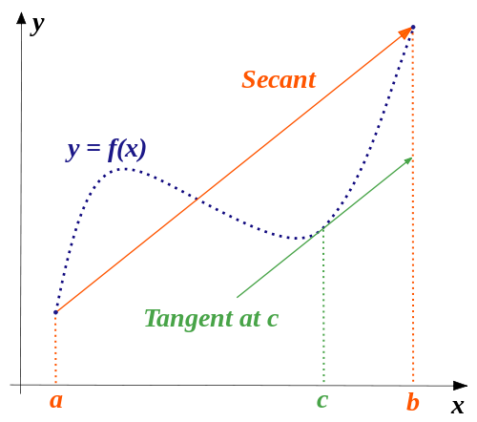

Clarification: Imagine a car with an average speed of 70 mph. In order to reach the average speed of 70 mph, the car must reach two speeds: one more than 70 mph, one less than 70 mph.

Definition; *Increasing and Decreasing Functions*:

A function f is:

* Increasing on (a, b) if f(x1) < f(x2) for x1 < x­2 at x1, x2 ϵ (a, b)
* Decreasing on (a, b) if f(x1) > f(x2) for x1 < x­2 at x1, x2 ϵ (a, b)

Definition; *Monotonic function*: f is monotonic on (a, b) if f is either inc. or dec. on (a, b).

Theorem: f is differentiable on (a, b) if:

* $f^{'}\left(x\right)>0 ∀ x∈\left(a,b\right)$ then f is increasing on (a, b).
* $f^{'}\left(x\right)<0 ∀ x∈\left(a,b\right)$ then f is decreasing on (a, b).

Proof: Let $f^{'}\left(x\right)>0 ∀ x∈\left(a,b\right)$

MVT (mean value theorem) gives us for any x1 < x­2

s.t.

> 0 > 0

Hence,