Khyle Calpe

405016683

10/31/2017

Math 31A Lecture Notes: Mins and Maxes

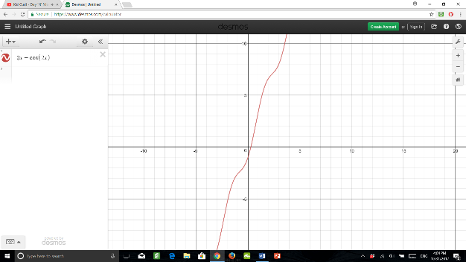Example 1: Show that is increasing

Solution: since

Hence, f(x) is increasing.

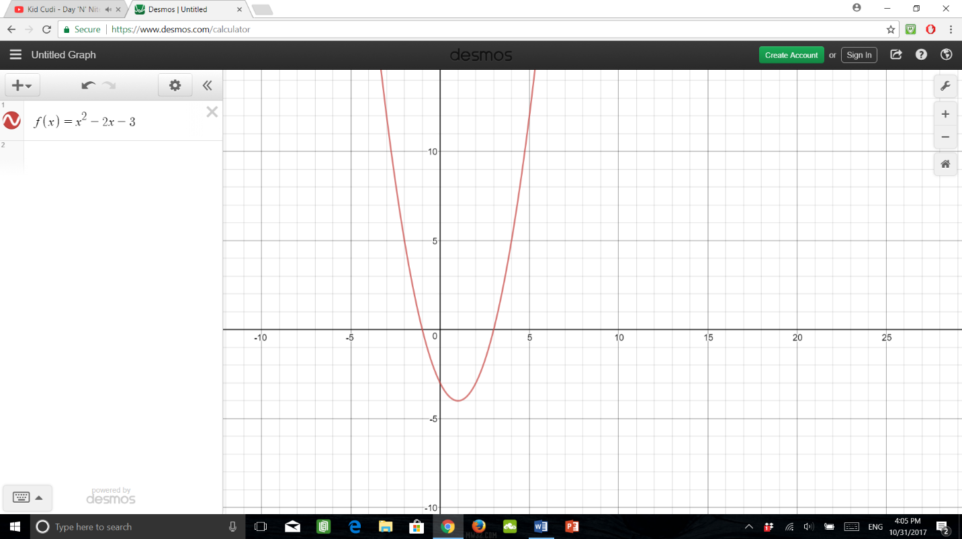Example 2: Find the intervals where f(x) is increasing/decreasing.

Solution:

for x > 1

for x = 0

for x < 1

Hence: f is increasing on (1, ∞)

f is decreasing on (-∞, 1)

|  |
| --- |
| Critical point + Sign change of = local minimum/maximum |

Theorem: let c be a critical point of a function f. Then:

* changes sign from + to – of c => f(c) is a local max
* changes sign from – to + of c => f(c) is a local min

Example 3: 1) 2)

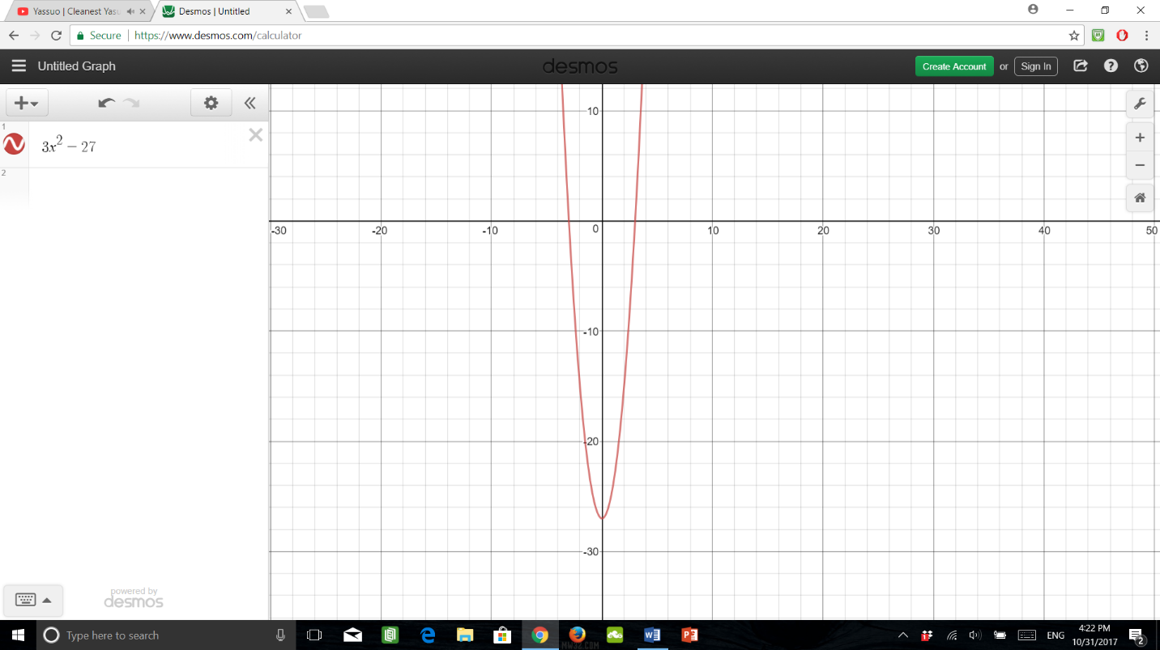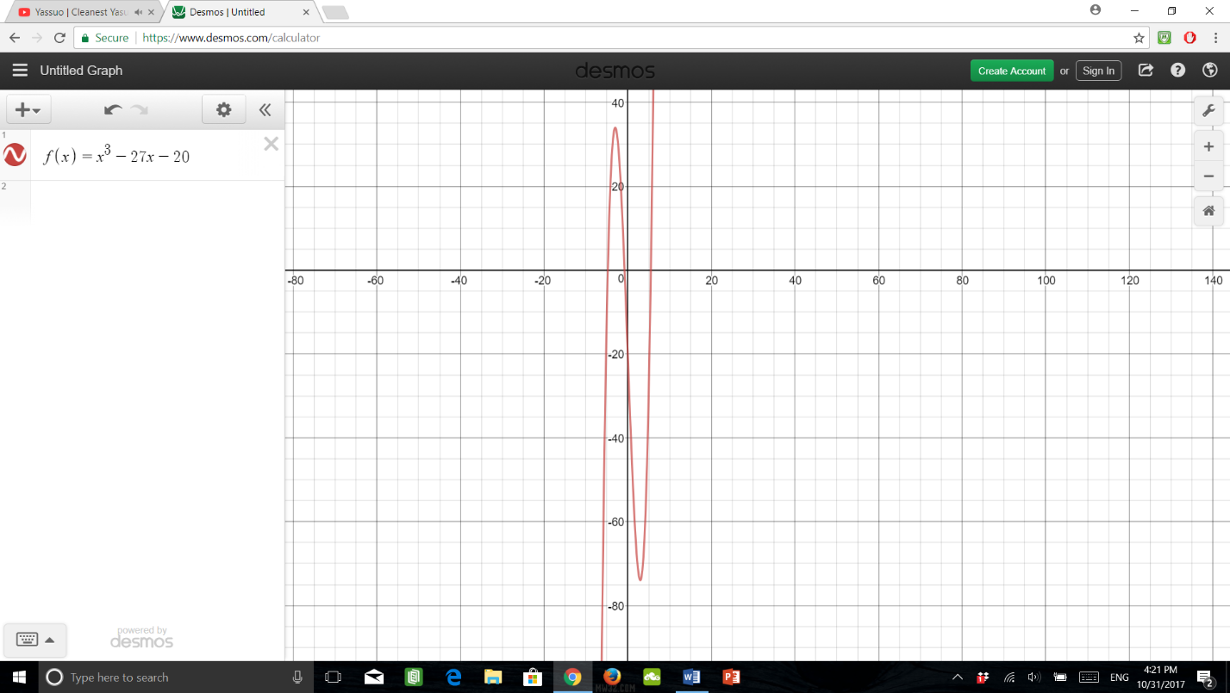

The graph of shows a local max exists at x = -3 and a local min exists at x = 3

The graph of shows at x = -3 and x = 3. This proves the local extrema.

How to solve for mins/maxes

Step 1: Find critical points

Step 2: Determine the signs of between critical points

Step 3: Analyze the behavior of and the signs of

Example 4: Find local min/max of

Critical Points: c = -3 and c = 3

is a local maximum since c = -3 is a critical point and changes signs from + to –

is a local maximum since c = 3 is a critical point and changes signs from – to +

Example 5: Find the critical points and intervals where f is increasing/decreasing for:

in

if or

Critical Points:

Intervals:

|  |  |  |  |
| --- | --- | --- | --- |
| Intervals | Test Values | Signs of | Behavior of |
|  |  | + |  |
|  |  | - |  |
|  |  | + |  |
|  |  | - |  |

Example 6: Find local min/max of

No sign change occurs at c = 1. Hence, there is no local min/max of f.

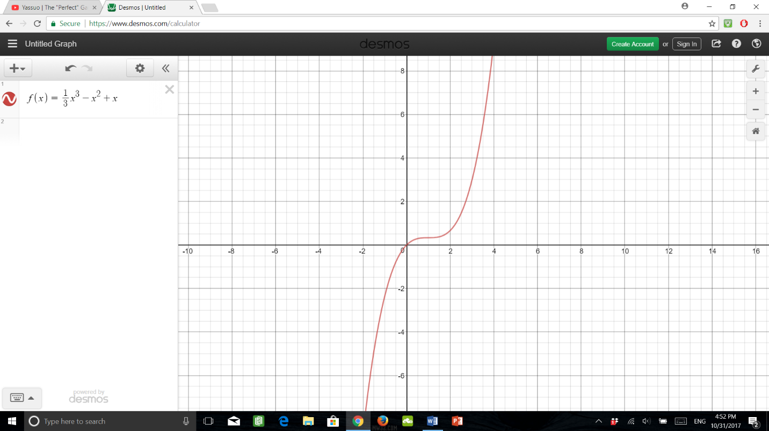

Example 7: Find local min/max of

Hence, the only critical point is c = 1 since does not exist.

For x < 1 is –

x > 1 is +

Hence, change at c = 1and is a local minimum.

