Khyle Calpe

405016683

11/1/2017

Math 31A Lecture Notes: Concavity

Review:

$f^{'}\left(x\right)>0$ on (a, b) $⇒$ is increasing on (a, b)

$f^{'}\left(x\right)=0$ on (a, b) $⇒$ is a critical point

$f^{'}\left(x\right)<0$ on (a, b) $⇒$ is decreasing on (a, b)

Theorem 1; *First derivative test*:

* c is a critical point of $f$ and $f^{'}$ changes sign from + to – $⇒$ $f\left(c\right)$ is a local maximum
* c is a critical point of $f$ and $f^{'}$ changes sign from – to + $⇒$ $f\left(c\right)$ is a local minimum

Definition; *Global min/max*:

If $f\left(c\right)$ is a global max/min on [a, b], then c is either a critical point or $c = a$ or $c = b$.

Concavity

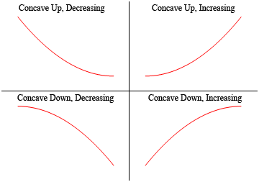

Definition; *Concavity*: Let $f$ be differentiable on (a, b)

* $f$ is concave up if $f^{'}$ is increasing on (a, b)
* $f$ is concave down if $f^{'}$ is decreasing on (a, b)

Theorem 1; *The Test for Concavity*: Assume $f"$ exists on (a, b)

* If $f">0$ for $x∈\left(a,b\right)$, then $f$ is concave up on (a, b)
* If $f"<0$ for $x∈\left(a,b\right)$, then $f$ is concave down on (a, b)

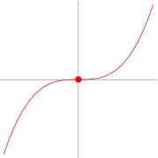Definition; *Point of Inflection*: $P=\left(c,f\left(c\right)\right)$ is a point of inflection of $f$ if the concavity of $f$ changes at $x=c$.

Theorem 2; *Test for Inflection Points*: If $f”(c)=0$ or $f”(c)$ does not exist and $f”(x)$ changes sign at $x=c$, then $f$ has a point of inflection at $x=c$.

Example 1: Points of inflection and concavity of $f\left(x\right)=\cos\left(x\right)$ on $\left[0,2π\right]$

$f=\cos\left(x\right)$ $f"=-cos(x)$

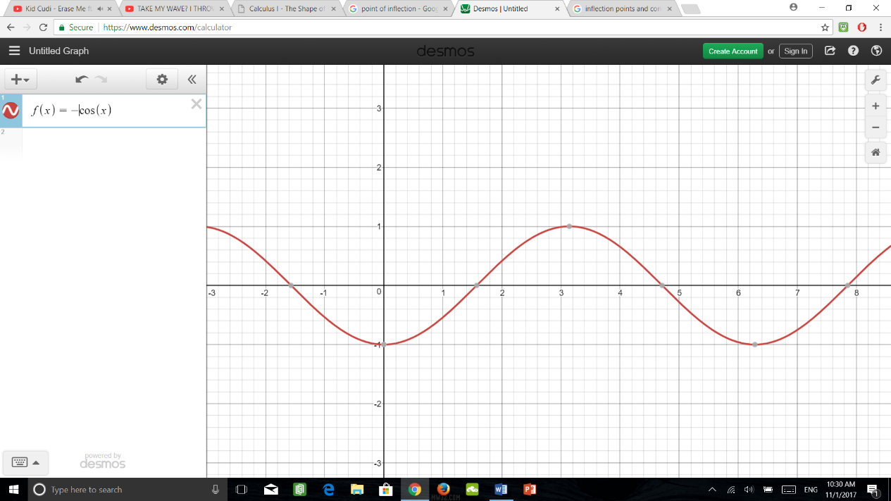

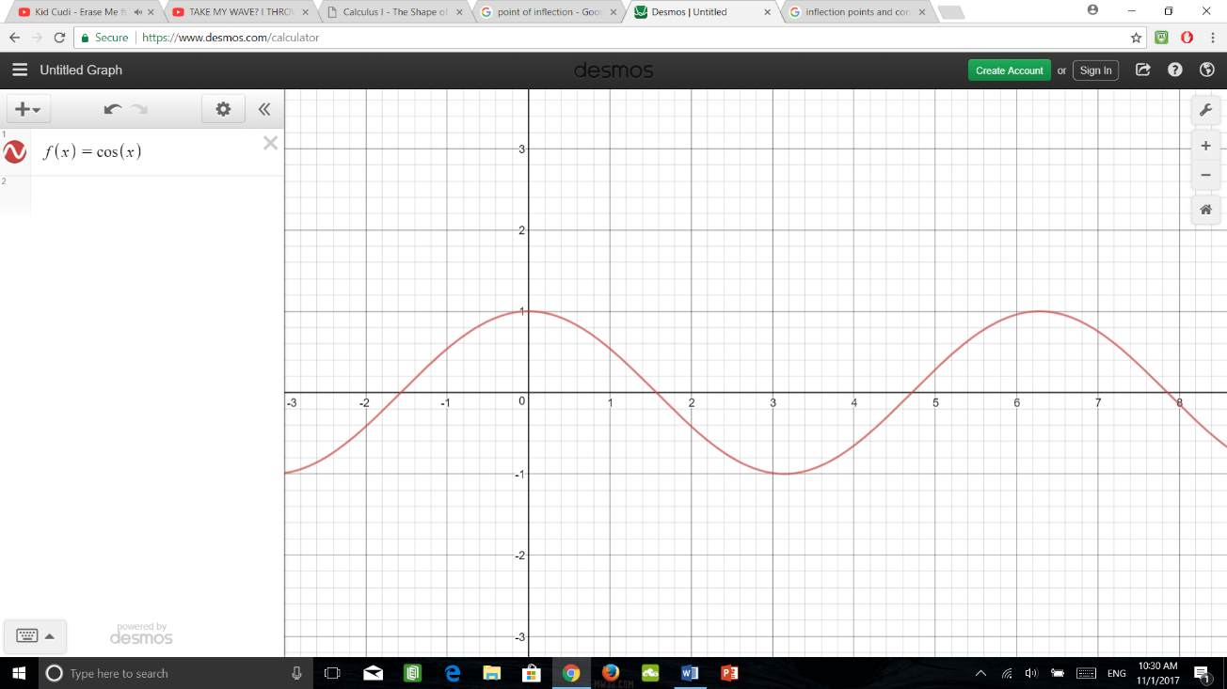

Concave down: $\left(0,\frac{π}{2}\right)\left(\frac{3π}{2},2π\right)$ $f"(x)<0$: $\left(0,\frac{π}{2}\right)\left(\frac{3π}{2},2π\right)$

Points of inflection: $\frac{π}{2},\frac{3π}{2}$ $f"(x)=0$: $\frac{π}{2},\frac{3π}{2}$

Concave up: $\left(\frac{π}{2},\frac{3π}{2}\right)$ $f"(x)>0$: $\left(\frac{π}{2},\frac{3π}{2}\right)$

Example 2: Find points of inflection of $f$ and determine the intervals of concavity

$f\left(x\right)=3x^{5}-5x^{4}+1$

Step 1: Solve $f"(x)=0$ $f^{'}\left(x\right)=15x^{4}-20x^{3}$

$f"\left(x\right)=60x^{3}-60x^{2}$

Hence, $f"(c)=0$ for $c=0$ and $c=1$

Step 2: Determine sign of $f"(x)$

|  |  |  |  |  |
| --- | --- | --- | --- | --- |
| Interval | Test Value | Sign of $f"(x)$ | Behavior of $f$ | Concavity |
|  |  | - | Image result for 2nd derivative concavity | Concave down |
|  |  | - | Image result for 2nd derivative concavity | Concave down |
|  |  | + | Image result for 2nd derivative concavity | Concave up |

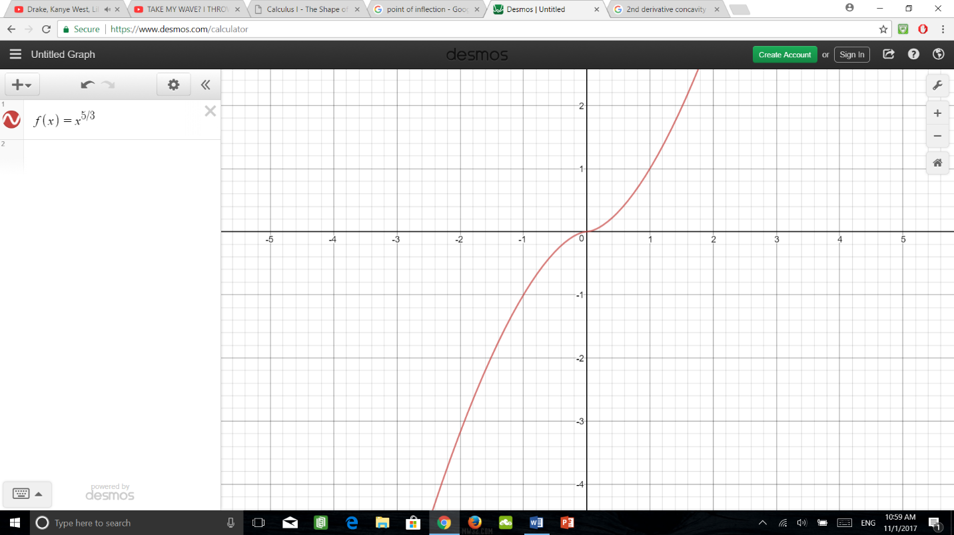Example 3: Find the points of inflection of $f\left(x\right)=x^{5/3}$

$f^{'}\left(x\right)=\frac{5}{3}x^{2/3}$ $f"\left(x\right)=\frac{10}{9x^{1/3}}$

$$f"\left(x\right)=\frac{10}{{9x}^{1/3}}=\left\{\begin{aligned}<0 for x>0 \\ >0 for x<0\end{aligned}\right.$$

Hence, by the test for inflection points, $c=0$ is an inflection point of $f$