Khyle Calpe

405016683

11/6/2017

Math 31A Lecture Notes: Graphing

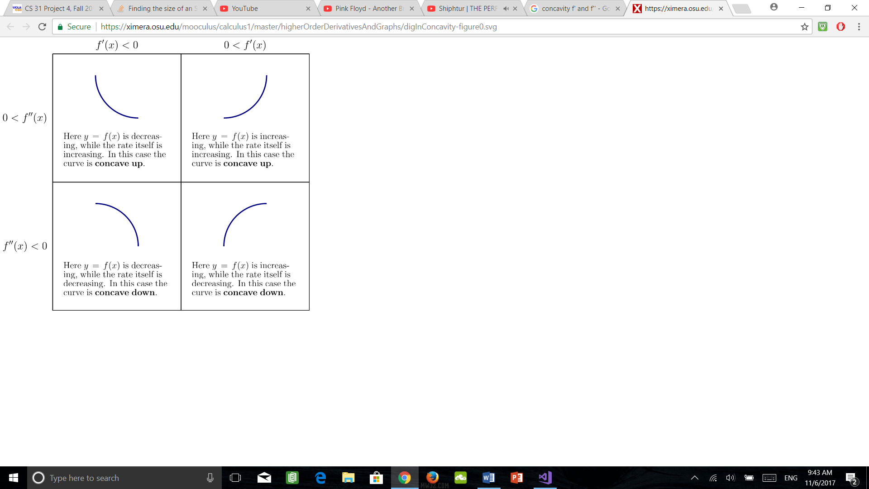

Example 1: Sketch $f\left(x\right)=3x^{4}-8x^{3}+6x^{2}+1$

Step 1: Determine the signs of $f^{'}$ and $f"$

$$f^{'}=12x^{3}-24x^{2}+12x=12{\left(x-1\right)}^{2}⇒x=0,1$$

$$f'^{'}=36x^{2}-48x+12=12\left(x-1\right)\left(3x-1\right)=0⇒x=1,\frac{1}{3}$$

|  |  |  |  |  |  |
| --- | --- | --- | --- | --- | --- |
| Interval | Test values | Sign of $f^{'}$ | Interval | Test values | Sign of $f'^{'}$ |
| $$\left(-∞,0\right)$$ | $$f^{'}\left(-1\right)=48$$ | - | $$\left(-∞,\frac{1}{3}\right)$$ | $$f'^{'}\left(0\right)=12$$ | + |
| $$\left(0,1\right)$$ | $$f^{'}\left(\frac{1}{2}\right)=\frac{3}{2}$$ | + | $$\left(\frac{1}{3},1\right)$$ | $$f'^{'}\left(\frac{1}{2}\right)=-3$$ | - |
| $$\left(1,∞\right)$$ | $$f^{'}\left(2\right)=24$$ | + | $$\left(1,∞\right)$$ | $$f'^{'}\left(2\right)=60$$ | + |

Step 2: Note transition points and sign combinations

|  |  |  |  |
| --- | --- | --- | --- |
|  |  |  |  |
|  |  | |  |

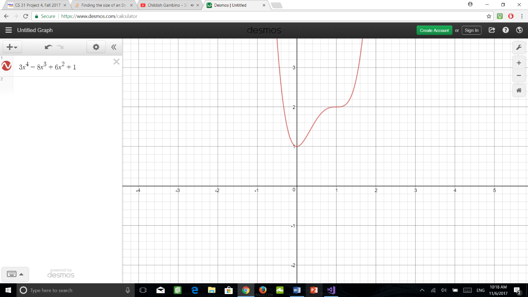

: local max $f\left(0\right)=1$

$c=1/3$: point of inflection $f\left(\frac{1}{3}\right)=\frac{38}{27}$

$c=1$: point of inflection $f\left(1\right)=2$

Step 3: Figure out $f\left(x\right)$ leading term

$$3x^{4}$$

$$f\left(x\right)→∞$$

$$x→±∞$$

Example 2: Sketch graph of $\frac{1}{x^{2}-1}$

Step 0: Determine domain of the function

$f\left(x\right)$ is not defined for $x=1$, $x=-1$

Analyze $f$ on $\left(-∞,-1\right),\left(-1,1\right),\left(1,∞\right)$ separately

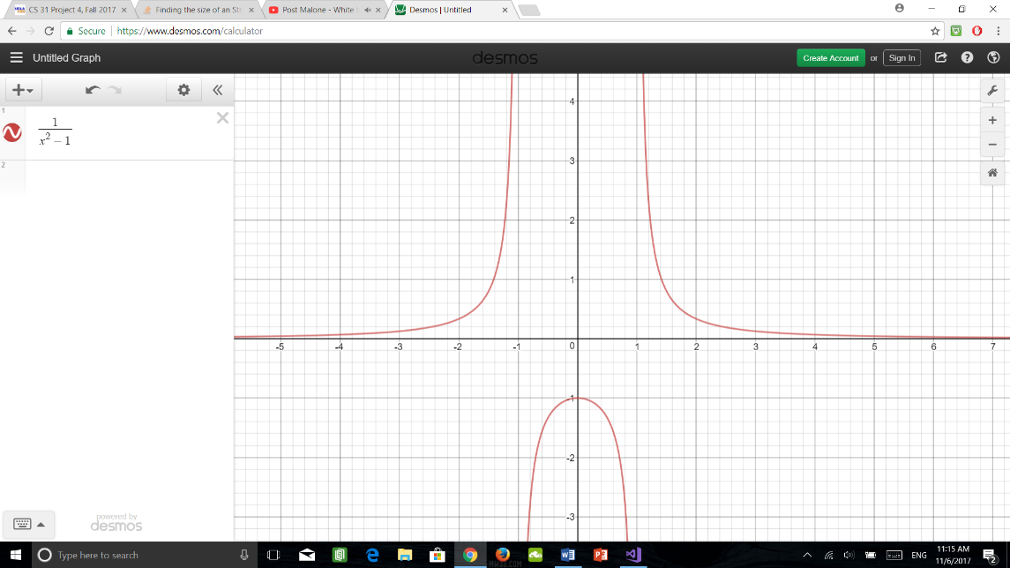Step 1: $f^{'}\left(x\right)=\frac{-2x}{{\left(x^{2}-1\right)}^{2}}$ $f'^{'}\left(x\right)=\frac{6x^{2}+2}{{\left(x^{2}-1\right)}^{3}}$

For $x≠±1$, the denominator of $f^{'}$ is positive

$\left.{f^{'}\left(x\right)>0 for x<0 \atop f^{'}\left(x\right)<0 for x>0}\right\}⇒x=0$ is a local max

$f'^{'}\left(x\right)>0$ for $x<-1$ or $x>1$

$f'^{'}\left(x\right)<0$ for $-1<x<1$

Step 2: Note transition points and sign combinations

|  |  |  |  |
| --- | --- | --- | --- |
|  |  |  |  |
|  |  | |  |

Step 3: Asymptotic behavior

$\lim_{x→±∞}{f\left(x\right)=0}$ ${f\left(x\right)<0 \atop f\left(x\right)>0}$ ${-1 < x < 1 \atop x>1, x<-1}$