Khyle Calpe

405016683

11/17/2017

Math 31A Lecture Notes: Riemann Sums

Area: Distance traveled = velocity * time lapsed (constant velocity)

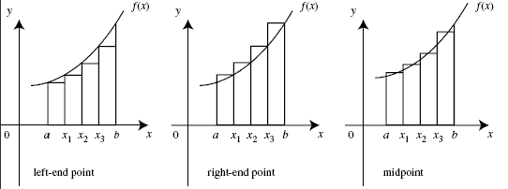

Let $f(x)$ be a positive continuous function on an interval $[a, b]$.

Goal: Compute area under the graph of $f(x)$ on $[a, b]$

Method: Approximate by rectangles and taking the limit

Subdivide $[a, b]$ into $n$ equally long intervals:

$∆x=\frac{b-a}{n}$

$x_{0}=a+∆x=a$, $x_{1}a+1∆x=a+1∆x$... $x_{n}=a+n∆x=b$

Approximate area under graph, by rectangles whose height is given by the value of $f(x)$

at the right endpoint.

Calculate area of rectangles:

$R_{n}=∆xf\left(x_{1}\right)+∆xf\left(x_{2}\right)+…+∆xf\left(x_{n}\right)=∆x\left(f\left(x_{1}\right)+f\left(x_{2}\right)+…+f\left(x_{n}\right)\right)$

This is called the nth right endpoint approximation of the area under the graph of $f(x)$

on $[a, b]$

Example 1: Compute ${R_{}}_{n}$ for $f(x)=x^2$ on the interval $[1,3]$

S1: Setup $∆x=\frac{3-1}{4}=\frac{1}{2}$ $x_{0}=\frac{2}{2},x_{1}=\frac{3}{2},x_{2}=\frac{4}{2},x_{3}=\frac{5}{2},x_{4}=\frac{6}{2}$

S2: Compute $R_{n}=∆x\left(f\left(x_{0}\right)+f\left(x_{1}\right)+f\left(x_{2}\right)+f\left(x_{3}\right)+f\left(x_{4}\right)\right)$

$R_{n}=∆x\left({\left(1\right)}^{2}+{\left(\frac{3}{2}\right)}^{2}+{\left(2\right)}^{2}+{\left(\frac{5}{2}\right)}^{2}+{\left(3\right)}^{2}\right)$

$R_{n}=10.75$

Summation notation:

Let $a_{m},a_{m+1},…,a_{n}$ be real numbers such that $\left(m≤n\right)$

$$\sum_{i=m}^{n}{a_{i}}=a_{m}+a_{m+1}+a_{m+2}+…+a_{n}$$

“Sum over $a_{i}$ from $i$ equals $m$ to $n$”

Properties of Summation

j _jies of Summaann ea under the graph of f()se height iThree common types of Riemann Sums

