Khyle Calpe

405016683

11/20/2017

Math 31A Lecture Notes: Summation

$f$ on an interval $\left[a,b\right]$ $L=\lim_{x→∞}{R_{n}}=\lim_{x→∞}L_{n}=\lim_{x→∞}M_{n}$

$x_{i}=a+∆x$, $∆x=\frac{b-a}{n}$ $L=$“area under the graph of $f$”

$R_{n}=∆x\sum_{i=1}^{n}{f\left(x_{i}\right)}$

$L_{n}=∆x\sum_{i=0}^{n-1}{f\left(x_{i}\right)}$

$M_{n}=∆x\sum_{i=0}^{n+1}{\left(\frac{x_{i}+x_{i+1}}{2}\right)}$

Sum formulas

$\sum_{j=1}^{n}{j}=1+2+3+…+n=\frac{n\left(n+1\right)}{2}$

$\sum_{j=1}^{n}{j^{2}}=1^{2}+2^{2}+3^{2}+…+n^{2}=\frac{n\left(2n+1\right)\left(n+1\right)}{6}$

$\sum_{j=1}^{n}{j^{3}}=1^{3}+2^{3}+3^{2}+…+n^{3}=\frac{n^{2}{\left(n+1\right)}^{2}}{4}$

Example 1: Compute the area $L$ under the graph of $f(x)=x$ on $[0,4]$

Solution: $L=0.5*4*4=8$

Using $R_{n}$: $∆x=\frac{b-a}{n}=\frac{4}{n}$ $x_{i}=a_{i}+∆x=\frac{4i}{n}$ $f\left(x_{i}\right)=\frac{4i}{n}$

$R_{n}=\frac{4}{n}\sum_{i=1}^{n}{\frac{4i}{n}}=\frac{16}{n^{2}}\sum_{i=1}^{n}{i}$

$R_{n}=\frac{16}{n^{2}}\left(\frac{n\left(n+1\right)}{2}\right)=\frac{16n^{2}+16n}{2n^{2}}=8+\frac{8}{n}$

$\lim_{n→∞}{R_{n}=8}$

Example 2: Prove that the area under the graph of $f\left(x\right)=x^{2}$ on $\left[0,b\right]$ is $\frac{b^{3}}{3}$

Solution: $R_{n}=\frac{b}{n}\sum_{j=1}^{n}{{\left(\frac{bj}{n}\right)}^{2}}={\left(\frac{b}{n}\right)}^{3}\sum_{j=1}^{n}{j^{2}}$

$R_{n}={\left(\frac{b}{n}\right)}^{3}\left(\frac{n\left(2n+1\right)\left(n+1\right)}{6}\right)=\frac{b^{3}\left({2n}^{2}+3n+1\right)}{6n^{2}}=\frac{2b^{3}n^{2}}{6n^{2}}+\frac{3b^{3}n}{6n^{2}}+\frac{b^{3}}{6n^{2}}$

$R_{n}=\frac{b^{3}}{3}+\frac{b^{3}}{2n}+\frac{b^{3}}{6n^{2}}$

$L$ = area of graph of $f$ on $\left[0,b\right]=\lim_{n→∞}{R_{n}}=\frac{b^{3}}{3}$

Partition: $f$ on an interval $[a,b]$. Partition of size $n$ is a choice of point subdividing $[a,b]$ into $n$ subintervals.

$$a=x_{0}<x_{1}<…<x_{n-1}<x_{n}=b$$

Sample points: $C={\{C}_{1},…,C_{n}\}$ where $C_{i}∈\left[x_{i-1},x_{i}\right]$

$C_{n}$\* is between two $x$ points $\left(x_{n-1},x_{n}\right)$

Define: $∆x_{i}=x_{i}-x_{i-1}=$ length of the interval $\left[x_{i-1},x_{i}\right]$

$\left|\left|P\right|\right|=$“nom of P” = maximum of $∆x_{i}$

Riemann Sum: R takes in three arguments; f, P, and C. f stands for the function. P stands for the partition, which is the space between each x coordinate. C stands for the points between each x coordinates to be evaluated for each partition.

$$R\left(f,P,C\right)=\sum_{i=1}^{n}{f\left(c_{i}\right)∆x_{i}}$$

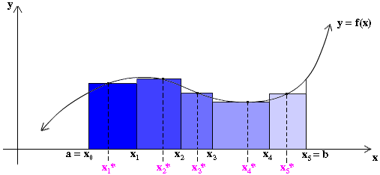

\* In this graph, $x_{n}^{*}$ is equivalent to $C{}_{n}$

Definition:

$f$ is integrable on $\left[a,b\right]$ if all Riemann sums approach the same limit. $L$ as $\left|\left|P\right|\right|→0$. The definite integral of $f$ over $[a,b]$ is defined by:

$$\int_{a}^{b}{f\left(x\right)dx}=\lim_{\left|\left|P\right|\right|→0}{R\left(f,P,C\right)}$$

$$\int_{a}^{b}{f\left(x\right)dx}=\lim_{\left|\left|P\right|\right|→0}{\sum_{i=1}^{n}{f\left(c_{i}\right)∆x_{i}}}$$

Theorem: If $f$ is continuous on $[a,b]$ or continuous up to finitely many jump discontinuities, then $f$ is integrable on $[a,b]$.

Definite Integral: “signed area of $f$”

: (area around above the x-axis) – (area under the x-axis)

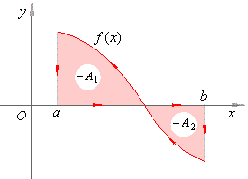

Example 3: Calculate $\int_{-1}^{1}{xdx}$ and $\int_{-1}^{1}{\left|x\right|dx}$

Solution: $\int_{-1}^{1}{xdx}=\frac{1}{2}-\frac{1}{2}=0$

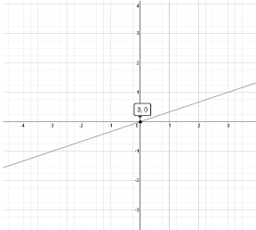

$\int_{-1}^{1}{\left|x\right|dx}=\frac{1}{2}+\frac{1}{2}=1$

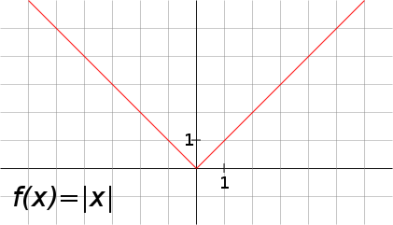

Properties of Definite Integrals

Theorem; Constant Rule:

$$\int_{c}^{b}{Cdx}=\left(b-a\right)C$$