Khyle Calpe

405016683

12/1/2017

Math 31A Lecture Notes: Area between Curves

$\int{f}\left(u\left(x\right)\right)u^{'}\left(x\right)dx$ $=$ $F\left(u\left(x\right)\right)+c$ when $F^{'}=f$

$\int{f\left(u\right)du}$ $=$ $F\left(u\left(x\right)\right)+c$

$\int_{a}^{b}{f\left(u\left(x\right)\right)u^{'}\left(x\right)dx}$ $=$ $\int_{u\left(a\right)}^{u\left(b\right)}{f\left(u\right)}du$

Example 1: Evaluate $\int_{0}^{2}{x^{2}\sqrt{x^{3}+1}}dx$

$u=x^{3}+1$ $du=3x^{2}dx⇔\frac{1}{3}du=x^{2}dx$

$u\left(0\right)=1$ $u\left(2\right)=9$

$$\int_{0}^{2}{x^{2}\sqrt{x^{3}+1}}dx=\frac{1}{3}\int_{1}^{9}{\sqrt{u}}du=\frac{1}{3}*\frac{2}{3}*u|_{1}^{9}=\frac{2}{9}\left(9^{3/2}-1^{3/2}\right)=\frac{52}{9}$$

Example 2: Calculate the area under the graph of $y=\frac{x}{{\left(x^{2}+1\right)}^{2}}$ over $\left[1,3\right]$

$u=x^{2}+1$ $du=2xdx⇔\frac{1}{2}du=xdx$

$u\left(1\right)=2$ $u\left(3\right)=10$

$$\int_{1}^{3}{\frac{x}{{\left(x^{2}+1\right)}^{2}}}dx=\frac{1}{2}\int_{2}^{10}{\frac{1}{u^{2}}}du=\frac{1}{2}*-u^{-1}|_{2}^{10}=-\frac{1}{2}\left(\frac{1}{10}-\frac{1}{2}\right)=\frac{1}{5}$$

Goal: Compute the area between the graphs of $f$ and $g$ on the interval $[a,b]$.

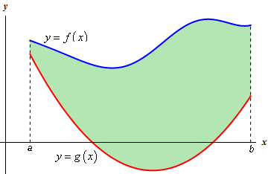Assume:

$$g\left(x\right)≤f\left(x\right) ∀ x∈\left[a,b\right]$$

A region like this is called vertically simple.

Area between the graphs:

$$\int_{a}^{b}{f\left(x\right)dx}-\int_{a}^{b}{g\left(x\right)}dx=\int_{a}^{b}{f\left(x\right)-g\left(x\right)dx}$$

If $f,g$ are arbitrary (region is not vertically simple):

* Subdividing $\left[a,b\right]$ in particular either $g\left(x\right)≤f\left(x\right)$ or $f\left(x\right)≤g\left(x\right)$
* Compute areas separately
* Add up

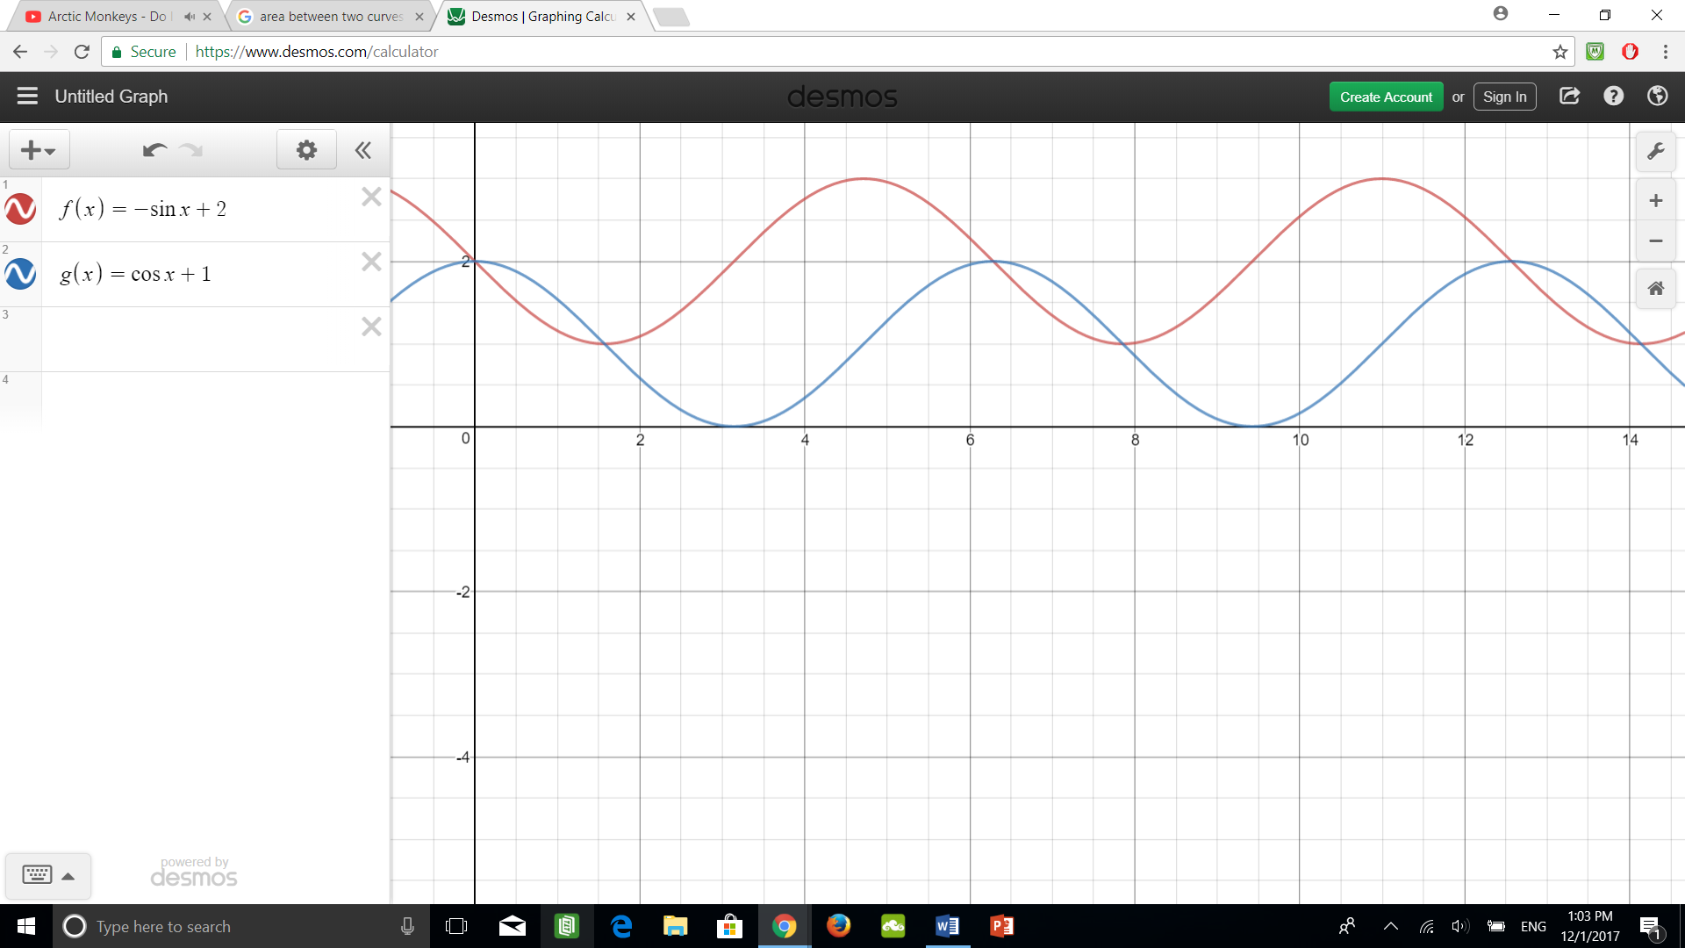

$a$ $x_{1}$ $x_{2}$ $x_{3}$

$$\int_{a}^{x_{1}}{g\left(x\right)-f\left(x\right)}dx+\int_{x_{1}}^{x_{2}}{f\left(x\right)-g\left(x\right)}dx+\int_{x_{2}}^{x_{3}}{g\left(x\right)-f\left(x\right)dx}$$

Example 3: Find the area of the region between the graphs $f\left(x\right)$ and $g\left(x\right)$ in the interval $\left[1,3\right]$

$f\left(x\right)=x^{2}-4x+16$ $g\left(x\right)=4x-x^{2}$

$f\left(x\right)-g\left(x\right)=\left(x^{2}-4x+16\right)-\left(4x-x^{2}\right)=2x^{2}-8x+10=2{\left(x-2\right)}^{2}+2>0$

$$⇒f\left(x\right)-g\left(x\right) ∀ x$$

Area: $\int_{1}^{3}{f\left(x\right)-g\left(x\right)dx}=\int_{1}^{3}{2x^{2}-8x+10}dx=\frac{2}{3}x^{3}-4x^{2}+10x|_{1}^{3}=\frac{16}{3}$

Example 4: Compute the area of the region between $f\left(x\right)$ and $g\left(x\right)$ over $\left[-2,5\right]$

$f\left(x\right)=x^{2}-5x-7$ $g\left(x\right)=x-12$

$$f\left(x\right)-g\left(x\right)=\left(x^{2}-5x-7\right)-\left(x-12\right)=x^{2}-6x+5=\left(x-5\right)\left(x-1\right)$$

The graphs intersect at points $x=1,5$

$\left[-2,1\right]:f\left(x\right)-g\left(x\right)>0$

$$\left[1,5\right]:f\left(x\right)-g\left(x\right)<0$$

$\int_{-2}^{1}{f\left(x\right)-g\left(x\right)}dx+\int_{1}^{5}{g\left(x\right)-f\left(x\right)}dx$ $=$ $\int_{-2}^{1}{f\left(x\right)-g\left(x\right)dx}+\int_{1}^{5}{g\left(x\right)-f\left(x\right)}dx$

$=$ $\int_{-2}^{1}{x^{2}-6x+5dx}+\int_{1}^{5}{-x^{2}+6x-5}dx$

$=$ $\frac{113}{3}$