Khyle Calpe

405016683

12/4/2017

Math 31A Lecture Notes: Integration of Volumes

Example 1: Find the area of the region enclosed by $y=\frac{8}{x^{2}}$, $y=8x$, and $y=x$

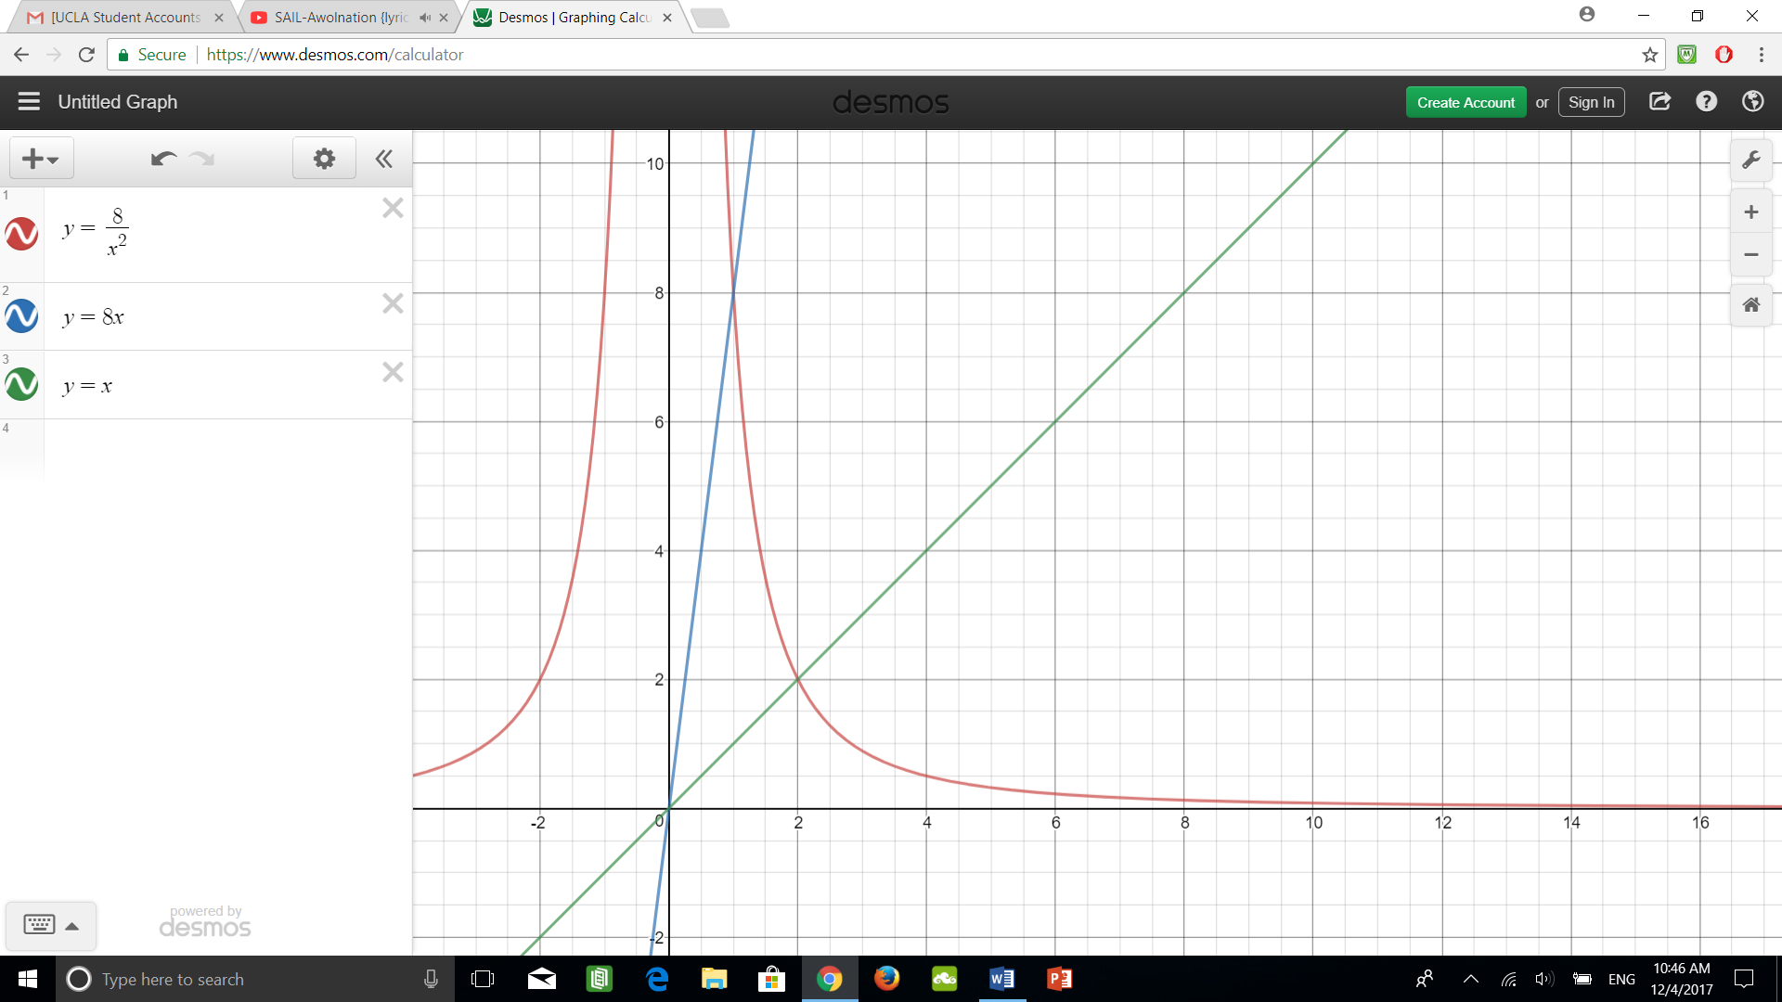

Sol: S1: Sketch region by intersecting the graphs

Intersect $y=\frac{8}{x^{2}}$ and $y=8x$: $\frac{8}{x^{2}}=8x⇒x=1$; $\left[0,1\right]:x≤8x$

Intersect $y=\frac{8}{x^{2}}$ and $y=x$: $\frac{8}{x^{2}}=x⇒x=2$; $\left[1,2\right]:x≤\frac{8}{x^{2}}$

S2: Calculate the areas and add up

Area $=\int_{0}^{1}{8x}-xdx+\int_{1}^{2}{\frac{8}{x^{2}}}-xdx=\frac{7}{2}x^{2}|_{0}^{1}+\left(-\frac{8}{x}-\frac{1}{2}x^{2}\right)|_{1}^{2}=6$

Definition; Integration of Volumes:

Let $A\left(y\right)$ be the area of the horizontal cross section of a solid extending from $y=a$ to $y=b$. The volume of the solid is given by:

$$\lim_{N→∞}{\sum_{i=1}^{N}{∆yA\left(y_{i}\right)}}=\int_{a}^{b}{A\left(y\right)}dy$$

Example 2: Find the volume of a pyramid with the measurements $l=4,w=4,h=12$

\* Treat the pyramid as a formation of multiple square cross sections; hence, we attain a changing height and side via proportionality of the initial side and height to the changing side and height.

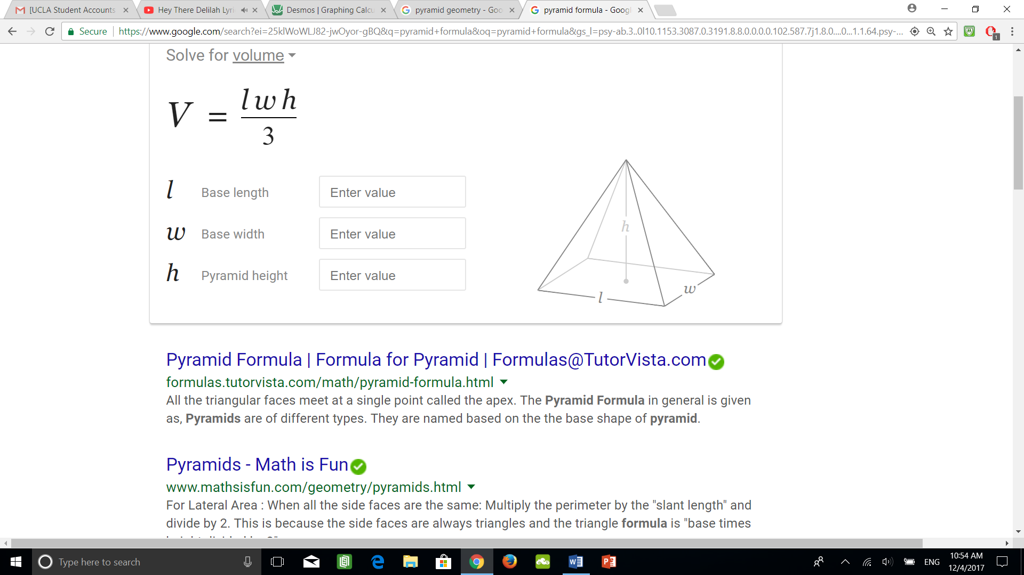 Sol: S1: Find the varying side length and compute for the area function

$\frac{4}{12}=\frac{s}{12-y}⇒\frac{1}{3}\left(12-y\right)$; $A\left(y\right)=s^{2}={\left(\frac{1}{3}\left(12-y\right)\right)}^{2}$

S2: Compute the volume

$\int_{0}^{12}{{\left(\frac{1}{3}\left(12-y\right)\right)}^{2}}dy=-\frac{1}{27}{\left(12-y\right)}^{3}|_{0}^{12}=64$

Example 3: Compute the volume of a sphere of radius R

 Sol: S1: Compute the area of a horizontal cross section

$r\left(y\right)=\sqrt{R^{2}-y^{2}}$ by Pythagorean theorem

$A\left(y\right)=πr{\left(y\right)}^{2}=π\left(R^{2}-y^{2}\right)$

S2: Compute integral

$\int_{-R}^{R}{A\left(y\right)}dy=\int_{-R}^{R}{π\left(R^{2}-y^{2}\right)}dy=π\left(R^{2}y-\frac{y^{3}}{3}\right)|_{-R}^{R}$

$=\frac{4}{3}πR^{3}$